U.S. Department of Veterans Affairs Office of Mental Health & Suicide Prevention

Social Media Content Calendar – September 2021

ID | Facebook Copy (280 characters) | Twitter Copy (280 characters) | Instagram Copy | Media Asset
1  Suggested post date:  9/1 | September is Suicide Prevention Month. If you’re struggling, take a moment to learn about resources. Visit  REACH.gov/SPM. | September is Suicide Prevention Month. If you’re struggling, take a moment to learn more about resources. Visit  REACH.gov/SPM. | September is #SuicidePreventionMonth. If you’re struggling, take a moment to learn more about resources. Visit  REACH.gov/SPM.  #SuicidePrevention #SuicideAwareness | Facebook/Twitter Image  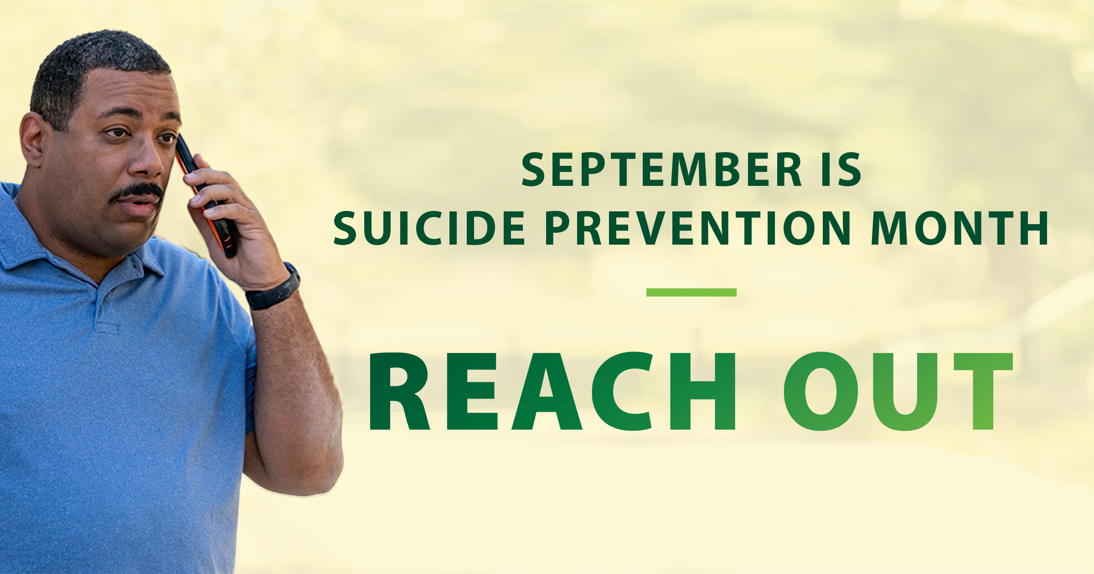  Instagram Image  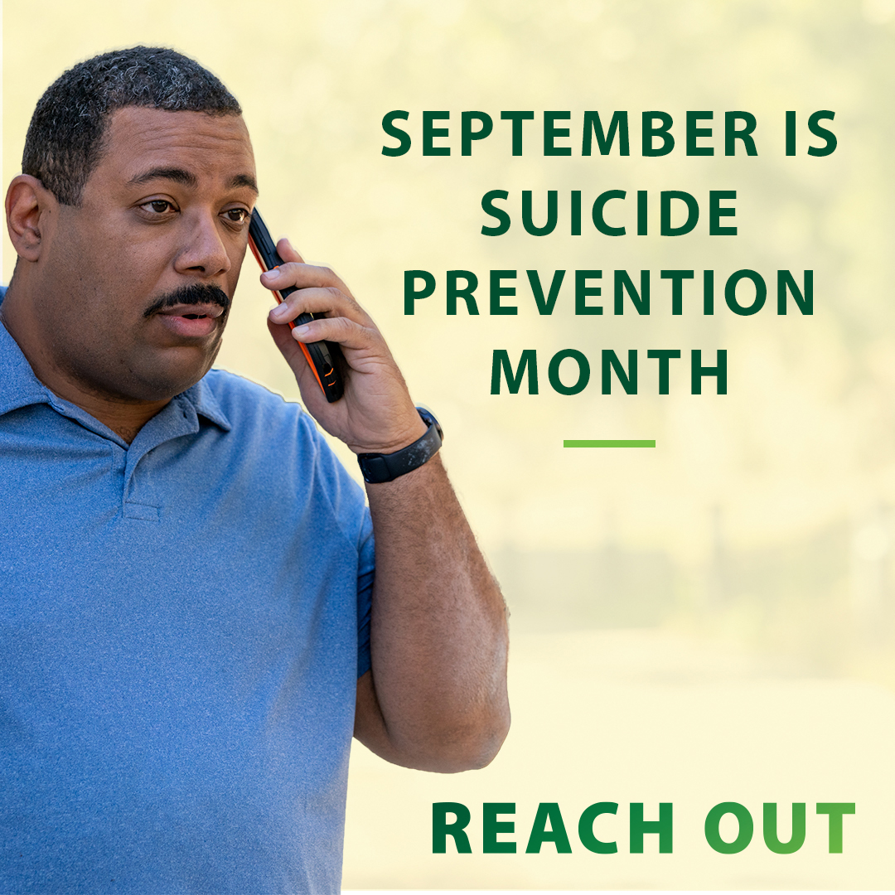
2  Suggested post date:  9/7 | Don’t wait until a crisis happens—reach out to your Veteran loved ones now to offer support.  REACH.gov/SPM | Don’t wait until a crisis happens—reach out to your #Veteran loved ones now to offer support.  REACH.gov/SPM | Don’t wait until a crisis happens—reach out to your #Veteran loved ones now to offer support.  #SuicidePrevention #SuicideAwareness  #SuicidePreventionMonth REACH.gov/SPM | Facebook/Twitter Image  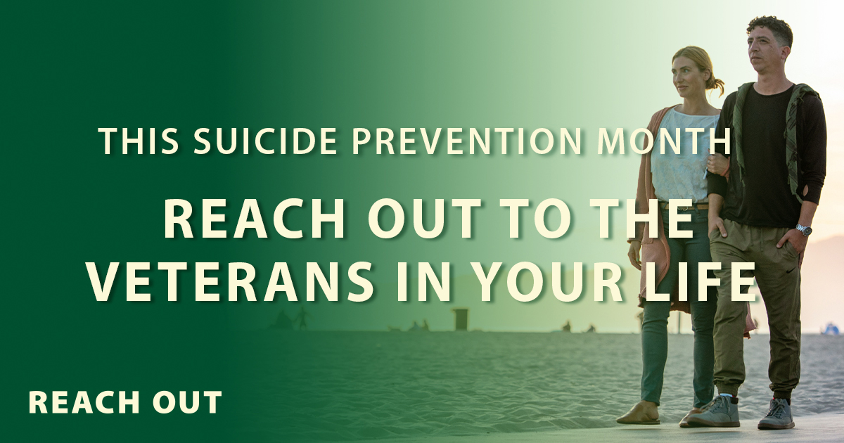  Instagram Image  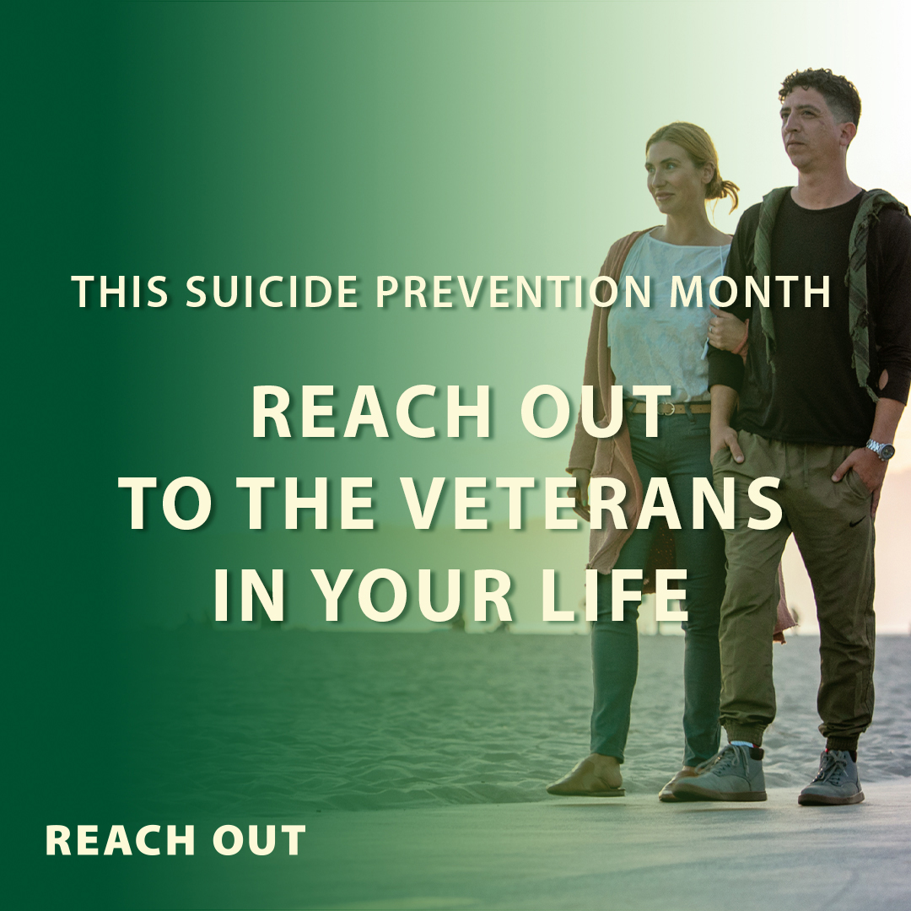
3  Suggested post date:  9/13 | During Suicide Prevention Month, talk to a Veteran about how you can support them. Let them know they’re not alone.  REACH.gov/SPM | During #SuicidePreventionMonth, talk to a #Veteran about how you can support them. Let them know they’re not alone.  REACH.gov/SPM | During #SuicidePreventionMonth, talk to a #Veteran about how you can support them. Let them know they’re not alone.  #SuicidePrevention #SuicideAwareness  REACH.gov/SPM | Facebook/Twitter Image  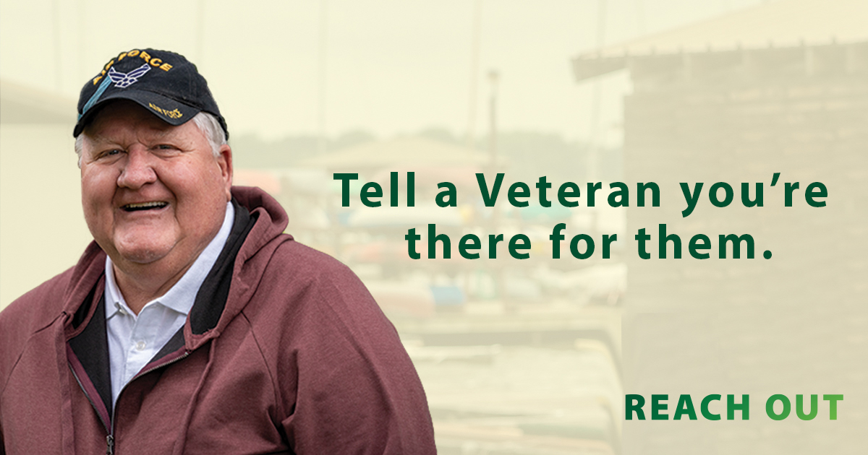  Instagram Image  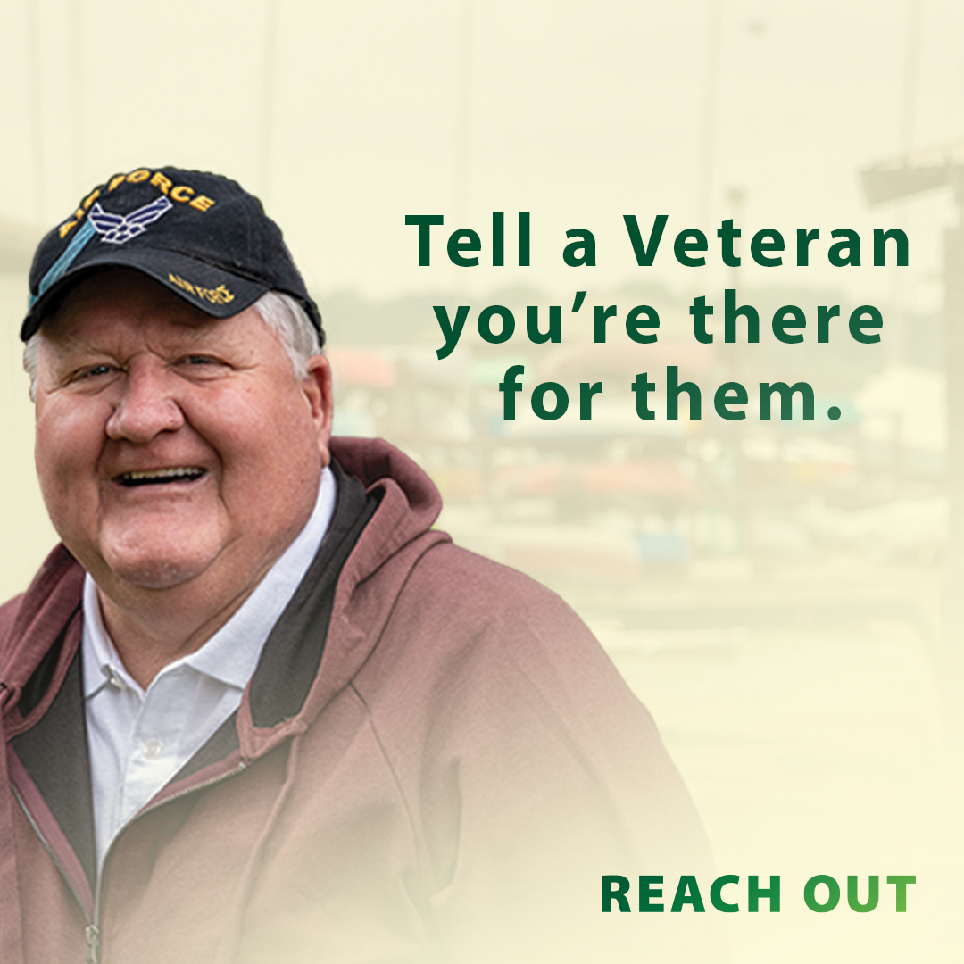
4  Suggested post date:  9/19 | You’ve been trained to carry the heavy stuff, but you don’t have to do it alone anymore. There are people available to support you—a loved one, a trained professional, or another Veteran. Reach out.  REACH.gov/SPM | You’ve been trained to carry the heavy stuff, but you don’t have to do it alone anymore. There are people available to support you—a loved one, a trained professional, or another #Veteran. Reach out.  REACH.gov/SPM | You’ve been trained to carry the heavy stuff, but you don’t have to do it alone anymore. There are people available to support you—a loved one, a trained professional, or another #Veteran. Reach out.  #SuicidePrevention #SuicideAwareness  #SuicidePreventionMonth  REACH.gov/SPM | Facebook/Twitter Image  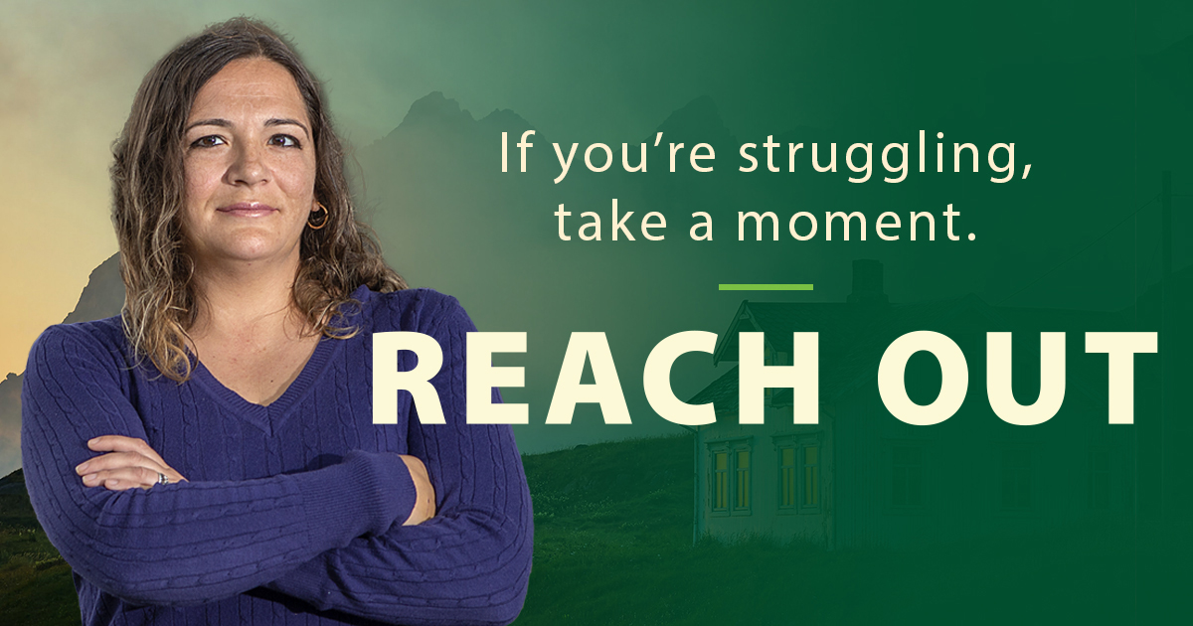  Instagram Image  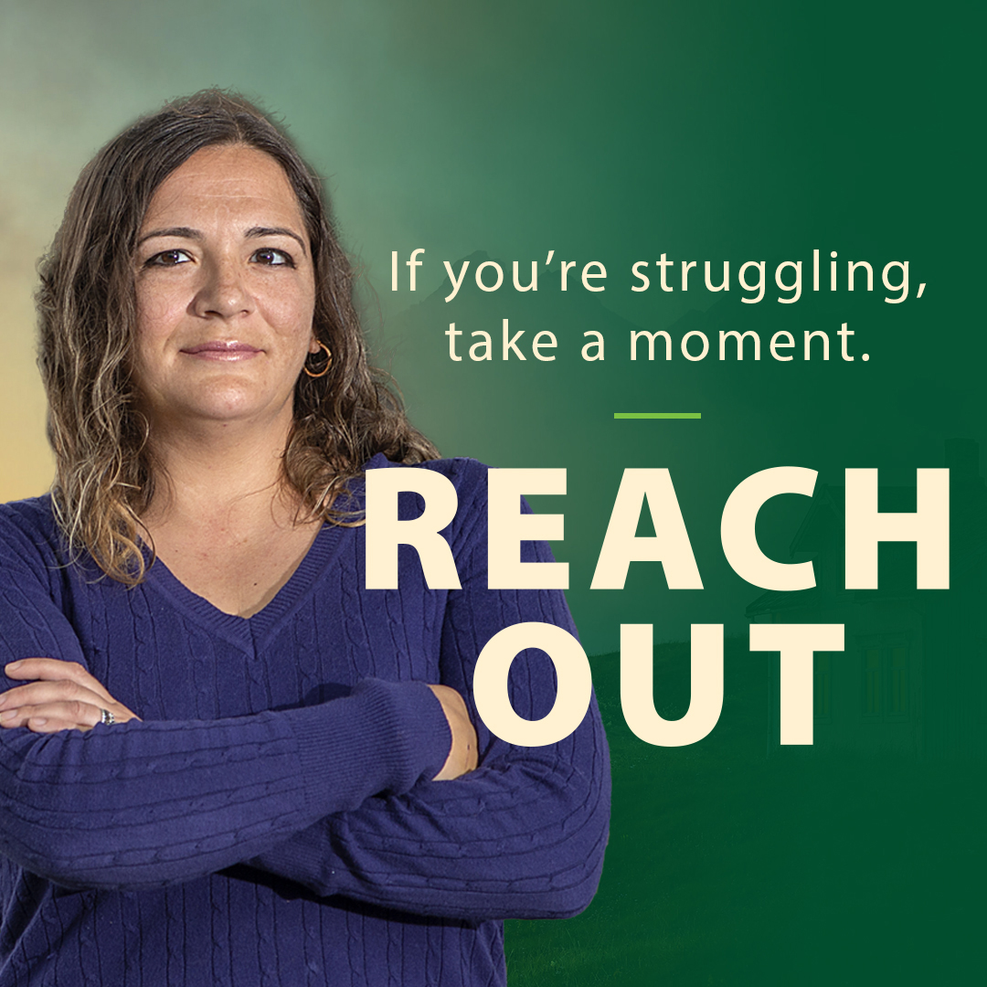
5  Suggested post date:  9/23 | This Suicide Prevention Month, take time to reach out to the Veterans in your life. Let them know you care.  REACH.gov/SPM | This #SuicidePreventionMonth, take time to reach out to the #Veterans in your life. Let them know you care.  REACH.gov/SPM | This #SuicidePreventionMonth, take time to reach out to the #Veterans in your life. Let them know you care.  #SuicidePrevention #SuicideAwareness  REACH.gov/SPM | Facebook/Twitter Image  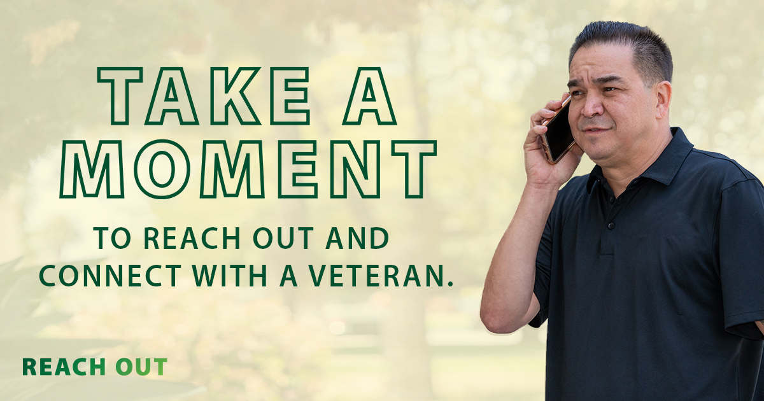  Instagram Image  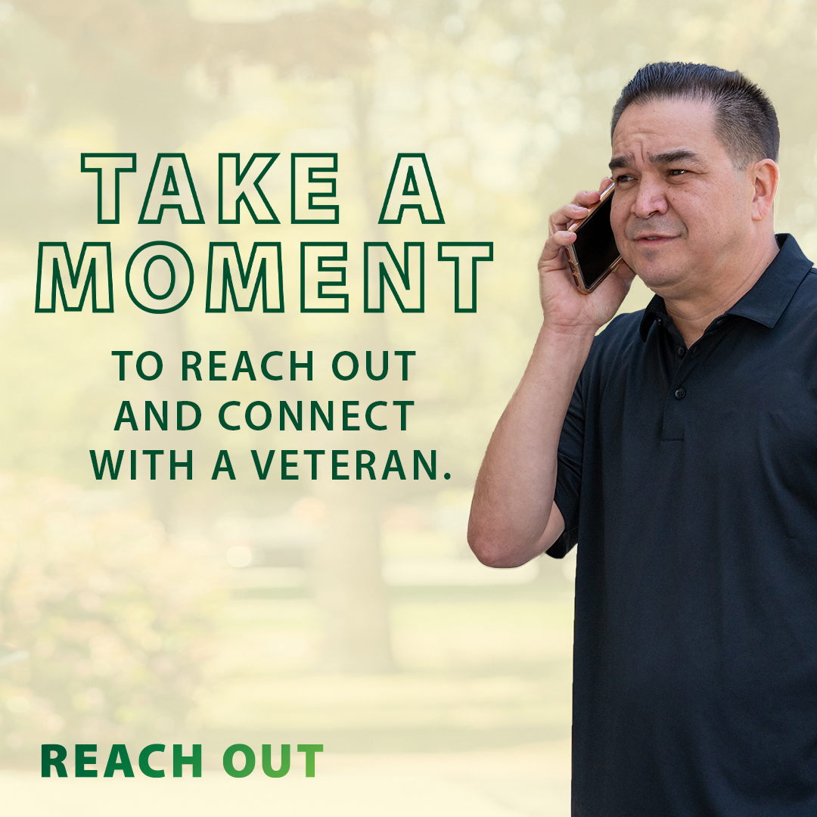
6  Suggested post date:  9/27 | Take a moment during Suicide Prevention Month to save the Veterans Crisis Line number in your phone: 1-800-273-8255 and Press 1.  VeteransCrisisLine.net | Take a moment during #SuicidePreventionMonth to save the #VeteransCrisisLine number in your phone: 1-800-273-8255 and Press 1.  VeteransCrisisLine.net | Take a moment during #SuicidePreventionMonth to save the #VeteransCrisisLine number in your phone: 1-800-273-8255 and Press 1. VeteransCrisisLine.net  #SuicidePrevention #SuicideAwareness | Facebook/Twitter Image  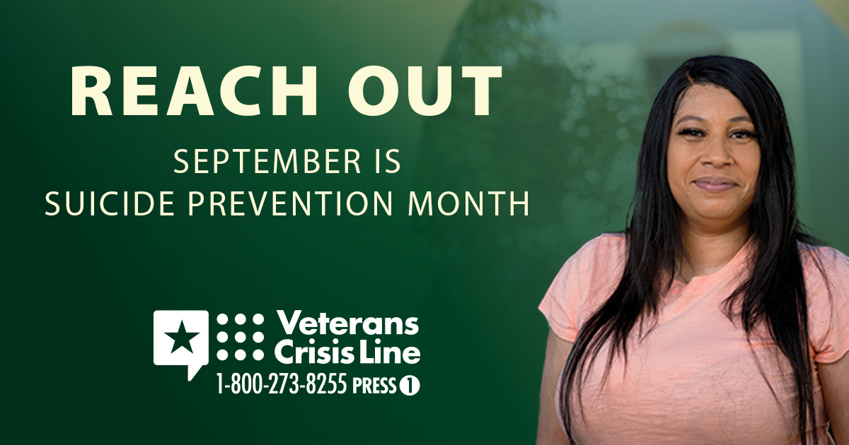  Instagram Image  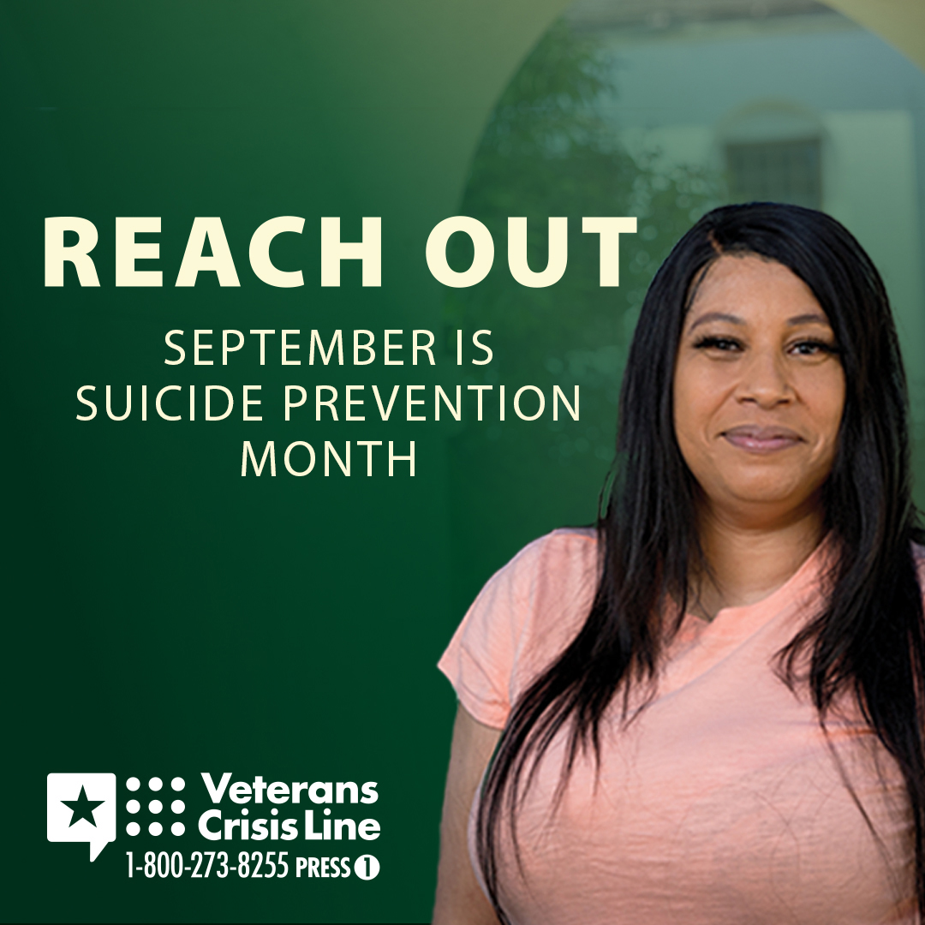
7  Suggested post date:  9/30 | September is Suicide Prevention Month. Remember the Veterans Crisis Line is always ready to support you. Call 1-800-273-8255 and Press 1—available 24/7. VeteransCrisisLine.net | September is #SuicidePreventionMonth. Remember the #VeteransCrisisLine is always ready to support you. Call 1-800-273-8255 and Press 1— available 24/7. VeteransCrisisLine.net | September is #SuicidePreventionMonth. Remember the #VeteransCrisisLine is always ready to support you. Call 1-800-273-8255 and Press 1— available 24/7. VeteransCrisisLine.net  #SuicidePrevention #SuicideAwareness | Facebook/Twitter Image  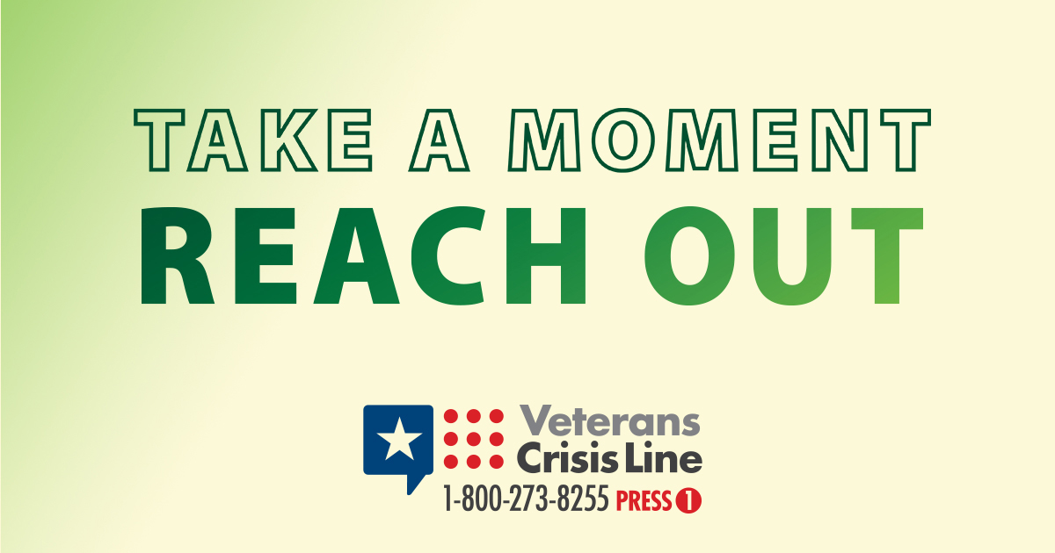  Instagram Image  