Greetings!
Since you watched the training program COVID-19 with a group, please help the creators of this program by completing a very brief survey. This survey will provide information on your reactions to the program and its usefulness. The team values your insights and would appreciate you taking the survey which takes less than 5 minutes.
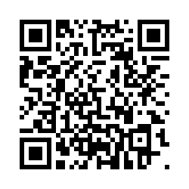
To take the survey, scan the QR code below by opening your phone’s camera and placing the little picture edges on this bar code photo. Once you do, a pop up will say----Connect to Qualtrics through your browser. Click that and you will be in the survey.

