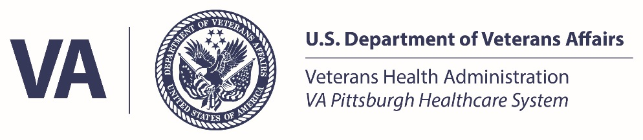

INSTITUTIONAL ANIMAL CARE AND USE PROGRAM

ANIMAL IMPORT/EXPORT

APPLICATION

VAPHS Animal Research Facility: VHAPTHARF@va.gov
(412) 360-6107

Please contact the VA Pittsburgh Healthcare System (VAPHS) Animal Research Facility (ARF) Supervisor for guidance on the import and export of animals. Veterinarians are also an available resource to investigators (e.g., discuss strains, approved and non-approved vendors utilized by the research community, experience, quarantine, health status, etc.) and can be reached by contacting the ARF Supervisor.

Note that the importing and exporting of animals (genetically modified or not) requires the strain to be on the active protocol listed on this application and even if no funding is changing hands to obtain the animal, may require a Material Transfer Agreement (MTA). For more information about obtaining an incoming or outgoing MTA, please see the VAPHS policy #R&D-014 Material Transfer Agreements Policy.

Instructions:
- Obtain a vendor quote (Statement of Work) defining the work to be performed (if applicable);
- Submit a protocol modification to the IACUC if your current protocol does not address the intended work or the animal strain to be imported. Note: A copy of the vendor quote can be attached to the protocol modification;
- Contact Research and Development Office (412-360-2842) to determine if an MTA must be in place;
- Complete this application in full;
- Submit the vendor quote with this application to the ARF Supervisor at VHAPTHARF@va.gov. The ARF Supervisor will seek approval to proceed from the IACUC or designee.

VAPHS ARF Information

Check One: Import of animals Export of animals

Date of Submission: |  |  |  | Species:
Department Name: |  |  |  | IACUC Protocol #:
Principal Investigator:
Address: |  |  |  | Phone:
Fax: |  |  |  | Email:
Contact Name (If not PI): |  |  |  | Phone (If not PI):
 |  |  |  | Email (If not PI):
Project Information
Grant/Contract/Agreement Number:
Prime Sponsor:
Project Title:
Project PI (if different from the name listed above):
Billing Information
Vendor Performing the Services:
Did they provide you with a Quote? |  | Yes No |  |  | If yes, please attach the quote
Account number to be billed for these services:
Will these services require a standing order? |  |  | Yes No
Ownership Information
Were the animals/materials being sent to the vendor independently developed by you or under your direction at the VAPHS? |  |  |  |  |  | Yes No
Do the animals/materials incorporate materials obtained from a third party? |  |  |  |  |  | Yes No
If yes, please list the party:
Is there a MTA or other type of agreement in place for the animals/materials? |  |  |  |  |  | Yes No  N/A
Housing Location
Housing Location after Import Quarantine (Bldg/Room): |  |  |  | N/A
Housing Location before Exportation (Bldg/Room): |  |  |  | N/A
For Acute Use Imports Only¹  Usage Location (Bldg/Lab#): |  |  |  | N/A
¹Acute Use Imports: Animals imported for acute experimental use in the PI’s lab may be held in the lab for no greater than 12 hours. Acute use imports must be approved in the IACUC protocol prior to animal import processing.

Other Institution (Not VAPHS)
Institution: |  |  |  | PHS Assurance #:
Principal Investigator: |  |  |  | Dept.:
IACUC Protocol #: |  |  |  | Phone:
Email:
Veterinarian Name: |  |  |  | Phone:
Email:
Shipping Coordinator: |  |  |  | Phone:
Email:
Shipping Address (Required for All Exports):
AAALAC Accreditation Status:

Courier / Transportation Information

Please supply the courier information. The billing address is the PI’s address. If importing, please ensure that the shipping address is the VAPHS ARF.
Name of Shipping Courier: |  | Phone:
Shipping Courier Acct #: |  | Contact:

Animal Information:
Complete the following information for both incoming and outgoing shipments.
Species: |  | Coat Color:
Strain (complete nomenclature):
Total Animals in Shipment: |  | Males: |  | Females:
Proposed Date of Shipment:

**For Imports: Animals are not to be shipped in breeding pairs to the VAPHS ARF. Males and females must be shipped in separate shipping boxes or shipping box compartments to prevent breeding in transit. With the exception of litter mates, males must be shipped separately to prevent fighting during shipment.

The following additional information must be provided for each rodent that will be exported. Please attach a separate sheet if necessary.
ID #  (tag, chip, notch, and tattoo) | DOB  (Date of Birth) | Gender  (Male/Female)

Housing / Health Information:
Have any of these animals received any experimental manipulations?
Yes No If yes, please describe:
Are any of these animals immunosuppressed or immunocompromised?
Yes No If yes, please describe:
Do any of these animals require special housing and management?
Yes No If yes, please describe:
Do any of these animals have any special health or breeding problems?
Yes No If yes, please describe:
Please provide other information you believe is pertinent:

Regulation of Custom Animal Production/Non-VAPHS Contract Research Animal Manipulation:
The use of a company or outside institution for custom animal production and non-VAPHS contract animal manipulation requires you to obtain: 1) IACUC approval AND 2) an MTA before initiation of the project. For questions about how to obtain an MTA for animal work, please contact the R&D Office at 412-360-2842.
Are the animals being imported custom gene manipulated or otherwise uniquely modified (i.e., the animal model would not have been generated without your order and is made to your specifications)?
Yes Not Applicable
Were the animals being imported manipulated by a company or outside institution (i.e., the animal(s) received work according to your research specifications)?
Yes Not Applicable

Other:
If animals are being shipped, the ARF Supervisor will exchange colony health reports with the sending or receiving institution. For animal imports, the VAPHS requires that health reports be signed by a designated veterinarian at the site of origin and be submitted to and reviewed by a VAPHS veterinarian prior to shipment.

Final approval of the import or export will be dependent on the health reports satisfying the requirements of the receiving institution.

PLEASE DO NOT WRITE BELOW THIS LINE – VAPHS ARF USE ONLY

 | Date | Initials |  | Date | Initials
Application Received |  |  | Project: R&D Approved
Project: IACUC Approved |  |  | Approved by Veterinarian
Sent to Veterinarian for Review
PI Contacted
Shipping Date |  |  | Arrival Date
Quarantine Completion

