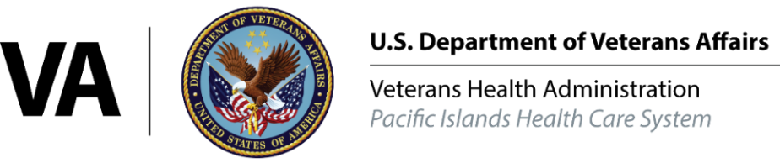
FOR IMMEDIATE RELEASE
August 25, 2021

VA awards more than $1,440,000 in grants to fight homelessness and improve transitional housing

Honolulu, HI — The VA Pacific Islands Health Care System will award $1,440,000 in grants to US Veterans Initiative in Honolulu starting September, 2021 under the Grant Per Diem program to combat homelessness.
The GPD program provides funding to community organizations that provide transitional housing and supportive services for Veterans experiencing homelessness, with the goal of helping them achieve residential stability, increase their skill levels and income and obtain greater self-determination.
“The Grant and Per Diem program is integral to VA’s continuum of services and resources to help Veterans exit homelessness,” said Director Adam Robinson. “The newly awarded grants allow VA to continue to tailor transitional housing and case management services to the unique needs and circumstances of individual Veterans facing housing crises, which helps put them on the pathway to permanent housing faster.”
GPD funding will l support three different types of grants to address the unique needs of Veterans who are experiencing homelessness:
- Capital Grants provide funding for community organizations through the Coronavirus Aid, Relief, and Economic Security Act of 2020. The funding supports capital improvements to GPD transitional housing facilties. The improvements result in less congregate and more individual unit style housing, thereby improving personal safety and reducing risks associated with close quarters living for Veterans.

- Case Management Grants are used to support case manager positions within community organizations. These positions provide services to help Veterans retain housing stability, adequate income support and self-sufficiency.

- Special Need Grants provide funding for community organizations that incur additional operational costs to help Veterans with special needs who are experiencing homelessness, including women, individuals with chronic mental illnesses and Veterans who care for minor dependents.

The GPD program has provided community-based transitional housing and supportive services since 1994. The number of Veterans experiencing homelessness in the U.S. has declined by 50% since 2010 resulting from the GPD program and other VA efforts.

A list of GPD grantees and nonprofit organizations seeking details about the program can visit homeless GPD.

Two grants to US VETS
$765, 120 Special Needs (Women)
$675, 000 Case Management

-VA-

For more information contact: Amy Rohlfs, public affairs officer, VAPIHCS 808-433-0049

