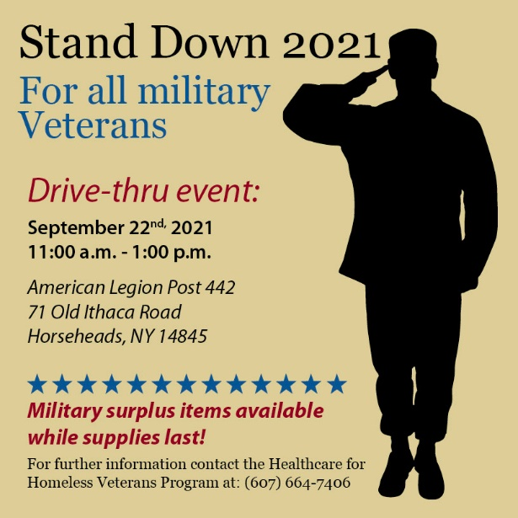
News Release
FOR IMMEDIATE RELEASE
September 21, 2021

Contact: Kathleen Hider, Public Affairs
Cell: (585) 330-5720
Email: Kathleen.hider@va.gov

Southern Tier Stand Down 2021 For All Military Veterans

VA Finger Lakes Healthcare System at Bath, NY is holding a Stand Down for all military Veterans in the Southern Tier area.

The event will be a drive-thru on:

Date: Wednesday September 22, 2021
Time: 11:00 a.m. - 1:00 p.m.
Place: American Legion Post 442, 71 Old Ithaca Road, Horseheads, NY 14845

Due to COVID-19 community providers will not be joining VA this year. Veterans should bring VA ID or DD214 and just show up - no registration required. Military surplus will be available as well as gift bags from various VA programs.

###

