News Release
FOR IMMEDIATE RELEASE
November 15, 2021
Contact: Kathleen Hider, Public Affairs
Cell: (585) 330-5720
Email: Kathleen.hider@va.gov

VA Finger Lakes Healthcare System Now Scheduling
Moderna COVID -19 Booster Shots

Call today.

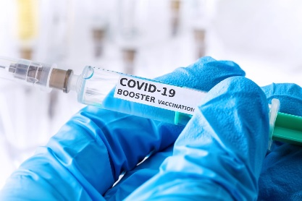

VA Finger Lakes Healthcare System is now scheduling MODERNA Booster vaccination appointments.
The vaccine is available to Veterans, their spouses, and caregivers.

If you meet the following criteria (Veterans and Spouse/Caregivers):
- 65 years and older
- Age 18+ who live in long-term care settings
- Age 18+ who have underlying medical conditions
- Age 18+ who work or live-in high-risk settings

AND

- It has been 6 months or more since you received your second dose of the Moderna or Pfizer vaccine series

OR

- If you received a single Janssen (J+J) vaccine over 2 months ago

THEN

YOU ARE ELIGIBLE TO RECEIVE A MODERNA BOOSTER AT THIS TIME!

PLEASE CALL TO SCHEDULE YOUR APPOINTMENT TODAY!
• Canandaigua – (585) 393-7401, Option 3
• Rochester – (585) 463-2757, Option 3
• Bath - (607)664-4626

###

