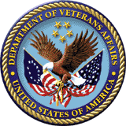

Durham Veterans Affairs Medical Center

**Durham, North Carolina**

# *PGY1 Residency Program Application Document*

 VETERANS AFFAIRS MEDICAL CENTER

DURHAM, NORTH CAROLINA

# PHARMACY PRACTICE RESIDENT APPLICATION



**Name**:

**Please answer the following questions using no more than 2 pages total:**

1. What specifically attracts you to the Durham VA PGY1 Residency Program?
2. Describe the specific characteristics of your ideal residency program, residency director, and residency preceptor.
3. What are your post-graduate career goals?