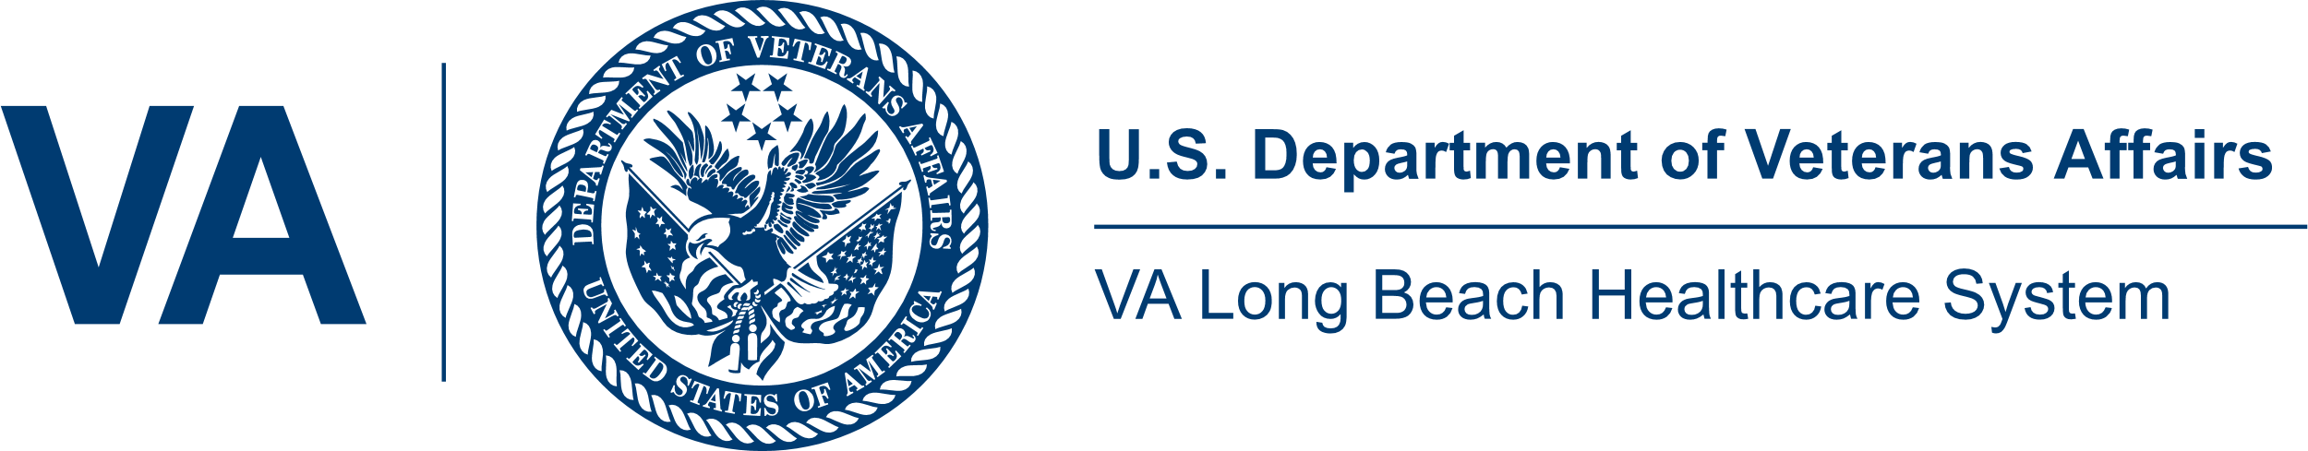
Memorandum of Assurance

This form is to be completed by Clinical Instructor Only

Date: Click or tap here to enter text.
From (Clinical Instructor): Click here to enter instructor name.
Academic Institution: Click here to enter school name.
Clinical Subject: Click here to enter clinical rotation subject.
To: Lilibeth Patricio, Academic Affiliation Coordinator
The Learner’s Perception Survey (LPS) is a mandatory requirement for all nursing students rotating through the VA Long Beach Healthcare System. The LP S needs to be completed by the student mid-way or at the end of their clinical rotation.
The instructor signs this Memorandum of Assurance validating that all nursing students in their clinical rotation have completed the survey as appropriate.
Please provide this survey link to your students: https://www.va.gov/oaa/current-trainee-survey.asp.

The LPS is open online annually, from July 1st to June 30th. Each nursing student can complete this survey only once during this timeframe regardless of the number of clinical rotations completed during this period.
Rotation Dates: Click or tap here to enter date range.
Unit: Click here to enter unit where clinicals were conducted.
# Students in this Clinical Rotation: Click or tap here to enter number.
# Students already completed an LPS this year: Click or tap here to enter number.
# Students Eligible to Complete LPS at this time: Click or tap here to enter number.
Click or tap here to enter signature.

Signature (Clinical Instructor): __________________________________

