How to Floss

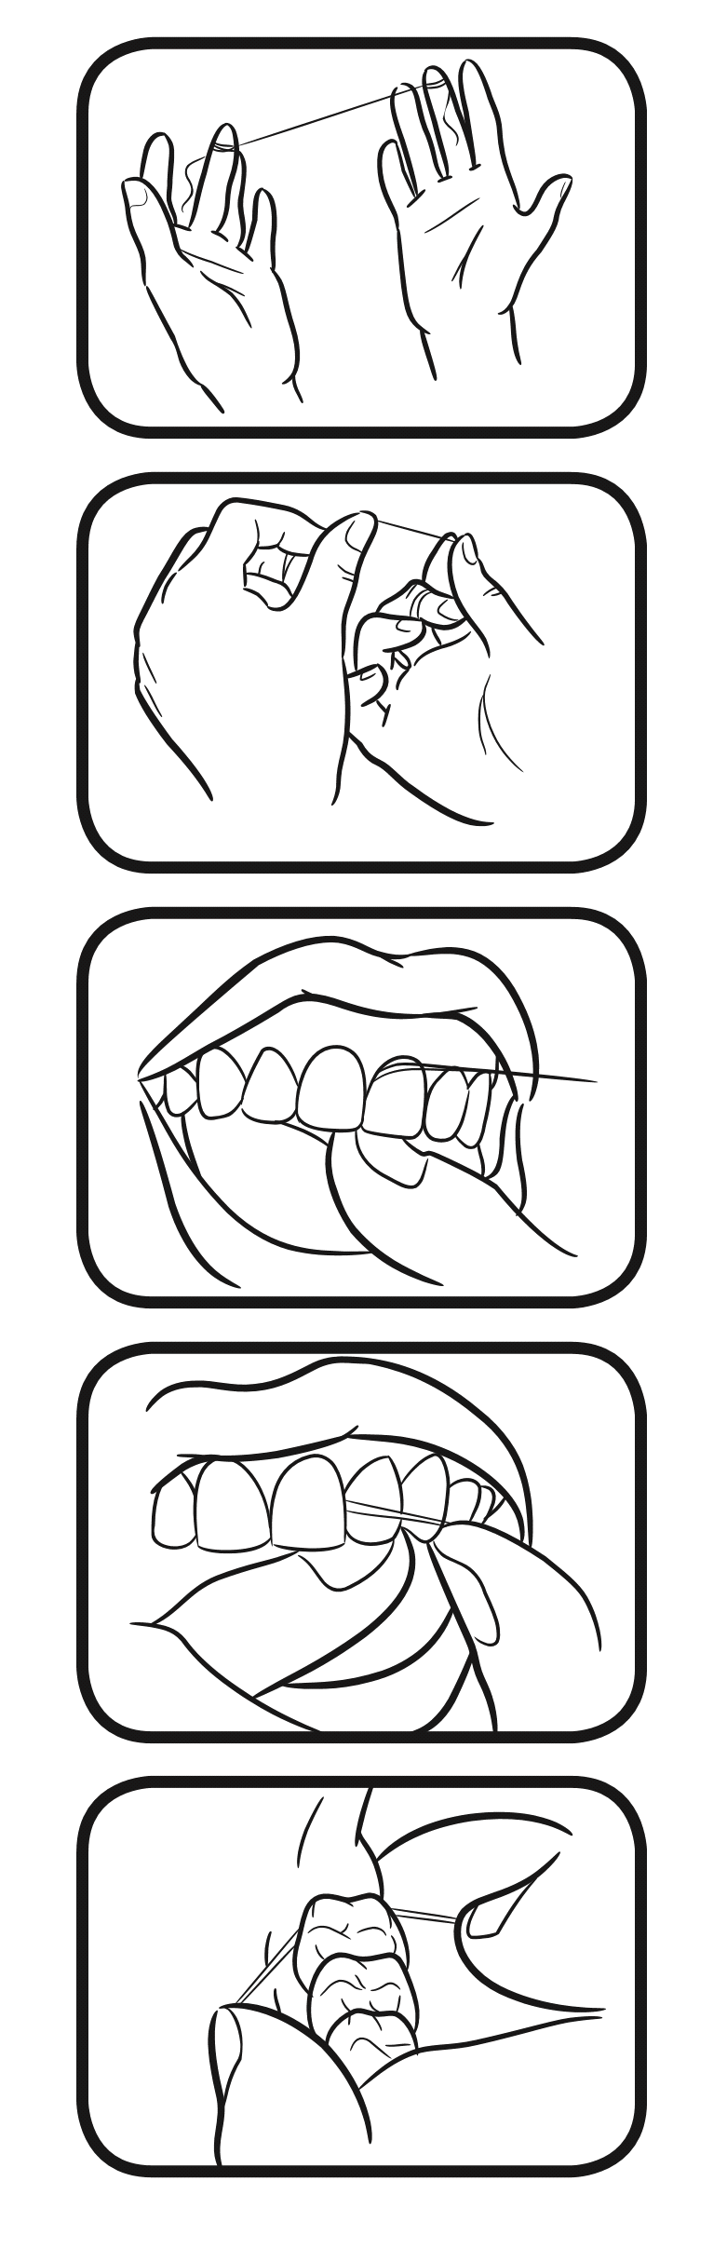
- Use about 18 inches of floss wrapped around one of your middle fingers, with the rest wrapped around the opposite middle finger.

- Hold the floss tightly between the thumbs and forefingers and gently insert it between the teeth.

- Curve the floss into a “C shape against the side of the tooth.

- Slide the floss gently up and down, keeping it pressed against the tooth. Do not jerk or snap the floss.

- Floss all your teeth. Do not forget to floss behind your back teeth.


Approved by the Veteran Education Workgroup: May 2020

