Press Release 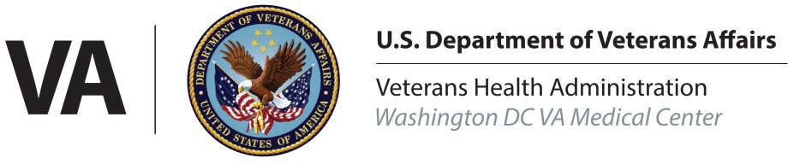
Washington DC Veterans Affairs Medical Center
https://www.washingtondc.va.gov

Washington DC Veterans Affairs Medical Center Office of Public Affairs:
Gloria Hairston: 202-603-1585

FOR IMMEDIATE RELEASE
September 15, 2022

DC VA Fisher House Celebrates 11 Years Of Service

Washington, D.C. – Washington DC VA Medical Center’s Fisher House celebrated 11 years of service to Veterans, their families, and caregivers on Sept. 8, 2022. To mark this milestone, leadership from Fisher House and Washington DC VA Medical Center hosted a lunch for residents and staff in accordance with COVID-19 safety guidelines.

“To preserve the privacy and safety of our guests, we held an anniversary celebration exclusive to current guests and employees,” said Washington DC VA Fisher House Manager Stacey Childs. “We’ve been truly blessed to be able to adopt pandemic guidelines that allow our doors to remain open to families in need during these uncertain times.”

The Washington DC VA Fisher House is the 19th “home of comfort” built by the Fisher House Foundation, who donated it to the Washington DC VA Medical Center in 2011. The facility offers 20 professionally decorated and furnished guest room suites, shared lounge areas and a communal kitchen and dining room, free of charge to Veterans, their families, and caregivers, who are supporting patients at the Washington DC VA Medical Center.

The Fisher House operates on the belief that “a family’s love is good medicine” and staff strive to provide a comfortable “home away from home” for residents during stressful times in their lives.

“Veterans sacrifice so much to serve, and so do their loved-ones who hold down the fort at home,” said Childs. “Serving them has been an honor and privilege for me.”

Since its inception, more than 24,000 Veterans, their families, and caregivers, have utilized this safe and free, temporary housing option. Guests have traveled from 45 different states, and internationally from Chile, to stay near loved ones receiving medical care. The average length of stay for guests is two nights, but there are no time restrictions for guests needing to support a Veteran on the road to recovery. The longest stay to date lasted 13 months.

Fisher House operations are made possible through support and donations from dedicated community stakeholders. So far in 2022, $23,000 in donated funds have helped to provide lodging for 180 families.

Since 1990, the Fisher House Foundation has built and donated 92 Fisher Houses Around the World, including the United Kingdom and Germany. Their services have housed more than 430,000 eligible Veteran families, saving them more than $547 million in lodging costs.

To coordinate an interview with a DC VA Fisher House representative, please contact the Washington DC VA Medical Center Office of Public Affairs at 202-603-1585.

