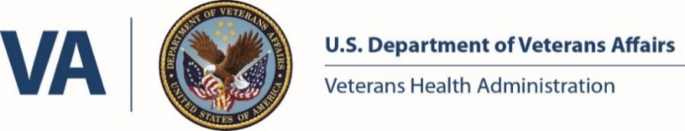

**James A. Haley Veterans’ Hospital**

**Pharmacy Residency Class of 2022 – 2023**

|  |  |
| --- | --- |
| **PGY-2 Pharmacy Residents** | |
|  | **Sung Soo Kim, PharmD**  sung.kim1@va.gov  PGY-2 Infectious Diseases Pharmacy Resident  **Hometown**: Gwangju, South Korea | Atlanta, Georgia  **Education:** University of Georgia College of Pharmacy  **PGY-1 Residency**: James A. Haley Veterans’ Hospital (Tampa, FL)  Dr. Kim is from Atlanta, GA and received his Bachelor of Science in Biology and Doctor of Pharmacy degrees from the University of Georgia. He completed a PGY1 Pharmacy Practice Residency at the James A. Haley VA. His professional interests include management of antimicrobial stewardship, outpatient clinics, and pharmacy administration. Outside of pharmacy, he enjoys skiing and traveling abroad. |
|  | **Riawna C. Kelly, PharmD**  riawna.kelly@va.gov  PGY-2 Ambulatory Care Pharmacy Resident  **Hometown**: Okinawa, Japan | Moore Haven, Florida  **Education:** Mercer University College of Pharmacy  **PGY-1 Residency**: Carl Vinson VA Medical Center (Dublin, GA)  Dr. Kelly received her B.S. in Biology at Florida Gulf Coast University in Fort Myers, Florida then moved to Atlanta, Georgia to complete her PharmD at Mercer University. She grew up as a military child, therefore has a passion for serving our Veteran population. She plans on having a long career within the VA system. Her ambulatory care interests include cardiology, endocrinology, and women’s health. Outside of pharmacy, she enjoys cooking, binge watching TV shows, playing with her dog, and spending time with her family and friends. |
|  | **Raisah W. Salhab, PharmD**  raisah.salhab@va.gov  PGY-2 Ambulatory Care Pharmacy Resident  **Hometown**: Palm Harbor, Florida  **Education:** University of South Florida Taneja College of Pharmacy  **PGY-1 Residency**: Yale New Haven Health  Dr. Salhab is from Palm Harbor and received her Doctor of Pharmacy degree from the University of South Florida Taneja College of Pharmacy. She completed a community based PGY1 at Yale New Haven Health in New Haven, CT before returning back to Florida to complete her current PGY2 in Ambulatory Care at JAHVA. Her professional interests include management of chronic disease states with focus on specialty disease states including inflammatory disease (such as rheumatology and gastroenterology), education, and serving underserved and vulnerable populations. Outside of residency, she enjoys record shopping to expand her ever growing collection and traveling. |
| **PGY-1 Pharmacy Residents** | |
|  | **Kayla P. Bartel, PharmD**  kayla.bartel@va.gov  **Hometown**: DeBary, Florida  **Education:** University of South Florida Taneja College of Pharmacy  Born and raised in Central Florida, Dr. Bartel attended the University of South Florida for both her undergraduate and pharmacy education and graduated with her PharmD in May of 2022. She has been involved in the American College of Clinical Pharmacy throughout pharmacy school and currently serves on the 2022-23 ACCP National Resident Advisory Committee. Professionally, her interests are in acute care and include Emergency Medicine, Infectious Disease, and Critical Care. Outside of pharmacy, Kayla enjoys aviation as a Student Pilot, outdoor activities such as hiking and running, and practicing yoga. |
|  | **Wedad N. Haddabeh, PharmD**  wedad.haddabeh@va.gov  **Hometown**: Cliffside Park, New Jersey  **Education:** University of South Florida Taneja College of Pharmacy  Dr. Haddabeh grew up in Cliffside Park, NJ and completed her undergraduate studies at Montclair State University prior to moving to Tampa, FL and receiving her Doctor of Pharmacy degree from the University of South Florida. Her professional interests include geriatrics, ambulatory care, cardiology, and preceptorship. Outside of pharmacy, she enjoys spending time with her family, horseback riding, and kickboxing. |
|  | **Andrea P. Tello, PharmD**  andrea.tello@va.gov  **Hometown**: Queens, New York  **Education:** University of Florida College of Pharmacy  Dr. Tello was born in New York City and moved to Miami, FL during high school. She completed her A.A. in chemistry at Miami Dade College and got her Doctor of Pharmacy degree at the University of Florida. Her professional interests include ambulatory care and geriatrics. Outside of pharmacy, she enjoys spending time with family and friends, going on walks and indoor cycling. |
|  | **Tacianna S. Williams, PharmD**  tacianna.williams@va.gov  **Hometown**: Lauderdale Lakes, Florida  **Education:** University of South Florida Taneja College of Pharmacy  Dr. Williams received her Bachelor of Science in Biological Sciences at Florida Atlantic University and her Doctor of Pharmacy degree from the University of South Florida. She is currently interested in ambulatory care but is keeping an open mind as she progresses through residency. Outside of pharmacy, she enjoys reading, writing, bowling, traveling, and attending concerts. After residency, she plans to become an author with hopes of being on the New York Times Best Sellers list. |