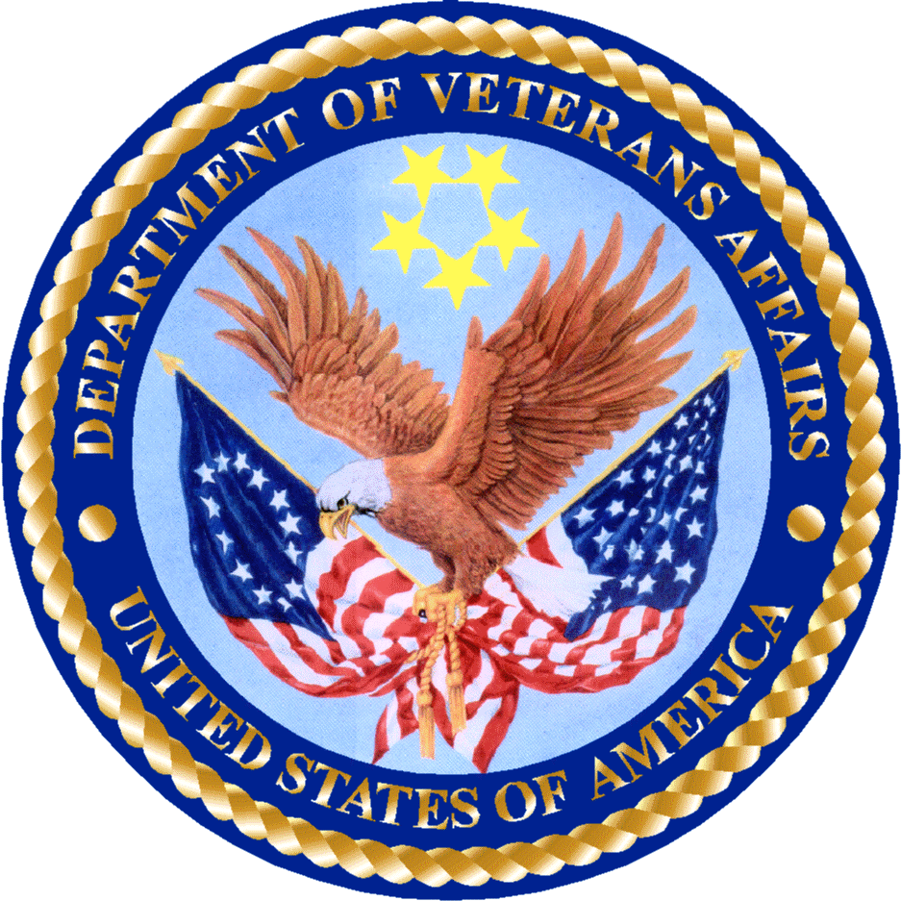
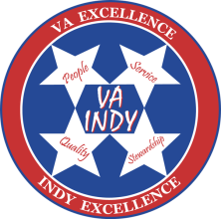
PGY 2 Internal Medicine Residency
Veteran Health Indiana
Richard L. Roudebush Veterans Affairs Medical Center

Indianapolis VAMC Pharmacy Residency Program | VA Indiana Health Care | Veterans Affairs

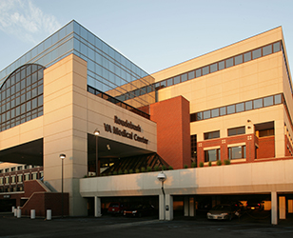
Program Purpose Statement:
PGY2 pharmacy residency programs build on Doctor of Pharmacy (Pharm.D.) education and PGY1 pharmacy residency programs to develop pharmacist practitioners with knowledge, skills, and abilities as defined in the educational competency areas, goals, and objectives for advanced practice areas. Residents who successfully complete PGY2 residency programs are prepared for advanced patient care or other specialized positions, and board certification in the advanced practice area, if available.

Specific Strengths of this Residency Program:
- Provides the necessary training to become a clinical pharmacy practitioner in acute care upon graduation by integrating the necessary experience and knowledge to provide comprehensive medication management for Veteran patients.
- Clinical education and advanced training in internal medicine will occur in both the inpatient and outpatient settings.
- Residents will gain clinical skills and knowledge in pharmacotherapy, pharmacokinetics, and the pathophysiology of core Internal Medicine disease states on multidisciplinary health care teams providing veteran-centered care
- Learning experiences include six months of rounding on VA Internal Medicine multidisciplinary medical teams (teaching and non-teaching) providing prospective, comprehensive pharmaceutical care.
  - Additional required learning experiences include ambulatory care, critical care, and medication safety to cover the entire continuum of care.
  - Additional 11 month long longitudinal experiences that are required are administration/management, and longitudinal quality improvement project
  - Elective Learning Experience opportunities:
    - Academic Rotation with Butler University College of Pharmacy
    - Emergency Medicine
    - Infectious Disease
    - Inpatient Psychiatry
    - Surgical Care
- This program has graduated 17 PGY2 IM residents over 14 years of existence. All are board certified and practicing in variety of acute care, ambulatory care, and pharmacy leadership positions across the country.
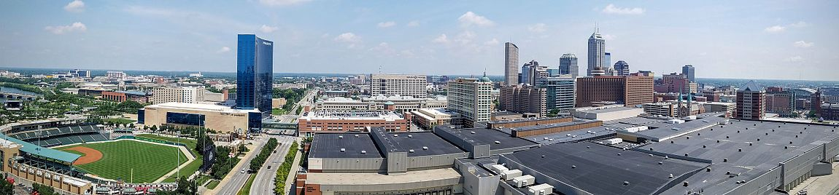
The resident experiences shall include, but are not limited to, the following:
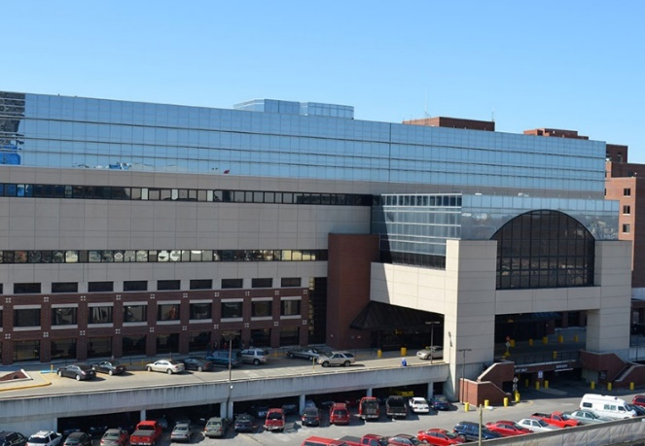
- Comprehensive care model includes clinical rounding, medication reconciliation, discharge education, and order entry activities
- Pharmacist to patient staffing ratios that allow pharmacist and pharmacy residents abilities to manage comprehensive care of their patients from admission to discharge
- Dedicated pharmacist computer space within the medicine team rooms enhancing collaboration and communication
- Teaching and precepting experiences for both APPE students and layered learning with PGY1 level residents
- Development and completion of a longitudinal project and presentation at a regional conference
- Certification in Basic Life Support (BLS) and Advanced Cardiac Life Support (ACLS)
- Co-chair of both local facility and VA national longitudinal committees and/or workgroups, along with Yellow and Green Belt certifications
- Elective opportunities for teaching certification program including development of a teaching portfolio
- Additional administrative responsibilities including formal presentations, drug information activities, peer review of medical literature, and regional/national journal clubs
- Opportunities to participate on national Clinical Pharmacy Practice Office (CPPO) national subject matter expert workgroup in acute care focused on enterprise level practice advancement
- Clinical Staffing Requirements include one every sixth weekend providing clinical coverage for core pharmacy functions

Recruitment Information:
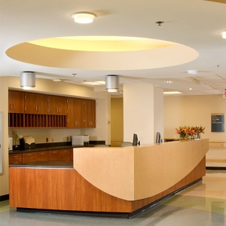
Veteran Health Indiana residency programs have made changes in their recruitment practices to assure that we have increased our accessibility for all individuals who are interested in pursuing post-graduate training at our facility. This includes participating in nationally run, free for everyone, recruitment forums that link interested candidates from any background to face-to-face interviews with residency program directors and preceptors. Additionally virtual platforms for interviews are available for any interested candidate who meet the pre-determined, objective criteria for initiation to interview. All preceptors complete implicit bias training and follow objective criteria for evaluation of candidates.

The following are mandatory requirements for all VA residents who are interested in PGY2 level training programs at Veteran Health Indiana.

- Am I Eligible? Checklist for VA HPTs
- Citizen of the United States of America
- Doctor of Pharmacy degree from an accredited college of pharmacy
- Active pharmacy licensure in any state
- Completion of an ASHP-accredited PGY1 Pharmacy Residency

Requirements for Application: Deadline for application = January 15th
- Letter of Intent
- Current curriculum vitae
- Three letters of recommendation using PhORCAS
- Personal interview
  - Candidates will be screened to offer interviews. Considerations will include the following:
    - Writing skills
    - Letters of recommendation
    - Leadership activities
    - Pharmacy experience
    - VA experience
    - Phone interview performance
  - Candidates will receive prior to interview the following:
    - Leave policy
    - Duty-hour policy
    - Licensure policy
    - Requirements for successful completion of the program
    - Residency specific remediation/disciplinary policy
    - Program start date and term of appointment
    - Stipend and benefit information
    - Financial support for required professional meeting attendance

Benefits:
- Competitive stipend per annual VA standards
- Medical and life insurance
- Thirteen vacation days and eleven federal holidays
- Professional days for attendance of national meetings and interviews
- Shared office space with other PGY2 residents along with dedicated computer space
- Lab coat and medical media access

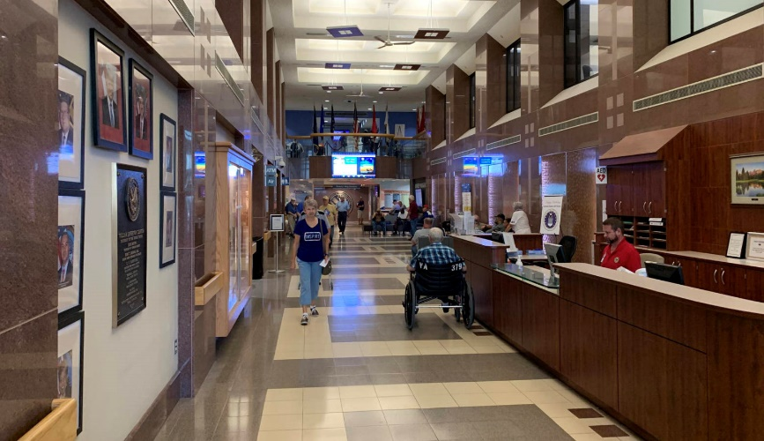

For more information please contact:
Christopher M. Degenkolb, Pharm.D., BCPS
Residency Program Director, PGY2 IM Residency
Clinical Pharmacy Specialist – Internal Medicine
Richard L. Roudebush Veterans Affairs Medical Center
1481 West Tenth Street
Indianapolis, Indiana 46202
Office: (317) 988-4565
Email: Chris.Degenkolb2@va.gov

