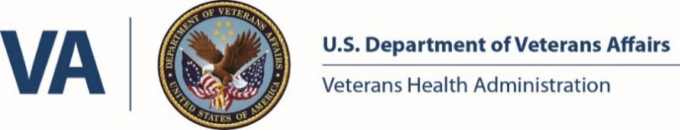
James A. Haley Veterans’ Hospital
Pharmacy Residency Program Directors

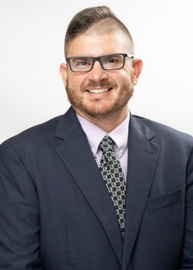 | Joseph J. Fierro, PharmD, BCACP  PGY-1 Pharmacy Residency Program Director  joseph.fierro@va.gov  Joseph J. Fierro, PharmD, BCACP is a Clinical Pharmacist Specialist in the anticoagulation and specialty clinics at the James A Haley Veterans’ Hospital. He earned his Pharm.D. degree from the University of Florida in 2008. He then completed a PGY-1 residency at the North Florida/South Georgia Veterans Health System in Gainesville, Florida with emphasis in primary care. Afterward, he pursued a PGY-2 Ambulatory Care Pharmacy residency at the James A. Haley Veterans’ Hospital in Tampa, Florida. He earned his board certification as an ambulatory care pharmacist (BCACP) in 2012. He was the PGY2 ambulatory care residency director from 2018 – 2021 and became the PGY1 residency director in 2022.

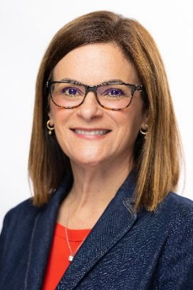 | Reina Carcifi, PharmD, BCPS  PGY-2 Ambulatory Care Pharmacy Residency Program Director  reina.carcifi@va.gov  Reina Carcifi, PharmD, BCPS received her Doctor of Pharmacy from the University of Florida College of Pharmacy in 1995 and completed an ASHP Accredited Residency in Primary Care at the James A. Haley Veterans' Hospital in Tampa in 1996. She is currently employed as a Clinical Pharmacy Specialist. Her main responsibility at James A. Haley Veterans' Hospital is serving the Charlie Primary Care Team as their PACT Pharmacist. She has served as the director of the ASHP PGY2 Ambulatory Care Residency since 2021.

Tiffany Ward, PharmD, BCIDP, BCPS, AAHIVP
PGY-2 Infectious Diseases Pharmacy Residency Program Director
tiffany.ward2@va.gov

Tiffany Ward, PharmD, BCIDP, BCPS, AAHIVP is the Antimicrobial Stewardship Program Director for Pharmacy and PGY2 Infectious Diseases Residency Program Director at the James A. Haley Veterans’ Hospital. She received her B.S. in Molecular and Microbiology from the University of Central Florida in 2012 and Doctor of Pharmacy from the University of Florida in 2016. Following graduation, she completed a PGY1 Pharmacy Practice Residency at James A. Haley Veterans’ Hospital from 2016 to 2017 followed by a PGY2 Infectious Disease Pharmacy Residency at James A. Haley Veterans’ Hospital from 2017 to 2018. Following completion of her residency she worked in the outpatient pharmacy and clinical acute care at the James A. Haley Veterans’ Hospital.

