**VA LOMA LINDA HEALTHCARE SYSTEM RESIDENT GUIDE**

*April 2019*

**WELCOME TO THE "VA!”**

The VA Loma Linda Healthcare System (VALLHCS) is an integral part of your residency program. The information in this guide will assist you in making the most of your residency experience at VALLHCS. If you need further assistance, please contact the Clinical Education Office on the second floor or by calling 909-583-6850 or extension 6850 from within the hospital. Additional information about education in the Department of Veterans Affairs is available at: <http://vaww.va.gov/oaa>.

**WHO WE ARE**

The VA Loma Linda Healthcare System consists of the Jerry L. Pettis Memorial VA Medical Center (VAMC) The Ambulatory Care Center (ACC) and five community clinics located in Corona, Murrieta, Palm Desert, Rancho Cucamonga, and Victorville. The VA Loma Linda HCS is one of 7 systems in the VA Desert Pacific Healthcare Network.

**OUR MISSION** To fulfill President Lincoln’s promise “To care for him who shall have borne the battle, and for his widow and his orphan.” – By serving and honoring men and women who are America’s Veterans.

**OUR VISION**

VHA will continue to be the benchmark of excellence and value in health care by providing exemplary services that are both patient-centered and evidence-based.

**OUR VALUES**

**Integrity:** Act with high moral principle. Adhere to the highest professional standards. Maintain the trust and confidence of all with whom I engage.

**Commitment:** Work diligently to serve Veterans and other beneficiaries. Be driven by an earnest belief in VA’s mission. Fulfill my individual responsibilities and organizational responsibilities.

**Advocacy:** Be truly Veteran-centric by identifying, fully considering, and appropriately advancing the interests of Veterans and other beneficiaries.

**Respect:** Treat all those I serve and with whom I work with dignity and respect. Show respect to earn it.

**Excellence:** Strive for the highest quality and continuous improvement. Be thoughtful and decisive in leadership, accountable for my actions, willing to admit mistakes, and rigorous in correcting them.

**ANNUAL MANDATORY TRAINING**

The Mandatory Training for Trainees is required by all trainees when they enter their first year of training at a VHA facility. The Annual Refresher Course for VHA Trainees is for clinical trainees who have already taken the VHA Mandatory Training for Trainees but have been in the VA training longer than a year from the last time the training was completed so they must retake the required annual training modules. The link to the online training is <https://www.tms.va.gov>

**IDENTIFICATION**

You will be issued a VA Personal Identification Verification badge that must be worn with your Loma Linda University Medical Center (LLUMC) ID Badge and physician name pin at all times while in the VA Medical Center. You will be subject to questioning by the VA police without it. If you have not begun the process of obtaining a PIV badge, contact Clinical Education at (909) 583-6850 for information on beginning the process.

**DRESS CODE**

A long white coat with the resident physician’s ID attached over the left pocket is standard attire while on duty. The VA does not provide lab coats to residents. “Scrubs” are optional wear only when on night call and post-call. Professional attire is expected. No casual wear, tennis shoes, sandals, or jeans. LLUMC or UCR dress code will be followed while at the VA.

**ACCESS TO BUILDING**

The Medical Center may be accessed through entrances in the front lobby, east and north entrances. Before 6 AM and after 5 PM, weekends and holidays, only the north entrance by the Emergency Department and VA Police is open. This information may change as we undergo major renovations and additions this year. The Ambulatory Care Center is open 7:00 am-4:30 pm Monday through Friday accept on holidays.

**VA LIBRARY SERVICES**

The VA medical library is open from 8:00 AM to 4:00 PM, Monday through Friday. The VA Library is closed on holidays and weekends. VA network computers and librarian assistance is available.

Online references available through the VHA National Desktop Library <http://www.va.gov/Library/>

Additional databases available on the local library page <http://apps.lomalinda.va.gov/applications/library/index.cfm>.

For remote access please register with

<http://www.va.gov/LIBRARY/Remote_Access.asp>

**FOOD SERVICE**

The Cafeteria is located on the second floor of the main facility and first floor at the ACC and is open from 7:00AM to 4:00PM Monday through Friday and Saturday from 8:00AM to 3:00PM. It is not open on Sunday or holidays.

The Canteen (Retail Store) next to the Cafeteria carries snacks, bottled drinks, incidentals and some clothing. It is open weekdays from 7:00 AM to 4:00 PM and Saturday and Sunday from 8:00 AM to 3:00 PM. Vending machines are located next to the cafeteria and in other limited areas.

**NIGHT CALL MEAL TICKETS**

Two meal tickets are available for each resident for each night on call. Tickets are issued only for those residents who must stay overnight in the hospital for on-call duties. Tickets must be used within the month of the issue date and must include a name and signature.

**SLEEPING ROOMS**

Resident and student sleeping rooms are located on 4SW (Medicine and Behavioral Service) and 3NW (Surgical Service). Room 4B-33 is for the ICU—CCU resident on call. The sleeping rooms can be accessed with the PIV badge. The PIV badge can be activated by the Clinical Education office on the second floor. The call rooms and lounges are reserved for the exclusive use of residents and students. Please report anyone other than residents/students who are accessing these areas to the Clinical Education office x6850 or VA Police x2135 if needed.

**LOUNGE**

A lounge is located in each of the call room suites on 3NW and 4SW. The lounges are for residents and medical students only. **Residents and students are responsible for the cleanup and monitoring of food stored in the refrigerator.** Food will be disposed of if left for more than a few days. Also, food will not be stocked by Nutrition Service if the refrigerator is cluttered with old food and personal items. A limited amount of food is available in this room for **on-call students and residents**. Out of courtesy for your fellow students and residents, please partake of this food **only if you are on-call** and have no access to other food after hours. Respect your colleagues by keeping the lounges clean!

**POLICE/SECURITY SERVICES**

Located near the Emergency Room entrance, 1B03. Telephone extensions:

***Emergencies: 911 or 1444***

***Non-Emergencies: 2135***

Notify police immediately in case of suspicious circumstances, persons, abandoned boxes or packages or loss of personal property. **Police escort is available for staff leaving at night. Requests must be made at least 10 minutes before departure.**

**Emergencies/Fire Safety**

***Code Blue 3333***

***Fire Safety - Code Red 2222 or Operator***

***Electrical/Utility Failure 6036/2184***

**RACE: Rescue, Alarm, Confine, Extinguish**

**PASS: Pull, Aim, Squeeze, Sweep (Fire extinguisher)**

**NEWS MEDIA** Wade Habshey, Public Affairs Officer, at extension 6193, manages all release of information to the news media regarding patients or employees. The telephone operator can contact him after hours or on weekends and holidays. Do not speak to members of the media regarding VA business.

**CONFIDENTIALITY**

All patient and staff information must be held in strict confidence. Conversations about patients should be avoided in elevators, the cafeteria and in other public places. Questions concerning specific release of information issues must be referred to the Health Information Management Section at (951) 601-4356. If in doubt, ask your senior resident or attending physician. **Notes on cards or any papers which contain patient identifiers must be secure at all times and/or destroyed by placing them in the gray shredding boxes located throughout the wards and clinics and NOT trash cans.**

**INFECTION CONTROL**

Hand washing is “the single most important means of preventing the spread of infection” in the Medical Center. **Wash your hands each time you enter and leave patient rooms**. Universal Precautions are practiced throughout this facility when caring for patients. Appropriate protection must be worn when it can be reasonably expected that you might have contact with blood or other potentially infectious materials, mucous membranes, non-intact skin or any body fluids. Gowns, gloves, masks and eye protection are provided on patient care units for your protection. The use of TB respirators requires fit testing by Safety. Contact nursing personnel for access to protective items. The proper management of patients with transmissible infections is addressed in the Infection Control Manual.

**NEEDLE STICKS/INJURY**

Report immediately to the Emergency Room (if you are located at the main building). An injury report must be completed promptly and signed by your immediate supervisor. Report the incident to the Loma Linda GME office or the UCR GME office depending on which institution you are affiliated with as soon as possible. If you are located at the ACC when the incident happens, go straight to Employee Health.

***Emergency Room Ext. 2114 Employee Health Ext.7051***

**COMPUTERIZED PATIENT RECORD SYSTEM (CPRS)**

Computer and CPRS (the VA electronic health record) access rights will be addressed at orientation and you will receive additional training at the VAMC. The Informatics staff are available for guidance 24/7 at pager 7622 or extension 1429. Please remember the following:

* You must obtain your own computer access by having an AIS form completed by your service IT coordinator and turning it into the IT Department located on the second floor of the Main Building.
* Always sign off CPRS and the hospital computer network when you leave a workstation.
* Never share computer codes
* Keep all patient information confidential.

Additionally, use CPRS responsibly:

* **Minimize “cut and paste” practices and do not plagiarize**
* Update problem lists
* Use the “History and Physical Examination” template for all inpatient H&P’s
* Resolve Clinical Reminders
* Use the electronic consent system (iMed)
* Use appropriate note titles for your area of assignment. The note title format is: service/section/note title (e.g., Med/Inpt/progress note or Surg/Inpt/Daily Visit Note)
* Use “D/C Summ” template for all discharges. **Don’t create a discharge summary without the intent to complete it before your shift ends.**
* Medical records completion is monitored and delinquencies forwarded to LLUMC for suspension.
* Do not access the Internet for personal use (home e-mail) or blocked sites (social networking sites, media downloads, etc.). Your Internet activities **will be monitored** and violations will result in disciplinary actions. If you need additional help, please call Information Technology Service at extension 4767.

**RESIDENT WORK HOURS**

Resident duty limits must be strictly adhered to while on rotation at the VA. Current duty hour requirements can be found at [www.acgme.org](http://www.acgme.org). While at the VA hospital, you may be subject to periodic monitoring of duty hours. This effort is designed to assure that our system complies with the duty limits therefore we request your cooperation with duty hour monitoring. If you have questions or concerns about resident duty hour limits, please contact the Associate Chief of Staff for Education at extension 6004.

**RESIDENT SUPERVISION**

All patient encounters must be supervised including outpatient clinic visits, ER and inpatient consultations, inpatient admissions and daily visits. **Residents must document supervision on every encounter in the progress note and identify an attending physician co-signer.** Appropriate documentation is: “The patient was seen and discussed with Dr. Jones who agrees with the assessment and plan as stated.” Examples of insufficient documentation are: “Discussed with attending” or “D/W with Dr. Jones.” Please call ext 4881 with any questions.

**CLINICAL PRACTICE GUIDELINES**

The Veterans Health Administration (VHA) has an extensive preventive and chronic disease care program that is monitored through performance measures. VA performance exceeds the private sector in most areas of preventive health and chronic disease care. Clinical reminders based on these evidence-based guidelines are found in the CPRS“Notes” tab in the lower left corner. After opening the “Reminders” drawer, dialogs will pop up with options to assist you with disease-specific and appropriate preventive measures for the patient including ordering tests, prescribing medication and patient education. All of the items that you select will be included in your note automatically.

**PATIENT SATISFACTION**

Patient satisfaction is critical to the success of patient care. In caring for Veterans, please remember to be courteous and timely, involve patients in their care and provide clear instructions.

**TELEPHONE USE**

Medical Center extensions have four numbers and can be dialed from any phone in the Medical Center. Outside lines, but not long distance, can be dialed from some telephones by first dialing ‘9.’ LLUMC extensions can be connected by first dialing ‘##’ and then the five number extension. To contact a physician, patient or another medical center that requires long distance, dial ‘9’ then ‘1’ then the area code and phone number.

**PAGING**

To initiate a page:

* Dial: 1717
* After beep, dial: PAGER #
* After 3 beeps, dial: EXTENSION # FOLLOWED BY * KEY (*indicates a VA number)

**MEDICAL CENTER PHONE DIRECTORY**

Our intranet site contains a telephone directory: <http://vaww.lomalinda.va.gov/>

**Parking at the Main Facility**

Residents and Medical Students are authorized to park in employee lots only, marked in green on the map.

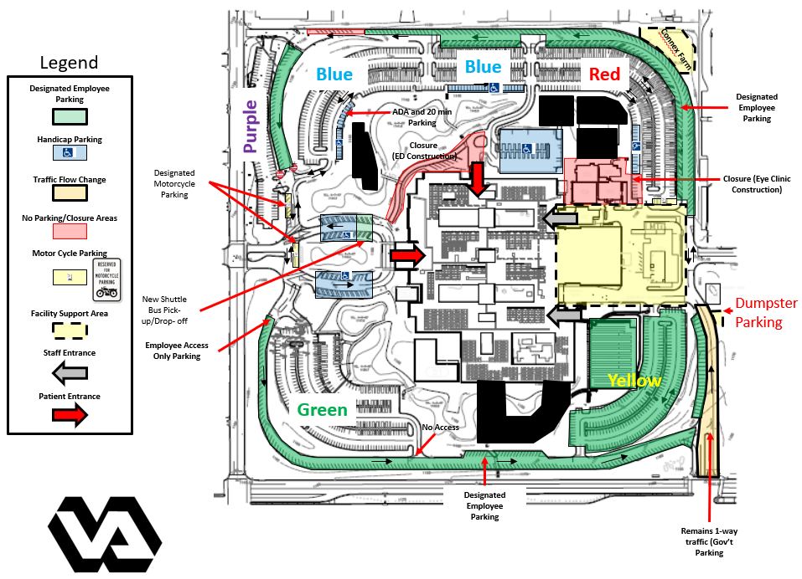

**Parking at the Ambulatory Care Center**

Residents and Medical Students are authorized to park in employee parking only, marked in yellow. Your PIV Badge will open the gates.

