Title: Research Recruitment Policy – Supplement A – Recruitment Templates | CSCSOP-4A

Purpose: This document serves as a supplement to the Research Recruitment Policy (CSCSOP-4). Included in this supplement are templates that can be modified as needed to meet the needs of the study.

Contents
Example Recruitment Letter #1 2
Example Recruitment Letter #2 4
Opt-In/Opt-Out Form 6
Example Recruitment Flyer 7

Example Recruitment Letter #1

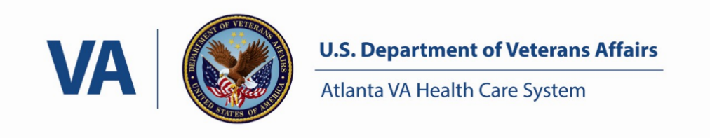

INSTRUCTIONS: Replace the red text with your study-specific information. Black text should only be updated with study-specific information, not deleted.

Date

Joan R. Patient
29 High Glucose Street
Atlanta, GA 30033

Dear Ms. Patient,

I am writing to tell you about a voluntary research study being conducted at the Atlanta VA Healthcare System by Dr. Iam Expert in the Diabetes Unit. I am letting my patients with diabetes who are under 40 years old know about this research project, in case they would like to participate.

Dr. Expert is studying environmental causes and effects of diabetes. Diabetes may run in certain families, but many other things like diet and exercise can influence a person's risk of developing this disorder. This research project is designed to find out whether diabetes in some people can be linked to specific genes.

The researchers are looking for patients under 40 years old, with diabetes, who have a brother or sister who also has diabetes. Participation would involve two visits to the Clinical Studies Center at the Atlanta VA Medical Center, each lasting about half a day. There are no medications involved. Participation includes a dietary evaluation, questionnaires, a medical and family history, a physical exam by a study doctor and blood and urine tests.

You will not receive any personal health benefits because of your participation in this research study. We hope that the results will help us understand diabetes better, and will benefit patients with diabetes in the future. Your participation in this research study is voluntary. Whether you participate or not will have no effect on the medical care or benefits that you receive at the Atlanta VA Healthcare System.

If you would like more information about the study, please contact the study coordinator Jane Helper, RN, at (404) 321-6111-XXXXXX or Dr. Expert at (404) 321-XXXXXX. You may also return the attached letter and check the box to indicate if you do or do not want to participate in this research study. You may return the letter enclosed in the postage paid addressed letter provided. If we haven’t heard from you in 2 weeks, someone from Dr. Expert's research team may phone you.

The Atlanta VA Research Compliance Officer (RCO):
If you have questions about your rights while taking part in this study, or you have concerns or suggestions and you want to talk to someone other than the researchers about the study, you may contact the Atlanta VA RCO at: (404) 321-6111 ext. 206964.

Thank you in advance for considering this request.

Sincerely,

Primary Care Physician, MD
(XXX) XXX-XXXX
Note: May also be a clinician or specialist well-known to patient but must not be a member of the research team.

Iam A. Expert, MD
Diabetes Research Unit
(XXX) XXX-XXXX

Include enclosure(s) as applicable:
Opt-in/Opt-Out Form
Recruitment materials, e.g. brochure, flyers, etc.

Version Date: MM/DD/YYYY

Example Recruitment Letter #2
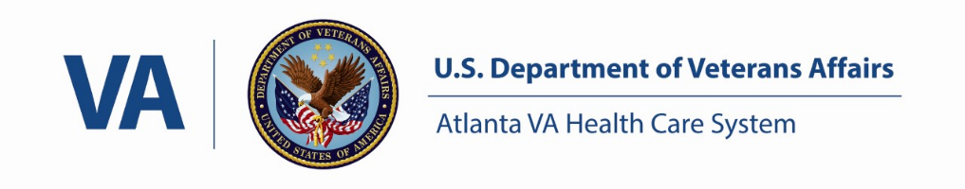
[Date]

Dear [Mr. / Ms. Last Name],

I am writing to tell you about the [Name of Study, If No Sensitive Information Is Included] being conducted by the [Name Group, If No Sensitive Information Is Included] at the Atlanta VA Healthcare System. I received permission from your [Primary Care Provider or Clinician] [Insert Name] to contact you.

The purpose of this research study is [Describe Purpose with No Sensitive Information Included.] You may be eligible for this study if you [Name 2 Or 3 Main Eligiblity Criteria in Lay Language With No Sensitive Information Included.]

Your participation is voluntary. Whether or not you participate in this study will have no effect on your healthcare or benefits you receive at the Atlanta VA Healthcare System.

Insert either Option #1 or Option #2 below:
Option#1: If you would like to learn more about this study, please check box #1 on the enclosed form and return it in the pre-paid envelope. If you do not wish to hear about this study and do not wish to be contacted again about this study, please check box #2 on the enclosed form and return it in the pre-paid envelope. If you have any questions or would like to talk to us directly, please call [Name Of Research Team Member] at [Telephone Number.]
If we do not receive your reply within [Insert Time Period, usually 2 Weeks] a research team member may send you another letter and/or contact you by phone.
Thank you for your consideration.
OR
Option #2: Please call us and let us know if you are interested in participating in the research study or are not interested in participating in the research study. You can talk directly to a member of our research team, [Name of Research Team Member], [days of the week and time of availability] at [Telephone Number.] If you have any questions about the research, please call [Mr./Ms Research Team Member].

If we do not receive a response from you within [Insert Time Period, Usually 2 Weeks] a research team member may contact you by phone.
Thank you for your consideration.

The Atlanta VA Research Compliance Officer (RCO):
If you have questions about your rights while taking part in this study, or you have concerns or suggestions and you want to talk to someone other than the researchers about the study, you may contact the Atlanta VA RCO at: (404) 321-6111 ext. 206964.

Sincerely,
[PI Signature]
[Printed Name And Title]

Version Date: MM/DD/YYYY

Opt-In/Opt-Out Form

[Insert Name of Study if No Sensitive Information is Included or IRB#]
[Insert Name and Phone Number of Research Team Contact]

[Insert Potential Subject’s Name]
Please complete this form and return in the pre-paid envelope provided
- I am interested in learning more about this study. Please contact me using the information below.

Telephone(s): ________________________________________________
Best time and day to call: _______________________________________

- I am not interested in this study. Please do not contact me again about this study.

Example Recruitment Flyer
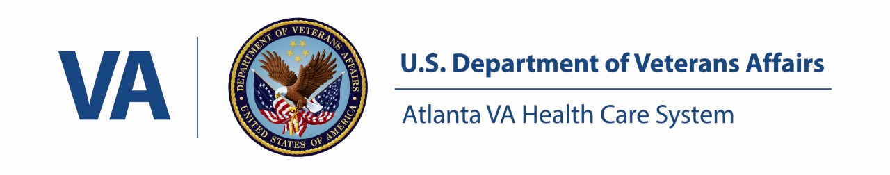
Weight Loss and Prevention Study
Research Investigator: Angela Woods, M.D. Atlanta VAMC
The purpose of this research study is to compare the effectiveness of different diets in preventing Type 2 diabetes. Benefits include a comprehensive medical evaluation and nutrition program. No medication will be given. Participants will be expected to make 3 visits to the Atlanta VAMC over a 3 month period in order to complete the study. Participants will receive monetary compensation.
Are you between the ages of 25-40?
Do you want to change your eating habits in order to lose weight?
If so, you may be eligible to participate. Participation in research is voluntary and your willingness to participate will not affect your rights or benefits as a veteran.
If you would like more information concerning this research study, entitled “Good Nutrition, Good Diabetes Control” please contact Camilla Jones Room 5A-105E Atlanta VAMC at (909) 472- 0999.

IRB #: XXXXX, Version Date: MM/DD/YYYY

