Post Baccalaureate Registered Nurse Residency (PB-RNR) Program
Application Period 2023- 2024

Program Overview: The PB-RNR program at the Southeast Louisiana Veterans Health Care System (SLVHCS) is a 12- month traineeship designed to provide additional training and support to post baccalaureate registered nurse graduates. Trainees receive didactic educational seminars, simulation and other educational activities, as well as rotate to a variety of clinical departments (in-patient medical and surgical services; emergency and critical care and mental health and out-patient services).

The mission of SLVHCS post baccalaureate program is to build upon the knowledge and experience of nurse residents by bridging academic education and professional nursing practice to provide optimum veteran-centered care. The traineeship is supported by the Veterans Affairs Office of Academic Affiliations. Upon successful graduation from the PB-RNR program, the trainee is eligible to apply for a staff registered nurse position at SLVHCS.

Program Goals and Outcomes:

Our program will:
- develop RNs who practice evidence-based, high quality, patient -centered care
- foster interprofessional collaboration in practice
- increase retention of new graduate RNs at SLVHCS
- increase RN satisfaction with the profession
- produce skilled, proficient educators, preceptors & mentors
- produce future healthcare nursing leaders

Program Benefits: PB-RNR Trainees will:
- Participate in a 12 -month paid academic-based residency program
- Receive 100% protected time to participate in educational seminars, simulation activities and precepted experiences
- Receive didactic, web-based, and clinical training consistent with guidelines established by the Commission on Collegiate Nursing Education (CCNE).
- Work with educators, subject matter experts, and preceptors who will contribute to the support and enhancement of their clinical skills.
- Participate in rotations to different clinical areas
- Receive eleven paid federal holidays /year
- Receive an annual paid stipend of $56,008
- Accrue 4 hours of vacation and 4 hours of sick leave per pay period (every 2 weeks)
- Be eligible for other healthcare benefits (details provided at interview)
- Complete required program surveys and evaluations for on-going program improvement
- Participate in a comprehensive evidence-based practice project
- Be scheduled for shifts only during day hours (no night shift, weekend shift or holiday work requirements during traineeship).

Eligibility Criteria:
- Be a U.S citizen
- Graduate of a BSN entry level program, accredited by the Commission on Collegiate Nursing Education (CCNE) or Accreditation Commission for Education in Nursing (ACEN)
- Be licensed as an RN by the program start date
- Be a licensed RN for less than one-year post graduation with no prior work experience as an RN. This must be your first RN role.
- Successful background and security investigation required
- Successful random drug testing required
- Commit to completing the 12- month PB-RNR Program

Application Requirements:
- Resume’
- Copy of unofficial transcript accepted. A hard copy of the official transcript will be required at the time of interview
- Copy of RN license or NCLEX authorization letter with testing appointment
- An essay of no more than 1,000 words to address:
  - Why interested in the PB-RNR program?
  - Why work for the VA?
  - What influenced your decision to pursue a career in nursing?
  - Where do you see yourself professionally in five years?
- Three letters of reference/recommendation
  - One from the Dean (School of Nursing)
  - Two from college of nursing faculty member

Additional onboarding requirements: (will be requested after initial review of qualifications)
  - Proof of TB screening
  - Hep B vaccination or waiver
  - Proof of current Influenza immunization
  - Proof of Covid 19 vaccination series

PB-RNR Program Participants:
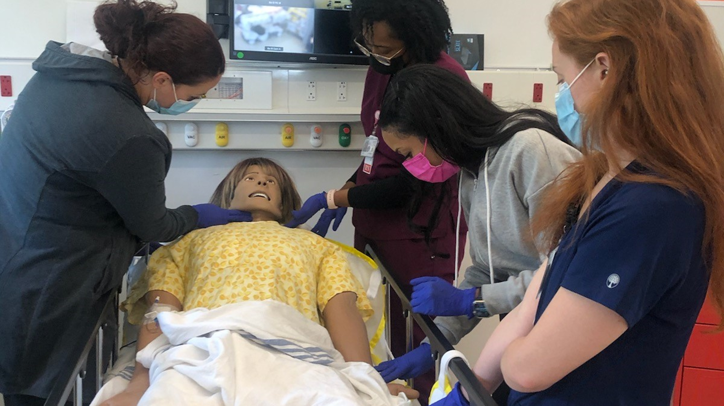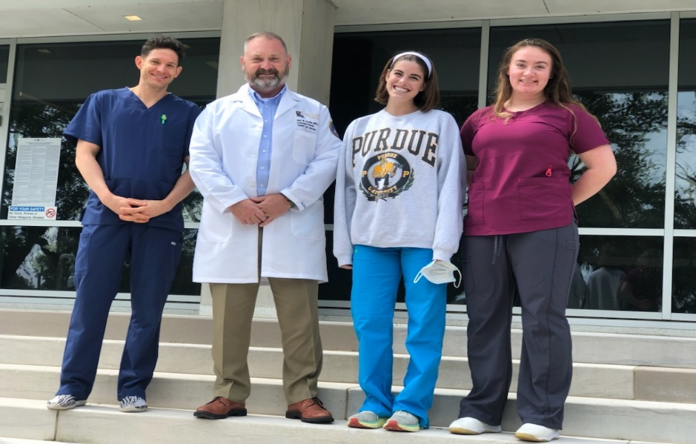
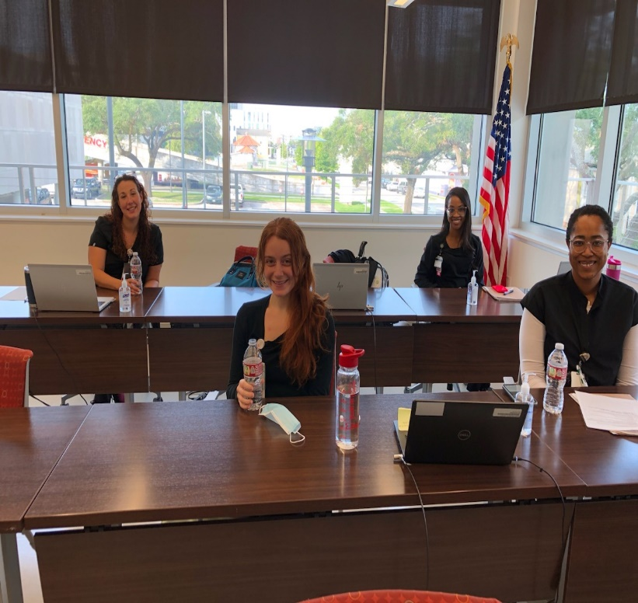

Mail application packets to:
Southeast Louisiana Veterans Healthcare System
Nursing Education Department
2400 Canal Street, Suite 2Q-108
New Orleans, Louisiana 70119

Attention:
Jacqueline Harrison, D.N.S., R.N.
PB- RNR, Program Director
Email: Jacqueline.harrison@va.gov
Office: (504) 507- 2000 (ext- 67517)

Antoinette Jefferson, Ph.D., R.N.
PB-RNR, Program Coordinator
Email: Antoinette.jefferson@va.gov
Office: (504) 507-7568

