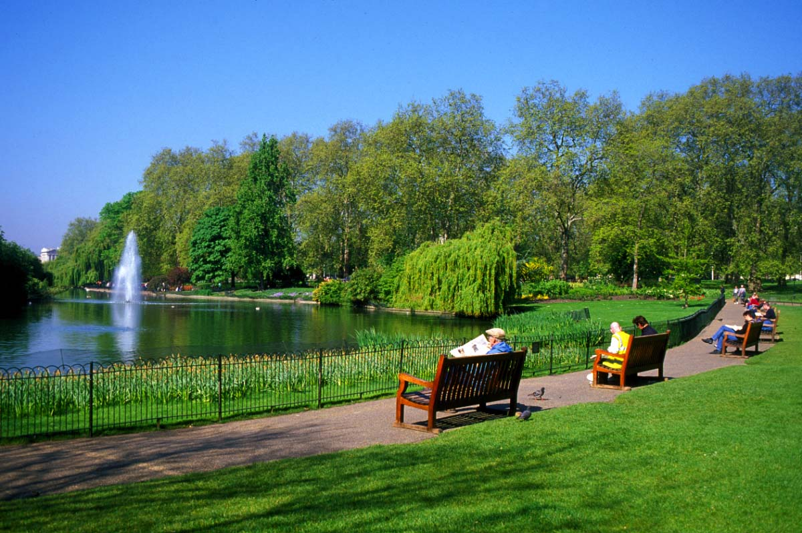PRRC Community Directory

A key step in your Mental Health Recovery is establishing links to your local community. You can gain more support, get involved with activities, and obtain the necessary resources to accomplish your goals.
Sometimes it is difficult to know where to start so the PRRC has developed this directory to help you get going. We encourage you to work closely with your PRRC provider as you explore the below community resources and if you require additional support you can reach out to our PRRC Peer Specialist, Bert Patania at 708-928-1622.
Good luck on this important mission.

American Legion Department of Illinois
The American Legion is the nation’s largest wartime Veterans service organization, committed to mentoring youth and sponsorship of wholesome programs in our communities, advocating patriotism and honor, promoting strong national security, and continued devotion to our fellow servicemembers and Veterans.
Go to the Resources tab on the online site and press the Post locator tab and type in you zip code to find your local American Legion Post.
Phone: (309) 663-0361 Email: Hdqs@Illegion.org

Veteran of Foreign Wars (VFW) Department of Illinois
The Mission of the Veterans of Foreign Wars, Department of Illinois is to provide resources to Veterans, servicemembers and our communities. Many of the Posts are active in food drives, clothing drives for the homeless, activities at local schools and are quick to donate to charities.
Go to the Resources tab on the online site and press the Post locator tab and type in you zip code to find your local VFW Post.
Phone: (217) 529-6688 website: www.VFWil.org

Help Heal Veterans
HEAL VETS supplies therapeutic craft kits to any military service member or Veteran. Kits include a wide variety of crafts and materials such as leatherwork, models, woodwork, jewelry, painting, needlecrafts, poster art, scrapbooks and many more. All kits are free and the staff are awesome. Check them out! They are located across from Hines Hospital on Roosevelt Road.
Phone: (708) 356-6243 website: www.healvets.org

Park District
Your local Park district offers large, open, outdoor spaces such as parks, gardens, and wilderness paths. Get outside and check them out! They also offer affordable fun and educational activities (fitness programs, senior programs, arts/crafts, music, etc.). We recommend contacting your local park districts to determine what programs are available to you.

Library
Your Local library offers many free programs/activities/events/books/magazines/movies. This is a great opportunity to meet new people and gain an abundance of resources at absolutely no cost. Your first mission could be obtaining a library card by applying online at your local library website or you could go to your library and present two forms of identification (make sure one is a picture ID) that include your name and current address. Let your learning begin today!

Local Township Services
State, County, Village and Township are forms of government in Illinois. They offer social services programs such as senior services, social activities for all ages, and other great resources. It’s a good idea to check your local governments for resources in your area. Please be aware, there are residency restrictions so make sure you’re eligible.

Forest Preserves
Forest Preserves are protected lands that provide many recreational and outdoor activities year-round. Get outside in nature in wide open, beautiful spaces. They offer bicycling, birding, boating, canoeing, kayaking, camping, cross-country skiing, fishing, equestrian, hiking, walking, and running to name a few of them. Don’t forget to ask for your Veteran or senior discount 😊
Website: https://fpdcc.com/things-to-do/
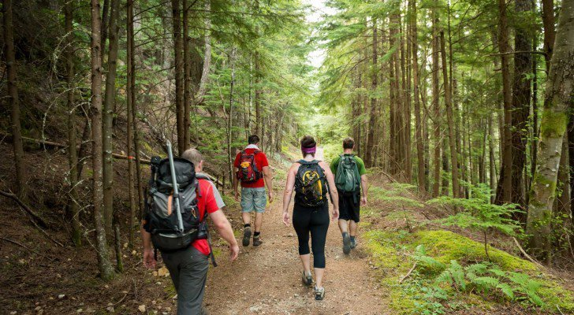
For Additional Community Resources
Check out the Italian Heritage Museum website that has numerous community resources at:
https://iavmuseum.org/resources/

