FOR IMMEDIATE RELEASE
February 23, 2023
VA and YMCA to Host Toxic Exposure Screenings/Benefits event

Resource event for Veterans affected by toxic exposure during military service
U.S. Military Veterans
YMCA Gymnasium, 5315 Lafayette Rd, Indianapolis, IN 46254
March 2, 2023, 3:30pm – 7:30pm

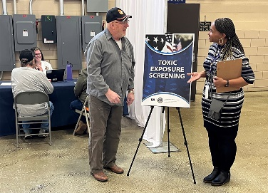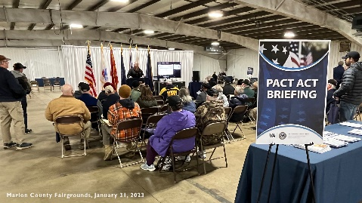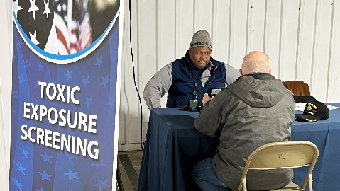

Veteran Health Indiana will host a Veterans benefits and resource event on March 2, 2023, from 3:30 p.m. to 7:30 p.m at the YMCA at 5314 Lafayette Road, Indianapolis, IN 46254.

Veterans, their families, caregivers, and survivors are also invited to attend one of three briefings scheduled for 4 p.m., 5 p.m., and 6 p.m., regarding the Promise to Address Comprehensive Toxics Act of 2022 – known as the PACT Act. The new law expands VA health care and benefits for Veterans exposed to burn pits and other toxic substances.

Representatives will be on-site to answer questions about toxic exposure health benefits, VA eligibility & enrollment, federal and state VA benefits, filing claims, and more. Toxic exposure screening will be available. Veterans should bring a copy of their DD-214.

va.gov/PACT va.gov/Indiana-health-care IMAGES OF PREVIOUS EVENT

Contact: Mark Turney, Public Affairs Officer mark.turney@va.gov | 317-224-8133 or
Ricardo Ramirez, Public Affairs Office, ricardo.ramirez@va.gov | 317-522-7776
—30—

