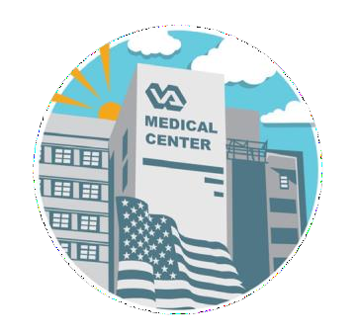
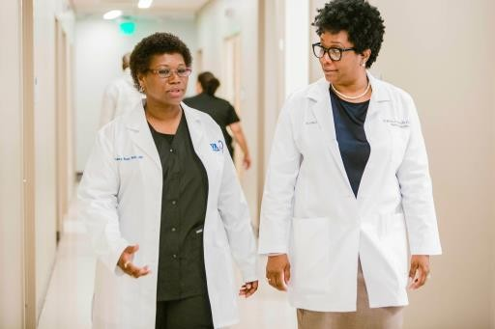
Applicant Qualifications
- U.S. Citizen
- Graduate of psychiatric nurse practitioner programs approved by the appropriate State agency AND either the Accreditation Commission for Education in Nursing (ACEN) or the Commission on Collegiate Nursing Education (CCNE).
- Recent graduate within the past 12 months.
- Licensure: Current, full, active, and unrestricted registration as a professional nurse in a State, Territory or Commonwealth (i.e., Puerto Rico) of the United States, or the District of Columbia.
- Active BLS certification.
- Proficient in written and spoken English.
- Pass a background/security investigation as required by the KCVA Medical Center.
- Pass pre-trainee physical examination.
- Random Drug Testing required.

Application Requirements
- Curriculum vitae
- Graduate nursing school transcripts
- Personal Statements:
  - What experiences (personal, professional, educational and/or clinical) informed your choice of nursing as a profession and the role of a mental health nurse practitioner as a specialty practice?
  - What are your goals and aspirations for this residency program, how do they fit with your early and long-term career plans as a nurse practitioner?
  - Discuss your interest in working with Veterans in the KCVAMC. Maximum: one (1) page.
- Three (3) letters of recommendation (one must be from faculty member or program director) in sealed envelopes or emailed directly
from the writer.
Benefits

-Competitive Stipend
-A comprehensive benefits package that includes, in part, paid vacation, sick leave, holidays
and health benefits.
-Hiring preference for open positions at any VA upon completion of the residency.

Apply Today!
Application Deadline: May 31, 2024
Residency Start Date: September 2024
Submission:
Completed application should be submitted to:

Traci Wentz
APRN, PMHNP-BC
Traci.Wentz@va.gov
4801 Linwood Blvd
Kansas City, MO 64128
(816) 922-2641
Questions? Please contact:
Traci Wentz APRN, PMHNP-BC
PMH-NPR Program Director

4801 Linwood Blvd Kansas City, MO 64128 (816) 861-4700
www.kansascity.va.gov

Psychiatric-Mental Health Nurse Practitioner Residency
Program
The Kansas City VA Medical Center in partnership with the University of Missouri-Kansas City.
2024 - 2025

s
i

About the Residency Program Partners

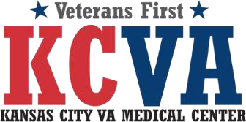
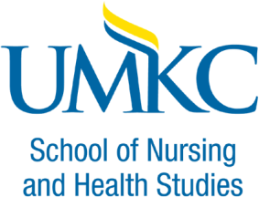

The Kansas City VA Medical Center in partnership with the University of Missouri, Kansas City School of Nursing, is currently accepting applications for the Psychiatric-Mental Health Nurse Practitioner Residency Program (PMH-NPRP) at the Kansas City Veteran Affairs Medical Center. Together, we foster a supportive learning environment for academic, professional, and personal success.
The PMH-NPRP is a 12-month program designed to provide clinical and academic experiences for new graduate Psychiatric-Mental Health Nurse Practitioner (PMHNP) transitioning into the professional role of PMHNP.

The KCVAMC and UMKC partnership promotes professional role transition integration and socializations of safe care delivery, advancement in critical thinking, academic and professional excellence, and a learning environment for strategizing and developing evidence-based clinical care.

The Veterans Health Administration (VHA) is the nation’s largest integrated health care system and is responsible for caring for our nation’s Veterans. As the population ages, the VHA is committed to making quality nursing led care a priority. With the PMH-NPRP, the VHA continues to expand its work force and meet the needs of those entering the nurse practitioner practice through the promotion of academic progression, leadership and research in practice.
Opened in 1952, the Kansas City VA Medical Center has a rich legacy of providing quality care to the men and women who have proudly served our nation - America’s Heroes. We consider it an honor and privilege to serve the health care needs of our Veterans. In addition to our main campus, the Medical Center provides health services at eight community-based outpatient clinics in addition to a mobile medical unit. As a component to the nationwide Veterans Health Administration, our organization continually evolves and cultivates on-going medical research and innovation to improve the lives of and meet the evolving needs of America’s Heroes.
Since 1929, the University of Missouri-Kansas City has grown to one of the largest comprehensive, fully accredited universities in the Kansas City area, spread across two campuses. Faculty are leaders in their fields and diligently work to provide opportunities for students to explore on their way to discovering and creating their perfect career. Fostering excellence and divergent thinking, students come from all 50 states and 85+ countries, enriching our community with diverse perspectives. The school is committed to serving at the heart of a thriving urban area, and the city’s life and energy influence everything that happens here.

Program Structure
- This is a 12-month residency
- Residency Curriculum includes clinical rotations, specialty rotations, didactic sessions, participation in APRN Council, and other learning opportunities
- Residents are assigned to a mentor who serves as a resource and provides support as they transition to autonomous and competent psychiatric-mental health nurse practitioners
- Upon successful completion of the residency, a certificate of completion is awarded
- Candidates who successfully complete the residency training program will be given the opportunity to apply for available vacancies within the Kansas City VA Medical Center

