

|  |  |  |
| --- | --- | --- |
| KC VA Health Care System  Nurse Practitioner Residency  Program Application | |  |
| The Kansas City VA Health Care System Nurse Practitioner Residency Program is a 12-month post-graduate, precepted training program within the Primary Care and Mental Health settings with a focus on interdisciplinary collaboration and the development of leadership skills within a dynamic and complex health care setting. Residents will manage a panel of patients alongside a dedicated NP preceptor.  The resident will participate in activities including journal clubs, grand round lectures and simulation practicums with other interdisciplinary team members. Residents will also complete an evidence-based, quality improvement project focused on the complex needs of the Veteran population.  Benefits   * Approximately $76,000/year * Healthcare insurance * 4 hours of annual leave and 4 hours of sick leave bi-weekly * 11 paid federal holidays * Gateway to an exciting career caring for America’s heroes!   Eligibility Requirements   * Graduated from an accredited master’s or Doctor of Nursing Practice program within the past 12 months * Board certification as an Adult-Gerontology or Family Nurse Practitioner from AANP or ANCC accrediting bodies by start date of residency program * APRN licensure by start date of residency program * BLS certification * US citizenship * Health Professional Scholarship recipients are unfortunately not eligible   Cohorts   * Fall cohort: Begins mid-late September | | |
|  | | |
|  |  | |

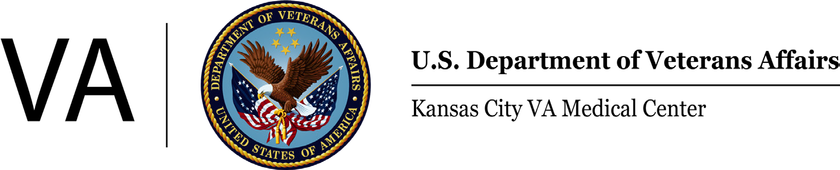

 KC VA Health Care System

PC/MH Nurse Practitioner

Residency Application

**APPLICATION FOR PRIMARY CARE AND MENTAL HEALTH NURSE PRACTITIONER**

**RESIDENCY PROGRAM**

**Fall Cohort: Applications due May 31st**

**PERSONAL DATA INFORMATION**

**Name:**

First MI Last

**Mailing Address:**

Street:

City/State/Zip:

**Phone:**

Home: Cell: Other:

**Email Address:**

Primary: Secondary:

**State Nursing License:**

|  |  |  |  |
| --- | --- | --- | --- |
| Type | Number | State | Exp. Date |
|  |  |  |  |
|  |  |  |  |

**Certification:**

|  |  |  |  |
| --- | --- | --- | --- |
| Type | Certifying Organization | Number | Exp. Date |
|  |  |  |  |
|  |  |  |  |

**Education:**

|  |  |  |  |  |  |
| --- | --- | --- | --- | --- | --- |
|  | Institution & Location | Dates Attended | Degree | Date Received | Field of Study |
| Undergraduate |  |  |  |  |  |
| Graduate |  |  |  |  |  |
|  |  |  |  |  |  |

*If more space needed for licensure, certification or education please attach additional paper*





 Residency Application 

KC VA Health Care System

PC/MH Nurse Practitioner

Residency Application

**PERSONAL ESSAY & RECOMMENDATIONS**

**APPLICATION QUESTIONS:**

**Please limit responses to each question to 200 words or less.**

1. What personal, professional, or educational experiences led you to pursue a career as a nurse practitioner?

2. What do you specifically desire to learn in an interprofessional residency training program?

3. What educational or experiential opportunities do you desire in a training program?

4. Are you interested in any research activity? If so, please elaborate.

5. What are your plans after completing the residency, if selected?

6. Have you completed any clinical rotations or been employed in a VA facility? If so, please list including date(s), VA facility, unit/clinic, school affiliation, and course.

**LETTERS OF RECOMMENDATION:**

Please provide three letters of recommendation from individuals who can comment on your clinical competence, achievements, and educational background. At least one letter must be from a clinical preceptor. Please have the individuals provide letters via e-mail or mail letters directly to the program using the contact information below. Please provide the name and e-mail address of each individual.

1.

2.

3.



 KC VA Health Care System

PC/MH Nurse Practitioner

Residency Application

**APPLICATION PACKET CHECKLIST:**

* Personal Data Information Form
* Answers to the application questions
* Copy of current CV/Resume
* Three letters of recommendation
* Copy of transcripts from graduate nursing programs

I attest that I hold an active, unencumbered license to practice as a registered nurse, am in good standing and have no current disciplinary actions pending in any jurisdiction. I attest that the information provided on all forms of this application is true and accurate to the best of my knowledge.

**Signature of Applicant**  **Date**

Thank you for applying to the KC VA Health Care System NP Residency Program. We look forward to reviewing your application. We will notify you as soon as selections are completed.

**Michelle Guinta, MSN, APRN, FNP-C**

**PC NPR Program Director**

[**Michelle.Guinta@va.gov**](mailto:Michelle.Guinta@va.gov)

**Traci Wentz, PMHNP-BC**

**MH NPR Program Director**

[**Traci.Wentz@va.gov**](mailto:Traci.Wentz@va.gov)

Please complete checklist and return contents of this application by

May 31 for the Fall cohort.

# 

