Psychology Doctoral Internship Training Program Brochure

2024-2025
Internship Training Year

Melissa S. Cyrus, Ph.D., ABPP
Director of Clinical Training
Published: July 27, 2023

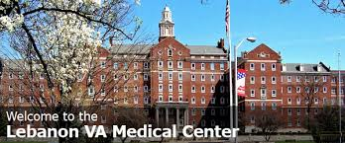

Lebanon Veterans Affairs (VA) Medical Center
Lebanon, PA
MATCH Number: 238511
Applications Due: November 3, 2023

Psychology Internship Program
(Mail Code – 550)
Attn: Dr. Melissa Cyrus
1700 South Lincoln Avenue
Lebanon, PA 17042

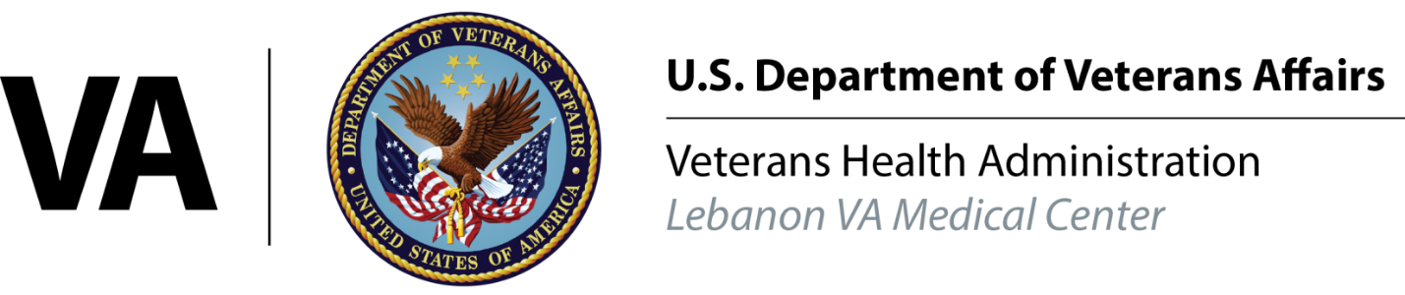

ACCREDITATION STATUS
The Doctoral Internship Program at the Lebanon Veterans Affairs Medical Center (LVAMC) in south-central Pennsylvania (PA) is a newly funded VA Internship site with (3) positions which began in 2016. The Commission on Accreditation of the American Psychological Association (APA) granted the program full accreditation at its meeting on October 17-20, 2019. Based on a review of the outcome data provided, the Commission scheduled the next accreditation site visit to be held in 2022. However, due to COVID-19, the APA recently informed us our next site visit would be sometime in Spring-Summer 2024.

The Commission on Accreditation of the American Psychological Association can be reached at:
The American Psychological Association
750 First St NE
Washington, DC 20002-4242
(202) 336-5979

INTRODUCTION
The Lebanon VA Medical Center Doctoral Internship Program provides qualified doctoral candidates a generalist training with a variety of psychiatric, medical, and geriatric patients in residential, inpatient, outpatient and primary care settings. Internship graduates are prepared for professional practice in VA facilities as well as a wide range of health care settings, including medical centers and non-VA hospitals that primarily serve adults.

TRAINING SETTING, MODEL, AND PHILOSOPHY
The Lebanon VA provides primary and behavioral health care throughout a mainly rural seven-county area of south-central Pennsylvania to a diverse clientele. Patients are also served at five additional community-based VA clinics at varying distances from the main campus in Lebanon. Most of the training takes place at the main hospital and the Residential Recovery Center (RRC) both located at the main campus in Lebanon. Interns have the option to have some of their outpatient experience at one of the outlying VA outpatient clinics. Interns are provided an office in the Behavioral Health building with a dedicated computer and phone.
The Lebanon VA Medical Center Doctoral Internship Program provides doctoral education and training for the practice of professional psychology. Training faculty and supervisors provide an intensive training experience to psychology interns within a generalist model and a practitioner-scholar philosophy. The Lebanon VAMC Internship Program will train interns to think critically regarding the integration of scientific knowledge with current practice. We believe this model to be highly effective in preparing interns for the successful practice of professional psychology.
AIM, TRAINING, COMPETENCIES AND OUTCOMES
The program's aim for internship training is to prepare interns for successful independent practice of professional psychology in VA facilities as well as a wide range of health care settings, including medical centers and non-VA hospitals that primarily serve adults.

This aim will be accomplished by the intern completing the program’s training activities, demonstrating competency in the nine profession-wide competencies, and obtaining job placement and licensure after graduation.

Training to develop the profession-wide competencies includes both experiential and didactic learning elements. The experiential opportunities are spent in direct contact with service recipients and include sufficient observation and supervision by psychologist supervisors. All learning follows a logical training sequence that is sequential, cumulative, and graded in complexity.

The following nine competencies are required for all interns who graduate from programs accredited in health service psychology. Opportunities are provided throughout the training year for all interns to demonstrate they have met each required profession-wide competency. By the end of the training year, all interns must demonstrate competence in:

- Research
- Ethical and legal standards
- Individual and cultural diversity
- Professional values, attitudes, and behaviors
- Communication and interpersonal skills
- Assessment
- Intervention
- Supervision
- Consultation and interprofessional/interdisciplinary skills

The expectation is that by the end of the training year the intern demonstrates competence in the above nine areas and graduates from the internship program. Interns are also expected to carry 2 Evidence-Based Psychotherapy (EBP) cases at some point in the year. After graduating from the program, expected outcomes include obtaining job placement in the field of psychology and licensure. Thus, the program’s aim of preparing interns for successful independent practice of professional psychology in VA facilities as well as a wide range of health care settings, including medical centers and non-VA hospitals that primarily serve adults, directly aligns with the program’s training activities and intended outcomes.

PROGRAM CURRICULUM DESCRIPTION
Our structure for the 2024-2025 training year will consist of a BHIP rotation of 12 months part-time, along with 2 additional intern-selected 6-month long part-time rotations, for a total of 3 rotations for the training year. The 6-month rotations to choose from include:
- Residential Recovery Center (RRC)
- Primary Care Mental Health Integration (PCMHI)
- Geriatrics and Hospice
- Traumatic Stress Recovery Program (PTSD Clinical Team)

In BHIP, interns will be exposed to Evidence Based Psychotherapies (EBP). Interns will rank order their preferences of the supervisors and EBPs they wish to be trained in, along with group therapy modalities they have interest in. The Geriatrics and Hospice Rotation (including time spent on the Community Living Center (CLC) and Hospice units), allows interns the opportunity to round with interdisciplinary teams, provide individual and group therapy interventions, assessments, behavioral contracts, modified EBPs, family therapy, and staff education as needed. Interns will have the opportunity to discuss and develop their individual learning goals within each placement. At the beginning of each rotation, the number of hours per week spent in direct contact with service recipients is expected to start out low, increasing to 10-15 hours per week.
In each rotation interns will have routine, on-site supervision by a licensed clinical psychologist. Additional clinical consultation, as appropriate, will also be available from the disciplines of psychiatry, primary care/emergency physicians, graduate level nursing, social work, vocational rehabilitation specialists and chaplains. Each rotation will comprise approximately 16 hours (2 days) per week, including 3+ hours for supervision on the rotations. Thursdays consist of 1 hour of group supervision provided by the clinical training director or other psychology supervisors, 3 hours of didactic seminar, and 3 hours of flextime to be used for dissertation, postdoctoral fellowship applications, additional clinical or administrative time, and other professional development activities. Clinical supervision will be comprised of 3+ individual hours provided by the rotation supervisors, 1 group hour provided by the DCT and others. Additionally, per SoA Standard II.D.I.a.v, “each intern evaluation will be based in part on direct observation. Direct observation includes in-person observation (e.g., in room or one-way mirror observation of client contact during an intake or test feedback session), live synchronous audio-video streaming, or audio or video recording”.
There will be opportunities for tiered supervision, in which interns provide supervision to practicum students. The staff supervisor always has primary professional responsibility for cases in which supervision is provided to a trainee. There are also regularly scheduled meetings with the interns and a staff psychologist dedicated to developing supervision skills and techniques and process their progress as a supervisor/consultant.
The title “doctor” should not be used in writing and/or orally in the absence of an earned doctorate. Doing so is a violation of the “Ethical Principles of Psychologists” and is consistent with APA guidelines. As such, the title of psychology intern is used for all who enter this program.

ROTATIONS:

Residential Recovery Center (RRC)
The RRC provides state-of-the-art, high-quality residential rehabilitation and treatment services for Veterans with addiction, multiple mental illness, and/or psychosocial deficits. The RRC identifies and addresses goals of rehabilitation, recovery, health maintenance, improved quality of life, and community integration along with specific treatment of addictive disorders, mental illnesses, and homelessness.
Each Veteran works with his/her interprofessional team to create an individualized treatment plan which includes specific goals, measurable objectives, and targeted dates for completion. This team is made up of psychologists, clinical social workers, psychiatric nurses, psychiatry, physician assistant, vocational rehabilitation specialists, chaplain, rehabilitation technicians, recreation therapist, health technicians, and peer support specialists. When helpful, other ancillary disciplines such as Probation Officers or outpatient therapists/case workers are invited to team meetings to support the goals of recovery.
Treatment is recovery and strength-based focused; an essential emphasis is having the Veteran as a full partner in the process of their recovery. In addition to the RRC’s stated recovery goals to address addiction, mental health, and psychosocial issues for those who need a residential level of care, the program also helps Veterans stabilize, find employment, earn money, and gain independent housing. Interns will be providing initial assessments, individual, family, and group therapy, psychoeducation, addictions work, and some case management. Additionally, there will be opportunities for brief assessments.

Behavioral Health Consultation Liaison Team (BHCLT)/Primary Care Mental Health Integration (PCMHI)
The Behavioral Health Consultation Liaison Team(BHCLT)/Primary Care-Mental Health Integration (PCMHI) program provides interns with the maximal opportunity to interact with a wide array of allied healthcare professionals who serve on Patient Aligned Care Teams (PACT), including physicians, physician assistants, nurses, social workers, pharmacists, dieticians, and care managers. The BHCLT provides clinical health psychology services throughout specialty medicine and surgery services, while the PCMHI program provides co-located collaborative care and care management services within the primary care setting.
Interns will have the opportunity to participate in the evaluation/assessment, treatment planning, consultation, and direct care of patients with co-morbid medical and psychological/adjustment issues using empirically based individual and group interventions. Within the BHCLT there may be exposure to pre-surgical psychological evaluations, consultations on medical/surgical floors, patient rounds with physician and pharmacy colleagues, evidence-based psychotherapies (CBT-insomnia, PE-PC and chronic pain), and the interdisciplinary pain management program. Within PCMHI Interns will work collaboratively with PACT members providing services throughout primary care aimed toward the identification and reduction of health risks (e.g., tobacco use, obesity, stress) and behavioral health concerns (e.g., depression, anxiety, adjustment disorders, substance use) in a “stepped care” fashion that fully appreciates and integrates the biopsychosocial model of care. The interprofessional nature of the BHCLT/ PCMHI allows for shared decision-making among providers on the team and successful collaboration with PACT members and specialty medicine providers. This ensures provision of high-quality assessment and management of Veteran concerns.

Geriatrics and Hospice
The Lebanon VA has 2 long-term care Community Living Center (CLC) units that are part of our Extended Care service. 1-4A unit consists of 15 beds and 1-5B unit has 20 beds. Additionally, we have an Inpatient Hospice unit with 17 beds for those near end of life. Each unit has an interdisciplinary team consisting of: physician, social worker, nursing staff, psychology, pharmacy, chaplain, and various trainees. Interns will participate in team rounds and IDM treatment team meetings and receive consultations for individual therapy and testing, behavioral
plans, and staff education. This rotation includes working with Veteran patients and their families. EBP opportunities include MI, CBT-D, and Interpersonal psychotherapy for Depression. Additionally, there are group opportunities including Reminiscence therapy group and Grief Support Group for family and friends on the Hospice Unit. Currently, there is also the opportunity to help facilitate a monthly loss support group for those in our Low Vision residential program. Assessment opportunities include mood and cognitive screeners and possibility of capacity and cognitive testing depending on clinical needs.

Behavioral Health Interdisciplinary Program-General MH Outpatient
The Behavioral Health Interdisciplinary Program (BHIP) was created in response to a growing need to treat patients in a more comprehensive, patient-centered interdisciplinary manner. Patients who are part of a BHIP team receive comprehensive care from psychology, psychiatry, social work, and nursing staff in the Specialty Mental Health Outpatient Clinic. Weekly meetings allow for case reviews, consultation with other staff members, and discussion regarding best treatment options available for each patient based on individual needs and goals. These meetings allow for the treatment planning process to begin in a setting where there is shared decision making among providers and collaboration with other areas of the hospital as needed to provide the best quality of services to our Veterans.
In the BHIP rotation, interns will work as part of an interdisciplinary team in the specialty Mental Health Outpatient Clinic at Lebanon or at one of our VA CLINIC locations. Patients come to a BHIP clinic through consultation requests from PCMHI and a variety of providers throughout the hospital. The BHIP rotation offers a breadth of training opportunities with a wide variety of treatments used and diagnoses treated. This rotation also offers depth of training as interns have the opportunity to follow the same patient throughout their rotation. Interns will leave this rotation with a robust generalist training experience. The interdisciplinary nature of the BHIP teams provides a rich experience for interns to attend weekly meetings, interact with and consult with team members, and help build interdisciplinary treatment plans for patients. This rotation will include exposure to EBPs used in BHIP. Interns will receive an overview of various EBPs and will have the opportunity to focus on one or more of their choice. The expectation is for the intern to complete at least 2 EBP cases over the 12- month period. Assessment opportunities are most frequently Measurement-based care mood screeners, but opportunities do exist for cognitive screens and personality assessments depending on clinical need, trainee goals, and supervisor expertise.

Behavioral Health Interdisciplinary Program-Substance Use Disorders (SUD)
This rotation is similar the BHIP-General MH rotation above in structure and interdisciplinary team experience. In addition to those opportunities noted above, this rotation is different in that it offers much more experience in group therapy as well as a focus in treating substance use disorders. In addition to working closely with the SUD team psychologist and social worker, you will also work closely with the SUD team nurse and Peer Support Specialist. EBP opportunities include MI and MET. Assessment opportunities include the potential for intelligence and personality testing, among other screening instruments.

Traumatic Stress Recovery Program (PTSD Clinical Team)
The Lebanon VA Medical Center Traumatic Stress Recovery Program (PTSD Clinical Team) is a specialized outpatient program focused on providing evidence-based practices to Veterans struggling to cope with any number of traumatic or life-threatening event(s). The treatment team consists of one Clinical Psychologist and two Licensed Clinical Social Workers. Through short-term, evidenced based treatment, the program serves Veterans with a wide variety of trauma experiences, spanning the life cycle, to include, but not limited to, combat, military sexual trauma, non-military child or adult sexual or physical abuse, and man-made or natural disasters. The program's primary theoretical orientation and associated treatments are cognitive and cognitive-behavioral, delivered primarily through individual modalities, though a women's only trauma recovery group is also available. Veterans are also afforded the opportunity to complement their trauma recovery care with complimentary treatments, such as mindfulness, yoga, and Qi Gong. Following a referral, Veterans participate in an initial individual orientation session during which time basic background and referral information is obtained, and they are provided brief information about trauma recovery and treatment. If agreeable, Veterans will then be scheduled to complete a more thorough trauma intake evaluation, which includes the completion of a trauma interview and administration of multiple assessment instruments for purposes of diagnostic clarification, assessment of treatment needs and goals, and general treatment recommendations. The focus of treatment delivery is on evidence-based practices and include Cognitive Processing Therapy (CPT), Prolonged Exposure Therapy (PE), Eye Movement Desensitization and Reprocessing (EMDR), and Written Exposure Therapy (WET). The Traumatic Stress Recovery Program works alongside many other behavioral health programs, including outpatient substance use, pain management, and residential, to provide a comprehensive and integrated level of care.
This rotation emphasizes learning two "gold standard" evidence-based practices for the treatment of PTSD: Cognitive Processing Therapy (CPT) and Prolonged Exposure Therapy (PE). Interns will also have the opportunity to enhance their skills in diagnostic assessment, case conceptualization, and delivery of cognitive and cognitive-behavioral therapy. Interns will also work to establish or refine their skills in interprofessional consultation and learn to work as part of an interdisciplinary treatment team. Additional opportunities exist to provide education and training through professional conferences, workshops, and grand rounds in the area of trauma and crisis management. Assessment opportunities are possible as well in this rotation.

Training Structure
Year- long BHIP Rotation
(16 Hours)
6-Month Rotation Selected
(16 Hours)
6-Month Rotation #1

Flex-Time (3 Hours) Group Supervision (1 Hour)

Didactics/Seminars (3 Hours)
Didactics/Seminars (4 hours per week):

Instruction in a wide range of clinical and professional issues takes place in the weekly 3-hour sequential Didactics Seminar. Topics typically covered in the seminar include psychopathology, treatment-specific interventions, and areas of professional development. The training year will begin with a series of didactics specifically targeted to the common needs of interns in this training setting, ensuring that all have the requisite skills and knowledge for a successful start to the internship year. These initial didactics (i.e., Orientation to the Internship and Medical Center, documentation and clinical interviewing, suicide prevention and risk assessment) are intended to provide a common foundation of knowledge and skills for all incoming interns, regardless of their previous level of experience. Other topics include specialized didactic offerings such as professional development, therapeutic intervention/ assessment, diversity and multicultural issues, ethics, supervision and consultation. In addition to didactic instructors from the psychology faculty, instructors representing various other professional disciplines such as pharmacy, chaplaincy, psychiatry, social work and nursing may be represented. Staff, graduate level trainees from other professions, and psychology practicum students will also be invited to attend didactic sessions. In addition to the didactic seminars, interns will attend Behavioral Health Grand Rounds and Psychology Discipline meeting every other month. Some didactic seminar topics may be shared with the Social Work and Chaplaincy trainees. Additionally, interns may have the opportunity to attend seminars at the Hershey Medical Center, interacting with interns of that program as well.

*COVID-19 Impact on Lebanon Psychology Training Program and Emergency Procedures:
The COVID-19 pandemic has created numerous personal and professional challenges for us all. One of these challenges is the uncertainty that we face about the future.
The Lebanon VA Psychology training program has prided itself on its transparency and communication with its trainees and prospective applicants.
With pride and confidence, we can tell you how things have been running since April 2, 2020. After careful consideration and a great deal of effort and planning, all 3 psychology interns shifted to providing clinical services remotely via telework. It should be noted that despite our physical distance, our connection and dedication to high-quality clinical care and psychology training has never been stronger. Interns are continuing to see Veterans via telehealth for individual therapy and assessment, couple therapy, group therapy, and intakes. Interns are also attending and participating in didactic seminars, individual and group supervision via virtual media technologies. Further, interns have the unique opportunity to benefit from live, direct observation of clinical care by supervising psychologists joining them virtually in VVC sessions.
As of July 2020, our interns came back on-site.
Regarding the 2020-2021 Training Year and beyond, interns mostly worked a hybrid model of both on-site and telework from home. We anticipate this will likely continue, with hybrid work, following the schedule of your supervisor of the day. Most interns have 1-2 days of telework.
The health and safety of our Psychology Trainees, along with the competent care of our Nation’s Veterans, is of utmost importance to us. We will continue to provide high quality training in professional psychology while simultaneously keeping our trainee’s health and wellness at the forefront.

EVALUATION OF INTERNS:
Interns will undergo individualized planning and periodic reassessment of goals. At the beginning of each rotation, interns will describe their individual learning goals for that placement. Progress during the internship will be assessed via the Core Competencies rating system. The Core Competencies include professional skills, knowledge, and behaviors that must be demonstrated at a satisfactory level for an intern to graduate from the internship program. Some Core Competencies are practiced and assessed on all rotations, while some are practiced and assessed only on certain rotations.

Mid-way through each rotation, the intern’s progress toward the training objectives will be evaluated by their supervisor (midterm evaluation). If the intern is having problems, this should be documented during the midterm evaluation. If there are serious deficiencies in the intern’s performance, the Training Director will be notified by the supervisor and guidance can be provided to the supervisor regarding the need for either an informal performance improvement plan or a formal remediation plan. Both midterm and end of rotation evaluations use the same Core Competencies form. There is room for comments to discuss strengths and weaknesses of the intern. Each evaluation period must be based in part on direct observation of the intern by the supervisor.
At the End of the Rotation, interns will be asked to complete an evaluation of the training experience on that rotation and of their supervisor. The same sequence of evaluations will occur with each rotation. Additionally, the last week of the program interns will complete an anonymous evaluation of the program itself. All the evaluations will be turned in to the Training Director and will be filed in the intern’s personnel folder, except for the evaluations of the rotation and program, which are filed separately in program files. Evaluations will be shared with the doctoral program training director around mid-point of the program and at the end.

Mechanisms for addressing impaired or deficient performance and grievance procedures

The purpose of this section is to describe process in place for responding to and correcting deficient and/or problematic behavior exhibited by interns and the grievance policy procedures afforded interns. Potential domains of problematic intern behavior include 1) Professionalism, skills, competence and personal functioning, and 2) Ethical or legal violations of professional standards or laws, failure to satisfy professional obligations that violates the rights, privileges, or responsibilities of others.

Relatively minor problems identified are encouraged to be addressed informally directly with the other party. If this initial attempt at resolution proves unsuccessful the concerned parties may approach the Director of Training to act as a mediator or to provide help in selecting a mediator agreeable to both intern and supervisor. Such informal efforts to resolve problems may involve the Psychology Manager of VA clinics and Specialty Programs as the final arbiter. This mediation may result in a satisfactory resolution or to recommended changes to the learning environment, rotation, or training experience. Minor problems identified at the end of a rotation will be communicated by the supervisor to the Training Director and incoming supervisor(s) via the Intern Rotation Transition meeting. Any changes in placements must be reviewed and approved by the Training Committee. In the event that this informal process does not result in resolution, a formal performance/behavior complaint, and/or intern grievance as the case may be, may be developed following the procedures outlined below. Should the matter be unresolved and become a formal issue, the intern is encouraged to utilize the assigned preceptor, or in the case of conflict of interest, another senior psychologist mutually agreed upon with the Director of Training, as a consultant on matriculating the formal process.

When supervisor(s) identify that an intern’s skills, professionalism, or personal functioning are inadequate for a doctoral internship, the Training Committee, with input from other relevant supervisory staff initiates the appropriate procedures.

Intern Grievance Procedures: Interns who receive an Acknowledgement Notice or Probation Notice, or who otherwise disagree with any Training Committee decision regarding their status in the program, are entitled to challenge the Committee’s actions by initiating a grievance procedure. Within 10 working days of receipt of the Training Committee’s notice or other decision, the intern must inform the Director of Training in writing that he/she disagrees with the Committee’s action and provide the Director of Training with information as to why the intern believes the Training Committee’s action is unwarranted. Failure to provide such information will constitute an irrevocable withdrawal of the challenge.

Staff Allegation of Intern Violation of Standards: Any staff member of the Lebanon VA Medical Center may file a written complaint against an intern for the following reasons: Unethical or legal violations of professional standards or laws, failure to satisfy professional obligations and in a manner that violates the rights, privileges, or responsibilities of others.

More information on these policies and procedures are available in the Intern Manual provided during the first week of orientation.

Statement of Nondiscrimination
The Psychology Internship program strongly seeks and values diverse experiences and backgrounds as the building blocks of a rich training environment. As such, the program emphasizes respect for trainees, patients, and staff members representing all forms of diversity, including (but not limited to) age, disability, ethnicity, gender, gender identity, language, national origin, race, religion, culture, sexual orientation, and socioeconomic status. Interns are entitled to equal treatment in selection decisions and freedom from harassment or unfair treatment. The program seeks to obtain a diverse intern class while selecting the most qualified candidates. Individuals from diverse backgrounds are particularly encouraged to apply. The VA is an Equal Opportunity Employer, and the training program follows institutional guidelines in this regard.

PERFORMANCE IMPROVEMENT:
Interns will be exposed to and encouraged to use patient satisfaction questionnaires already in use during their different rotations in order to review the care they are providing. Interns will be expected to incorporate patient outcome measures, such as the BDI-II, BAI, and the PCL, into their treatment planning and work with their patients.

ADMISSION REQUIREMENTS FOR APPLYING TO THE PROGRAM:

Basic Eligibility
- Applicants must meet all requirements for VA internship eligibility, which includes:
- US Citizenship
- Student in good standing in an APA accredited clinical or counseling psychology doctoral program
- Approved for internship status by their graduate training program coordinator
- Applicants must complete at least 3 years of graduate training prior to internship and have at least 400 intervention and assessment hours documented on the AAPI. (300 of which are intervention hours).

- There are also Federal Government requirements:
- Verification of Selective Service Registration (Male applicants born after 12/31/1959 must sign a pre-appointment Certification Statement for Selective Service Registration)
-Prior to participating in training at a VA facility, each health professions trainee (HPT) must first be listed on a Trainee Qualifications and Credentials Verification Letter (TQCVL). The Program Director (VA or non-VA) provides a TQCVL to complete HPT onboarding. A TQCVL is required for all HPTs: Affiliate program, VA program, VA stipend paid or Without Compensation (WOC). For multi-year programs, all trainees, new and continuing, will be listed on a TQCVL prior to the start of the academic year.
The TQCVL confirms that HPTs are:
- Enrolled in or accepted into the training program and have had primary source verification of appropriate qualifications and credentials as required by the admission criteria of the training program;
- Qualified and have the required credentials to participate in the training program, as agreed to by the sponsoring institution, affiliated participating institutions, and the VA;
- Eligible for appointment to a federal government position;
- Physically and mentally fit to perform the essential functions of the training program; and
- Immunized following current Center for Disease Control (CDC) guidelines and VHA policy for healthcare workers to protect themselves, other employees and patients while working in a healthcare facility.
If a trainee does not meet all applicable eligibility criteria they should not be listed on the TCQVL. Only after a trainee meets all criteria may a TQCVL be submitted with their name on the enclosed list. Program directors should inform the VA DEO of pending issues but should not list unqualified trainees on the TQCVL list of HPTs.
- The TQCVL is a templated letter; add your institution’s logo/mast head, modify salutation and signature blocks, but do not change the body text of the letter. Copy the text from the MS Word template and paste onto letterhead. The content must in no way be altered. A List of qualified HPTs must always be attached to the letter.
Selection Criteria:
Applicants are evaluated based on a number of criteria, including breadth and quality of clinical training experience, academic performance and preparation, scholarship and contributions to the profession (e.g., publications presentations, participation in professional organizations), quality of written expression, progress on dissertation or final project, attributes outlined in recommendation letters, and compatibility of training preparation and interests with the program’s goals and resources.

Application Materials:

The Lebanon VA Internship Program has 3 Internship positions and participates in
the APPIC match. All applications must be submitted through the online AAPI (which can be found at the APPIC website: www.appic.org). No mail or email application materials will be accepted.

It is required that applicants include curriculum vitae and three letters of recommendation. All candidates are to be certified by their Director of Training that they are academically ready to start internship. Applicants’ curriculum vitae and three letters of recommendation should also be submitted through the online AAPI. Applicants are encouraged to complete the application as early as possible so that ample time will be available for application review.
MATCH Number: 238511

All applications are due by: November 3, 2023.

This internship site abides by the APPIC policy that no person at this training facility will solicit, accept or use any ranking-related information from any Intern applicant. Additionally, our program follows the APPIC policy on nondiscrimination in regard to race/ethnic background, age, gender, sexual orientation or disabilities.

Selection Procedures and Interviews
Our internship program utilizes a two-part selection procedure. First, application materials are reviewed for basic eligibility, strength of training and experience, and goodness of fit with our program. Second, the selection committee will subsequently develop a pool of applicants to invite for a formal interview. Interviews are an integral part of our selection process, and an on-site, phone, or virtual interview is required. Applicants will be notified of interview status by December 22, 2023. Interview days consist of meeting with the Training Director, Training Staff, and Current Interns. Upon the completion of our interviews, applicants will be ranked in terms of their suitability for our program in accordance with APPIC guidelines and submitted for the match. Interviews will most likely be January 9-11, 2024, full days, and likely held on a virtual platform as has been the case in the past 2 years of the COVID pandemic. We will update our materials if this changed.

ADMINISTRATIVE POLICIES AND PROCEDURES:

Start date for the internship is July 1, 2024
End date is June 27, 2025.

We have 3 Internship Positions for the 2024-2025 year.

Benefits: health insurance, life insurance, 11 federal holidays, 13 paid vacation days and 13 sick leave days.
Interns receive 13 paid vacation days and up to 13 paid sick days per year. It should be noted that this leave accumulates over time (4 hours per 2 week pay period for both vacation and sick leave), so interns should not plan
on taking an extended leave early in the training year. In addition, you may be granted "professional leave", which can be used for dissertation work/research meetings, conference attendance, and in some cases post-doc interviews but must be approved in advance by the Training Director. In the case of maternity/paternity leave or serious medical illness, extended time off may be taken. That time is added to the end of the training year in order to ensure the intern receives the required hours of clinical training over the course of the year.

Policy on Psychology Trainee Self Disclosure:
Consistent with the Ethical Code of the American Psychological Association, psychology trainees at the Lebanon VA Medical Center are generally not required to self-disclose sensitive topics (e.g., sexual history, history of abuse and neglect, psychological treatment or conditions, and relationships with parents/family members, peers, and spouses or significant others) during application to the program or during the course of training. The only exception is in situations in which a trainee's personal problems or condition could reasonably be judged to put patient care, the trainee, or clinical and educational operations at risk. This policy is designed to balance the importance of trust and personal privacy in the supervisory relationship with the supervisor's responsibility for care of the patient and safety of all staff and trainees. In cases when self-disclosure of personal information is necessary, the required disclosure is limited to circumscribed information related to managing the specific clinical, safety, or patient care concern.
Privacy Policy: We will not collect any personal information about you when you visit our website.

TRAINING PROGRAM RESOURCES
Stipend: The stipend is $33,959 for the 2023-2024 training year (plus benefits), paid bi-weekly. Pay is directly deposited into the intern’s bank account. Information about payroll will be provided during the Human Resources orientation.
Health Insurance: Interns are eligible to participate in federal health insurance plans. Information will be provided by Human Resources during orientation. Interns may elect to participate in a plan if interested.
Liability Coverage: The Federal Tort Claims Act prescribes a uniform procedure for handling of claims against the United States, for money only, on account of damage to or loss of property, or on account of personal injury or death, caused by the negligent or wrongful act or omission of a Government employee while acting within the scope of his or her office or employment. Thus, as a federal employee, interns are included as part of the Federal Tort Claims Act and are not required to carry any liability/malpractice insurance for training work at the Lebanon VAMC.
Office: Interns will have an office together in which they can store their personal items and materials, complete documentation, and attend didactic seminars. Additionally, interns will have office space on each rotation, which will vary. The office will have workstations with individual computers which will provide access to the computerized patient record system (CPRS), Vista system, Microsoft Office programs, and internet access. Each workstation will also be equipped with individual phones. To set up your own voicemail message you must contact FITS or review instruction in your BH&S Orientation policy binder. Most offices also have a “panic button” to use in the event of a behavioral health emergency.
Keys: Office keys will be issued by the Behavioral Health program support staff at the beginning of the year. You will “sign for” all keys and thus it is imperative that you protect them and do not lose them. You will need to return keys upon your completion of the internship, during clearing station, prior to your departure.
Training Supplies: There are many training supplies available for your use. Audio recorders may be available from the DCT or your individual supervisors. Office supplies are also available from the Behavioral Health program support staff.
Clerical/Technical Support: The Behavioral Health program support staff can assist you with many questions pertaining to telephone and computer problems. Your timekeeper is one of our Behavioral Health program support assistants. The program clerks are available to assist interns with scheduling of patients.
Parking: Parking is available without cost at Lebanon VAMC. You must obtain a parking permit from VA Police, and can do so during orientation week.
GRADUATE PROGRAMS OF CURRENT AND FORMER INTERNS:

2022-2023:
Lehigh University
Nova Southeastern University
William Patterson University

2021-2022:
Immaculata University
West Chester University
Chestnut Hill College

2020-2021:
Immaculata University
James Madison University
La Salle University

2019-2020:
La Salle University
Nova Southeastern University
Philadelphia College of Osteopathic Medicine

2018-2019:
Immaculata University
Marywood University
University of Iowa

2017-2018:
Chatham University
Indiana University of Pennsylvania
Philadelphia College of Osteopathic Medicine

2016-2017:
Hofstra University
Rosemead School of Psychology, Biola University

Requests for further information should be directed to:
Melissa S. Cyrus, Ph.D., ABPP
Psychology Director of Clinical Training
Lebanon VA Medical Center (Mail Code #630) Attn: Dr. Cyrus
1700 South Lincoln Avenue
Lebanon, PA 17042
E-mail: Melissa.cyrus@va.gov

PSYCHOLOGY TRAINING FACULTY

*Robert J. Beachy, Psy.D., Biola University (1989) -Staff Psychologist, Outpatient BH, Lebanon

Paulihna S. Cechak, Psy.D., James Madison University (2021) – Staff Psychologist, Primary Care-Mental Health Integration, Lebanon
Melissa S. Cyrus, Ph.D., ABPP, University of Alabama (2008) – Staff Psychologist, Psychology Director of Clinical Training, Psychology Discipline Lead -Community Living Center (CLC)/Hospice
Lane E. Dahlke, Ph.D., Long Island University – Brooklyn, NY (2005)– Staff Psychologist, Residential Recovery Center/Domiciliary Program, (DOM)
*Donald B. Danser, Ph.D., Virginia Commonwealth University (1986) -Staff Psychologist, Cumberland VA Clinic. Manager of Lebanon TR/RRC and Lebanon Outpatient SUD Team
Joel Deloy, Ph.D., University of North Dakota (2006)
-Staff Psychologist Lebanon VAMC Outpatient Behavioral Health Clinic (BHIP)

Kerri Garruba, Psy.D., Philadelphia College of Osteopathic Medicine (2015)
– Staff Psychologist; Team Lead for Primary Care-Mental Health Integration/Behavioral Health Consultation Liaison Team, Lebanon VAMC

Patricia Gready, Psy.D., University of Hartford, GIPP (2006) – Clinical Psychologist, Primary Care Mental Health Integration
*John Grisbacher, Psy.D., Rosemead School of Psychology, Biola University (1993)-Staff Psychologist, Home-Based Primary Care, Mentoring Coordinator, Supervision Coordinator

*Holly R. Kricher, Psy.D., Philadelphia College of Osteopathic Medicine (2005)
– Staff Psychologist, York Community Based Outpatient Clinic (BHIP)

*Amy J. Kucirka, Psy.D., Institute for Graduate Clinical Psychology, Widener University (1999) – Staff Neuropsychologist, Lebanon VAMC

*Susan Matties, Psy.D., Widener University (2006) -Staff Psychologist, Lancaster outpatient clinic

Jennifer M. Morrison, Psy.D., Widener University (2016)-Staff Psychologist
-Outpatient Substance Use Disorders Clinic
Micah L. Robinson, Psy.D., Philadelphia College of Osteopathic Medicine (2020)– Graduate Psychologist -PCMHI-BHCLT
*Thomas M. Roedema, Ph.D., University of Delaware (2002)
-Staff Psychologist, York Community Clinic

Wayne Roffer, Psy.D., University of Hartford (2006)
-Staff Psychologist, Team Lead of the Traumatic Stress Recovery Program/PTSD Clinical Team (PCT), Didactic Committee Chair

Carrie Smith, Psy.D., Virginia Consortium Program in Clinical Psychology (2010)
– Staff Psychologist, – York Community Based Outpatient Clinic (BHIP)

Brad M. Pillman, Ph.D., California School of Professional Psychology (2000)
– Staff Psychologist, Lebanon VAMC Outpatient Behavioral Health Clinic (BHIP)

Kristen Tosi, Ph.D., New School (2014)-Staff Psychologist, Lebanon VAMC Outpatient Behavioral Health Clinic (BHIP)

*Steven Williams, Ph.D., University of Florida (1987)
– Staff Psychologist, Team Lead Behavioral Health Consultation Liaison Team & Primary Care-Mental Health Integration Program. York Community Based Outpatient Clinic

Jamie Via, Psy.D., Philadelphia College of Osteopathic Medicine (2012)
– Staff Psychologist; Team Lead of Outpatient Substance Use Disorder Program (BHIP)
*Patricia Young, Psy.D., University of Hartford (2007)– Clinical Psychologist, Primary Care Mental Health Integration - Behavioral Health Consultation and Liaison Team
*=No rotation, but available for back-up supervision coverage and/or mentoring program, and presenting in didactic seminars.

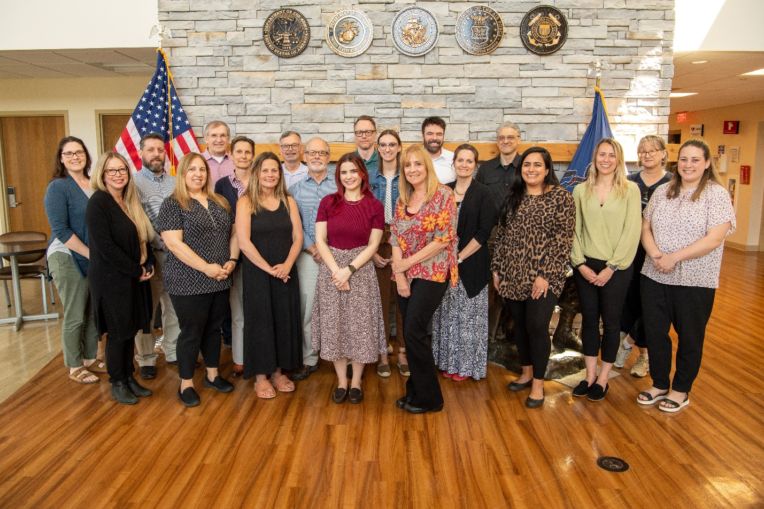

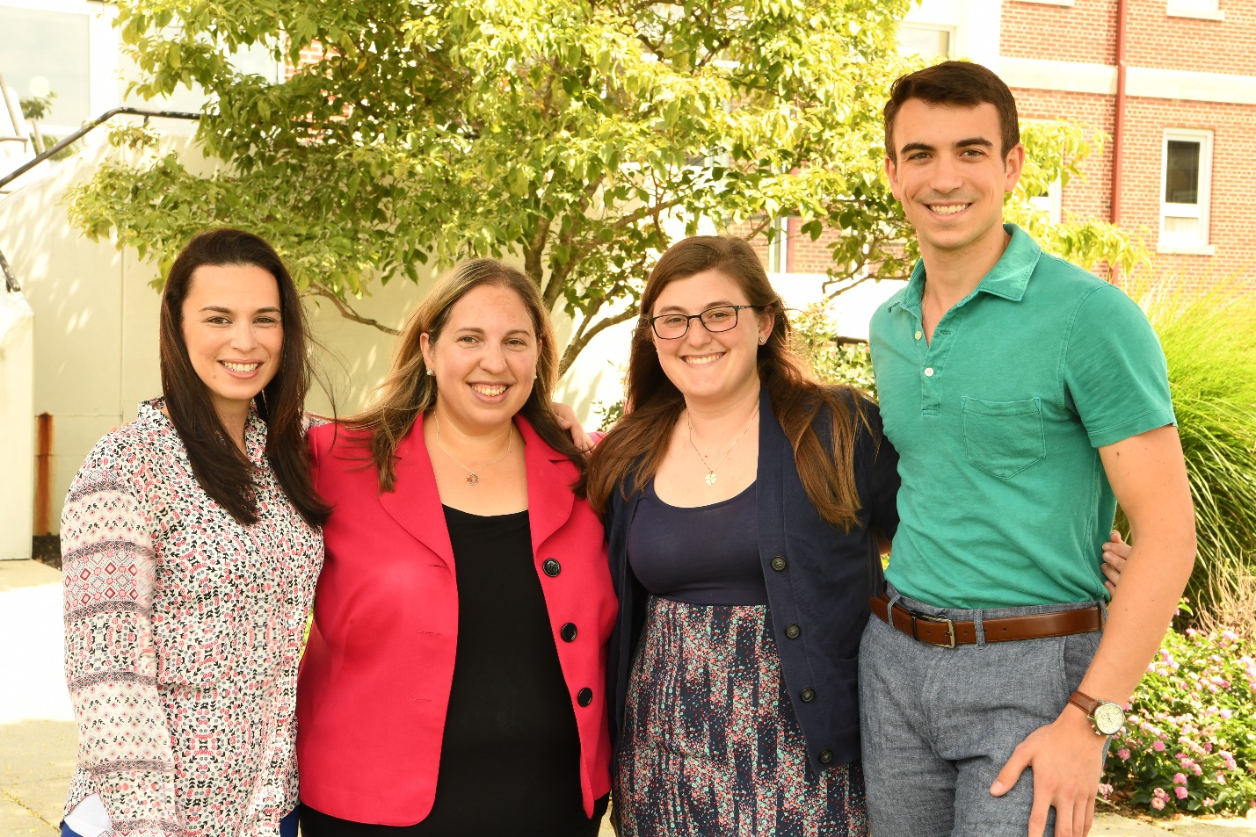

Lebanon Veterans Affairs Medical Center
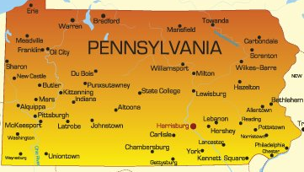
Lebanon VA Medical Center is located in South Central Pennsylvania, in the heart of Pennsylvania Dutch country. The city of Lebanon has a diverse population of over 24,000 residents and is surrounded by quaint small towns and rural agricultural areas. The main hospital is located in South Lebanon Township, approximately 30 miles east of Harrisburg, the state capital, and 30 minutes from the cities of Hershey, Reading, Lancaster, and York. Lebanon is also 1.5 hours from Philadelphia and Baltimore, and 3 hours from Washington, DC and New York City.

The Lebanon Valley is an area rich in culture and home to many famous attractions. The city of Harrisburg, the state capital, is home of the Harrisburg Senators baseball team and the Pennsylvania Farm Show. Hershey, “Chocolatetown USA”, is the home of Hershey’s chocolate as well as Hershey Park and Zoo America. Lebanon is also close to Lititz, PA, recently voted the “coolest small town in America”. Lititz is home to the Wilbur candy factory, Sturgis pretzels, Rock Lititz practice concert hall, and many independent restaurants and boutiques.

Lebanon is also close to many state parks and the Appalachian Trail. The Poconos are a short drive away and offer many recreational opportunities including skiing, whitewater rafting, paintball and mountain biking, just to name a few. Lancaster is also known for its outlet and antique shopping.
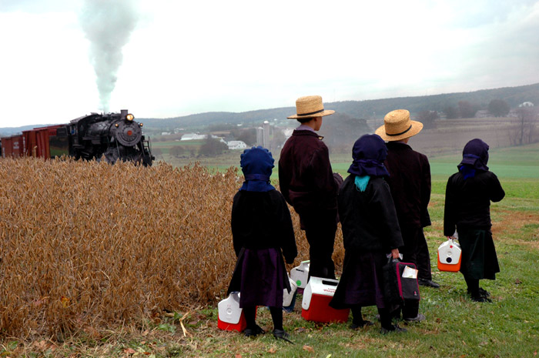

In terms of culture, the Lebanon area is a mixture of agricultural and manufacturing communities and was heavily influenced by the early settlers from Germany. The Pennsylvania Dutch (also called Pennsylvania Germans or Pennsylvania Deutsch) are descendants of early German immigrants to Pennsylvania. Not all Pennsylvania Germans are Amish. Although they are the best-known group, the Amish make up only a small portion of the Pennsylvania Germans in the state. Other groups include the Mennonites, the Brethren, and sub-groups within each group, many of whom use cars and electricity.

The early immigrants arrived in droves, mostly before 1800, to escape religious persecution in Europe. Like so many other persecuted groups, they came here for William Penn’s promise of religious freedom in his new land of Pennsylvania. These colonists embraced a strong work ethic, which led to the development of a number of business producing a wide variety of goods from natural resources.

Pennsylvania became part of the “rustbelt” and was home to the coal, iron, steel, railroads, and petroleum industries beginning in the 19th century. Textile processing, milling, and, in the early 20th century, food processing (e.g., Hershey’s chocolate), were also important to the state’s economy.
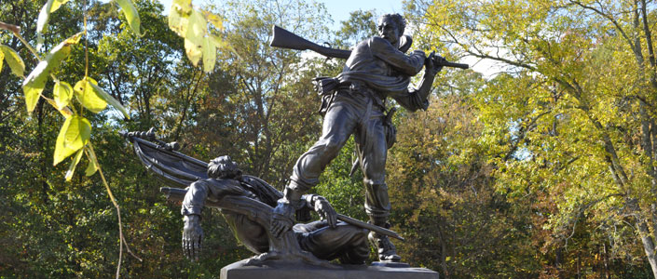

As psychologists, we respect how the history and culture of this area affects our Veterans and their families. Working as part of the VA system, we also strive to understand how our local military history and current military installations contribute to our Veteran’s identities.

The Battle of Gettysburg, fought from July 1-3, 1963, was the largest battle of the Civil War. Confederate forces reached as far north as Mechanicsburg, threatening to take Harrisburg. York was the largest Northern town to fall to the Confederates during the war. The U.S. Army War College is located on the campus of the Carlisle Barracks, in Carlisle, PA (Cumberland County). Fort Indiantown Gap, located mainly in Lebanon and to a lesser extent in Dauphin County, is a National Guard training center. FTIG serves as the headquarters for the PA Department of Military and Veterans Affairs and the PA National Guard. And finally, the Naval Support Activity, located in Mechanicsburg (Cumberland County), is a naval supply depot and employs many Veterans.
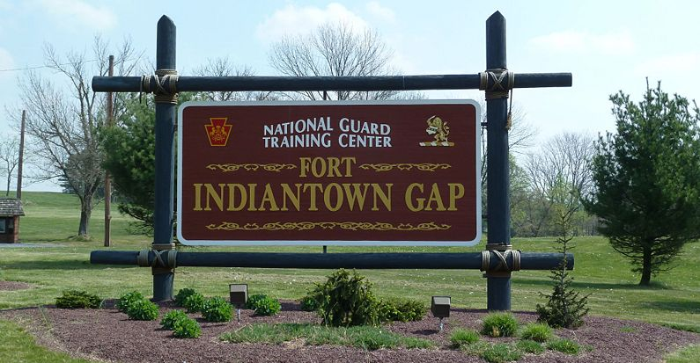
Today, the people in this area remain predominately White and of German descent but that is changing. Current demographics reveal the counties of South-Central PA are over 90% White, with the exception of Dauphin County, which was 71% White in the 2010 Census. According to the 2000 Census, while anywhere from 29-45% of residents consider themselves to be German, additional notable nationalities include American, Irish, and English. Schuylkill county has a large Polish (almost 10%) population, as well as a considerable Lithuanian (5%) population. Hispanic/Latino individuals comprise 9.5% of the Lancaster County’s population and 16.4% of Berks County’s population.

We at Lebanon VA welcome interns from all areas, cultures and backgrounds to continue to grow a more diverse staff of clinical psychologists! We invite you to explore our area, listen with an open heart and share your story so we can all learn from each other.

Local Attractions:
http://gettysburgmuseum.com/
http://www.hersheypa.com/
http://www.crystalcavepa.com/
http://www.hersheyharrisburgwinecountry.com/
http://www.poconomountains.com/
http://www.parenfaire.com/
https://www.sight-sound.com/WebSite/home.do

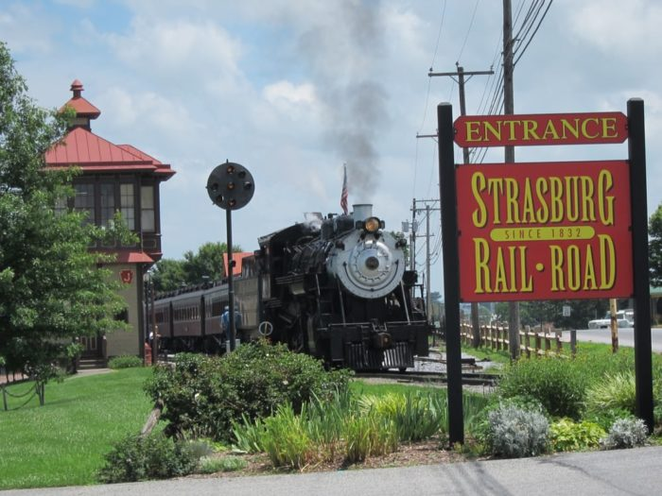

Lebanon VAMC

Program Tables - Admissions, Support, and Placement Data
Date Program Tables are updated: 7/27/23

Program Disclosures

Does the program or institution require students, trainees, and/or staff (faculty) to comply with specific policies or practices related to the institution’s affiliation or purpose? Such policies or practices may include, but are not limited to, admissions, hiring, retention policies, and/or requirements for completion that express mission and values? | No
If yes, provide website link (or content from brochure) where this specific information is presented: | NA
Internship Program Admissions

Briefly describe in narrative form important information to assist potential applicants in assessing their likely fit with your program. This description must be consistent with the program’s policies on intern selection and practicum and academic preparation requirements:
Applicants must meet the following prerequisites to be considered for our program The Lebanon VA Medical Center Doctoral Internship Program provides qualified doctoral candidates a generalist training with a variety of psychiatric, medical, and geriatric patients in residential, inpatient, outpatient and primary care settings. Internship graduates are prepared for professional practice in VA facilities as well as a wide range of health care settings, including medical centers and non-VA hospitals that primarily serve adults. Applicants must complete at least 3 years of graduate training prior to internship and have at least 400 intervention and assessment hours documented on the AAPI. (300 of which are intervention hours).

Applicants must meet all requirements for VA internship eligibility, which includes:
- US Citizenship
- Student in good standing in an APA accredited clinical or counseling psychology doctoral program
- Approved for internship status by their graduate training program coordinator
- Verification of Selective Service Registration (Male applicants born after 12/31/1959 must sign a pre-appointment Certification Statement for Selective Service Registration)

Does the program require that applicants have received a minimum number of hours of the following at time of application? If Yes, indicate how many:
Total Direct Contact Intervention Hours | Yes, Amount = 300
Total Direct Contact Assessment Hours | Yes, Amount = 50
Describe any other required minimum criteria used to screen applicants:
The program does not have additional screening criteria.

Financial and Other Benefit Support for Upcoming Training Year*

Annual Stipend/Salary for Full-time Interns | 3
Annual Stipend/Salary for Half-time Interns | NA
Program provides access to medical insurance for intern? | Yes
If access to medical insurance is provided:
Trainee contribution to cost required? | Yes
Coverage of family member(s) available? | Yes
Coverage of legally married partner available? | Yes
Coverage of domestic partner available? | Yes
Hours of Annual Paid Personal Time Off (PTO and/or Vacation) | 104
Hours of Annual Paid Sick Leave | 104
In the event of medical conditions and/or family needs that require extended leave, does the program allow reasonable unpaid leave to interns/residents in excess of personal time off and sick leave? | Yes
Other Benefits (please describe): Administrative Leave for dissertation defense, post-doctoral interviews, and conferences (approved by Training Director)
*Note. Programs are not required by the Commission on Accreditation to provide all benefits listed in this table

Initial Post-Internship Positions

(Provide an Aggregated Tally for the Preceding 3 Cohorts) 2020-2023
Total # of interns who were in the 3 cohorts | 9
Total # of interns who did not seek employment because they returned to their doctoral program/are completing doctoral degree | 0
Academic teaching | PD=0, EP=0
Community mental health center | PD=0, EP=0
Consortium | PD=0, EP =0
University Counseling Center | PD=0, EP =0
Hospital/Medical Center | PD=1, EP =0
Veterans Affairs Health Care System | PD=0, EP =7
Psychiatric facility | PD=0, EP =0
Correctional facility | PD=0, EP =0
Health maintenance organization | PD=0, EP =0
School district/system | PD=0, EP =0
Independent practice setting | PD=0, EP =1
Other | PD=0, EP =0
Note: “PD” = Post-doctoral residency position; “EP” = Employed Position. Each individual represented in this table should be counted only one time. For former trainees working in more than one setting, select the setting that represents their primary position.

