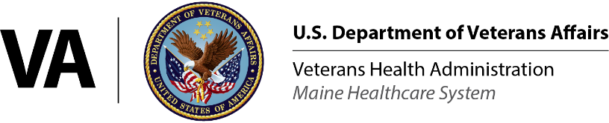

**VA MAINE HEALTHCARE SYSTEM**

**CLINICAL NEUROPSYCHOLOGY** **POSTDOCTORAL RESIDENCY PROGRAM**  
15 Challenger Dr. (116B)

Lewiston, ME 04240

Ph: 207-623-8411 ext. 2840

Number of position available in 2024: One (1)

Anticipated start date: 08/26/2024

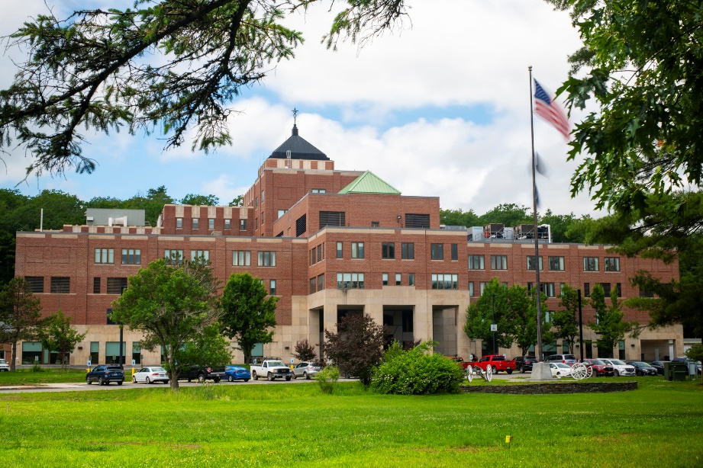

The Clinical Neuropsychology Postdoctoral Residency at VA Maine is a fulltime, two-year, adult-focused training program with a focus on providing neuropsychological services to Veterans in rural communities.

The program is a member of the Association of Postdoctoral Programs in Clinical Neuropsychology (APPCN).

Using the Taxonomy for Education and Training in Clinical Neuropsychology, the program offers a “Major Area of Study” in clinical neuropsychology, to include relevant didactics, clinical experiences, and research activities.

Contents

ACCREDITATION STATUS 3

Land Acknowledgement 4

RESIDENCY ADMISSIONS, SUPPORT, AND INITIAL PLACEMENT DATA 6

Program Disclosures 6

Postdoctoral Program Admissions 6

Financial and Other Benefit Support for Upcoming Training Year* 8

Post-Residency Data 9

THE APPLICATION PROCESS 11

Application Due Date 11

THE INTERVIEW PROCESS 12

Number of position available in 2024 12

Training Community and Socialization 13

Training Resources 13

Patient Population and Characteristics 14

TRAINING ADMINISTRATION AND POLICIES 15

VA Maine Neuropsychology Training Program Conflict Resolution and Grievances Standard Operating Procedures 16

TRAINING MODEL AND TRAINING EXPERIENCES 21

Clinical Training 21

Research and Program Development Activities 22

Supervision Opportunities and Teaching 23

Seminars and Didactics 23

The Neuropsychology Seminar 23

The Rotating Seminar: 23

The Interdisciplinary Professional Education (IPE) seminar: 24

Individual and Group Supervision 24

Mentorship 25

Other Activities 25

PROGRAM AIMS AND COMPETENCIES 26

Competency Domains 26

ROTATION AND GRADUATION REQUIREMENTS 27

Rotation Requirements 27

Graduation Requirements 28

TRAINING STAFF 28

The Clinical Neuropsychology Postdoctoral Residency Supervisors 28

The Hall of Fame: Current and Past Clinical Neuropsychology Residents 30

LIVING IN MAINE 30

# ACCREDITATION STATUS

The program is accredited by the Commission on Accreditation (CoA) of the American Psychological Association. A self-study for reaccreditation was submitted and the program is waiting to schedule a site visit. For questions related to VA Maine’s accreditation status, please contact CoA using the information below:

Office of Program Consultation and Accreditation

American Psychological Association

750 1st Street, NE, Washington, DC 20002

Phone: (202) 336-5979 / E-mail: [apaaccred@apa.org](mailto:apaaccred@apa.org)

Web: [www.apa.org/ed/accreditation](http://www.apa.org/ed/accreditation)

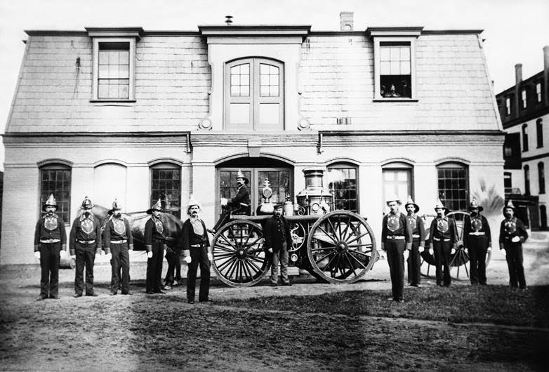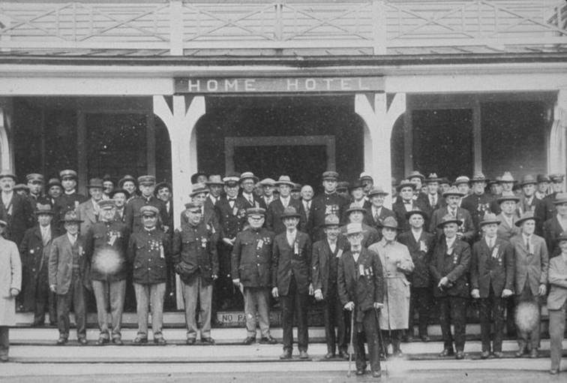

**Top left: In this 1885 photo of Togus Fire Department, you can see the new 2-cylinder steam engine. General Butler wanted the nicest in firefighting equipment on site... after the second hospital fire.**

**Bottom Left: On June 1, 1883 a young German Musician named Berthold W. Thieme arrived with his wife and two young children to Togus. “Professor” Thieme (pronounced Ty-Me), transformed the Togus Home Band, considered an amateur band, in to one of, if not the best, bands in all of New England. Thieme often got together with John Philip Sousa and compared notes. Sousa considered Thieme to be one of the finest conductors in the country and once called him a “public benefactor.”**

**Top Right: In 1890, a Narrow Gauge railroad from the Kennebec River in Randolph and an electric trolley line from Augusta were completed. The relative isolation of Togus was ended and it became a popular excursion spot for Sunday picnics.**

**Bottom Right: The Togus Hotel, Originally built in 1885 was located behind the Chapel. In 1889 it got a facelift and became the first Togus Hotel. It was prosperous until 1917 when it was closed due to the high cost of heating during the cold Maine winters.**

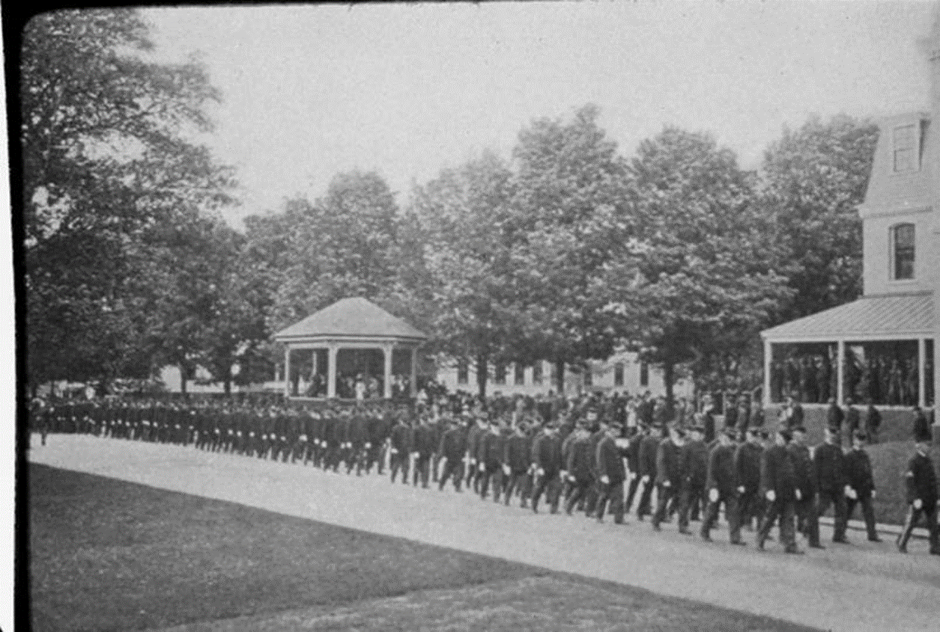

**Ever mindful of its military traditions, Memorial Day at Togus was first observed in 1901, replacing the traditional “Decoration Day” held on June 17th to commemorate the Battle of Bunker Hill. This photo is of the Veterans passing in review while returning from the Memorial Day Exercises at the cemetery.**

## Land Acknowledgement

**VA Maine Healthcare System Psychology Training Programs acknowledge that our facilities are located on the ancestral lands of the Abenaki people and the sovereign people of the Wabanaki Confederacy: the Penobscot, Passamaquoddy, Maliseet, and Mi'kmaq peoples. We recognize the peoples for whom these were ancestral lands, as well as the many indigenous peoples who live and work in this region today. Committed to diversity and inclusion, the Psychology Training Program strives to acknowledge historical truths, encourage education, and seek partnership with our indigenous communities. Nationally, approximately 19% of all Native Americans have served in the military, the highest rate of service for any single ethnicity in our nation. Our intention with this statement is to acknowledge our alignment with the VA’s duty to serve all who have served and recognize the unique challenges faced by Native American Veterans.**

# RESIDENCY ADMISSIONS, SUPPORT, AND INITIAL PLACEMENT DATA

Date Program Tables Updated: 09/08/2023

|  |  |  |  |  |  |  |  |  |  |  |  |  |  |
| --- | --- | --- | --- | --- | --- | --- | --- | --- | --- | --- | --- | --- | --- |
| Program Disclosures As articulated in Standard I.B.2, programs may have “admission and employment policies that directly relate to affiliation or purpose” that may be faith-based or secular in nature. However, such policies and practices must be disclosed to the public. Therefore, programs are asked to respond to the following question.     |  |  | | --- | --- | | Does the program or institution require students, trainees, and/or staff (faculty) to comply with specific policies or practices related to the institution’s affiliation or purpose? Such policies or practices may include, but are not limited to, admissions, hiring, retention policies, and/or requirements for completion that express mission and values. | **No** | | If yes, provide website link (or content from brochure) where this specific information is presented. | **NA** |  Postdoctoral Program Admissions | |  |  |  |  |  |  |  |  |
| Goodness-of-fit is demonstrated by:   1. Clinical neuropsychology is the applicant’s major area of study during doctoral and internship training, or at least an emphasis of prior training coupled with other significant experiences in neuropsychology. 2. Dedication to becoming a board-certified clinical neuropsychologist. 3. Career goals include working in VA healthcare and/or rural healthcare settings.   **Applicants are strongly encouraged to review** [Link to Eligibility Requirements](https://www.va.gov/oaa/hpt-eligibility.asp) **prior to applying. This link provides the most up-to-date information about eligibility requirements and the process of being appointed to a VA position after selection (i.e., onboarding).**  All VA Psychology Postdoctoral Programs require:   1. A doctorate degree from an APA or CPA accredited graduate program in Clinical, Counseling, or Combined Psychology or PCSAS accredited Clinical Science program. Persons with a doctorate in another area of psychology who meet the APA or CPA criteria for respecialization training in Clinical, Counseling, or Combined Psychology are also eligible. 2. Completion of an internship program accredited by APA or CPA or have completed a VA-sponsored internship. 3. In lieu of having the doctoral degree conferred (sometimes it is not possible to “walk” before the start date of postdoctoral training), it is acceptable to have the Director of Clinical Training verify that ALL degree requirements are completed.  This verification letter must be on the University’s letterhead.  The verification that all degree requirements have been met is meant to denote that there are no additional tasks for the student to complete prior to the degree being conferred (e.g., the student has completed any final revision that must be made to the dissertation and the dissertation has been accepted by the graduate program and graduate school).   Additional VA Requirements:  Health Profession Trainees (HPTs) must be citizens of the United States (US).  All HPTs must have a US social security number (SSN) prior to beginning the VA pre-employment,  onboarding process. HPTs not eligible to apply for an SSN will not be permitted to train at VA.  Federal law requires that most males living in the US between the ages of 18 and 26 register with  the Selective Service System (SSS). Male, for this purpose, is any individual born male on their birth  certificate regardless of current gender. Males required to register, but who fail to do so by their  26th birthday, may be ineligible for VA appointment. Visit <https://www.sss.gov> to register, print  proof of registration or obtain a Status Information Letter.  Onboarding requires two source identification documents (IDs) to prove identity. Documents must  be unexpired and names on both documents must match. For more information visit:  <https://www.oit.va.gov/programs/piv/_media/docs/IDMatrix.pdf>. States have begun issuing  Secure Driver’s Licenses. Be sure yours will be accepted as a Real ID <https://www.dhs.gov/real-id>.  HPTs who are currently licensed, or who previously held a license in the same or a different  discipline, must be screened against the National Practitioner Data Bank. Visit the site to perform a self-query and confirm you are eligible for VA appointment. <https://www.npdb.hrsa.gov/>  The Department of Health and Human Services Office of the Inspector General has compiled a list  of individuals excluded from participation in Medicare, Medicaid and all other Federal healthcare  programs. Visit the site to confirm you are NOT on this list <https://exclusions.oig.hhs.gov/>.  As a condition of appointment, HPTs must furnish evidence of satisfactory physical condition  based on a physical examination in the past 12 months; have up-to-date vaccinations for healthcare  workers as recommended by the Centers for Disease Control (CDC)  <https://www.cdc.gov/vaccines/adults/rec-vac/hcw.html>; and have undergone baseline  tuberculosis (TB) screening and testing per CDC health care personnel guidelines  <https://www.cdc.gov/tb/topic/testing/healthcareworkers.htm> (for direct VA-paid HPTs, this means  within 90-days of hire). Of note, proof of covid vaccination or exemption is required.  HPTs will be fingerprinted and undergo screenings and background investigations. A VA Human  Resources Security Specialist will determine suitability. Additional details can be found here:  <http://www.archives.gov/federal-register/codification/executive-order/10450.html>  Additional pre-employment forms include the:  Application for Health Professions Trainees (VA 10-2850D)  Declaration for Federal Employment (OF 306)  HPT Random Drug Testing Notification and Acknowledgement memo (see below)  These documents, and others, are available online for review at [Application Forms & Mandatory Training - Office of Academic Affiliations (va.gov)](https://www.va.gov/oaa/app-forms.asp). Falsifying any answer on any Federal document will result in the inability to appoint or immediate dismissal from the VA.  HPTs are not drug-tested prior to receiving an appointment; however certain HPTs are subject to  random drug testing throughout the entire VA appointment period. HPTs sign an  acknowledgement form stating awareness of this practice (see form <https://www.va.gov/OAA/onboarding/VHA_HPTsDrug-FreeWorkplaceOAA_HRA.pdf> )  Federal employees are tested for marijuana, as it is still considered a Schedule 1 drug under federal law. Please keep in mind, CBD products could contain THC. Therefore, an individual using a CBD product may test positive for THC metabolite. | |  |  |  |  |  |  |  |  |
|  |  |  |  |  |  |  |  |
|  |  |  |  |  |  |  |  |
|  |  |  |  |  |  |  |  |
| **Describe any other required minimum criteria used to screen applicants:** | |  |  |  |  |  |  |  |  |
| We are pleased to inform applicants from all backgrounds that our selection process makes every reasonable effort to attract, interview, and eventually match with a diverse range of candidates. VA Maine has a diversity and inclusion workgroup, consisting of psychology staff and trainees. This group assists with informing the training programs of recruitment and selection practices, to include providing attention and consideration to applicants coming from underrepresented communities. Further, the training program adheres to all Equal Employment Opportunity (EEO) and federal policies regarding non-discriminatory hiring and retention procedures. For more information plaese visit:  [Policies - Office of Resolution Management, Diversity & Inclusion (ORMDI) (va.gov)](https://www.va.gov/ORMDI/DiversityInclusion/Policies.asp) | |  |  |  |  |  |  |  |  |
|  |  |  |  |  |  |  |  |
|  |  |  |  |  |  |  |  |
|  |  |  |  |  |  |  |  |
|  |  |  |  |  |  |  |  |
|  |  |  |  |  |  |  |  |
|  |  |  |  |  |  |  |  |
| Financial and Other Benefit Support for Upcoming Training Year* | |
| Annual Stipend/Salary for Full-time Residents | Year 1 = 52,005  Year 2 = 54,816 |
| Annual Stipend/Salary for Half-time Residents | NA |
| Program provides access to medical insurance for resident? | Yes |
| **If access to medical insurance is provided:** |  |
| Trainee contribution to cost required? | Yes |
| Coverage of family member(s) available? | Yes |
| Coverage of legally married partner available? | Yes |
| Coverage of domestic partner available? | No |
| Hours of Annual Paid Personal Time Off (PTO and/or Vacation) | Accrues at a rate of 4 hours every two weeks, amounting to 13 vacation days |
| Hours of Annual Paid Sick Leave | Accrues at a rate of 4 hours every two weeks, amounting to 13 sick leave days |
| In the event of medical conditions and/or family needs that require extended leave, does the program allow reasonable unpaid leave to interns/residents in excess of personal time off and sick leave? | Yes |
| **Stipend:** Postdoctoral fellows receive a competitive stipend paid in 26 biweekly installments per year. VA fellowship stipends are locality adjusted to reflect different relative costs in different geographical areas.  **Benefits:** Most fellowship appointments are for 2080 hours, which is full time for a one year period. The anticipated start date is 08/26/24. VA fellows are eligible for health insurance (for self, spouse, and legal dependents). Some fellows will be eligible for life insurance, vision, or dental benefits; eligibility is based on prior federal service and the individual’s service computation date.  **Holidays and Leave:**Fellows are eligible for federal holidays throughout the calendar year. In addition, most fellows will be in Leave Category I, meaning they will accrue 4 hours of sick leave and 4 hours of annual leave for each full two-week pay period, for a total of between 96 and 104 hours of each during the year.  If a fellow has prior federal service, their leave category will be determined based on their service computation date.  **Authorized Absence:** According to VA Handbook 5011, Part III, Chapter 2, Section 12, employees, including trainees, may be given authorized absence without charge to leave when the activity is considered to be of substantial benefit to VA in accomplishing its general mission or one of its specific functions, such as education and training. Application of this policy varies from site to site. Questions for a specific program must be directed to the Training Director.  **Liability Protection for Trainees:** When providing professional services at a VA healthcare facility, VA sponsored trainees acting within the scope of their educational programs are protected from personal liability under the Federal Employees Liability Reform and Tort Compensation Act 28, U.S.C.2679 (b)-(d). | |

* Note. Programs are not required by the Commission on Accreditation to provide all benefits listed in this table.

|  |  |
| --- | --- |
| Post-Residency Data | |
| (Aggregated Tally for the Preceding 3 Cohorts) | |
| This is a two-year program. The three previous graduating cohorts include the 2019-2021, 2020-2022, and 2021-2023 cohorts. | 2019-2023 |
| Total # of residents who were in the cohorts | Total = 4  2019-2021: n = 1  2020-2022: n = 2  2021-2023: n = 1 |
| Total # of residents who remain in training in the residency program | 0 |
| Academic teaching | PD=NA, EP=0 |
| Community mental health center | PD=NA, EP=0 |
| Consortium | PD=NA, EP=0 |
| University Counseling Center | PD=NA, EP=0 |
| Hospital/Medical Center | PD=NA, EP=0 |
| Veterans Affairs Health Care System | PD=NA, EP=3 |
| Psychiatric facility | PD=NA, EP=0 |
| Correctional facility | PD=NA, EP=0 |
| Health maintenance organization | PD=NA, EP=0 |
| School district/system | PD=NA, EP=0 |
| Independent practice setting | PD=NA, EP=0 |
| Other | PD=NA, EP=1 |
| Note. PD = Post-doctoral residency position; EP = Employed Position. Each individual represented in this table should be counted only one time. For former trainees working in more than one setting, select the setting that represents their primary position. | |

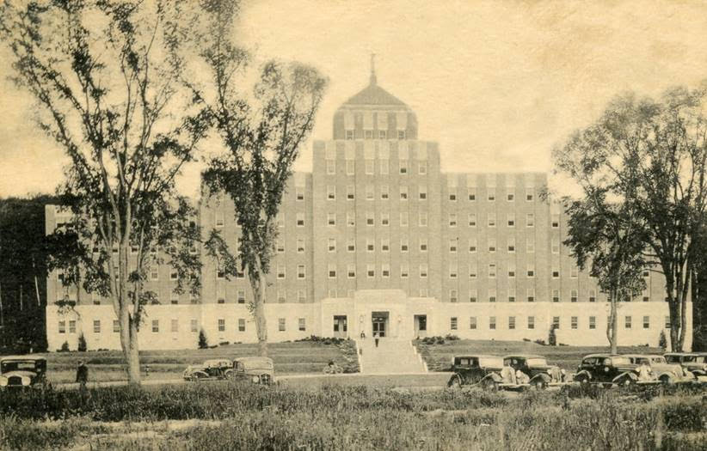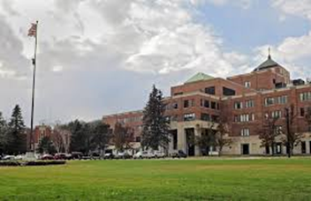

**On July 3,1930, congress passed a law authorizing President Hoover to “consolidate and coordinate governmental activities affecting war veterans.” President Hoover formed the Veterans Administration with Executive Order on July 21, 1930. On May 12, 1932, the National Home broke ground on its new hospital. The contractors were given 275 days to complete the new construction. On November 15, 1933, the new hospital, known now as building 200, was opened (pictured left). On the right is building 200 now.**

**Pictured below is the Lewiston CBOC, which is the home to the Neuropsychology Postdoctoral Residency Program.**

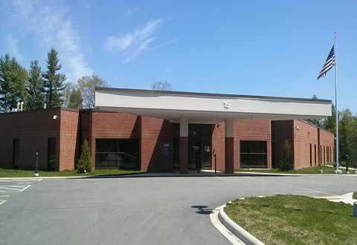

# THE APPLICATION PROCESS

Applications are submitted through APPA CAS (APPIC Psychology Postdoctoral Application). The website is: <https://appicpostdoc.liaisoncas.com/applicant-ux/#/login>

Application Due Date: January 8th, 2024

PLEASE BE AWARE: VA Maine HCS has two postdoctoral training programs: 1) Neuropsychology and 2) Clinical Psychology. MAKE SURE you are submitting your application to the Neuropsychology Postdoctoral Residency Program.

The application requires six (6) items:

1. A cover letter no longer than 1.5 pages. The cover letter should address three (3) topics:
   1. Fit with the program. Please describe why this program is a good fit for your training and how it will help you achieve your career goals. Ideally, your goals should align with what the program offers. Briefly describe your previous neuropsychological training and how it prepared you for a residency in neuropsychology. Also explain the level of neuropsychological training received during graduate school and internship utilizing the descriptive terms from the Taxonomy for Education and Training* (i.e., a major area of study, an emphasis, an experience, or an exposure). While we are looking for candidates with strong neuropsychology training, we consider applicants from less traditional paths, whether due to lack of availability of neuropsychological training sites, developing an interest in neuropsychology later in graduate school, or other considerations. If that describes your background, please discuss how you were able to overcome those barriers.
   2. Dissertation or Research Project. Please describe your dissertation or research project, including current progress, anticipated completion date, and a brief summary of the project’s aims. There is a preference for applicants with a neuropsychology-focused dissertation. We may not rank an applicant if their dissertation appears unlikely to be completed before the start of the residency based on information in written materials or information gathered during interview.
   3. Help us understand you better as a person. There is no right way to do this, and you are free to add as much or as little as you choose. We are interested in learning about qualities that you think would make you a strong candidate and resident. Are you driven? Are you a team player? Any unique hobbies or interests? Moreover, we would appreciate an opportunity to learn about you from a cultural and diversity perspective. Applicants from communities that are underrepresented in neuropsychology receive additional consideration.

2) Curriculum Vita.

3) Verification of Completion of Doctorate (to be completed by Dissertation Chair or Director of Clinical Training). The form may be downloaded from: <http://appcn.sitewrench.com/assets/1748/doctorate_verification_form.pdf>.

4) Applicants currently on internship need a letter from their Director of Internship Training verifying their standing in the internship program and expected date of completion. Applicants who have already completed internship may upload a copy of their graduation certificate.

5) Three (3) letters of recommendation from current or former clinical supervisors, with one letter from an internship supervisor and at least one letter from a clinical neuropsychologist. In general, there is a preference for letters from clinical neuropsychologists (especially board-certified neuropsychologists) who supervised your training.

6) Graduate school transcripts.

*For more information regarding the Taxonomy for Education and Training, please refer to:

Sperling, S. A., Cimino, C. R., Stricker, N. H., Heffelfinger, A. K., Gess, J. L., Osborn, K. E., & Roper, B. L. (2017). Taxonomy for Education and Training in Clinical Neuropsychology: past, present, and future. The Clinical Neuropsychologist (Neuropsychology, Development and Cognition: Sec, 31(5), 817-828.

# THE INTERVIEW PROCESS

The program typically interviews all applicants as long as they meet the minimum eligibility requirements and complete all application materials before the deadline, as we want to meet and provide an opportunity to anyone interested in training at VA Maine. However, if there are a large number of applications received (in the range of 20-25 or more), the program may not be able to guarantee an interview.

In accordance with recent recommendations from APPCN for its member programs, interviews will no longer be completed during the week of INS and will continue to be completed via video conferencing (Microsoft Teams). Interviews will be offered throughout the second half of January and the first week of February. Applicants will complete one interview with all four members of the neuropsychology staff. The interview will take approximately 60 minutes to complete. The first part of the meeting will consist of a performance based interview, where staff will take turns asking a standard set of questions. The second half of the interview will allow applicants to ask questions about the program, supervisors, and life in Maine to determine if the program is a good fit for their training goals. The group interview format is meant to provide applicants with an opportunity to meet training faculty, observe the dynamic of staff, offer different perspectives of working and training at VA Maine, and reduce applicants’ scheduling burden.

THE SELECTION PROCESS

Number of position available in 2024: One (1)

Anticipated start date: 08/26/24

VA Maine participates in the match for clinical neuropsychology postdoctoral residencies as administered by National Matching Services (NMS). We adhere to all policies regarding the matching program. VA Maine agrees to abide by the APPCN policy that no person at this facility will solicit, accept, or use any ranking-related information from any residency applicant. For more information on the matching program, see the websites for APPCN ([www.appcn.org](http://www.appcn.org)) and NMS ([www.natmatch.com/appcnmat](http://www.natmatch.com/appcnmat)).

VA Maine makes all reasonable efforts to attract, interview, and eventually match with residents from diverse backgrounds. VA Maine maintains an active diversity and inclusion workgroup, helping to inform our candidate recruitment and selection practices. Further, the training program adheres to all Equal Employment Opportunity (EEO) and federal policies regarding non-discriminatory hiring and retention procedures. Lastly, the program provides additional scoring support to applicants whose individual or cultural backgrounds may be underrepresented in the field, which may benefit their standing on the rank order list submitted to NMS.

The diversity and inclusion workgroup is a group of psychologists and psychology trainees focused on diversity, equity and inclusion initiatives within the psychology and neuropsychology training programs. The overall mission of this workgroup is to create a sustainable and thoughtful process to recruit and retain psychology interns, residents, and psychologists of diverse backgrounds. This includes cultivating an inclusive work environment for all trainees and psychologists, providing education around multicultural considerations, and supporting the Psychology Training Committee in fostering a safe and supportive atmosphere for learning and professional growth. To this end, the workgroup provides consultation and recommendations to both trainees and the training committee regarding diversity-related policy and procedures, and guidance for multicultural and diversity training for the internship and the general psychology and neuropsychology postdoctoral programs. Additionally, workgroup members have focused on facility-wide outreach and training in topics and systemic issues that may impact recruitment and retention of diverse trainees and practitioners.

THE RESIDENCY SETTING

The VA Maine Healthcare System was established in 1866 as the first veterans' facility "Soldiers' Home" in the country. It now provides medical, surgical, psychiatric, and nursing home care. In addition to the primary Medical Center (Togus), VA Maine HCS has nine Community Based Outpatient Clinics (CBOC).

Neuropsychology postdoctoral residents train primarily at the Lewiston CBOC, and as such, residents should expect to work in Lewiston for much of the residency. However, some activities require attendance at the main hospital (Togus), and residents can expect occasional travel to Togus will be needed. Togus is located just outside of Augusta and is about 45 minutes away from the Lewiston CBOC. Residents are not expected to travel back-and-forth between the Lewiston CBOC and Togus during the day. When going to Togus, residents usually reserve a “swing office” and stay there for the day. There are also opportunities to receive supervised neuropsychological training at our new Portland CBOC, located in Maine’s largest city. The opportunity to train in Portland is voluntary, though it is not possible to offer this opportunity to all residents in the program simultaneously. If using the highway, Portland is approximately 45 minutes away from Lewiston and an hour or more away from Togus.

During the COVID-19 pandemic, partial telework schedules were put into place and telework allowances are currently expected to continue. As such, residents are allowed to telework from home, presuming they have sufficient space and internet access to do so. Typically, residents work from home 2-3 days per week and will be at the Lewiston CBOC (or other training locations) on other days. With that being said, it is difficult to predict how long telework opportunities will continue, and it is possible that full-time in office work will be required at some point during the two year training period. Fulltime telework is unable to be offered. Telework policies are at the discretion of VA Maine administration and not the residency program.

Telework agreements are completed during the onboarding process. Prior to filling out the agreements, residents will need to complete several online trainings regarding telework. The agreements are then filled out to document the days, times, and methods of telework. Telework activities will also be documented and submitted to the training director(s) and/or supervisor(s). These procedures will be reviewed with residents during orientation.

Masking mandates at VA Maine changed on May 1, 2023. Under most circumstances, masking while at a VA Maine facility is not required. However, there are some exceptions. Masking is required if: a person has been exposed to COVID-19 in the past 10 days; is experiencing flu-like symptoms or symptoms of upper respiratory illness (though if this is the case, staying home and contacting occupational health for a COVID test may be recommended); a person is entering a high risk clinical area (unlikely for working out of a CBOC, though may be a consideration if conducting inpatient evaluations at Togus); upon request of a Veteran patient, caregiver, or family member. A resident may also wear a mask if they choose to due to personal preference.

## Training Community and Socialization

The Neuropsychology Residency Program is one of four psychology training programs at VA Maine. The other three include 1) practicum training for University of Maine doctoral students specializing in clinical neuropsychology (typically one student per year), 2) an APA-accredited clinical psychology internship program that has up to three clinical psychology interns each year (one is a dedicated neuropsychology-track intern) and 3) an APA-accredited clinical psychology postdoctoral program that has up to six clinical psychology postdoc positions next year. Therefore, the neuropsychology residents are part of a large cohort of psychology trainees at all training levels.

In addition to practicum, predoctoral and postdoctoral psychology trainees, VA Maine is a teaching hospital hosting several other training programs with medical students, psychiatry residents, urology and ophthalmology residents, dental externs, optometry residents, physician assistant and nurse practitioner students, pharmacy residents, nursing students, dietetics students, social work trainees, occupational therapy students, and physical therapy students. As a result, there is a vibrant learning atmosphere, and there are opportunities to engage in collaborative learning activities with other disciplines.

## Training Resources

Residents are provided offices for patient care and completion of other residency-related tasks. Offices are equipped with laptop docking stations for VA issued laptops providing easy access to patients' computerized medical records, e-mail, and internet. We also have a full range of neuropsychological tests and budgeted support for those test materials.

The Neuropsychology Postdoctoral Residency Program is housed within the Mental Health wing of the Lewiston CBOC building. The Mental Health wing has offices for clinical staff and trainees, two conference rooms, and a waiting area to accommodate patients and family members. Computer testing/scoring (via Mental Health Assistant) is available on all personal computers for psychological instruments such as the PAI or MMPI-2RF.

Library services are available to residents through the Medical Center's professional library located on the Togus campus. Assistance with literature retrieval is provided through VISN 1’s Knowledge Library, which is accessed on-line and provides searchable databases for electronic journals and books. If not immediately available through Knowledge Library online, there is an interlibrary loan service that provides very quick turnarounds. The Neuropsychology Postdoctoral Program also maintains its own library of journals and books that are stored electronically on a shared drive (i.e., PDF files) and available to residents at any time.

## Patient Population and Characteristics

Neuropsychology postdoctoral residents at VA Maine evaluate and treat veterans with neurocognitive, neurodegenerative, and emotional health concerns. Some of the more typical histories include dementias, stroke, TBI, ADHD, MS, substance-induced cognitive disorders, and metabolic and infectious disorders. Many of our veterans have pre-existing medical and psychological conditions that require significant clinical attention.

Beyond the clinical characteristics, the patient population at VA Maine offers residents an opportunity to work with rural veterans. Over 80% of VA Maine’s veterans live in areas considered rural or highly rural. Most veterans come from small towns, farming communities, and fishing villages where their families have resided for generations. Our residents see adults of all ages, but there is a preponderance of older adults in most caseloads. Maine boasts the highest median age in the U.S, and that is certainly reflected in our veteran population.

Maine also has a sizeable LGBTQ+ community, which is also reflected in its veteran (and staff) population. According to the LGBT Demographic Data collected by The Williams Institute (2019), Maine was in the top ten states with the highest percentage of people identifying as LGBTQ+. When postdoctoral residents take pride in serving all veterans who served our country, they are going to fit right in with our program’s culture.

Maine is home to a large French-speaking ethnic population. Although U.S. born, many Maine veterans are of French-Canadian heritage and were raised in homes speaking French. This is truer for our older veterans compared to our younger veterans, but residents in the program should expect to evaluate many people whose first language was French and not English.

What we now call Maine has been the homeland for the Wabanaki for 12,000 years, and many of our veterans come from four tribal communities that are collectively known as the Wabanaki: the Miꞌkmaq, Maliseet, Passamaquoddy and Penobscot. The name Wabanaki translates to “People of the Dawnland.” While the proportion of native people in Maine may be smaller than in some other states, the culture here is vibrant. Many people from the Wabanaki communities have served in the military, and are in return proudly served at VA Maine. Recently, Janet T. Mills, Governor of the great state of Maine, proclaimed June 21st, 2022 as Native American Veterans Day, and this day is recognized throughout the State of Maine. <https://www1.maine.gov/governor/mills/official_documents/proclamations/2022-06-native-american-veterans-day-june-21st>

Finally, regardless of what community a person comes from in Maine, what really makes our patient population so unique is that they are from Maine. Mainers- even the adopted ones “from away”- tend to be incredibly nice people who look out for one another, work hard, and have an amazing sense of humor (hope you like dry wit).

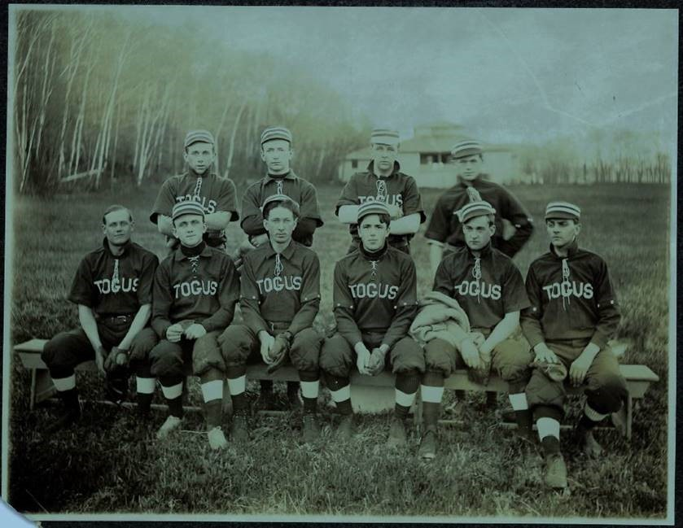

**The small gloves, uniforms, and hats help date this photograph to about 1901. The Togus teams were playing 35 to 40 baseball games a year from about 1910 to 1917 against area town teams and teams supported by local businesses. Togus had a baseball field and a grandstand for spectators.**

# TRAINING ADMINISTRATION AND POLICIES

Dr. Josh Caron is responsible for the training and administrative duties related to the Clinical Neuropsychology Postdoctoral Residency Program and is the preceptor for neuropsychology practicum training. The program is undergoing a transition period in program administration. Dr. Kate Charpentier is expected to join Dr. Caron as Co-Director of the residency program and this will likely be the administrative structure when the 2024 residency begins. The training directors use input from supervisory clinical neuropsychologists, the VA Maine Psychology Training Committee, and VA Maine Administrators to coordinate training resources, develop training curricula and experiences, and create the program’s policies and procedures. They are also responsible for receiving direct feedback from supervisory clinical neuropsychologists about residents’ performance. Likewise, they solicit and respond to feedback from the residents regarding their training needs, the quality of their training experience, and any other issues that may influence their training experience. Drs. Caron and Charpentier will maintain all Clinical Neuropsychology Postdoctoral Residency Program records.

As mentioned previously, the Clinical Neuropsychology Postdoctoral Residency Program is a part of the larger training infrastructure at VA Maine, to include several other psychology training programs. Dr. Jennifer Breslin is the Training Director for the clinical psychology internship and postdoctoral programs.

Dr. Christine Ramsay is the Psychology Lead for Psychology Services, and is the immediate supervisor to the Training Directors who are managing the training programs within the Psychology Service.

Dr. Brad Schimelman is the Associate Chief of Staff for Education and Research, and is responsible for all training programs at VA Maine.

The Psychology Training Committee (PTC) oversees the policies and procedures concerning psychology training at VA Maine and maintains responsibility for addressing trainee conduct and performance. The PTC is chaired by Dr. Liesl Beecher-Flad. Dr. Charpentier currently serves as the PTC Secretary, though she will be transitioning out of this role. The PTC consists of representatives from all psychology training areas. It meets twice per month to discuss and review the psychology training programs (the Clinical Psychology Internship Program, the Clinical Psychology Postdoctoral Program, and The Clinical Neuropsychology Postdoctoral Residency Program). The PTC also monitors the progress of psychology trainees and assures continuity of training across rotations and training settings. Lastly, there is an additional group called the Psychology Training Advisory Board (PTAB) whose function is to review and approve psychology supervisors before they begin supervising trainees. Additionally, the PTAB is an integral part of the grievance policy and conflict resolution procedures described next.

## VA Maine Neuropsychology Training Program Conflict Resolution and Grievances Standard Operating Procedures

1. PURPOSE: To delineate procedures for conflict resolution and grievances for pre-doctoral interns and post-doctoral residents (henceforth refer to as “Trainee”) under the Psychology and Neuropsychology Training Programs.
2. POLICY: The psychology and neuropsychology services offer comprehensive training and supervision to pre-doctoral and post-doctoral trainees in the disciplines of clinical psychology and neuropsychology. This policy offers trainees and staff members a mutually acceptable method for prompt and equitable settlement of grievances and/or conflicts. It provides clear guidelines of the effective/efficient management of conflicts and grievances while promoting professionalism, adherence to moral and ethical standards, and generating a safe learning/working environment for trainees and staff.

Note: It is agreed, as part of professional and ethical behavior, that conflicts and grievances should normally be resolved at the lowest level possible.

1. DEFINITIONS:
2. Conflicts are defined as any disagreement that occurs between a trainee and other trainee(s), supervisor(s), or any other staff member(s).
3. Grievances are defined by the VA Master Agreement (2011) as “any complaint by an employee(s)… concerning any matter relating to employment… or any claimed violation, misinterpretation or misapplication of law, rule or regulation affecting condition of employment.” Examples of grievances may include unsatisfactory work environment, harassment, unsatisfactory supervision, etc.
4. RESPONSIBILITIES
5. The Lead of Psychology Service will be responsible for the implementation of this policy. They will provide executive leadership to the Psychology Training Committee and oversee procedures delineated in this policy.
6. The Psychology Training Advisory Board is responsible for the oversight of procedures delineated in this policy and as a sounding board during conflict resolution and appeals. The Associate Chief of Staff for Education is the Chair of the Psychology Training Advisory Board and will be notified of any significant conflicts that cannot be settled between the affected individuals or with the assistance of the Training Directors.
7. The Psychology and Neuropsychology Training Directors (here forth refer to as Training Directors) are responsible for the education to trainees regarding conflict resolution and grievances procedures on the scope of their respective program. Training directors also serve as mediator during disputes as delineated in this policy.
8. Clinical supervisors, members of Psychology Training Committee, members of the Psychology Training Advisory Board, and any other Psychology Service staff are responsible to provide guidance and assistance to trainees for the adherence to procedures hereby delineated and to facilitate grievances and conflict resolution according to this policy.
9. Trainees are responsible for the adherence to this policy and for seeking consultation from Training Directors, Supervisors, or Psychology Staff for assistance during grievances/conflict resolutions.
10. PROCEDURES:
11. EDUCATION:
12. A copy of this policy should be provided to trainees in a welcome package prior to arrival on station.
13. At the beginning of the training year and NLT that five (5 days) of trainees start date, Training Directors must discuss this policy in detail with all trainees and will obtain acknowledgement and understanding receipt from trainees (ATTACHMENT A). A signed copy will be maintained in trainees training record.
14. Trainees will receive a formal didactic in conflict resolution to support the implementation of this SOP.
15. Group supervision will serve as a forum to discuss concerns or doubts regarding this policy.
16. Review of this policy will be completed with Trainees when deemed necessary by Training Directors and at least once during the training year (i.e., midterm evaluation). This education must be documented in Trainees training records with the use of ATTACHMENT A.
17. TRAINEE-SUPERVISOR CONFLICTS: In the event that disagreement occurs between a Supervisor and a Trainee regarding the Supervisor’s requirement for a training rotation, a Supervisor’s evaluation, or other conflict, the following procedures apply:
18. The Supervisor and Trainee must first meet to attempt to resolve the conflict. A memorandum for the record may be prepared. If a lack of resolution remains, the Trainee and Supervisor must each present a written statement to the Training Director within five working days of the Trainee-Supervisor meeting. The written statements will specify the areas of disagreement and each party’s recommended solutions.
19. The Training Director will meet with the Trainee and Supervisor together within five (5) working days of receipt of their statements. The Training Director will attempt to mediate the dispute.
20. If no acceptable solution is reached, the Training Director will write a statement indicating a recommended solution and forward it to the Chair of the Psychology Training Committee, with a copy to the Trainee and the Supervisor.
21. Upon receipt of the Director’s recommendations, the Chair of the Psychology Training Committee will call a meeting of the Committee to occur within ten (10) working days. The Committee will hear information on the dispute from the Trainee, the Supervisor, the Training Director, and any other person who the Committee believes may provide information to assist it in reaching an appropriate decision.
22. The Psychology Training Committee will decide the dispute by majority decision, with at least half of the Committee members being present constituting a quorum. The supervisor and the Training Director, who are normally part of the Training Committee, will not be permitted to vote. The decision will be in writing, with the areas of dispute and their decision in each area being specified. The Psychology Training Committee’s decision can be appealed to the Psychology Training Advisory Board (see paragraph E, APPEALS).
23. In disputes involving a Supervisor’s evaluation, the Psychology Training Committee may decide to amend the Supervisor’s evaluation. The findings and amendment will be permanently attached to the Supervisor’s evaluation.
24. In the event of a failed rotation, the procedures for dismissal apply (see paragraph G, DISMISSAL).
25. CONFLICTS WITH THE TRAINING DIRECTOR: In the event there is a disagreement with the Training Director regarding a matter in which the Director is serving as Supervisor or an aspect of the Psychology/Neuropsychology Training Program other than those specified in paragraphs 2, 3, 4 and 5 below, the following procedures apply:
26. The Director and Trainee must first meet to attempt to resolve the conflict. A memorandum for the record may be prepared.
27. Trainee and Training director may request the Training Director of the other program (i.e., Psychology or Neuropsychology) attempt to mediate the conflict.
28. If resolution remains elusive, the Trainee and the Director must each present a written statement to the Chair of the Psychology Training Committee within five working days of the Trainee-Director meeting. The written statements will specify the areas of disagreement and each party’s recommended solutions.
29. Upon receipt of the written statements, the Chair of the Psychology Training Committee will call a meeting of the Committee to occur within ten working days. The Committee will hear information on the dispute from the Trainee, the Training Director, and any other person who the Committee believes may provide information to assist it in reaching an appropriate decision.
30. The Psychology Training Committee will decide the dispute by majority decision with at least half of the Committee members being present constituting a quorum. The Trainee’s Training Director will not be permitted to vote. The decision will be in writing with the areas of dispute and their decision in each area being specified. The Psychology Training Committee’s decision can be appealed to the Psychology Training Advisory Board (see paragraph E, APPEALS).
31. TRAINEE-TRAINEE OR TRAINEE-NON-SUPERVISORY STAFF CONFLICTS: In the event that disagreement occurs between a Trainee and another Trainee or Trainee and non-Supervisory Staff, the following procedures apply:
32. The Trainee and other Trainee/Staff preferably first meet to attempt to resolve the conflict. A memorandum for the record may be prepared. If a lack of resolution remains, the Trainee and other Trainee/Staff must each present a written statement to the Trainees’ Training Director within five working days of the Trainee and other Trainee/Staff meeting. The written statements will specify the areas of disagreement and each party’s recommended solutions.
33. The Training Director will meet with the Trainee and other Trainee/Staff together within five (5) working days of receipt of their statements. The Training Director will attempt to mediate the dispute.
34. If no acceptable solution is reached, the Training Director will write a statement indicating a recommended solution and forward it to the Chair of the Psychology Training Committee, with a copy to the Trainee and other Trainee/Staff.
35. Upon receipt of the Director’s recommendations, the Chair of the Psychology Training Committee will call a meeting of the Committee to occur within ten (10) working days. The Committee will hear information on the dispute from the Trainee, the other Trainee/Staff, the Training Director, and any other person who the Committee believes may provide information to assist it in reaching an appropriate decision.
36. The Psychology Training Committee will decide the dispute by majority decision, with at least half of the Committee members being present constituting a quorum. The staff and Training Director, who are normally part of the Training Committee, will not be permitted to vote. The decision will be in writing, with the areas of dispute and their decision in each area being specified. The Psychology Training Committee’s decision can be appealed to the Psychology Training Advisory Board (see paragraph E, APPEALS.
37. APPEALS: In the event that an appeal of the decision being handed down by the Psychology Training Committee to the Psychology Training Advisory Board is sought, the following procedures apply:
38. The decision to appeal must be made in writing and submitted to the Psychology Training Advisory Board within five (5) business days of receipt of the written decision of the Psychology Training Committee.
39. The Chair of the Psychology Training Advisory Board will then call a meeting of the Psychology Training Advisory Board within ten (10) business days of receiving the appeal request.
40. The Board will have access to all written statements and decisions involved in the dispute and may request to hear from the trainee, other trainee/Staff, Supervisor, Training Director, and any other person whom the Board believes may provide information to assist it in reaching the appropriate decision.
41. The Board will decide the vote with a majority decision, with at least half of the Board members being present, constituting a quorum. Any Board member that has been directly involved in the conflict and/or resolution attempts (e.g., as staff, Supervisor, or Training Director) will not be allowed to vote. The decision will be in writing, with the areas of dispute and their decision in each area being specified. The Psychology Training Advisory Board’s decision will be final.
42. GRIEVANCES: For any other grievance not related to conflict resolution, Staff will adhere to procedures detailed in the Master Agreement between the Department of Veterans Affairs and the American Federation of Government Employees (AFGE; 2011) which can be accessed at <https://www.va.gov/LMR/docs/Agreements/AFGE/Master_Agreement_between_DVA_and_AFGE-fin_March_2011.pdf>.
43. DISMISSAL: Involuntary dismissal from the Psychology and Neuropsychology Training Programs prior to program completion may be based upon the Trainee’s failure to receive a satisfactory evaluation at the conclusion of a training rotation, a Trainee’s unsuitability for clinical responsibilities based upon personal or behavioral problems, criminal activity, or unethical conduct. In each case, except for the commission of a felony or unethical sexual behavior (see paragraph 5, EXCEPTIONS), the following procedures apply:
44. Upon learning of any situation that might result in dismissal, the Training Director will meet with the involved Trainee within five (5) working days of notification. At this meeting, the Training Director will specify the problem(s), the remedial action required of the Trainee, and the amount of time required for completion of the remedial action. A written memorandum specifying the problem(s), the required remedial action, and the time for completion will be signed by both the Training Director and the Trainee. In some circumstances, the remediation plan may provide for the Trainee’s voluntary resignation from the program. If the Trainee disagrees with the remediation plan, they may appeal to the Psychology Training Committee (see paragraph H, INTERNAL APPEAL).
45. The Training Director will evaluate the Trainee’s compliance with the remediation plan and will certify, in writing, successful completion, or, if the Training Director determines that the remediation plan has not been satisfactorily completed, they will notify, in writing, the Chair of the Psychology Training Committee of the Trainee’s lack of compliance.
46. Upon receipt of a memorandum indicating a Trainee’s lack of compliance with a remediation plan, the Chair of the Psychology Training Committee will call a meeting of the Psychology Training Committee to occur within ten (10) working days. The Committee will hear the evidence presented by the Training Director and statements from the Trainee regarding lack of compliance with the remediation plan. The Committee may request additional information from Supervisors or any other person who may assist the Committee in reaching an appropriate decision. The Psychology Training Committee will determine whether just cause exists to dismiss the Trainee. A majority vote is required with half of the Committee members being present constituting a quorum. The Training Director will not be permitted to vote during this process. The Psychology Training Committee’s findings will be in writing with the problem(s) specified and the areas of noncompliance noted. If the Trainee disagrees with the findings of the Psychology Training Committee with regard to dismissal, they may appeal to the Psychology Training Advisory Board (see paragraph I, SECOND APPEAL).
47. The Psychology/Neuropsychology Training Directors and the Psychology Training Committee are not limited to the provision of paragraph F (DISMISSAL) in cases alleging the commission of a felony or unethical sexual behavior. Such cases may be dealt with under the provisions of paragraph I (EXCEPTION), as well.
48. INTERNAL APPEAL: A Trainee may appeal a remediation plan developed by the Training Director. If the Trainee disagrees with the remediation plan, an appeal may be made to the Psychology Training Committee within five (5) working days of the initial presentation of the remediation plan. The following procedures apply:
49. The specific reasons for the Trainee’s unwillingness to accept the remediation plan must be stated in writing and submitted to the Chair of the Psychology Training Committee.
50. The Chair of the Psychology Training Committee will call a meeting of the Psychology Training Committee within ten (10) working days of receipt of an appeal. The Committee will hear information presented by the Trainee and the Training Director regarding the remediation plan, and the Committee may request information from Supervisors and other persons necessary for the Committee to reach an appropriate decision.
51. The Psychology Training Committee will then prepare a revised remediation plan which is binding on the Trainee and program. The Training Director will meet with the Committee, but will not vote on the revised plan.
52. If the Trainee refuses to accept the Committee-prepared remediation plan, the Psychology Training Committee will vote on whether just cause exists to dismiss the Trainee from the program. A majority vote is required with half of the Committee members present constituting a quorum. The Training Director will not be permitted to vote. The Psychology Training Committee’s findings will be in writing with the problem(s) that require remediation specified. A copy of the remediation plan and the decision of the Committee will be provided to the Trainee.
53. SECOND APPEAL: A Trainee may appeal a dismissal decision rendered by the Psychology Training Committee to the Psychology Training Advisory Board. If the Trainee disagrees with the dismissal decision, an appeal may be made to the Psychology Training Advisory Board within five (5) working days of the initial dismissal decision. The following procedures apply:
54. The specific reasons for the Trainee’s unwillingness to accept the dismissal decision must be stated in writing and submitted to the Chair of the Psychology Training Advisory Board with a courtesy copy to the Chair of the Psychology Training Committee.
55. The Chair of the Psychology Training Advisory Board will call a meeting of the Board within ten (10) working days of receipt of an appeal. The Trainee may, if they wish, attend the Board meeting and present a brief statement regarding the dismissal. The Trainee will also have the opportunity to respond to any questions from the Board. The Board will review the information submitted by the Trainee and the Chair of the Togus Psychology Training Committee regarding the dismissal decision. If necessary, the Board may request additional information from the Togus Training Directors, Supervisors, or other persons as required for the Board to reach an appropriate decision.
56. The Psychology Training Advisory Board will then vote on whether just cause existed to dismiss the Trainee from the program. A majority vote is required among the members serving on this Board. The Board’s decision will be in writing with the salient reasons for their decision specified. The decision of the Psychology Training Advisory Board is final. A copy of the decision will be provided to the Psychology Training Committee and to the Trainee.
57. EXCEPTIONS:
58. Unethical Sexual Behavior. If there is reason to believe that a Trainee has engaged in unethical sexual behavior, as defined by the Ethical Principles of Psychologists and Code of Conduct, the Training Director will immediately suspend the Trainee from the Psychology/Neuropsychology Training Program. The Training Director will immediately notify the Chair of the Psychology Training Committee, and the Chair will call a meeting of the Committee within five (5) working days of the Trainee’s suspension. The Committee will determine whether just cause exists to dismiss the Trainee from the Psychology/Neuropsychology Training Program. The Psychology Training Committee’s decision will be based on whether such behavior did or did not actually occur. In the absence of information necessary to determine if the behavior occurred, the Trainee shall be reinstated without prejudice. A majority vote is required with half of the Committee members being present constituting a quorum. The Committee’s findings will be in writing, with the unethical sexual behavior specified, if found to exist. The decision of the Psychology Training Committee is final, and a copy will be provided to the Trainee.
59. Felony Charges. If a Trainee is charged with a felony, the Trainee will be suspended from the Psychology/Neuropsychology Training Program by the Training Director pending judicial decision. If found not guilty of the charge(s), the Trainee will be reinstated in the Training Program without prejudice, except that if the Trainee is found not guilty, and there is a detrimental nexus between the Trainee’s behavior and the efficiency of service, action may be taken under paragraph G (DISMISSAL), above. If a Trainee is found guilty of a felony, they will be immediately dismissed from the Psychology/Neuropsychology Training Program. Nothing in this memorandum is intended to preclude the Training Director and the Psychology Training Committee from taking the actions prescribed under paragraph G (DISMISSAL), above, with respect to the behavior of Trainees with felony charges pending.
60. ADDITIONAL INFORMATION:
61. Absence of the Neuropsychology/Psychology Training Director. In the event of the absence of the Training Director, their Acting Designee will act in the Director’s capacity as specified by this memorandum.
62. Absence of the Chair of the Psychology Training Committee. In the event of the absence of the Chair of the Psychology Training Committee, the Psychology Training Committee will meet and elect an Acting Chair, who will act in the capacity of the Chair of the Psychology Training Committee as described in this memorandum.
63. Absence of the Psychology Training Advisory Board. In the event of the absence or non-availability of the Psychology Training Advisory Board, the Chair of the Psychology Training Committee will act to arrange an Acting External Appeal Board from another VAMC Psychology Training Program, preferably within the VA New England Healthcare System.
64. REFERENCES:

Department of Veterans Affairs (2011) Master Agreement between the Department of

Veterans Affairs and the American Federation of Government Employees. VA Pamphlet 05-68. Retrieved from <https://www.va.gov/LMR/docs/Agreements/AFGE/Master_Agreement_between_DVA_and_AFGE-fin_March_2011.pdf>

# TRAINING MODEL AND TRAINING EXPERIENCES

Our training is a scientist-practitioner model that adheres to Houston Conference Guidelines to prepare neuropsychology residents for independent practice and board certification. The training program has specialty-specific competency expectations for residents that involve brain-behavior relationships, neuropsychological evaluation and consultation, neuropsychological intervention, research, supervision and teaching, and organization/administration. Consistent with core competency expectations outlined by APA’s Standards of Accreditation, we strive to produce ethically grounded and culturally sensitive neuropsychologists who are informed by science and use evidence-based practices.

To ensure competencies are met, individual training plans are developed for every resident at the start of each training year. Prior experiences, current interests, and the resident’s self-assessment of strengths and weaknesses are used to formulate this training plan. Residents and supervisors work collaboratively on the plan to ensure it meets the program’s core and specialty-specific competency expectations while also empowering self-directed learning. Based on identified needs or interests that may arise during training, the training plan can be revised at any time.

## Clinical Training

The program is fast-paced and requires strong organizational skills, as the resident’s activities are numerous and include clinical work, research, program development, teaching of didactics, and other projects. The expectations are set to assist with developing profession-wide competencies and readiness for independent practice. Training activities are never related to the needs of the facility. Even with the busy schedule, there is no expectation for residents to work beyond their tour hours. Maintaining a 40-hour work week and engaging in self-care is encouraged by training staff for resident well-being and as part of overall professional development. With that being said, residents occasionally stay late to complete patient care tasks or other training activities, and we want to be transparent about that. With improving competencies it is expected that the trainees will become more efficient over time and better able to meet training demands within their 40-hour work week.

As mentioned in the Residency Setting section of this brochure, most of the residents’ clinical training takes place at the Lewiston CBOC when not teleworking. The Lewiston CBOC is one of only three VA Centers for Rural Health in the Eastern Region. Therefore, much of the training focuses on working with rural populations and utilization of teleneuropsychological assessment. Teleneuropsychology is an important tool for VA Maine, allowing us to provide services to remote regions of Maine where neuropsychology is not otherwise available. The program has been training residents to provide teleneuropsychology services since 2015, and staff were utilizing telehealth technology even before that. As a result, teleneuropsychology is an important part of the residency training, and a well-established tool at VA Maine to ensure equitable services are offered to rural veterans.

Clinical activities include neuropsychological assessment and facilitating cognitive skills training groups. The assessment experience is primarily outpatient, but some limited opportunity to do inpatient neuropsych evaluations at Togus may come up from time-to-time. In a normal week, however, residents can count on providing two outpatient assessments. One is with a patient onsite and the other is through teleneuropsychological assessment where the patient is located at a different VA facility. Onsite examinations are traditional, face-to-face assessments, but there is a caveat. At the beginning of residency a “hybrid model” of onsite testing may be utilized to facilitate the resident’s competency development and to help supervisors better assess strengths and limitations without being a distraction in the room. The hybrid model of onsite testing simply means that some of the test administration will be face-to-face, but many tests will be administered through clinical video technology (CVT) where the examiner and patient are in adjacent rooms rather than face-to-face. Using CVT to interview patients and administer some tests allows supervisors to provide in vivo feedback to residents through backchannel messages, which is more effective for learning given the immediacy of the feedback. Once residents develop autonomy with test administration, they often transition to traditional onsite evaluations that are conducted in their office except for when the hybrid model is preferable based on the comfort level of the resident and/or veteran. Of note. residents completing evaluations at our Togus or Portland CBOC sites will only provide traditional face-to-face evaluations. Lewiston is the only clinic providing hybrid assessments or teleneuropsychological assessments.

The teleneuropsychological evaluations are provided to veterans who live closer to VA CBOCs in northern and eastern regions of Maine or to veterans receiving services at the White River Junction VAMC in Vermont. Teleneuropsychology appointments also use CVT to meet with the patient (similar to onsite hybrid testing). A technician is available on the patient-side to assist with administering tests that are impossible to give through CVT such as Trail Making Test, Coding, or most visual memory tests. Once the assessment is completed, the technician at the remote facility scans and emails the completed work to the resident via HIPAA compliant encrypted email.

Whether face-to-face or teleneuropsychology, feedback appointments are the most important part of our neuropsychological services. If feedback cannot be given immediately at the end of an evaluation, then a feedback appointment is negotiated with the patient (usually the following week). Our current procedure is to provide feedback sessions through video telehealth services directly into the patient’s home rather than bring them back to the testing clinic; however, onsite or CVT feedbacks to other facilities are fairly routine as well, especially when it is clinically indicated or when the a veteran finds it preferable.

The other primary clinical training experience is cognitive skills training. Currently, cognitive skills training groups are only offered virtually, but with the end of COVID precautions it may be possible to provide some in-person groups; however, most groups will remain virtual so that veterans across the state, not just locally, will have access to the service. Postdoctoral residents lead weekly cognitive compensatory training groups. These groups provide psychoeducation on risk factors contributing to cognitive deficits as well as teaching cognitive compensation strategies. These strategies help veterans address difficulties with attention, memory, problem-solving, and other aspects of cognitive functioning important to daily activities. Emphasis is on generalization of skills to "real life" through extensive practice during and between sessions.

In summary, the supervised neuropsychology training activities involve two outpatient neuropsychological assessments per week in addition to delivering CogSMART or CCT group services. This starting point is then modified depending on the resident’s progress (if falling behind or not challenged enough), and whether the resident has other demands such as supervising a junior colleague during vertical supervision. In other words, the resident’s clinical caseload is adjusted to accommodate their skill level and other activities, but the general expectation is that they will see two assessment cases per week and run a weekly CogSMART or CCT group. Additionally, residents complete administration tasks related to these activities, such as scheduling, documentation, and overseeing clinic management as part of organizational and professional competency development during the rotation experiences.

In addition to the weekly clinical case activities described above, residents also engage in other weekly activities to include working on research and program development projects, teaching (seminar presentations, supervising other trainees, etc.), as well as attending scheduled supervision, didactics/seminars, and other meetings (e.g., Mental Health Service Line meetings, Training Committee meetings). These additional activities are addressed in more detail below.

## Research and Program Development Activities

Supervised research activities include reviewing empirical literature, developing research questions, managing databases, coordinating activities related to research, performing statistical analyses, interpreting findings, and preparing/submitting results for presentation and/or publication. Program development involves identifying weakness in VA Maine services or administrative systems and then developing and implementing solutions for improvement. Examples of previous projects include developing a Cultural Diversity Seminar series for all the training programs, developing a research database, and modifying the CogSMART program to be more adaptable to patient’s schedules and examining the effectiveness of those modifications.

All residents are allowed one day a week (~20% of their time) to engage in the research and program development activities. By the end of the two-year training experience, all residents are required to complete at least one program development project and produce at least one scholarly product (e.g., conference presentation, manuscript submission).

## Supervision Opportunities and Teaching

Clinical neuropsychology residents gain competencies in supervision by supervising junior trainees. The supervisees include psychology practicum students and psychology interns. Supervision experiences are introduced in the second year of training through tiered supervision with a neuropsychology staff member.

Residents gain experience in teaching by creating and presenting lectures for the Neuropsychology Seminar. They are also expected to present during the Rotating Seminar and at times the IPE Seminar. More information on these seminars are presented below. There are also opportunities to teach/present at VA Maine’s Grand Rounds if desired, though this is not an expectation of the program.

## Seminars and Didactics

Didactics and seminars are conducted through MS Teams, a practice that started the beginning of the COVID-19 pandemic. With the ending of pandemic precautions, in-person didactics and seminars are being integrated back into training. Currently, in-person didactics are scheduled for one Monday every-other-month. The location of the trainings will alternate between Togus and the Lewiston CBOC. Residents will be expected to travel to Togus or Lewiston for in-person training days, even if they fall on a typical telework day. This model will likely continue into 2024 and it is possible that more in-person training days will be added to the schedule.

A rich array of didactics is offered through the three psychology training programs. Residents often attend 4 hours of didactic presentations per week, and sometimes more. Didactic offerings are designed to facilitate the integration of science and practice by presenting relevant empirical and theoretical information. Seminars address substantive aspects of clinical neuropsychology to enhance professional development. Currently, most seminars and didactics are scheduled on Mondays. These weekly seminars include the Rotating Seminar and the Neuropsychology Seminar. Although not mandatory in the second year of training, neuropsychology postdoctoral residents are always encouraged to attend the two-hour Clinical Psychology Seminar offered by the Clinical Psychology Postdoctoral Residency Program when there are relevant topics discussed. They may also attend Grand Rounds, and/or other national and VISN-level seminars often offered through VA education programs if desired (not required). Similarly, APPCN often holds interesting neuropsychology didactics for its member programs, and these are available to VA Maine postdoctoral residents. In addition to the weekly training activities, neuropsychology residents attend the Interdisciplinary Professional Education (IPE) seminar once a month. Descriptions of the mandatory seminars for neuropsychology residents are presented below.

The Neuropsychology Seminar**:**

This is a weekly 75-minute seminar that covers several pertinent neuropsychological topics such as neuroscience, neuropathology/neuroanatomy, clinical neurology, testing and psychometrics, neuropsychological assessment, and neurological and psychiatric disorders. Postdocs are required to present three topics of their choice in the first year, and five topics of their choice in the second year. This seminar is designed to provide foundational knowledge and begin preparation for the competencies needed to pass board certification exams in clinical neuropsychology. The first trimester of the seminar focuses on professional practices important to neuropsychology, to include ethics and multicultural consideration in assessment, evaluation and interpretation strategies, psychometrics and test theory, and much, much more. The second trimester focuses on neuroanatomy and neuropathology. The third trimester is dedicated to in-depth review of neuropsychological syndromes (e.g., various forms of dementia, TBI, adult ADHD, seizure disorders, toxin exposure, etc.).

The Rotating Seminar:

The Rotating Seminar is 60-minutes every week and is organized by Dr. Breslin who directs the Clinical Psychology Postdoctoral Residency Program. Residents attend this seminar with trainees from other programs (psychology interns, psychology residents, and some clinical social work trainees). The Rotating Seminar covers four focus areas every month (on a rotating basis) and include Case Conference, Journal Club, Diversity Seminar, and Professional Development. The Case Conference is a trainee-lead case discussion allowing for in-depth conceptualization of assessment and psychotherapy cases. The Journal Club week offers a forum for review and discussion of relevant articles in the field of psychology. Readings of interest are selected on a rotating basis by residents and interns, and the responsible trainee prepares questions for the group and manages the discussion. The Diversity Seminar covers topics related to diversity considerations in clinical practice. The Professional Development Seminar provides practical consideration and preparation for careers in psychology. Topics include preparation for the EPPP, licensure, applying for jobs, early-career options, interviewing skills, balancing personal and professional life, service and citizenship, and publication and presentation strategies. This seminar also incorporates discussion of relevant articles and topics related to administration, organization, and management.

The Interdisciplinary Professional Education (IPE) seminar:

This 30-minute seminar is held on the last Wednesday of every month (12:15 to 12:45). It focuses on multidisciplinary rural healthcare and professional identity. Preceptors and trainees from social work, pharmacy, optometry, and mental health attend the seminar. Topics are wide ranging, but generally centered around disease-state management or veteran issues encountered by all disciplines. Further, the seminar focuses on issues regarding service delivery in rural healthcare settings and adapting to professional life within VA.

## Individual and Group Supervision

Due to Covid-19 supervision necessarily transitioned to a virtual format for both individual and group supervision meetings. This was done in the interest of safety and to adapt to newly implemented telework schedules. While the supervision format changed, the amount of supervision residents received did not. If anything, the amount of supervision a resident received increased to accommodate the limitations of supervision over video. However, it was discovered that this model of supervision also offers many advantages for direct supervision of activities and for group meetings. Moreover, feedback from current and recent residents about incorporating video supervision into training has been very positive. As such, the program will continue using some aspects of video-based supervision for the foreseeable future.

Residents can count on at minimum two hours of regularly scheduled and ad hoc individual supervision per week, with at least one hour being in-person supervision. In reality, the amount of supervision each resident receives per week far exceeds the minimum two-hour requirement. Supervision time typically includes, but is not limited to, meeting immediately before the clinical activity to prepare, being directly observed while providing the clinical activity, and meeting again immediately after the activity to review. All residents receive extensive direct observation of clinical work as they begin the residency, but, as they demonstrate competencies, supervisors grant greater autonomy over clinical activities. That is, supervision evolves during the residency such that less direct observation of testing is needed over time, and more time is dedicated to discussing nuances important for advanced competencies. One measure of successful training is that the supervision naturally evolves from directive supervision to more consultative supervision as the resident approaches graduation.

Postdoctoral residents will be supervised by different people across the course of their two-year program. The residents' opportunity to observe and receive individual supervision from multiple supervisors is an essential training experience. While all neuropsychology supervisors share similar approaches to supervision, each supervisor also has unique strengths. We believe this exposure to diverse supervisory styles and clinical approaches will broaden and enhance residents’ professional development. With several staff being involved in direct supervision, and oversight of the program by the Training Committee, it is important to note that residents’ progress over the course of their training, including strengths and growth edges, will be discussed with other direct supervisors, the training director(s), and the training committee. During the course of supervision, residents may choose to share personal information as it relates to professional growth or aiding with self-reflective practices. This information will be treated with discretion; however, if it is felt this information significantly impacts the residents’ training, parts of this information may be shared with other supervisors, the training director(s), or the training committee. Further, if a resident discloses ethical and/or legal violations, or indication of harm to self or others, this information will not be kept private.

In addition to individual supervision, residents participate in group supervision. There are two group supervision activities every week, and each one is 60 minutes in length for a total of two hours per week. The first group supervision meeting is only for neuropsychology residents, and it is dedicated to specific supervision topics. Those topics change each week of the month. The first week of the month is dedicated to supervision of research projects and activities. The second week is dedicated to supervision of ethics and multicultural topics related to training activities. The third week is dedicated to supervision of professional development topics, and includes guidance on licensure, teaching/supervision approaches, job searches, board certification, and more. The fourth week is reserved for supervision of program development projects, as well as review of administrative duties and responsibilities. When there is a fifth week of a month, the special-topics supervision hour is dedicated to additional activities such as mock exams for board certification, or mock peer-review of manuscripts for journals. It should be noted that many of the special topics discussed in group supervision are also discussed during individual supervision, but it insures there is a dedicated time for supervision related to important professional competencies.

The second supervision hour includes neuropsychology trainees of all levels. The participants receiving group supervision here include neuropsychology residents, the neuropsychology-track intern, and any clinical psychology trainee (practicum, intern or postdoc) electing to take a neuropsychology rotation. This second hour of group supervision is dedicated to reviewing clinical cases from the previous week. Trainees take turns presenting their cases to the group, and simultaneously taking turns practicing “fact-finding” with each other’s cases.

## Mentorship

VA Maine offers residents the opportunity to engage in professional mentorship with a neuropsychologist that is familiar with, but outside of, the training program. The mentors are not faculty at VA Maine and do not have an evaluative role within the program. Mentors also do not provide supervision. The program does not determine the frequency of mentorship meetings or the topics that will be covered. It is asked that once a resident and mentor are matched, they meet at least twice to determine needs and schedules. From there, the planning and focus of the meetings are determined by the mentor and mentee, and mentors are not asked to provide feedback about the resident to the program. The goal of the mentorship program is to allow residents an opportunity to discuss professional development and receive support and advice throughout the residency process from neuropsychologists who are in a non-evaluative role.

## Other Activities

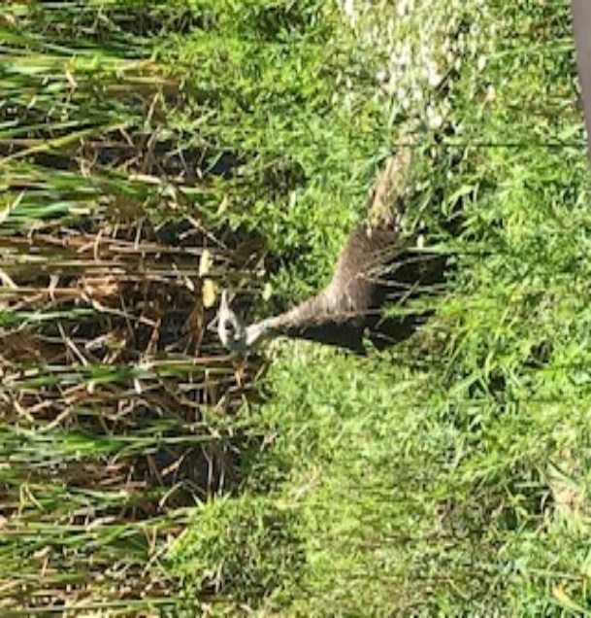As an APPCN member program, VA Maine neuropsychology residents get to take a mock written exam for board certification at the end of their first year. There is no passing or failing this mock exam. The benefit is residents get to experience taking an exam like the ABCN written exam. This also allows them to see areas of needed improvement in order to pass the real exam. Information from the mock exam can be used in part to help inform the training goals for the second year of postdoctoral training, but results of the exam are not used punitively (e.g., a lower performance on the mock exam would not cause the resident to fail a rotation or be rated lower in any way). Similarly, mock ethics exams are sometimes woven into group supervision when appropriate and time permits.

**Dr. Caron is sometimes mistaken for Dr. Doolittle. All pictures below were taken from his office window in Lewiston. Pictured: a deer, a wild turkey, and… a gremlin, who is just as interested in residency training at VA Maine (I’m 99% sure).**

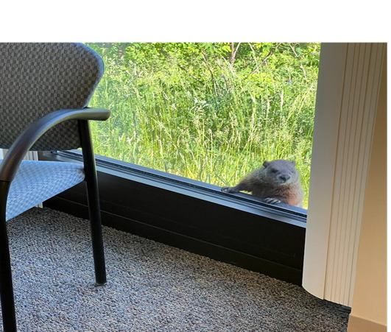

# PROGRAM AIMS AND COMPETENCIES

The program’s aim is to produce neuropsychologists with advanced competencies in adult clinical neuropsychology. At minimum this includes profession wide competencies, brain-behavior relationships, neuropsychological evaluation, neuropsychological intervention, consultation, research, supervision/teaching, and program development. Each training year is broken into two six-month rotations where these competencies are formally evaluated. Residents must achieve specific competency expectations that increase with each rotation. These competency areas are listed below.

## Competency Domains

**General professional competencies**

* Demonstrates knowledge and application of ethics and professional issues in psychology and neuropsychology.
* Uses supervision productively.
* Completes patient care tasks in a timely manner.
* Demonstrates effective social and relational functioning.
* Demonstrates awareness of cultural issues and diversity in professional activities.
* Demonstrates that professional activities are informed by scientific/scholarly literature.

**Brain-behavior relationships competencies**

* Demonstrates knowledge of functional neuroanatomy and neuropsychology of behavior
* Demonstrates knowledge of neurological and related disorders including their etiology, pathology, course, and treatment.
* Demonstrates knowledge of non-neurological conditions and their CNS effects.
* Demonstrates knowledge of neuroimaging, EEG, labs, and other neurodiagnostic techniques
* Demonstrates knowledge of neurochemistry of behavior and psychopharmacology.

**Neuropsychological evaluation competencies**

* Demonstrates information gathering skills.
* Demonstrates knowledge and skills in psychometric theory, test selection, test administration, and specialized neuropsychological assessment techniques.
* Demonstrates competence in the diagnosis of psychiatric disorders.
* Demonstrates competence in interpretation of neuropsychological and psychological tests and diagnosis of neurobehavioral conditions.
* Identifies practical implications and provides appropriate recommendations.

**Neuropsychological intervention competencies**

* Effectively utilizes evidence-based neuropsychological and psychological interventions.
* Demonstrates competence in the adaptation and delivery of interventions to neuropsychological populations.
* Provides effective psychoeducation to patients, caregivers, and/or families.

**Neuropsychological consultation competencies**

* Clarifies referral issues and when appropriate educates referral sources.
* Communicates feedback and practical implications to patients and family members.
* Communicates evaluation results and recommendations to team members and other providers.
* Demonstrates competence in report writing and written communication skills.

**Research competencies**

* Effectively performs lit reviews and evaluates quality of published research
* Effectively selects a research topic.
* Demonstrates skills in research design and statistical analysis.
* Effectively manages IRB procedures, research activities, and research progress.
* Effectively presents and communicates research findings.

**Supervision and teaching competencies**

* Demonstrates skills in the provision of supervision.
* Demonstrates skills in presenting and teaching during didactics, seminars, and case presentations.

**Organization, management, and administration competencies**

* Demonstrates skills in program evaluation and program development.
* Reliably uses the organization’s procedures (e.g., billing codes, leave time, scheduling).
* Effectively represents and promotes neuropsychological services within the VA healthcare system.

# ROTATION AND GRADUATION REQUIREMENTS

## Rotation Requirements

Residents must meet specific competency expectations for the competencies listed on the previous page. These expectations increase after each six-month rotation. Descriptions of competency levels expectations for each rotation are described in the tables below:

Competency Rating Levels

|  |  |
| --- | --- |
| 5 | Expert Competence: Demonstrates a level of competence commensurate with that of an experienced practicing neuropsychologist or board-certified neuropsychologist. Almost all of the routine communication in supervision is from the resident to the supervisor. Supervision is collaborative and collegial and may resemble peer supervision between independent practitioners. There are no significant gap in knowledge or skill in this competency area. |
| 4 | Advanced Competence: Demonstrates a level of competence expected upon completion of the postdoctoral residency. Most of the routine communication in supervision is from the resident to the supervisor. Supervision is typically collaborative, and the resident shows at most only minor gaps in knowledge and/or skills. |
| 3 | Intermediate to Advanced Competence: Competence at a level expected at the completion of the first year of the residency. Routine communication in supervision involves a combination of the resident reporting to the supervisor and the supervisor advising the resident, at times in a directive manner. Some gaps in skills and/or knowledge remain and are a focus of supervision. Competencies at this level during the final months prior to graduation may require a remediation plan. |
| 2 | Intermediate Competence: Competence at a level expected at the beginning of the residency. Supervision is frequently directive, with the supervisor providing frequent extended input during routine supervision. Large gaps in skills and/or knowledge are present and are a major focus of ongoing supervision. Other than within Elective Rotation Competencies (see below), competencies at this level during the second year would require a remediation plan. |
| 1 | Basic Competence: Competence below the level expected at the beginning of the residency. Supervision is very directive, structured, and intensive. Multiple large gaps in skills and/or knowledge are present. Remedial work is needed in this competency area. |

Competency Rating Expectations for each Primary Rotation

|  |  |
| --- | --- |
| YEAR 1  1st Rotation | No competency rating below “2” (Intermediate Competence), with at least 50% of the competency ratings at “3” (Intermediate to Advanced Competence) by the end of the first rotation. |
| YEAR 1  2nd Rotation | No competency rating below “3” (Intermediate to Advanced Competence) by the end of the first year. |
| YEAR 2  1st Rotation | No competency rating below “3” (Intermediate to Advanced Competence), with at least 50% of the competency ratings at “4” (Advanced Competence) by the end of the first rotation. |
| Year 2  2nd Rotation | No competency rating below “4” (Advanced Competence) by the end of the second year. |

In addition to the formal competency rating evaluations at the end of each six-month rotation, supervisors also meet with residents to discuss growth on competencies at the midway point of every rotation. This mid-rotation meeting is used to inform residents about their progress toward expected competencies at the end of the rotation. If there are significant concerns identified at the midway point, a remediation plan is created to help the resident successfully meet the competency expectations by the end of the rotation.

## Graduation Requirements

1. The resident must complete two full years of training, which is defined as a minimum of 1,792 postdoctoral hours per year (3,584 total for the two-year residency). Residents will not graduate without meeting the minimum number of required postdoctoral training hours. We do encourage residents to take leave, and we view leave as a necessary component of self-care and burnout prevention; however, we also want residents to be very careful with their leave hours in the event of unexpected situations requiring extended leave. For that reason, we recommend the resident make sure they leave themselves a “training hours cushion” each year rather than use it all up early and hope nothing goes wrong later. If something unforeseen does happen that prevents the resident from reaching the minimum required training hours, then the resident will have to extend their time in the program beyond the expected graduation date. In other words, the resident will have to make up those training hours before they are allowed to graduate, and the extra time to get those hours will not be covered by their resident stipend in most cases.
2. Ratings must be at or above “Advanced Competence” for all of the competency domains by the end of two-years.
   1. The resident must successfully meet the expected levels of competency for each six-month rotation. If the resident does not successfully meet the expected competency level by the end of a rotation they may still be eligible to graduate as long as the resident is willing to comply with a remediation plan and can demonstrate improved competencies development such that they fully meet expectations by the end of the next rotation. Residents failing to meet competency level expectations for two successive rotations will be dismissed from the training program without graduating.
3. The resident must teach eight Neuropsychology Seminar presentations (three in the first year and five in the second).
4. The resident must author at least one scholarly product (e.g., conference submission, manuscript submission, or comprehensive research presentation).
5. The resident must successfully complete a program development project.

# TRAINING STAFF

## The Clinical Neuropsychology Postdoctoral Residency Supervisors

**(presented in alphabetical order)**

***Stephen L. Aita, Ph.D.***

Clinical Neuropsychologist (Main hospital/Togus VAMC)

Cooperating Clinical Faculty (University of Maine)

Graduate Program: Clinical/Counseling Psychology, University of South Alabama

Internship Program: University of Alabama at Birmingham-Birmingham VA Medical Center Clinical Psychology Internship Consortium, Neuropsychology Track

Fellowship Program: Dartmouth-Hitchcock Medical Center/Geisel School of Medicine at Dartmouth College, Clinical Neuropsychology

Dr. Aita is a fulltime neuropsychology staff member at Togus, and maintains an academic affiliation at the University of Maine.  He is the primary supervisor for the neuropsychology-track intern.  He supervises clinical and research neuropsychological training activities at Togus.  He is in the process of obtaining board certification in Clinical Neuropsychology through the American Board of Professional Psychology (ABPP).  He is committed to providing trainees with an inclusive, collegial, and healthy environment to facilitate learning.  To this end, he sees trainees as “junior colleagues.”  He embraces a culturally and developmentally appropriate style supervision where he meets trainees where they are.  True to his scientist-practitioner professional identity, he is an avid researcher with interests in psychometrics, intra-individual variability, validity assessment (including assessing positive aspects of effort and motivation), executive functions, and non-motor symptoms in movement disorders.  He also embodies a spirit of collaboration, which has led to fruitful ongoing research collaborations in myriad areas such as LGBTQ+ mental health, sociocultural factors in neurodegenerative diseases, and using personality and cognitive markers to predict police officer misconduct (see [https://scholar.google.com/citations?user=1NXalGQAAAAJ&hl=en&oi=ao](https://gcc02.safelinks.protection.outlook.com/?url=https%3A%2F%2Fscholar.google.com%2Fcitations%3Fuser%3D1NXalGQAAAAJ%26hl%3Den%26oi%3Dao&data=05%7C01%7C%7Ce40ba185642e498b2fc208db98714335%7Ce95f1b23abaf45ee821db7ab251ab3bf%7C0%7C0%7C638271384444130984%7CUnknown%7CTWFpbGZsb3d8eyJWIjoiMC4wLjAwMDAiLCJQIjoiV2luMzIiLCJBTiI6Ik1haWwiLCJXVCI6Mn0%3D%7C3000%7C%7C%7C&sdata=O%2FemHxpehazPBblnpulmEZIMJwaybZxKEcW7Lwvs84M%3D&reserved=0) for his complete works).  He serves on the VA Maine Research and Development Committee.  Though much of Dr. Aita’s training occurred in the “Deep South,” he is a Northerner at heart, hailing from New Jersey.  Outside of work, he enjoys spending time with his wife and their busy toddler and even busier labradoodle, watching soccer (go Chelsea!), exploring nature, and painting miniatures.

***Joshua Caron, Ph.D., ABPP-CN***

Director of Training, Neuropsychology Postdoctoral Residency Program (Lewiston CBOC)

Graduate Program: Clinical Psychology (Neuropsychology), University Nevada Las Vegas

Internship Program: University of Miami/Jackson Memorial Hospital, Neuropsychology Track

Fellowship Program: Memphis VAMC, Clinical Neuropsychology

Dr. Caron is a board-certified clinical neuropsychologist at the Lewiston CBOC and the Co-Director of Clinical Training for the Neuropsychology Postdoctoral Residency Program. He serves on several committees at VA Maine to include Vice-Chair of the Research and Development Committee, VA Maine Strategic Planning Committee, Psychology Training Committee, and the Psychology Training Advisory Board. He has authored or co-authored book chapters on neuropsychological training in the VA, forensic neuropsychology, forensic geropsychology, and the quantitative process approach. His past research explored classification rates for embedded measures of performance validity. Dr. Caron is a native Mainer (pronounced, “Maine-ah”) who was in the Army before becoming a neuropsychologist. Most of his family are veterans who receive care at VA Maine. Thus, he is committed to making the training program at VA Maine a premier site, and he is dedicated to making sure Maine veterans receive the best care in the world. He is equally committed to creating a welcoming, supportive, and inclusive culture within the training program. One fair warning about him though, he is also one of those annoying, knuckle-dragging, New England sports fans.

***Katherine Charpentier, Psy.D.***

Graduate Program: American School of Professional Psychology at Argosy University, Southern California

Internship Program: Montana VA Healthcare System

Fellowship Program: VA Maine Neuropsychology Postdoctoral Residency Program

Dr. Charpentier is a fulltime neuropsychology staff member at the Lewiston CBOC and is a supervisor for the neuropsychology residency program. Dr. Charpentier’s clinical interests include dementia evaluations, multicultural considerations in assessment, and diversity/inclusion and social justice issues in psychology. Her previous research activities include investigations of personality structures in patients with chronic pain, and exploring MMPI-2-RF elevations in ADHD. She is active in several committees, including the VA Maine Psychology Training Committee, the VA Psychology Training Council Model Curriculum Committee, Psychology Training and Advisory Board, and is the continuing education coordinator for the Cultural and Diversity Neuropsychology network. Outside of the VA, she serves on the executive board of the Queer Neuropsychological Society. Dr. Charpentier is a native New Englander who enjoys traveling.

***Christine Ramsay, Ph.D.***

VA Maine Psychology Lead, Neuropsychology Clinics Coordinator

Graduate program: University of Connecticut

Internship Program: Boston VAMC/Tufts University School of Medicine Predoctoral Internship Consortium

Fellowship Program: Boston VAMC/ Boston University School of Medicine

Dr. Ramsay has a longstanding interest in the science of brain and behavior relationships. She earned a Bachelor’s degree in Neuroscience (contract major) from Williams College before working at the Boston VA as a research assistant in the Language in the Aging Brain laboratory. She then returned to graduate school to obtain a professional degree which would allow her to practice clinical neuropsychology. During that training, her research interests and clinical experiences expanded to include autism and other neurodevelopmental disorders, hypnosis, neurotoxic chemical exposure, and aphasia. She also was indoctrinated into the Boston Process evaluation approach. Dr. Ramsay then worked in private practice in southern Maine for almost ten years while raising her children before returning to the VA system. Dr. Ramsay has been practicing neuropsychology at VA Maine with an appreciation to lifespan considerations and functional implications since 2011. She has served in Mental Health Administration as the Psychology Lead since 2020.

## The Hall of Fame: Current and Past Clinical Neuropsychology Residents

2023-2025 Michael Broggi, Ph.D.

2022-2024 David Austin, Psy.D. and Emily Montgomery, Psy.D.

2021-2023 Eli Dapolonia, Ph.D. and Sarah Knapp, Ph.D.

2020-2022 Amy Albright, Ph.D. and William Otero, Ph.D.

2019-2021 Anthony Paul Andrews, Ph.D.

2018-2020 Jillian Keener, Psy.D. and Yesenia Serrano, Psy.D.

2017-2019 Sarah Schubmehl, Psy.D.

2016-2018 Steven Erickson, Psy.D.

2015-2017 Katherine Charpentier, Psy.D.

# LIVING IN MAINE

Maine is a true paradise for those who love the outdoors, and VA Maine facilities are within easy driving distance to mountains, lakes, rivers, and seacoast. Much of Maine is rural, so if missing the big city, it is possible to drive to Boston in about 2-3 hours, Montreal in about 4-5 hours, and Quebec City or New York city in about 5-6 hours. Of course, Portland, Maine is the best little city anywhere, so there really isn’t any need to go anywhere else. Maine is also an incredible foodie destination with world-renowned chefs using locally sourced foods in their culinary masterpieces. There are more local breweries, wineries, distilleries, pubs, restaurants, and farmer’s markets, farm stands, and farm coops than anyone could visit in a lifetime. The cost of living varies A LOT based on where you live (coastal/waterfront vs. inland/rural), and ranges from absurd to reasonably affordable. Central Maine, where the training program is located, is generally comparable to, or slightly less than, the average cost of living for the rest of the country. Unfortunately, a shortage of available houses and rental units is a real problem in Maine, so if you match here please start your housing search early. The program strongly encourage you to visit the links below to learn more about living in Maine and what it has to offer. Additional links are provided to help learn about cost of living and assistance with housing searches.

[**www.visitmaine.com**](http://www.visitmaine.com)

[**https://www.discovernewengland.org/about-new-england/new-england-states/maine**](https://www.discovernewengland.org/about-new-england/new-england-states/maine)

[**https://en.wikipedia.org/wiki/Maine**](https://en.wikipedia.org/wiki/Maine)

[**https://curlie.org/Regional/North_America/United_States/Maine**](https://curlie.org/Regional/North_America/United_States/Maine)

[**Cost of Living in Maine | The True Cost to Live Here | UpNest**](https://www.upnest.com/1/post/cost-of-living-maine/#:~:text=The%20median%20rent%20in%20Maine%20is%20%24853%20per,numbers%20may%20be%20higher%20than%20the%20Census%20figures.)

[**Cost of Living in Maine, 2022 (apartmentlist.com)**](https://www.apartmentlist.com/renter-life/cost-of-living-in-maine)

[**What Is the Cost of Living in Maine? - SmartAsset**](https://smartasset.com/mortgage/what-is-the-cost-of-living-in-maine)

[**Apartments for Rent in Maine | Apartment Finder**](https://www.apartmentfinder.com/Maine?gclid=3a306d104fa519aeb30e0fd5c2b44128&gclsrc=3p.ds&frontdoor=msn&msclkid=3a306d104fa519aeb30e0fd5c2b44128)

[**Average Rent Prices and Market Trend in Maine — Point2 (point2homes.com)**](https://www.point2homes.com/US/Average-Rent/ME.html)

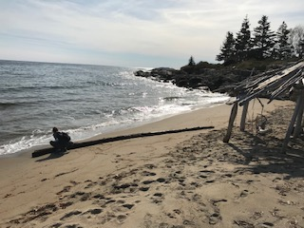

**The two pictures above were taken by Dr. Caron at Reid State Park.**

**Left to right: Heritage Park in Lewiston, Maine, taken across the Androscoggin River; Simard-Payne Park in Lewiston.**



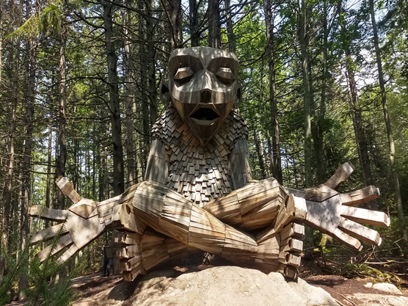

**Giant Troll sculpture by artist Thomas Dambo, displayed at Maine Botanical Gardens in Boothbay, ME.**