Cincinnati VA Pharmacy
Residency Program Directors, Leadership, and Preceptors

Residency Program Directors

Tina M. Hamilton, PharmD, BCPS
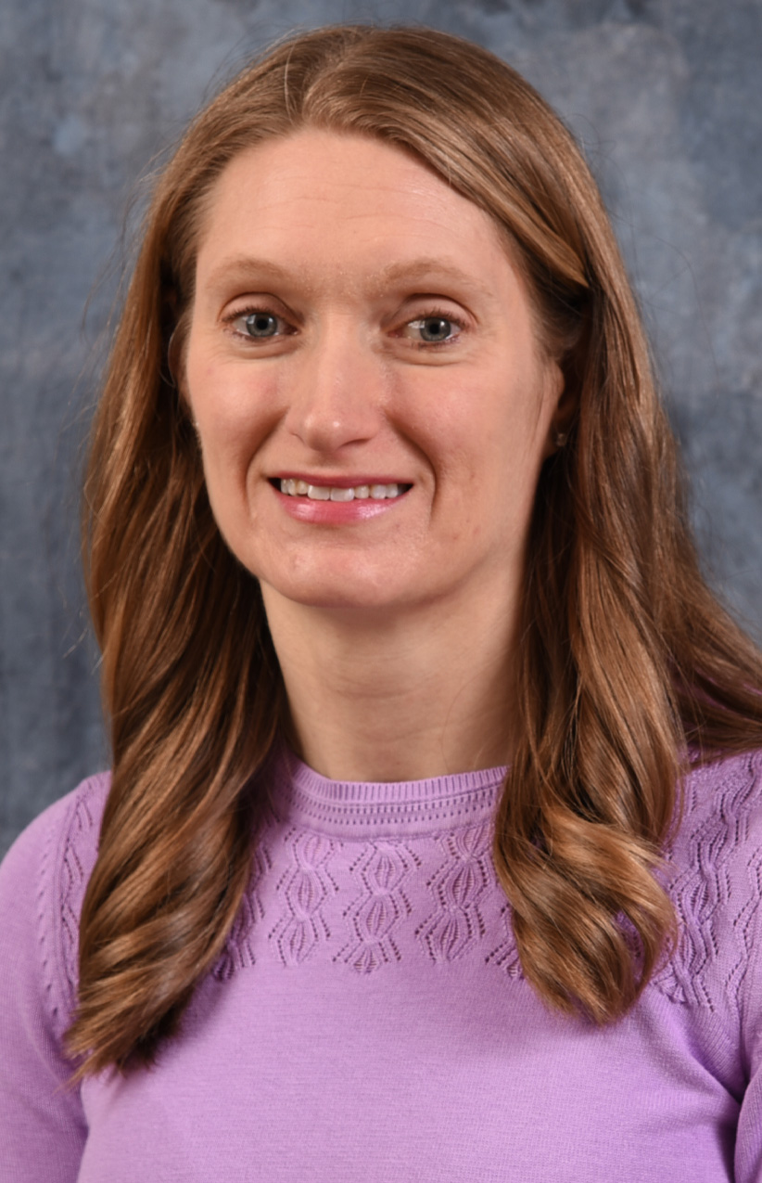
PGY1 Residency Program Director/Primary Care Clinical Pharmacy Specialist

Dr. Hamilton graduated with her PharmD in 2007 from the James L. Winkle University of Cincinnati College of Pharmacy. She then went on to complete a PGY1 residency program at Providence Health and Services in Portland, Oregon. Upon completion of her PGY1 she accepted an ambulatory care clinical pharmacy specialist (CPS) position at the Cincinnati VAMC, where she worked as CPS in primary care, home based primary care, and women’s health until accepting the RPD position in 2018. Her passions include clinical pharmacy services, mentoring, and process improvement.
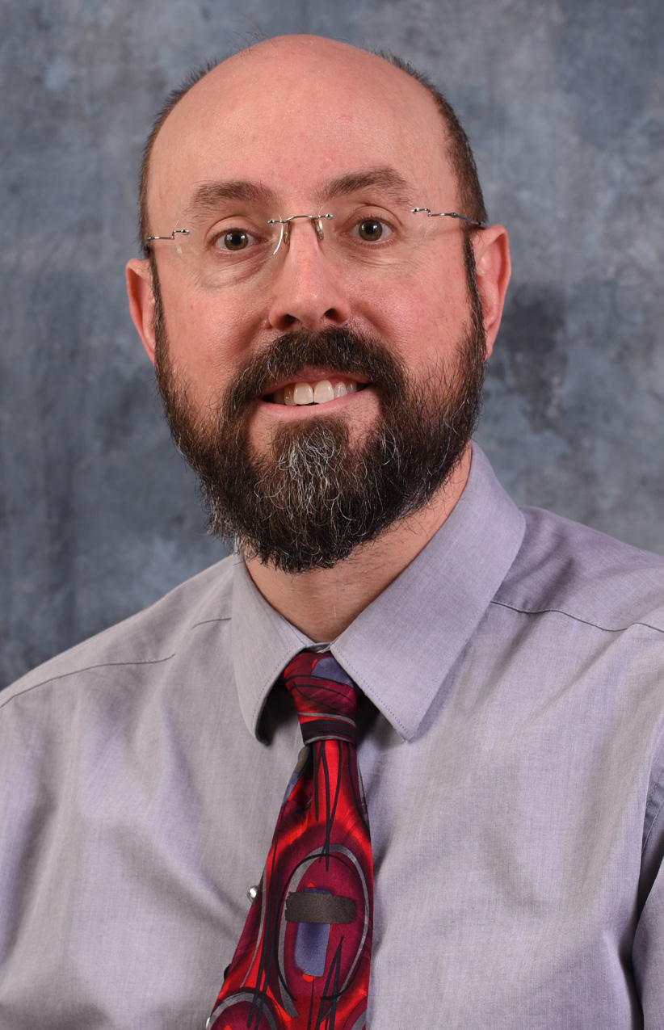
Matthew Brown, PharmD, BCPP, TTC
Psychiatric PGY2 Residency Program Director/Mental Health Clinical Pharmacy Specialist

Dr. Brown graduated from the University of Cincinnati College of Pharmacy in 2008. Following completion of a PGY1 pharmacy residency at the VA Medical Center in Chillicothe, OH he began a career as a clinical pharmacy specialist (CPS) in mental health at the Cincinnati VA. He became the PGY2 psychiatric pharmacy residency program director in 2014. His current practice site area covers outpatient substance use disorders clinic including treatment of opioid use disorders, alcohol use disorder, stimulant use disorder and tobacco use disorder.
Areas of Interest: Geriatric psychiatry, ADHD, medication adherence, motivational interviewing, bipolar disorder, tobacco use disorder and other substance use disorders.

Pharmacy Leadership

Kristen Schmitt: Chief, Pharmacy Service
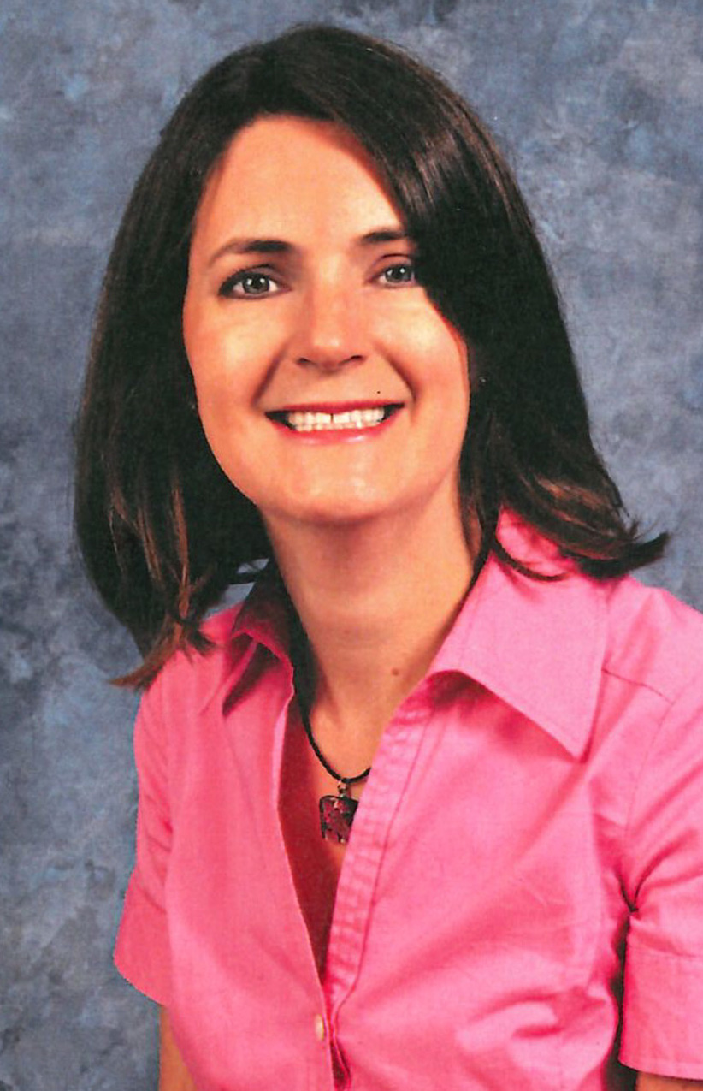
Assistant Adjunct Professor Pharmacy Practice,
James L Winkle College of Pharmacy, University of Cincinnati
Education: Pharm. D., Samford University
Residency Information: Pharmacy Practice, Cincinnati VAMC
Board Certifications: BCPS
Areas of Interest: Administration, , formulary management, quality improvement, academic detailing, resident and student education

Rebecca Brothers: Associate Chief, Clinical Services
Assistant Adjunct Professor Pharmacy Practice,
James L Winkle College of Pharmacy, University of Cincinnati
Education: Pharm. BS. and Pharm. D., University of Cincinnati
Residency Information: Primary Care Residency at
William S. Middleton Memorial Veterans Hospital, Madison, WI
Board Certifications: BCPS
Areas of Interest: Administration, Formulary management/
Pharmacy benefits management, Cardiology, Anticoagulation,
Patient education; Teaching and mentoring of pharmacy residents

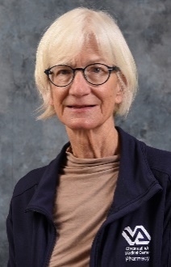
Judy M. Harrer: Associate Chief, Inpatient Pharmacy Services

Assistant Adjunct Professor Pharmacy Practice,
James L Winkle College of Pharmacy, University of Cincinnati
Education: BS Pharm, University of Kentucky; MS University of Cincinnati,
College of Pharm; Ph.D. University of Cincinnati, College of Medicine;
Post-Doctoral Experience: University of Cincinnati College of Medicine
Board Certification: RPh
Areas of Interest: Pharmacy management

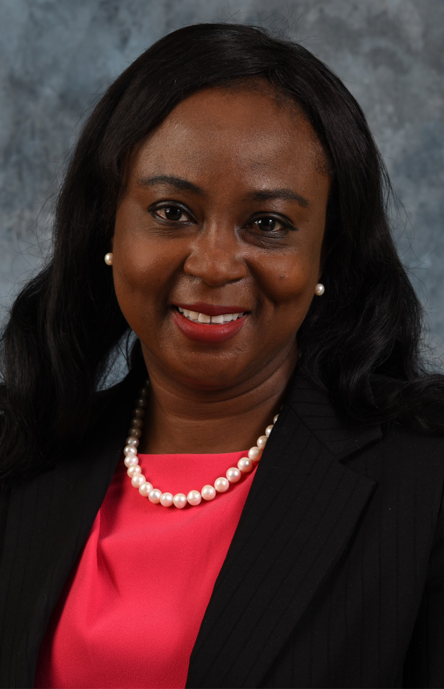
Tolu Onadeko : Associate Chief, Outpatient Pharmacy Services
Assistant Adjunct Professor Pharmacy Practice,
James L Winkle College of Pharmacy, University of Cincinnati
Education: BPharm-University of Ibadan, MSc-Pharmaceutics-Duquesne University, Pittsburgh PA
PharmD- MCPHS, MBA-University of Cincinnati, Linder College of Business
Board Certification: BCGP
Areas of Interest: Anticoagulation, Geriatrics, Pharmacogenomics

Casey Guilfoyle: Pharmacy Supervisor, Outpatient Pharmacy Operations
Assistant Adjunct Professor Pharmacy Practice,
James L Winkle College of Pharmacy, University of Cincinnati
Education: BS Xavier University; Pharm.D. University of Cincinnati
Board Certifications: RPh
Areas of interest: Pharmacy Administration, Staff Development, Teaching and Mentoring of pharmacy students and residents, Quality and Process Improvement
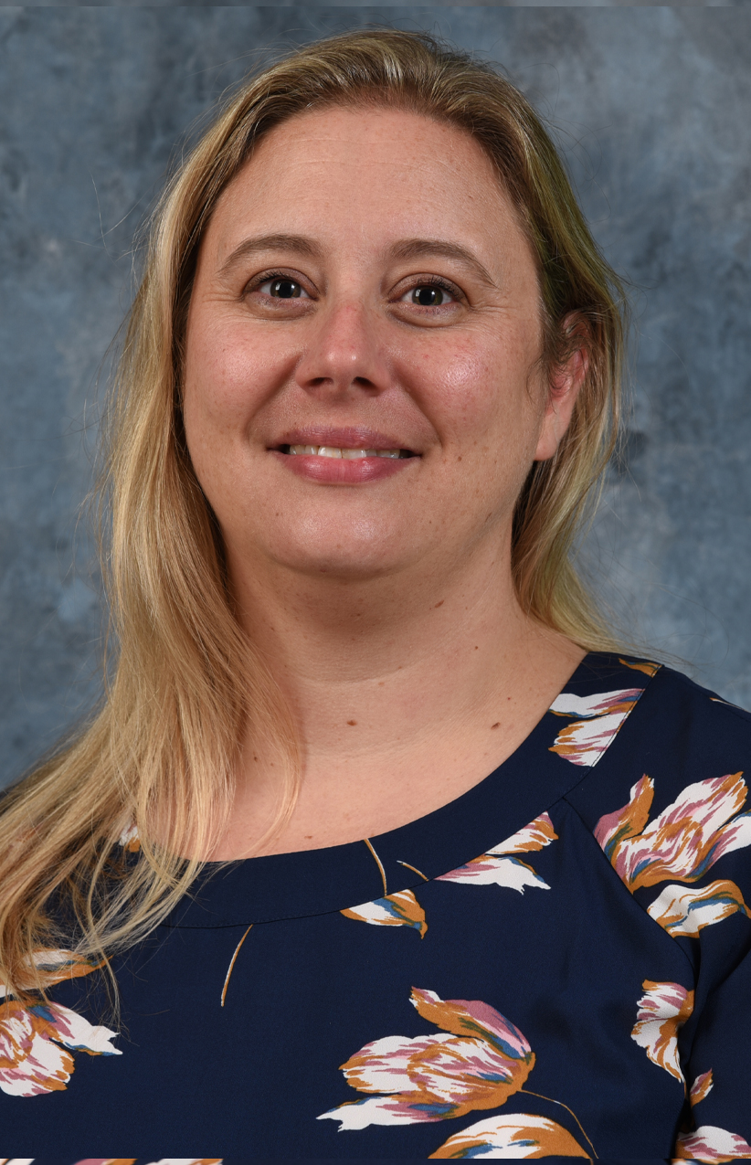

Monica M. Hess: Clinical Pharmacy Specialist, Home Based Primary Care, PACT Pharmacy Manager
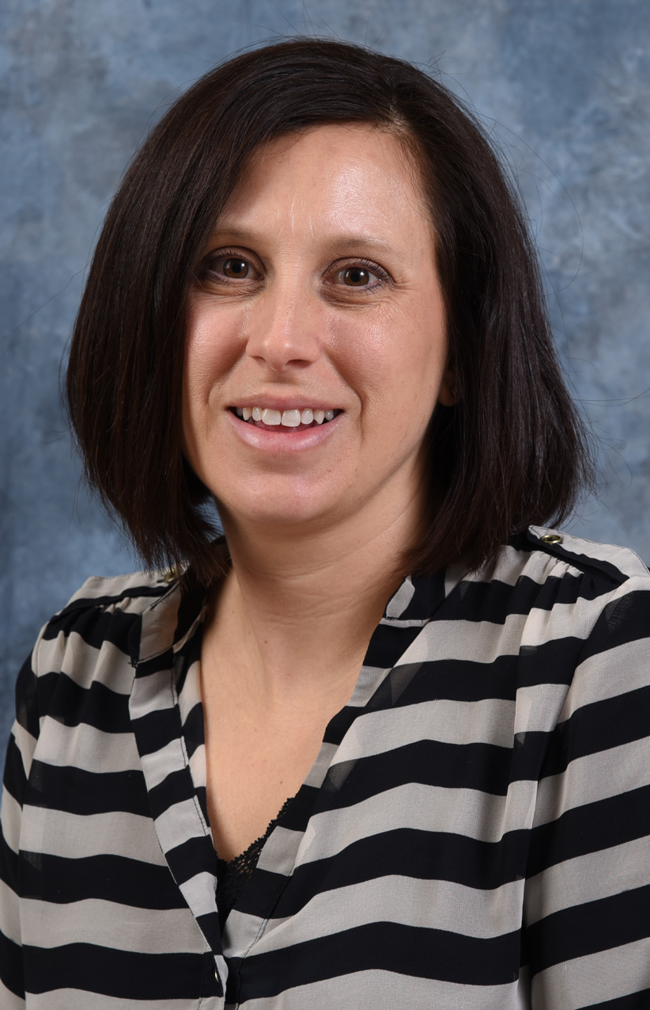
Assistant Adjunct Professor Pharmacy Practice,
James L Winkle College of Pharmacy, University of Cincinnati
Education: Pharm. D., University of Kentucky
Residency Information: Pharmacy Practice, Cincinnati VAMC
Board Certifications: BCPS
Areas of Interest: Primary Care disease state management; Patient and family education, Mentoring students and residents

Jacqueline Dages: Facility PMOP Coordinator (Pain Management, Opioid Safety, and Prescription Drug Monitoring Program)
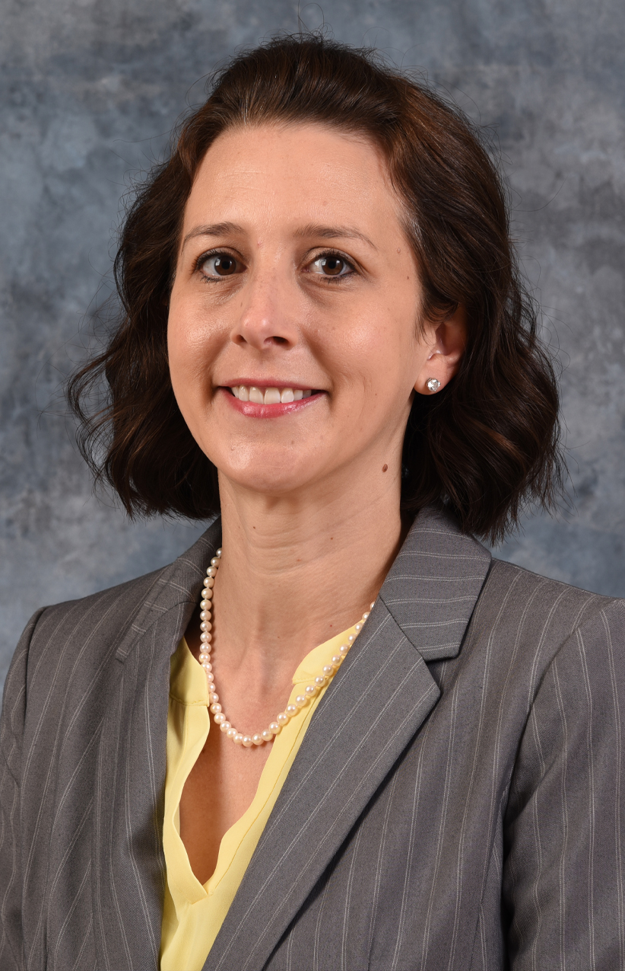
Assistant Adjunct Professor Pharmacy Practice,
James L Winkle College of Pharmacy, University of Cincinnati
Education: Pharm. D., University of Kentucky
Residency Information: PGY1 Pharmacy Practice, Cincinnati VAMC
Board Certifications: RPh
Areas of Interest: Pain management, Primary Care, Administration, Education of patients/family, student and residents, and other healthcare professionals

Pharmacy Preceptors

Stephanie Bahrey: Clinical Pharmacy Specialist, Primary Care
Assistant Adjunct Professor Pharmacy Practice,
James L Winkle College of Pharmacy, University of Cincinnati
Education: Pharm. D. from the Ohio Northern University
Board Certifications: BCACP
Areas of Interest: Primary Care, Pharmacogenomics, Pain

Toebben Bolte: Clinical Pharmacy Specialist, Primary Care, Pain Management, Cardiology
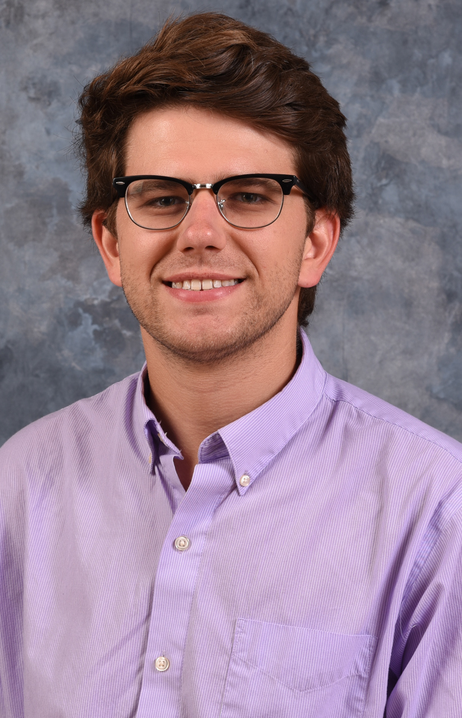
Assistant Adjunct Professor Pharmacy Practice,
James L Winkle College of Pharmacy, University of Cincinnati
Education: BS in Pharmaceutical Sciences, Pharm. D., University of Toledo
Residency Information: PGY-1 Cincinnati VAMC
Board Certifications: RPh
Areas of Interest: Primary Care, Diabetes, Pain Management, Heart Failure Management

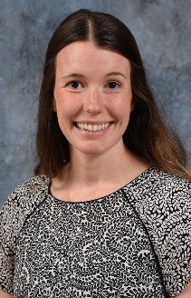
Macey Booth: Clinical Pharmacy Specialist, Primary Care, Women’s Health, Pain Management
Education: Pharm. D., Purdue University College of Pharmacy
Residency: PGY1 Pharmacy Practice – VA Pacific Islands, Honolulu, HI and PGY2 Psychiatry – VA Loma Linda, Loma Linda, CA
Board Certifications: BCPS
Areas of Interest: Primary Care, Women’s Health, Pain, Mental Health

Matthew R. Bradley: Clinical Pharmacy Specialist, Primary Care and Home Based Primary Care
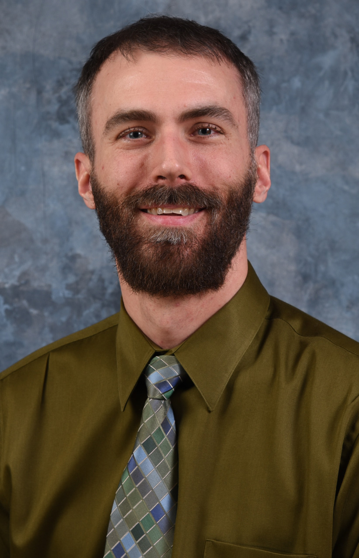
Assistant Adjunct Professor Pharmacy Practice,
James L Winkle College of Pharmacy, University of Cincinnati
Education: Pharm.D., Ohio Northern University
Residency Information: PGY1, Erie VAMC
Board Certifications: BCPS
Areas of Interest: Diabetes, Cardiology, Nephrology, Geriatrics, Quality Improvement, Patient Education
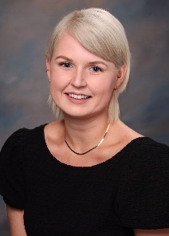
Kacy Chaplin: Clinical Pharmacy Specialist, Mental Health
Education: Pharm.D., Nova Southeastern University
Residency Information: PGY1 Pharmacy Practice & PGY2 Psychiatry, VA Tennessee Valley Healthcare System
Board Certifications: RPh
Areas of Interest: Acute psychiatry, Severe mental illness, Substance use disorders, Indigent population mental health management

Bonnie Clark: Clinical Pharmacy Specialist, Home Based Primary Care
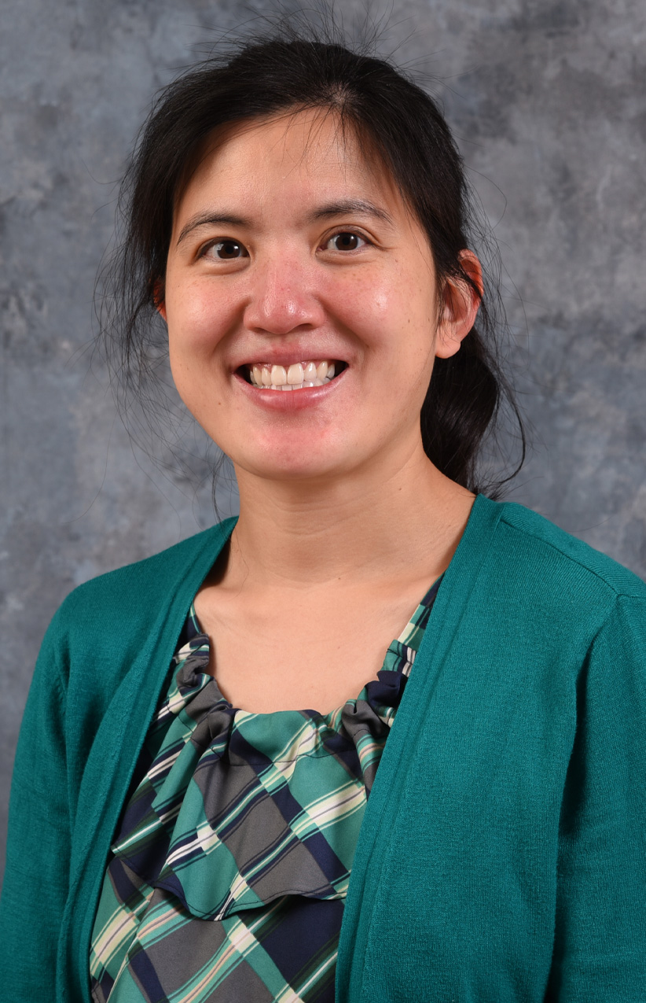
Assistant Adjunct Professor Pharmacy Practice,
James L Winkle College of Pharmacy, University of Cincinnati
Education: Pharm.D. from University of Cincinnati
Residency Information: PGY1 Pharmacy Practice, Cincinnati VAMC
Board Certifications: BCPS
Areas of Interest: Long-term care, Infectious diseases, Primary Care,
Precepting, Mentoring and teaching

Jennifer Curtis: Clinical Pharmacy Specialist, Primary Care, Home Based Primary Care
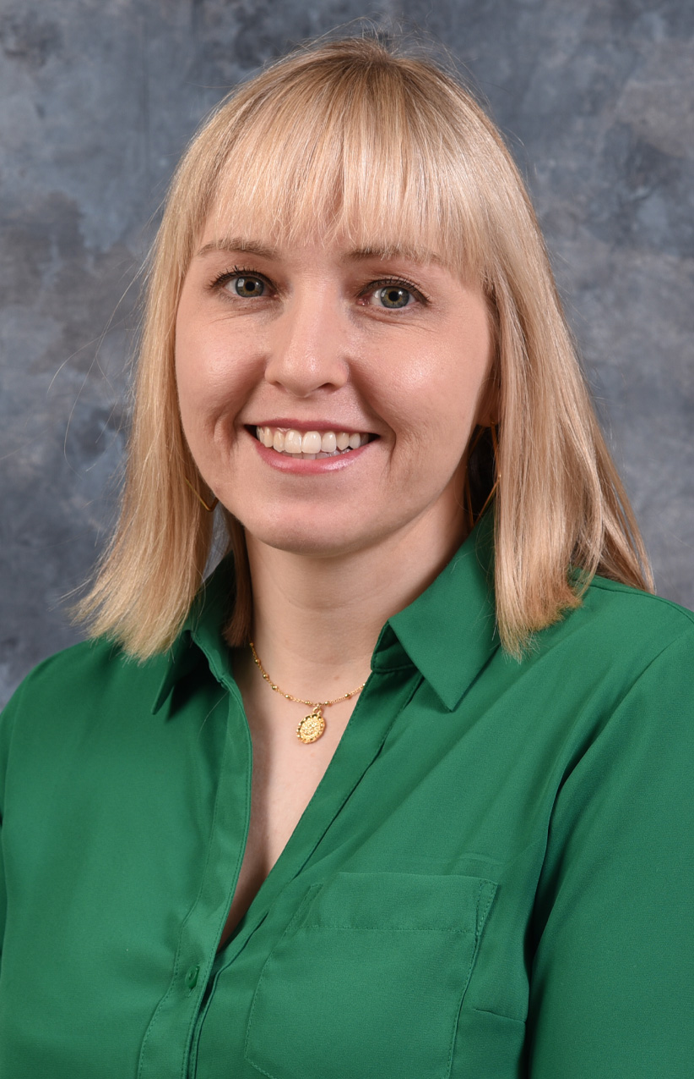
Assistant Adjunct Professor Pharmacy Practice,
James L Winkle College of Pharmacy, University of Cincinnati
Education: BAS Morehead State University, Pharm.D., West Virginia University
Residency Information: PGY1 Pharmacy Practice, Cincinnati VAMC
Board Certifications: BCACP
Areas of interest: Primary Care

Susan Drees: Clinical Pharmacy Specialist, Acute Care, Hem/Onc
Assistant Adjunct Professor Pharmacy Practice,
James L Winkle College of Pharmacy, University of Cincinnati
Education: Pharm. D., University of Cincinnati
Residency Information: Pharmacy Practice, VAMC Cincinnati, Ohio
Board Certifications: BCPS
Areas of Interest: Hematology/Oncology, Acute Care

Beth Fischer: Clinical Pharmacy Specialist, Mental Health
Assistant Adjunct Professor Pharmacy Practice,
James L Winkle College of Pharmacy, University of Cincinnati
Education: Pharm. D., University of Cincinnati
Residency Information: PGY1 Pharmacy Practice, VAMC Cincinnati, Ohio
Board Certifications: BCPS
Areas of Interest: Posttraumatic Stress Disorder (PTSD), Traumatic Brain Injury (TBI), Substance abuse disorders

Tamara M. Hammons: Primary Care Clinical Pharmacy Specialist and Academic Detailer
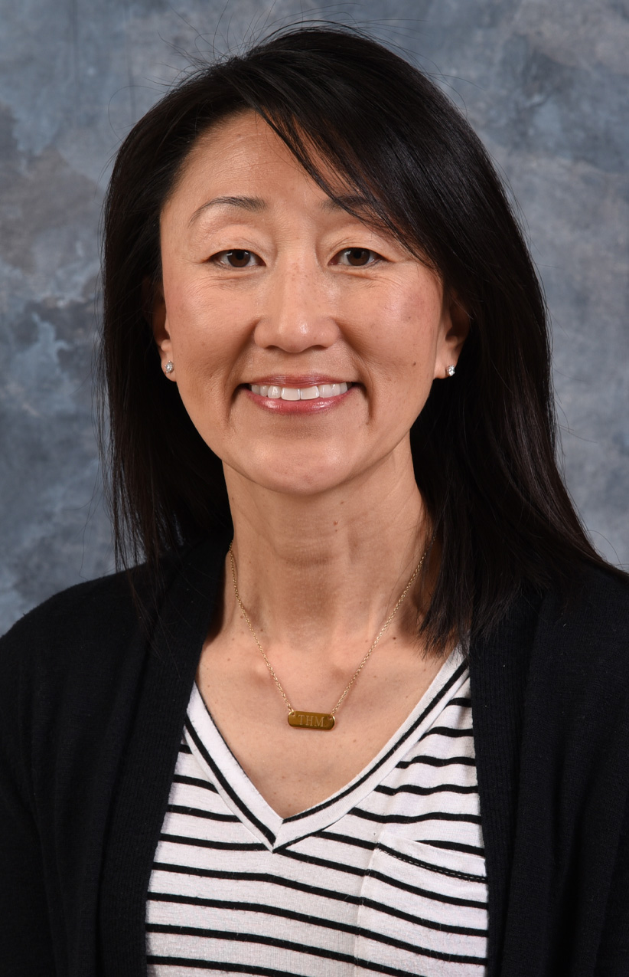
Assistant Adjunct Professor Pharmacy Practice,
James L Winkle College of Pharmacy, University of Cincinnati
Education: Pharm.D., University of Kentucky
Residency Information: PGY1, The University Hospital – Cincinnati, OH
Board Certifications: CDCES, BCPS
Areas of Interest: Diabetes self-management education, Primary Care, Academic Detailing

Jason Hiett: Clinical Pharmacy Specialist, Critical Care
Assistant Adjunct Professor Pharmacy Practice,
James L Winkle College of Pharmacy, University of Cincinnati
Education: Pharm. D. from Ohio Northern University
Residency Information: Pharmacy Practice, University Hospital, Cincinnati, OH
Board Certifications: BCPS
Areas of Interest: Critical care disease state management; Critical care team development and collaborative practice; Teaching and mentoring of pharmacy residents and students; Teaching multidisciplinary critical care team

Jeremy Hilty: Clinical Pharmacy Specialist, Emergency Department
Assistant Adjunct Professor Pharmacy Practice,
James L Winkle College of Pharmacy, University of Cincinnati
Education: Pharm. D., Ph.D University of Cincinnati
Residency Information: PGY1 Pharmacy Practice, Cincinnati VAMC
Board Certifications: BCPS
Areas of Interest: Emergency medicine, Infectious diseases
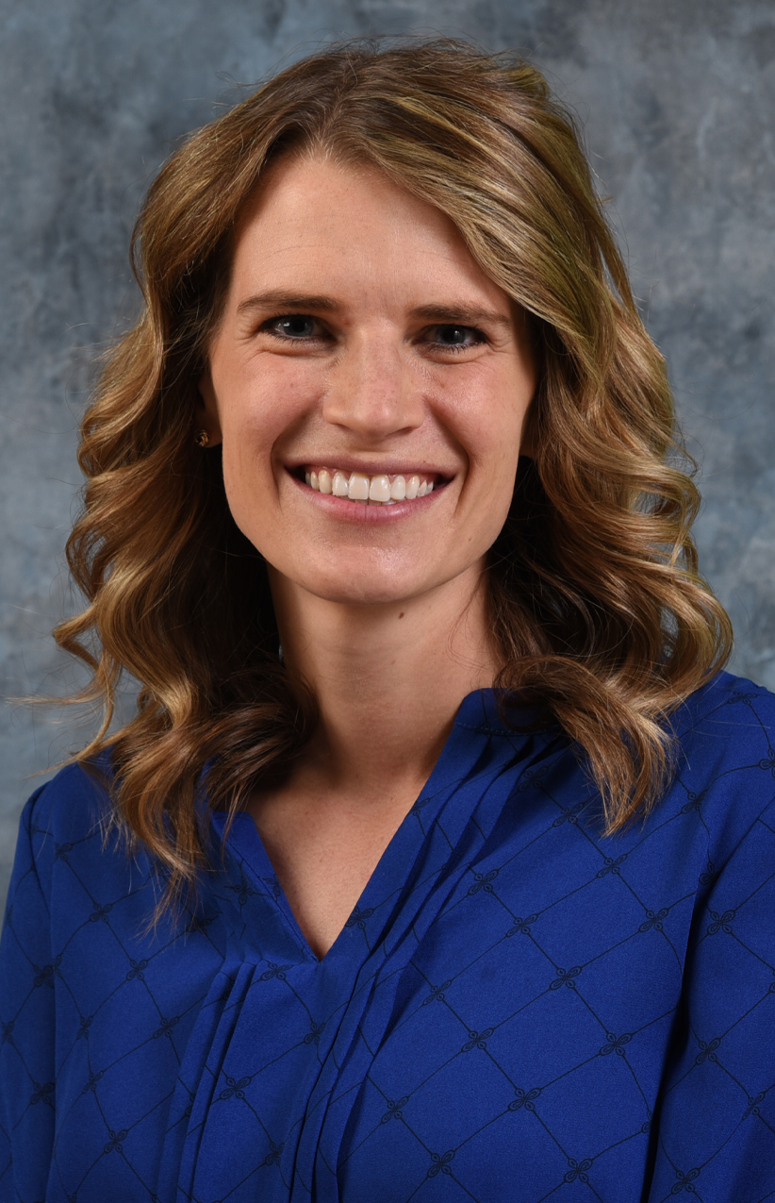

Malorie Hoban: Clinical Pharmacy Specialist, Anticoagulation
Education: PharmD from Ohio State University
Residency Information: Pharmacy Practice, Cincinnati VAMC
Board Certifications: RPh
Areas of Interest: Anticoagulation, Geriatrics, Patient education

Kathy Imhoff-Witt: Clinical Pharmacist Specialist, Ambulatory Care (HIV/Endocrine)
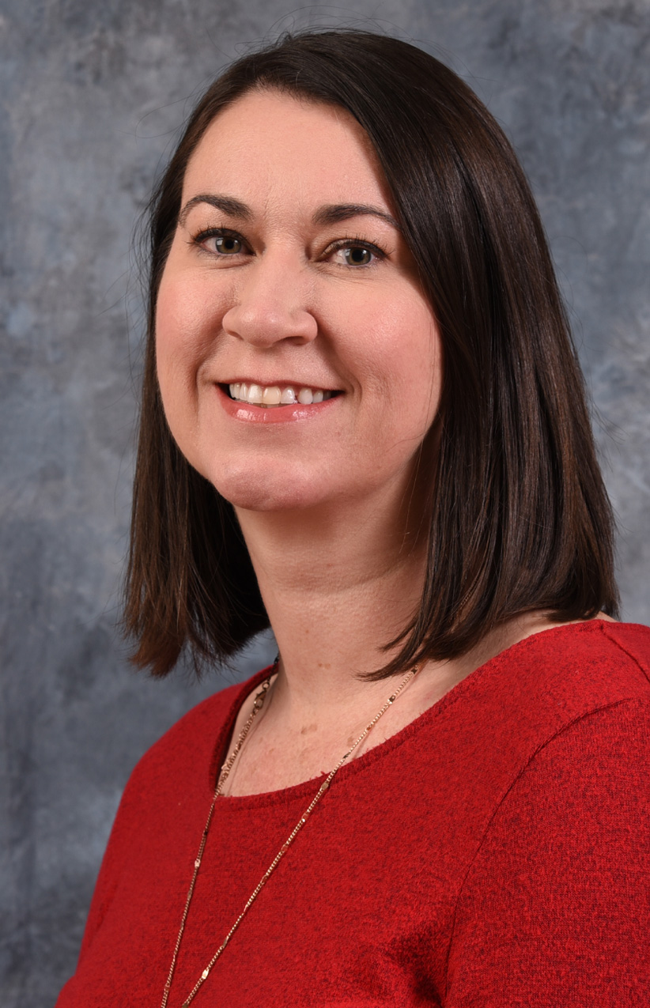
Assistant Adjunct Professor Pharmacy Practice,
James L Winkle College of Pharmacy, University of Cincinnati
Education: Pharm. D. University of Cincinnati
Residency Information: PGY-1 University Hospital, Cincinnati, OH; PGY-2 University Hospital Cincinnati, OH (Specialized in Ambulatory Care)
Board Certifications: BCPS
Areas of Interest: Diabetes and HIV

Catie Meier: Clinical Pharmacy Specialist, Primary Care, Pain Management, Home Based Primary Care
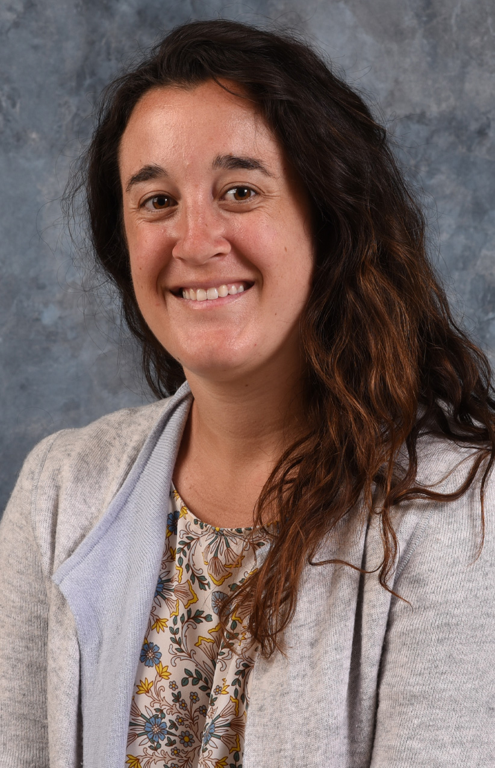
Education: PharmD from the University of Kentucky College of Pharmacy
Residency Information: PGY1 Pharmacy Practice - Lexington, KY VAMC, PGY2 Ambulatory Care - Lexington, KY VAMC
Board Certifications: BCACP
Areas of Interest: Primary Care, Pain Management, Geriatrics, Anticoagulation

Rachel Minrath: Clinical Pharmacy Specialist, Pain Management
Education: PharmD from the University of Kentucky College of Pharmacy
Residency Information: PGY1 Pharmacy Practice - Lexington, KY VA HCS, PGY2 Pain Management and Palliative Care- Lexington, KY VA HCS
Board Certifications: RPh
Areas of Interest: Pain Management, Hospice & Palliative Care, Substance Use Disorders, and Resident and Student Precepting

Krista Noll: Clinical Pharmacy Specialist, Emergency Department
Education: PharmD, Butler University
Residency Information: PGY1 Pharmacy Practice – Southern Arizona VA HCS in Tucson, AZ
PGY2 Critical Care – Malcom Randall VAMC in Gainesville, FL
Board Certifications: BCCCP
Areas of Interest: Emergency Medicine, Critical Care, Acute Care

Natalie O'Toole: Clinical Pharmacy Specialist, Internal Medicine
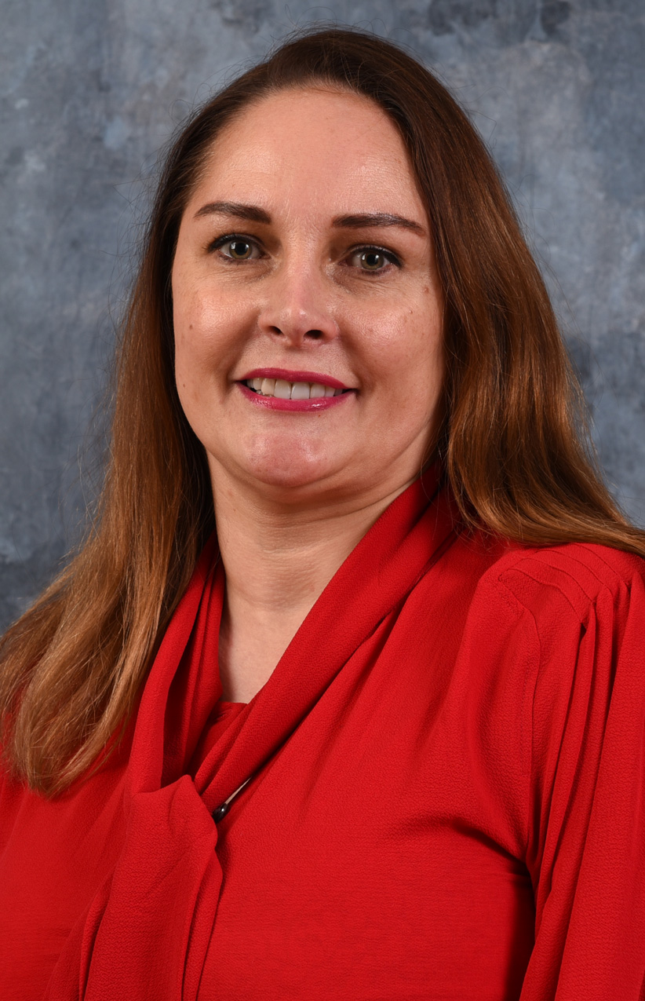
Assistant Adjunct Professor Pharmacy Practice,
James L Winkle College of Pharmacy, University of Cincinnati
Education: Pharm. D., University of Cincinnati College of Pharmacy
Residency Information: Pharmacy Practice, Cincinnati VAMC
Board Certifications: BCPS
Area of Interest: Internal medicine disease states management; patient education; Formulary management; Quality improvement; Resident and student education

Brianne Potter: Clinical Pharmacy Specialist, Anticoagulation
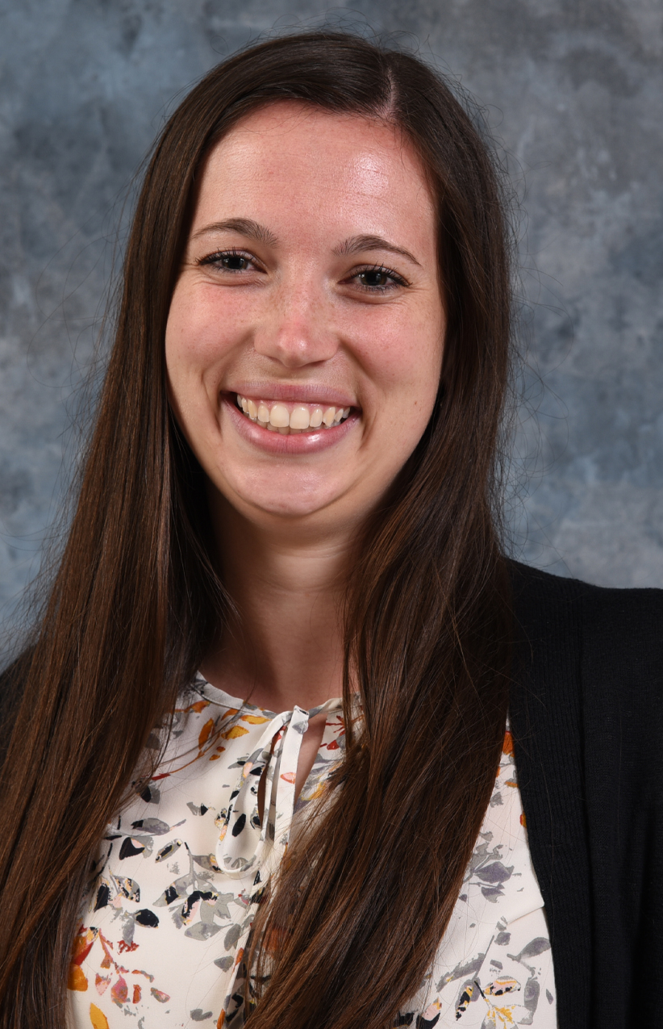
Education: PharmD, Cedarville University
Residency Information: PGY-1 Cincinnati VAMC
Board Certifications: RPh
Areas of Interest: Anticoagulation, Geriatrics, Patient Education

Courtney Ridge: Clinical Pharmacy Specialist, Internal Medicine
Education: Pharm.D., University of Kentucky College of Pharmacy
Residency Information: Pharmacy Practice Residency, Cincinnati VAMC
Board Certifications: RPh
Areas of Interest: Infectious disease, cardiology

Gabrielle Sawyer: Clinical Pharmacy Specialist, Acute Care
Assistant Adjunct Professor Pharmacy Practice,
James L Winkle College of Pharmacy, University of Cincinnati
Education: Pharm. D., Purdue University
Residency Information: Pharmacy Practice, Cincinnati VAMC
Board Certifications: BCPS
Areas of Interest: Hematology/Oncology, Acute care

Kathryn Schmidt: Clinical Pharmacy Specialist, Anticoagulation
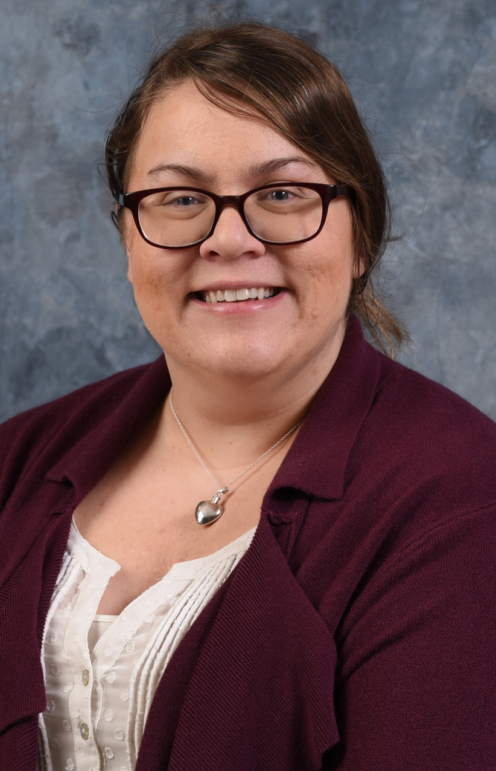
Education: PharmD from Ohio State University
Residency Information: Pharmacy Practice, Cincinnati VAMC
Board Certifications: RPh
Areas of Interest: Anticoagulation, Cardiology, Patient education

Kristen H. Schwetschenau: Clinical Pharmacy Specialist, Primary Care
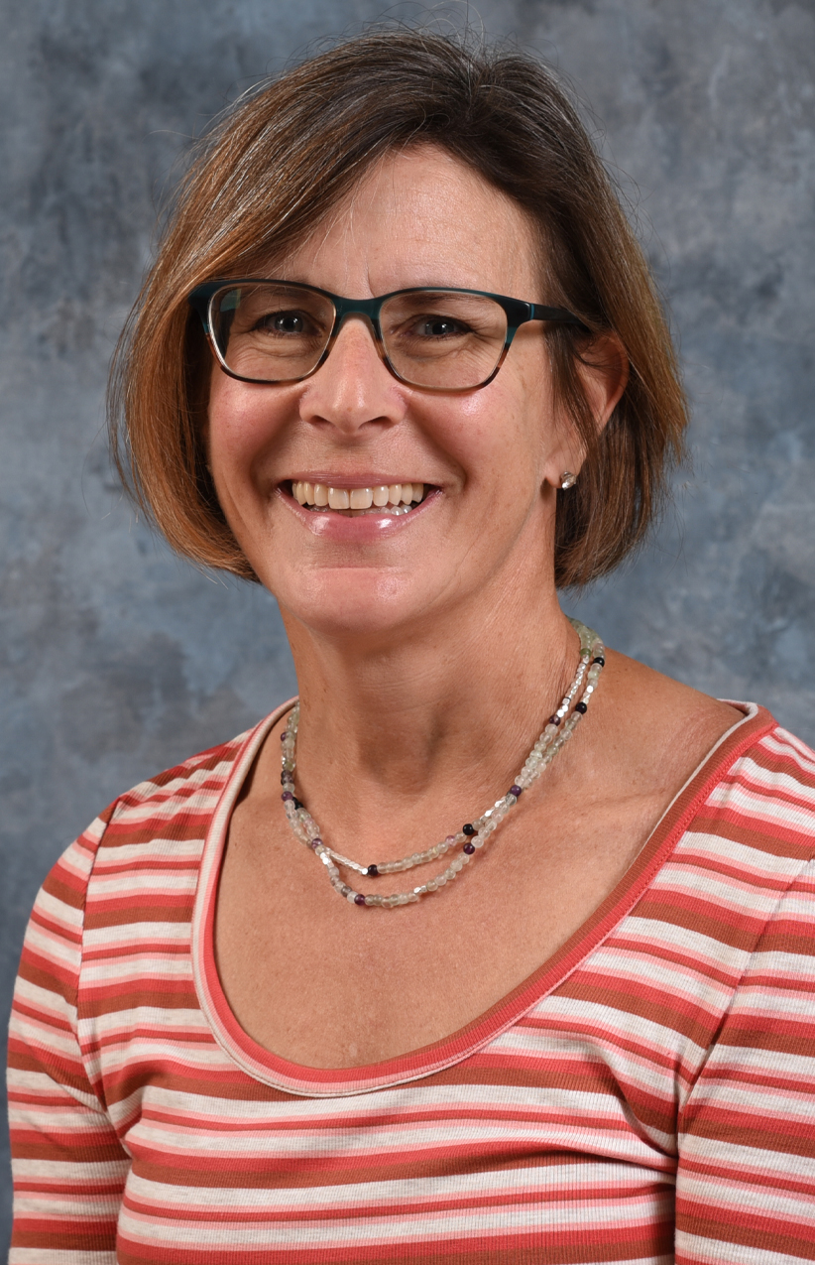
Assistant Adjunct Professor Pharmacy Practice,
James L Winkle College of Pharmacy, University of Cincinnati
Education: Pharm BS, Purdue University; Pharm. D., University of Cincinnati
Residency information: Primary Care Specialty, St Louis College of Pharmacy and John Cochran VAMC
Board Certifications: RPh
Areas of Interest: Comprehensive pharmaceutical care pertaining to disease and medical education; Primary care disease state management; Teaching and mentoring of pharmacy residents and students

Nathan Sexton: Clinical Pharmacy Specialist, Internal Medicine
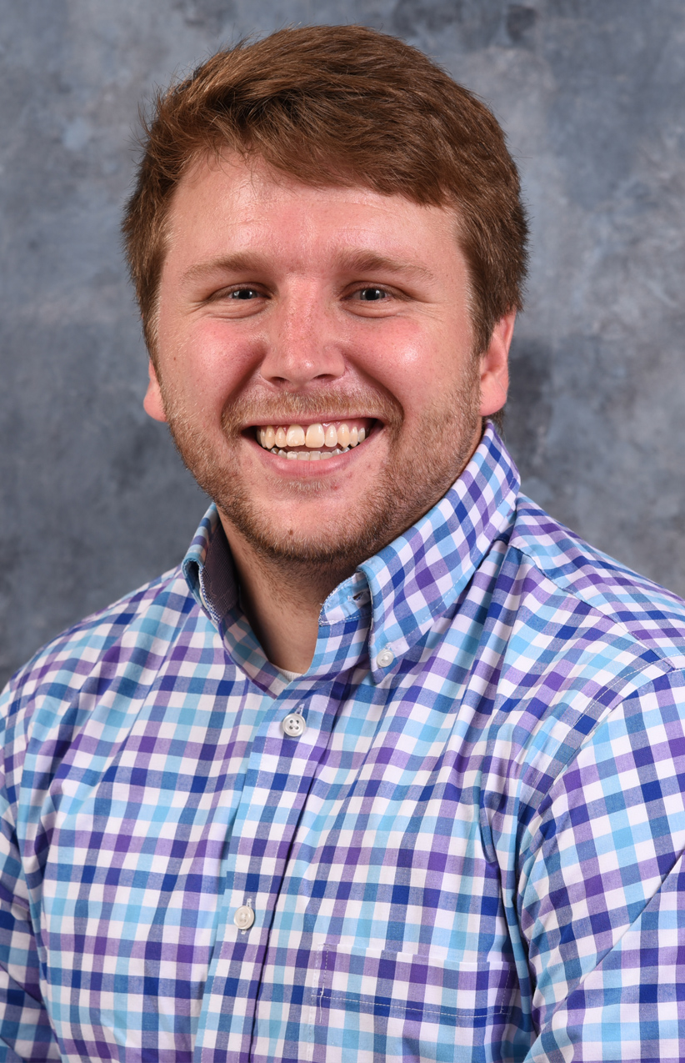
Assistant Adjunct Professor Pharmacy Practice,
James L Winkle College of Pharmacy, University of Cincinnati
Education: BS Northern Kentucky University, PharmD, University of Cincinnati
Residency Information: PGY-1 Pharmacy Practice Residency, Cincinnati VAMC
Board Certification: BCPS
Areas of Interest: Acute Care, Internal Medicine, Infectious Diseases

Dana Short: Clinical Pharmacy Specialist, Anticoagulation; Anticoagulation Program Manager
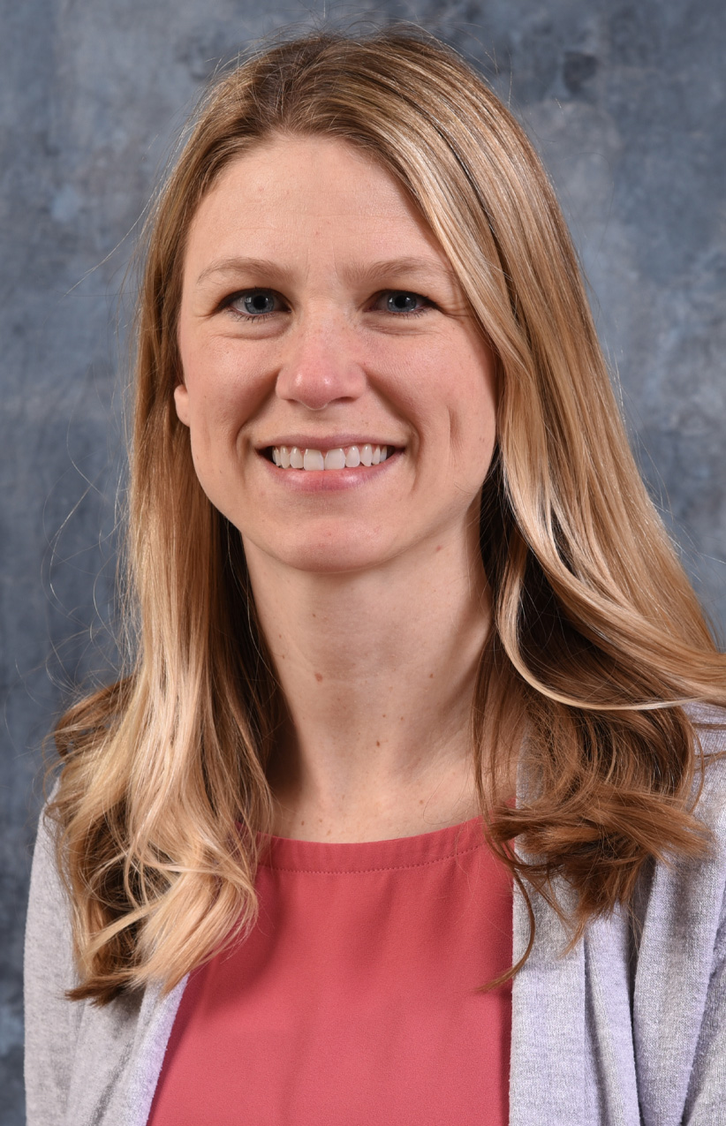
Education: PharmD from the University of Toledo
Residency Information: Pharmacy Practice Residency, Cincinnati VAMC
Board Certifications: BCPS, CACP
Areas of Interest: Anticoagulation, Cardiology, Patient education, Geriatrics, Resident and student teaching

Sarah Sutton: Clinical Pharmacy Specialist, Primary Care and Home Based Primary Care
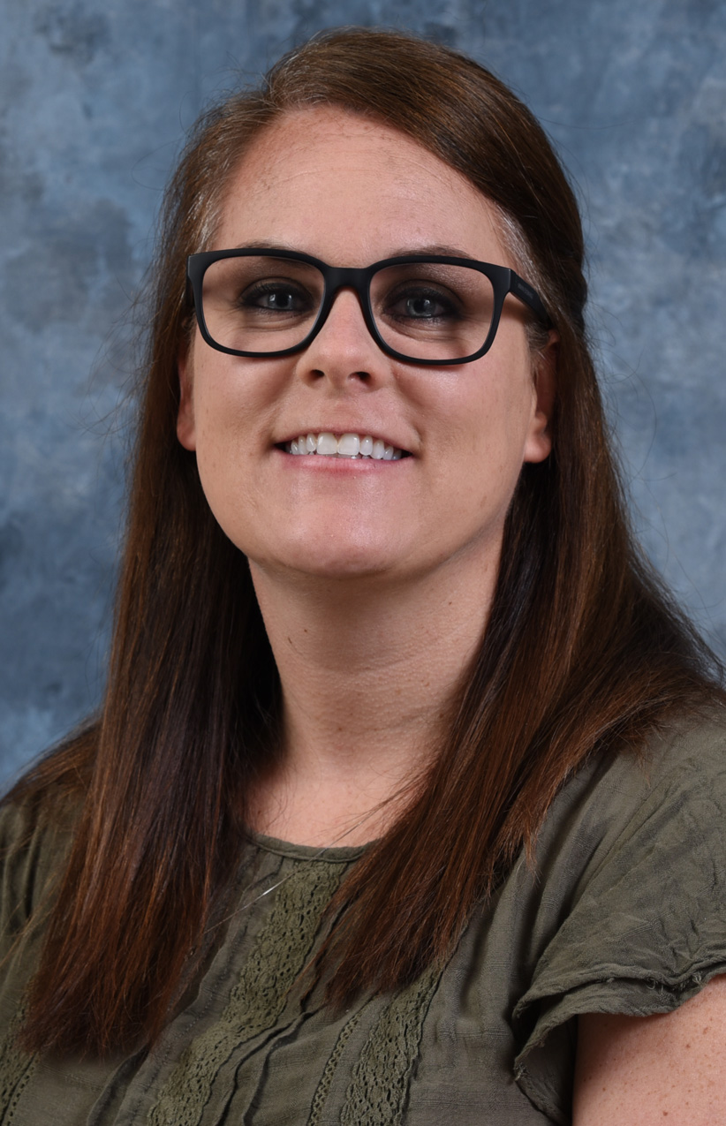
Assistant Adjunct Professor Pharmacy Practice,
James L Winkle College of Pharmacy, University of Cincinnati
Education: Pharm.D., Auburn University Harrison School of Pharmacy
Residency Information: PGY-1 Pharmacy Practice, Central Alabama VAMC
Areas of Interest: Primary Care, Endocrinology

Vickie Tate: Clinical Pharmacy Specialist, SICU
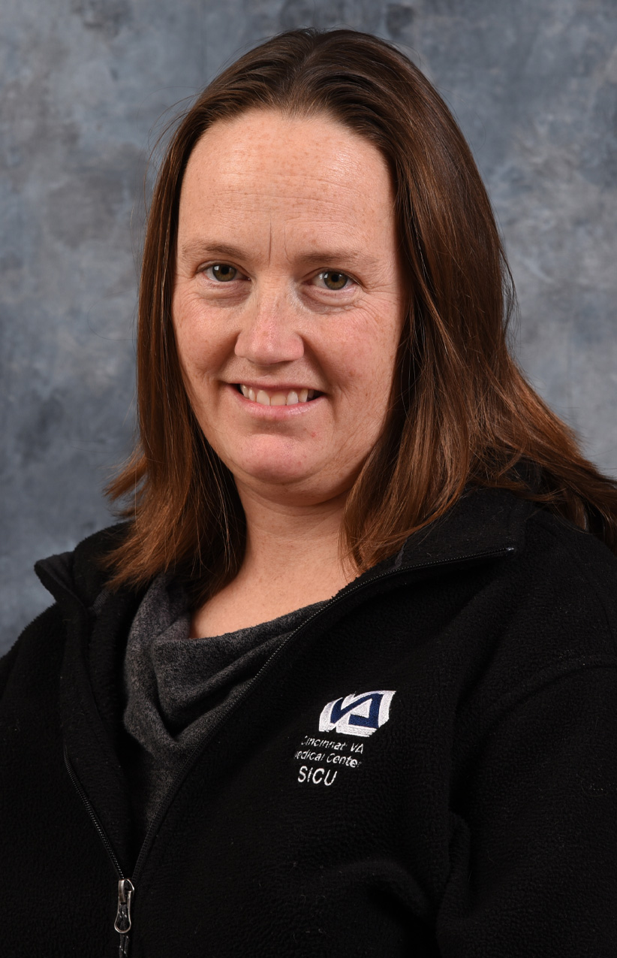
Assistant Adjunct Professor Pharmacy Practice,
James L Winkle College of Pharmacy, University of Cincinnati
Education: Pharm. D., University of Cincinnati
Residency Information: PGY-1 University Hospital Cincinnati, OH; PGY-2 University Hospital Cincinnati, OH (Specialized in Critical Care)
Board Certifications: BCPS
Areas of Interest: Critical Care, Nutrition, Sedation, Infectious disease

Darrow G. Thomas: Pharmacy Informatics Program Manager
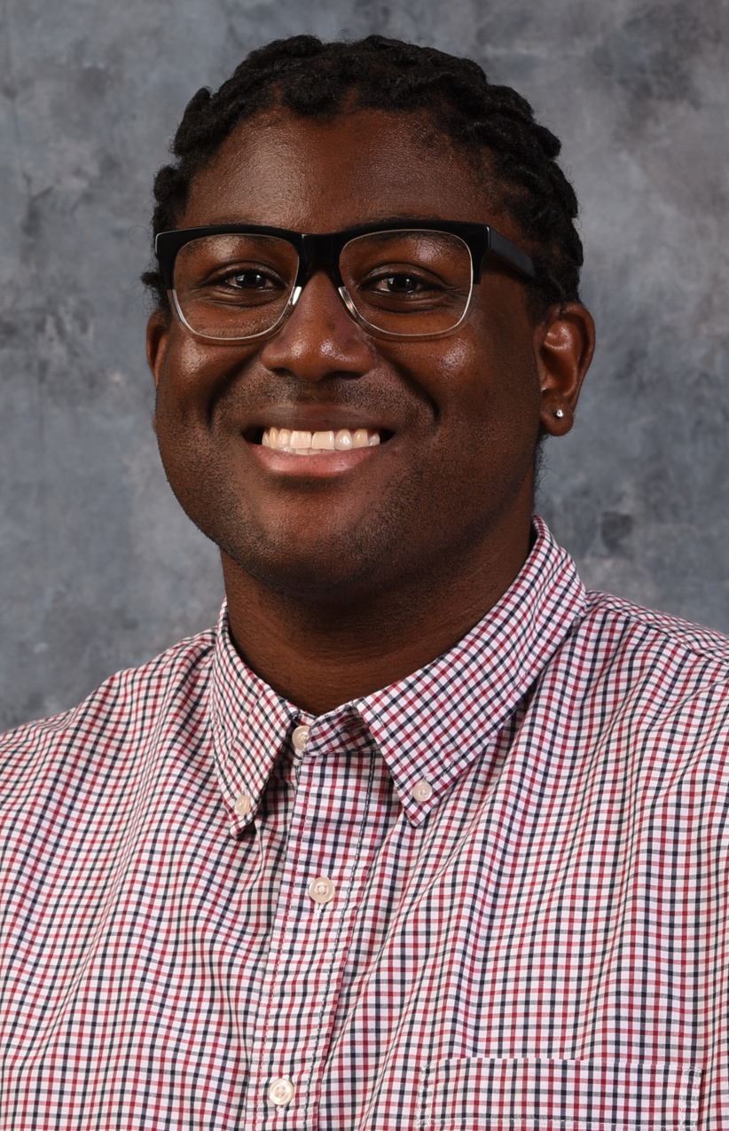
Education: Pharm. D. from Samford University, MBS from Mississippi College, BS from The University of Alabama.
Residency Information: PGY1 – Vanderbilt University Medical Center
Board Certifications: RPh
Areas of Interest: Informatics, Pharmacogenomics, Pharmacy Administration, Staff Development, Teaching and Mentoring of pharmacy students and residents, Quality and Process Improvement

Brittany Tomlin: Clinical Pharmacy Specialist, Community Living Center (CLC)
Assistant Adjunct Professor Pharmacy Practice,
James L Winkle College of Pharmacy, University of Cincinnati
Education: Pharm. D., Ohio State University
Residency Information: PGY-1 Cincinnati VAMC
Board Certifications: BCPS
Areas of Interest: Geriatrics, Long Term Care, Hospice and Palliative care,

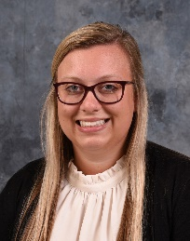
Delaney Wright: Clinical Pharmacy Specialist, Mental Health

Assistant Adjunct Professor Pharmacy Practice,
James L Winkle College of Pharmacy, University of Cincinnati
Education: PharmD, MBA University of Kentucky
Residency Information: PGY1 Pharmacy Practice - Cincinnati VAMC, PGY2 Psychiatry - Cincinnati VAMC
Board Certification: BCPP
Areas of Interest: Depression, anxiety, PTSD, substance use disorders, suicide prevention

