New Mexico Veteran’s Affairs Health Care System
Resident Snapshots

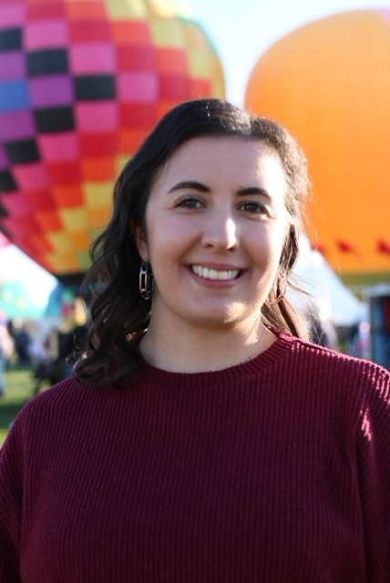 | Jennah is from North Carolina and finished her Master of Science in Public Health and PharmD at Campbell University. Jennah completed her PGY1 Pharmacy Residency at the New Mexico VA Health Care System. She chose the New Mexico VA Health Care System due to the interdisciplinary pain clinic and opportunities to work with palliative care and other unique specialty area. After this year, Jennah is hoping to continue to work in an outpatient, interdisciplinary pain clinic within the VA while precepting students and residents. In her free time, she likes to take her dog for long walks, go hiking, watch sports, perfect family recipes, and explore different food spots all over Albuquerque.
Jennah Badger
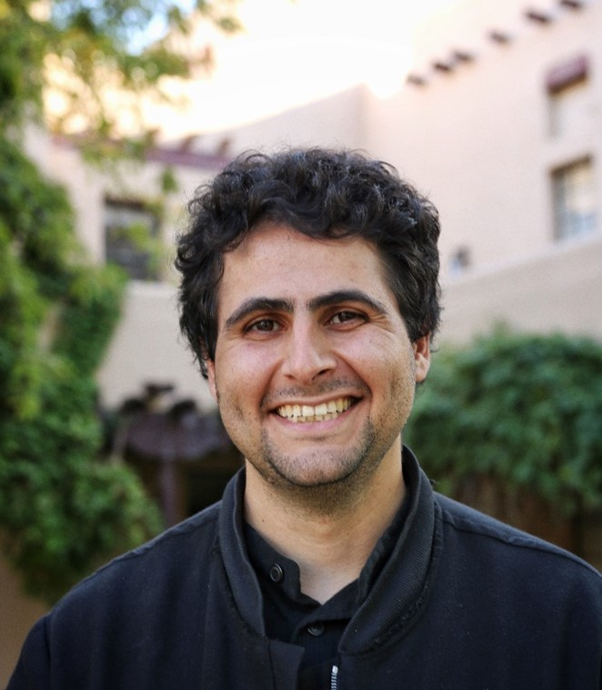 | Nariman "Nari" Piri is a first-year pharmacy resident at NMVAHCS, from Los Angeles, CA. Before relocating to New Mexico, he received his bachelor's from the University of California San Diego in Neuroscience & Physiology and went on to earn his PharmD from the University of California San Francisco. His clinical interests include substance use disorders, psychiatric pharmacy, and pain management. Nari's short-term goals include pursuing a second-year residency in one his areas of clinical interest. His long-term career goal centers on continued service benefitting the Veteran community. In his free time, Nari enjoys all things outdoors, such as biking, hiking, and bird watching. He also enjoys artistic endeavors such as visiting museums, attending art fairs, listening to music, and watching movies.
Nariman Piri
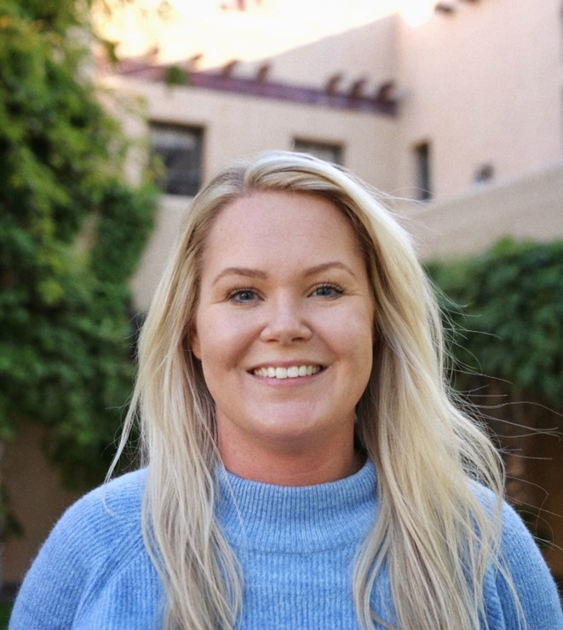  Emily Plunk  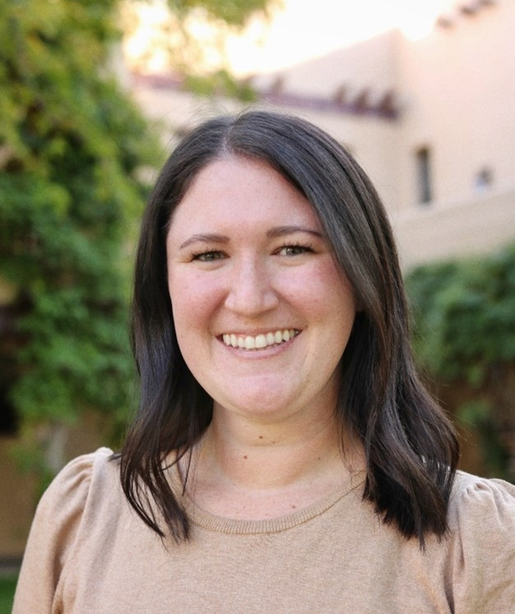  Courtney Pos  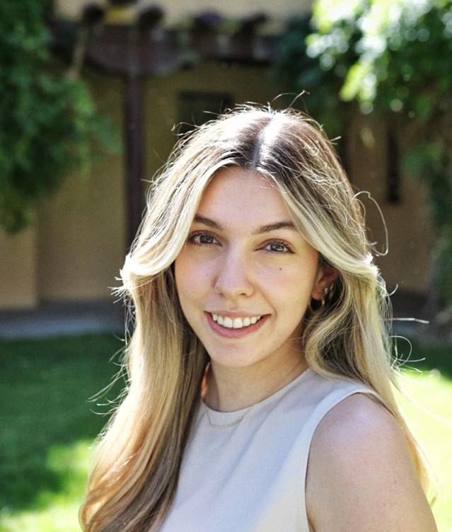  Erena Hovhannisyan Romero  Erena Hovhannisyan Romero is a PGY-1 Pharmacy Resident at the Albuquerque VA Health System. She is originally from Yerevan, Armenia and completed her pharmacy education at the University of New Mexico College of Pharmacy. She is looking forward to fulfilling her goal of becoming a clinical pharmacy specialist in mental health. The US veteran population has a major need for mental health management. Working with and learning from veterans has been a true privilege for Erena. This program has allowed her to work in a multidimensional environment, with focus evenly distributed between ambulatory and inpatient care. She plans to continue her training by pursuing a PGY2 in Mental Health. She is grateful to be working with a program that has invested in her success, provided her with a major sense of community, prioritized a substantial work-life-balance culture, and greatly supported her every endeavor along the way. Aside from residency, Erena enjoys any opportunity to get outside to spend time with her dogs, play golf, and taking any opportunity to ski during the colder months. | Emily Plunk is the PGY2 Psychiatry resident. She is originally from Martin, Tennessee where she graduated from Union University College of Pharmacy. Following graduation, she moved to Wisconsin to complete her first year of residency at Tomah VA Medical Center. She found New Mexico VA Healthcare System to be the perfect fit for her aspirations and moved to the Land of Enchantment. Emily's favorite things about the Albuquerque VA are the people she works closely with and the rabbits that live on campus. In her free time, she enjoys exploring the city, reading, and hanging out with her cats. After PGY2 year, Emily plans to continue working with the VA Healthcare System as a psychiatric clinical pharmacy practitioner.  Courtney is from Chicago, IL and attended pharmacy school at the University of Colorado Skaggs School of Pharmacy and Pharmaceutical Sciences in Aurora, CO. After graduation, she moved to Albuquerque to complete her PGY1 Pharmacy Residency at the New Mexico VA Health Care System (NMVAHCS). What intrigued Courtney the most about the NMVAHCS was the opportunities to work with an interdisciplinary team while gaining experience in both ambulatory care and general medicine. She has a strong interest in geriatrics and ambulatory care and hopes to complete a PGY2 Pharmacy Residency in one of these specialties next year. Her favorite part about Albuquerque so far has been the Balloon Fiesta and trying out different hikes in the area. In her free time, Courtney enjoys hiking, traveling to visit family and friends around the country, attempting to bake at elevation, and painting.

