Meet our VA Leadership

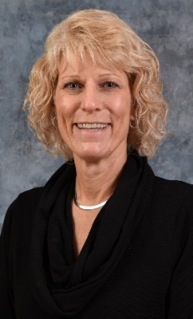
Sandy Stenger MSN, Chief Nurse of Professional Staff Development
17 years with the VA
Master of Science in Nursing, University of Phoenix
Areas of interest: Human Resources, Nursing Recruitment and Retention, Nursing Administration, Staffing and Operations

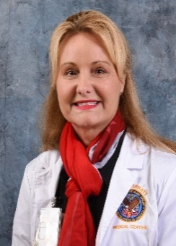
Sara M. Krzywkowski-Mohn EdD, MSN, FNP-BC, Director Nurse Residency Programs
15 years with the VA
Doctorate in Urban Educational Leadership, University of Cincinnati College of Education
Areas of Interest: Health Disparities, Food Insecurity and Adult Learning

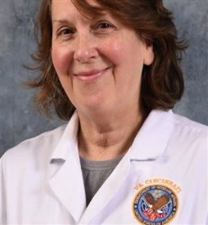
Cindy Childress MSN, MS, BSN, Director Post Baccalaureate Nurse Residency Program
6 years with the VA
Master of Science in Microbiology, Miami University
Master of Nursing Education, Northern Kentucky University
Areas of interest: Microbiology, Evidence-Based Practice, Infectious Disease, Burns, Nutritional Immunity, and Adult Education

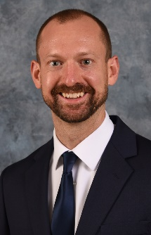
Brian Thesing MSN, Nurse Residency Coordinator
10+ years RN experience, VA team member since 9/2022
Master of Science in Nursing, Mount St. Joseph University
Areas of Interest: Health & Wellness, Pharmacology

PB-RNR Current Resident Bios

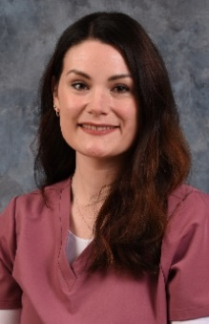
Amanda Brown, University of Cincinnati, BSN
I chose the Cincinnati VA because it is a great workplace that allows me to impact veterans’ health positively and to serve those who have served our country. I have family members who served in the military and the Cincinnati VA PB-RNR residency provides the unique opportunity to rotate through different areas of the VA while serving our country’s veterans.

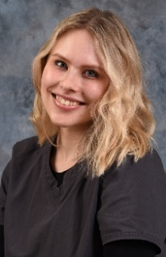
Rachel Gessler, University of Cincinnati, BSN
I chose Cincinnati VA because of the wonderful opportunities and sense of community that it provides. I loved the idea of doing a residency program where I could explore different specialties of nursing as well as work to care for such a unique population. I feel so grateful to be here!

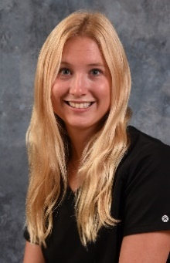
Haley Hall, University of Cincinnati, BSN
I chose the PB-RNR Program at the Cincinnati VA because I love this patient population. Coming from a family full of Veterans has allowed me to feel a purpose. It was also important for me to feel confident in my nursing skills, since being a new nurse. This Residency has allowed me to grow and learn at my own pace. I cannot wait to see the nurse I become at the end of this program!

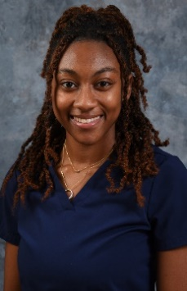
Trinity Patterson, University of Cincinnati, BSN
I decided to come to Cincinnati VA to take advantage of an amazing opportunity presented to me! I can proudly say I don't regret my decision because of the passionate and knowledgeable staff. And of course, because of lovely Veterans who keep me on my toes and constantly smiling.

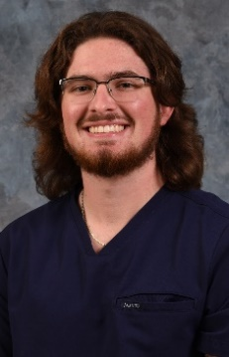
Adam Rosenacker, Xavier University, BSN
I chose the PB-RNR program because I had a burning desire to serve those who have served. I aspire to join the military myself, and I wanted to work with the veteran population to help determine if the military pathway was for me. I completed the VA-STEP program, which allowed me to grow personally and professionally in ways that I could never have imagined. I have been able to share valuable conversations with veterans while providing safe and veteran-centered care, and I wanted to continue my journey at the VA. The VA programs have made me a better person and will make me a more well-rounded nurse in my future career!

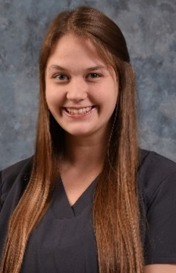
Anna Schultz University of Cincinnati, BSN
I chose the VA to care for those who have served the country. The RN residency offered here at the Cincinnati VAMC allows me to explore the different areas that nursing offers and expand my skills all while serving those who have served. The commitment the VA has to veterans and their families is a commitment I desire to carry with me throughout my career as a nurse.

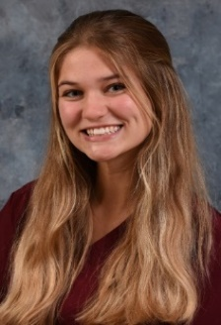
Lauren Spangler, University of Cincinnati, BSN
I chose the Cincinnati VA because I find it an honor to be able to give back to those who served our country. I fell in love with the Nurse Residency Program and the opportunity to gain experience in many different fields and establish connections.

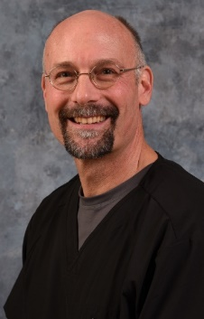
Harry E.M. Brandicourt, University of Cincinnati, MSN
Wonderful opportunity to work in a great hospital and serve our veterans.

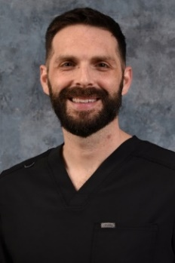
Jesse Raake, University of Cincinnati, MSN
PBNR offers me the opportunity to experience many different aspects of nursing throughout the VA. In addition, it helps guide me into the field and ease the transition into nursing.

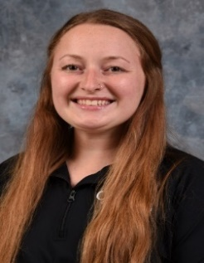
Megan (Byrd) White, Mount St. Joseph University, MSN
I have always wanted to give back to those who gave us our freedom and I feel I can do so by supporting and honoring Veterans as their nurse!

PB-RNR Former Residents Bios
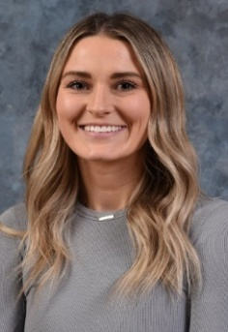
Emily Lundrigan, Northern Kentucky University, BSN
I chose the PB-RNR program at the VA because I knew that it would allow me to gain the knowledge and hands-on experience that I need to become a more comfortable and competent nurse who can make a positive impact on the lives of our veterans.

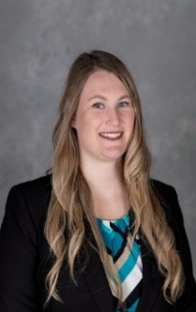
Jacqueline Porter, Northern Kentucky University, BSN
I chose the VA because this is my way to give back to those who have sacrificed so much for our freedom. PB-RNR has given me experience in a multitude of areas and has made me confident in my nursing practice. Everyone at the Cincinnati VA is welcoming, helpful and friendly. I truly am so happy to have decided to enter the VA through the PBRNR program.

PB-RNR Former Residents (pictures only)

Amar Alic Caitlyn Anderson Jeff Boehler
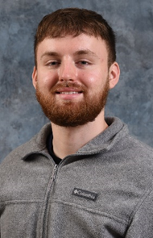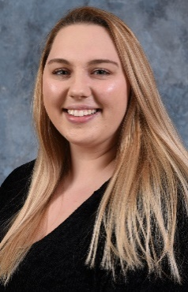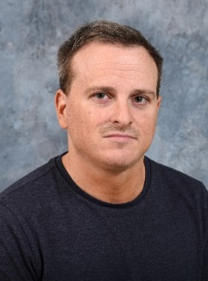

Hilary Chaney Jillian Hacker Tyler Harley
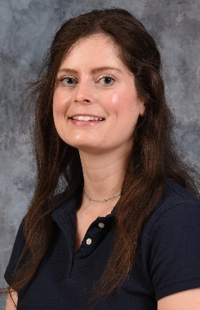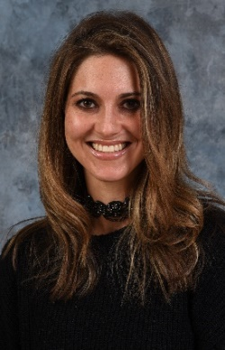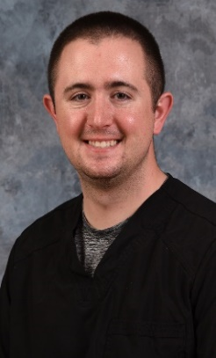

Leah Helbling Kawonda Holland Latasha Landrum
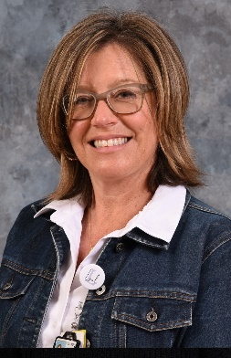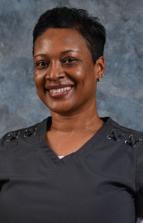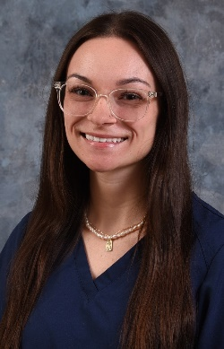

Danielle Marki Casandra Maurer Madeline Okuley
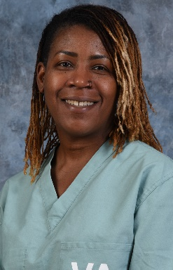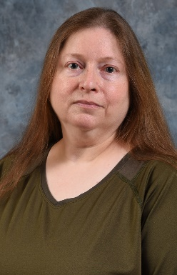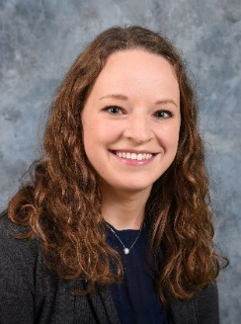

Grant Piccerillo Morgan Reyes Eric Riehle
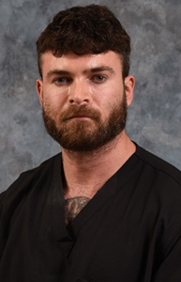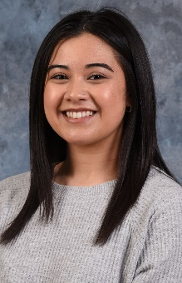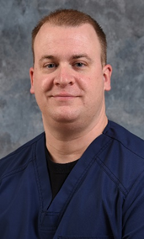

Emily Wilkes Alexis Wood
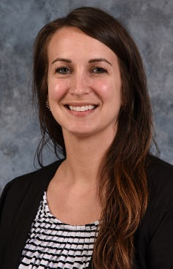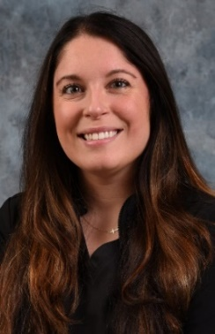

PB-RNR Former Residents (Not Pictured)
Jose’ Carrillo
Merita Dallta
Rudolf Hagedorn
Isabel Limosnero
Chelsea Porter
Ashley Woolridge

