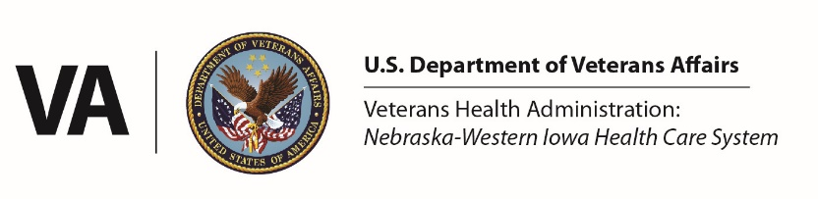
Primary Care NP Residency Application 2024-2025
VA Nebraska-Western Iowa Health Care System
4101 Woolworth Ave.
Omaha, NE 68105

Please complete the application using Microsoft Word, print, and sign. Completed applications and CV’s should be scanned and submitted as a .PDF email attachment. Applicants are encouraged to keep a copy of the completed document for their own records. Submit applications to PATRICIA.HOTALING@UNMC.EDU no later than April 29, 2024. Incomplete and late applications will not be reviewed.

RESIDENCY APPLICATION

Applicant Information
Name: Click here to enter text.
Phone: Click here to enter text.
Current address: Click here to enter text.
City: Click here to enter text. | State: Click here to enter text. |  |  | ZIP Code: Click here to enter text.
Email: Click here to enter text.

Graduate Nursing education
School: Click here to enter text.
City: Click here to enter text. |  |  |  | State: Click here to enter text.
Dates attended: From Click here to enter a date. To Click here to enter a date.
Degree: Choose an item. |  | Honors/Awards: Click here to enter text.
Other graduate degrees/certificates: Click here to enter text.

undergraduate education
School: Click here to enter text.
City: Click here to enter text. |  |  |  | State: Click here to enter text.
Dates attended: From Click here to enter a date. To Click here to enter a date.
Degree: Click here to enter text. |  | Honors/Awards: Click here to enter text.
School: Click here to enter text.
City: Click here to enter text. |  |  |  | State: Click here to enter text.
Dates attended: From Click here to enter a date. To Click here to enter a date.
Degree: Click here to enter text. |  | Honors/Awards: Click here to enter text.

Veteran information
Are you a Veteran or do you have a significant Military Background? |  | If yes, please describe: Click here to enter text.
Are you a current or previous VA employee? |  | If yes, include dates and assignments. Click here to enter text.

VA NWIHCS - experience
Were you a VA NWIHCS trainee or did you complete the majority of your graduate clinical experience at the VA? Choose an item.

Interest statement
Please provide interest statement (no more than two, double-spaced pages) and must clearly address the following:
- Motivation for working with the Veteran population.
- What are your aspirations for a Residency program?
- Level of commitment to a career in the VA Healthcare System
  - Please comment upon your vision and planning for your short and long-term goals.

Letters of reference
Please include three letters of reference (academic instructor, a preceptor and one from a place of employment/co-worker) which include the following:
- A paragraph or sentence explaining how you know the applicant and the nature of your relationship with them.
- An honest evaluation of the applicants’ skills and accomplishments. Try to include specific examples.
- A statement or summary that explains why you would recommend the applicant for the primary care NP Residency.

Letters must be sent from the author via email to patricia.hotaling@unmc.edu by April 29th 2024 to meet the deadline.

Curriculum Vitae
Please include a copy of your most recent CV. This should be included with submission of your completed application in PDF format.

Signature
I do hereby attest that the information in this document is true, accurate, and complete to the best of my knowledge and I understand that any falsification, omission, or concealment of material may result in my application not being considered for review.
Signature: |  |  | Date:

