Insert Agency Logo

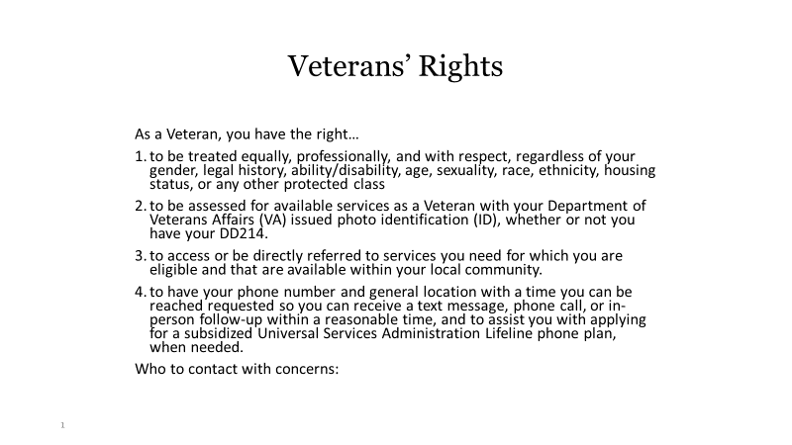

Insert Agency Contact Name, Title, Telephone Number and Email