We are the VA Inaugural Veteran Health Indiana Nurses Conference 2020

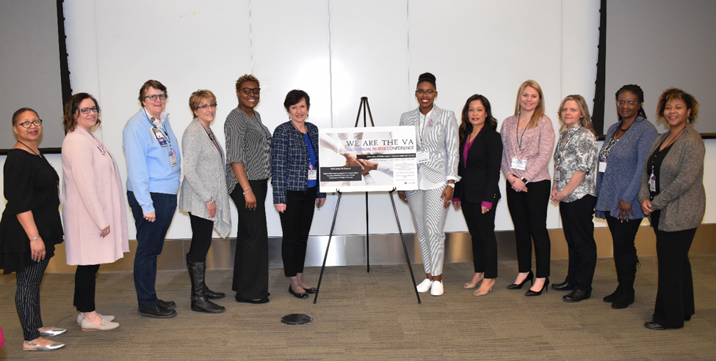
Planning Committee- Left to Right: Donna Mathis, Ginine Klemme, Diane Doty, Jo Lee Coleman, Freda Anthony-Hinkle, ADPCS Christie Artuso, Brandice Terry, Anna Bober, Katlin Jay, Angela Diskey, Brigette Lander, and Candace Whittler-Ducre.

On March 9, 2020 the Richard L. Roudebush VA Medical Center celebrated the Year of the Nurse by hosting the We are the VA Inaugural Veteran Health Indiana Nurses Conference 2020. The focal point of the We are the VA Inaugural Veteran Health Indiana Nurses Conference 2020 was engagement and empowerment of VA nurses from diverse backgrounds utilizing evidence-based practice in the delivery of care to improve Veteran outcomes and experiences. The conference was open to Veteran Health Indiana front line staff nurses and nursing leadership with approximately 80 VA nurses in attendance. Participants defined practice strategies to improve opportunities in clinical practice to promote professional development, engagement, and leadership in alignment with the VA Core Values. Associate Director of Patient Care Services, Christie E. Artuso, Ed.D., RN, FACHE; Indiana Institute for Medical Research Executive Director, Mary Gray, and We are the VA Planning Committee were on hand to open the conference. The keynote speaker, W. Graham Carlos III, MD, Chief of Medicine & Chief of Pulmonary/Critical Care Eskenazi Health spoke about “A Prescription for Positivity”. The focus of the presentation was understanding the scope of the problem of burnout on the medical profession, matching chemical mediators to elements of resilience and positivity, and discovering strategies for educators to foster resilience and positivity in learners. Dr. Carlos highlighted that the healers are hurting. Burnout in medicine (including nursing) has become a major factor leading to depression, anxiety, addictions, and suicide. There was discussion addressing the role hormones can play in the development of burnout and resiliency. During the day, conference participants had the opportunity to attend the We are the VA Evidence Based Practice Poster Exhibition, among various sessions to discuss topics. Topics included: Research, Stroke, Ventilator Associated Events (VAE), Whole Health, Palliative Care, VA Mission Act, and the VA Nurses Impact with each session 45 minutes and CEUs (Continuing Education Units) available for participants. At the end of each session, the attendees participated in a post discussion for brainstorming and networking with presenters to identify barriers and solutions for each topic. Overall, the We are the VA Inaugural Veteran Health Indiana Nurses Conference 2020 was a success! The generous contribution from the Indiana Institute for Medical Research made this event at no cost to Veteran Health Indiana Nurses.

“I just wanted to say how much I enjoyed this conference. It was outstanding and everyone that worked hard to put this together should be very very proud of themselves. The speakers were very good and kept me off my phone. Dr Carlos was exceptionally good and really should be at every conference you do from now on. Actually he should do a TED talk…he is THAT good. Thank you to all of this team that put so much hard work into making this an OUTSTANDING conference.” Teri Weller Sundine BSN, RN, Interventional Radiology.

Author:
Brandice Terry, MSN RN HCSM
Richard L Roudebush VA Medical Center

