APRN Clinical Simulation Educator with SimLEARN

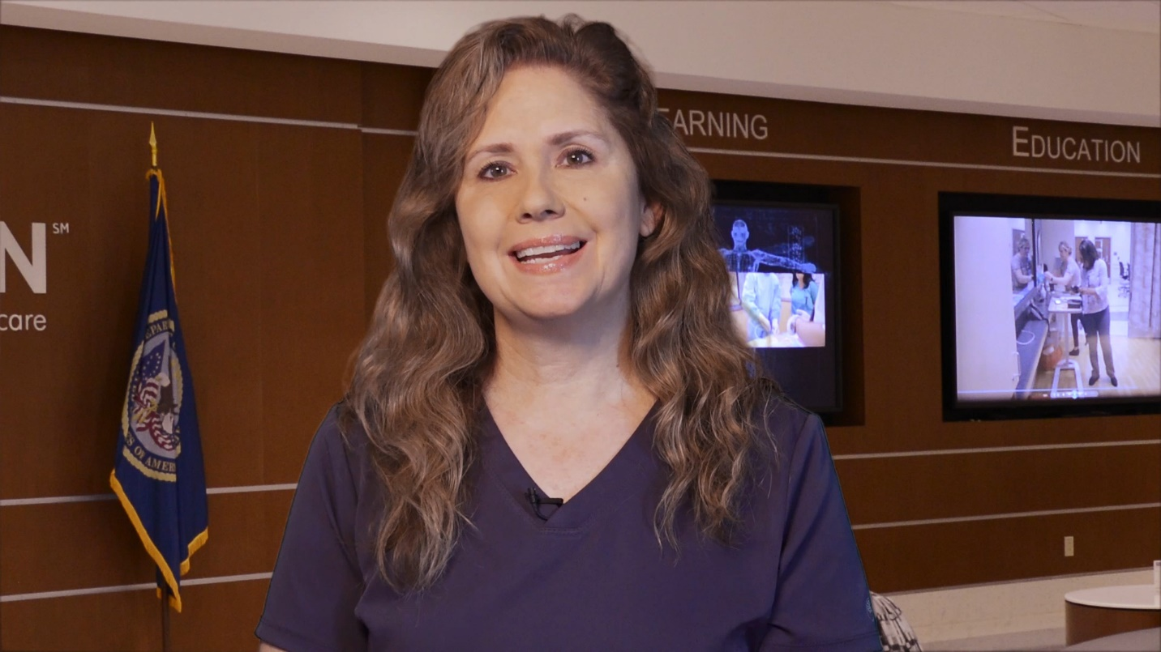
Lisa Hubbard, MSN, APRN, FNP-BC

Being an APRN clinical simulation educator with SimLEARN provides a unique approach to simulation that merges and incorporates traditional nursing skills and advanced practice skills while designing, developing and implementing simulation scenarios. I have the opportunity to lead and organize delivery of large health care simulation-based clinical training of established protocols and best practices. I am course lead for Introduction to Clinical Simulation (ICS) and for our Musculoskeletal Training for Clinicians (MSK-C) course. I serve as clinical faculty instructor for Simulations for Clinical Excellence in Nursing (SCENS), Fundamentals of Critical Care Support (FCCS), SimLEARN Faculty Instructor Course (SFIC), and the SimLEARN Fellowship program. Additionally, collaborations with the Women’s Musculoskeletal Health Training Program and National Telestroke Training Program (NTSP) where I serve as a faculty instructor.
The MSK Clinician course which I am the course lead is a 2-day face to face training that enhances Primary Care Providers’ knowledge, skills and confidence to manage common MSK problems of the shoulder and knee. This training is a combination of didactic and hands on with actual standardized patients and task trainers for injections. As an advance practice provider this course affords me the opportunity to work alongside providers from both a teaching and collegial standpoint.

