Healing Arts at VA Puget Sound

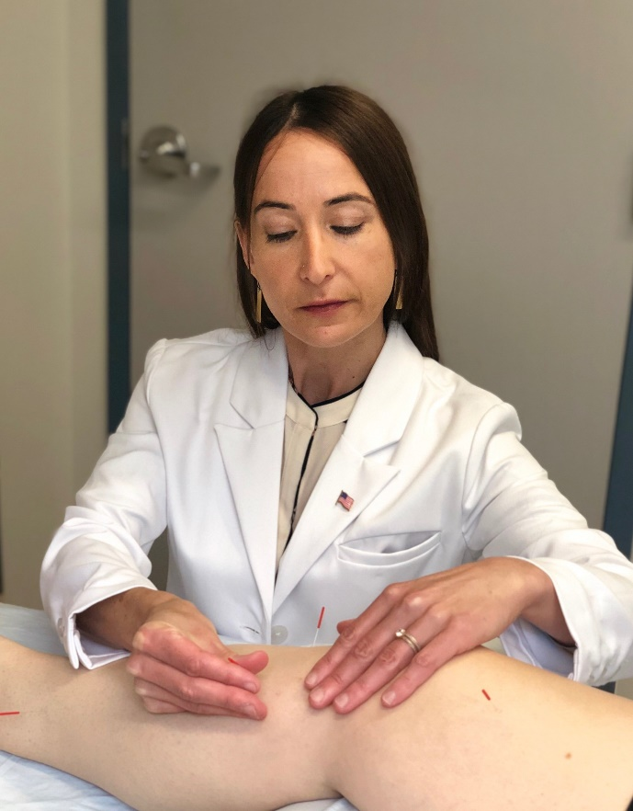
Laurieanne Nabinger was first introduced to the healing arts at a young age when she volunteered at a local hospital. That early introduction encouraged her to pursue a career in nursing. During nursing school, Laurieanne discovered acupuncture when a nurse presented a lecture and demonstration of auricular acupuncture. She realized that she wanted to combine nursing and acupuncture as a career after a personally beneficial acupuncture experience.
After nursing school, Laurieanne earned a masters of Acupuncture and East Asian Medicine in 2001. For many years she worked part time as a nurse while simultaneously managing a private acupuncture clinic. She came to the VA Puget Sound in 2006. As the daughter of a Navy Veteran and career Air National Guardsman, Laurieanne was familiar with military culture and enjoyed working with Veterans in the Veterans Health Administration (VA).
After a few years of VA practice as a nurse in the emergency department and intensive care unit, Laurieanne introduced the possibility of an acupuncture clinic for Veterans to her nursing leadership. At that time there were very few sites that offered acupuncture services. “It was very progressive” she said of the leadership that supported her in opening the site’s first acupuncture clinic.
“There was some skepticism about the research confirming the effectiveness of acupuncture. Mindfulness and yoga were not fully accepted at that time either.” Laurieanne felt that her medical training as a nurse and the acceptance in the facility as a trusted provider, allowed her to “facilitate the conversation between traditional medicine and Chinese medicine”.
Laurieanne remembers a Veteran she was treating with acupuncture. The Veteran was experiencing neck pain, headaches and anxiety. His wife was in hospice care at the time. “Caring for himself and managing pain without taking too much pain medication was an essential part his goal. After a few treatments his neck pain began to improve, and he had better range of motion. He also noted fewer headaches and was beginning to feel more relaxed. He was able to take less medication which left him more alert and able to attend to his wife’s needs.”
Laurieanne describes her work as a nurse within the VA as “very fulfilling” and highlights how the VA offers distinct opportunities for quality improvement that might not be available in the private sector. She finds the VA’s multi-disciplinary approach in the delivery of care as essential for Veterans. “If a Veteran has suicidal ideation, I can reach out to the Psychiatric Emergency Service, or if a Veteran is having a problem with medications I can contact the primary care provider or pharmacy. Acupuncture plays a vital role in treating complex chronic pain, a team approach is needed.”
“For years, Veterans have been interested in non-pharmacological options for pain management that include mind-body healing. Additionally, healing that involves human touch and connection. I am happy to see that we are offering more integrative therapies to Veterans.”
With the movement toward Whole Health in the VA, looking at the whole person and what drives them to their health goals, many complementary and integrative approaches are being more widely used. By putting the Veteran at the center of their health care and partnering with them to achieve their best health, the VA hopes to position each Veteran to live their best life.

