# Mental Health Residential Rehabilitation Treatment Program (MHRRTP) at the Roseburg VA Health Care System

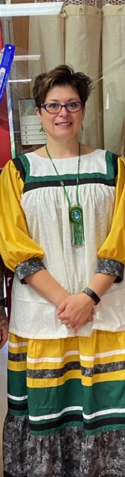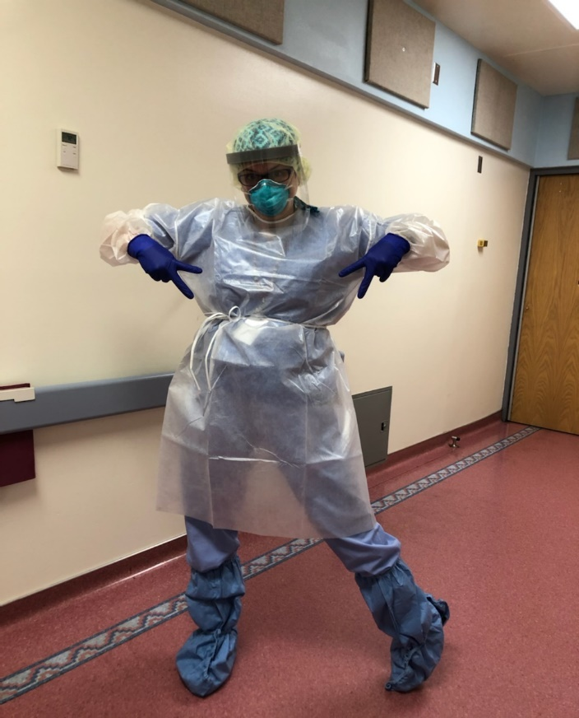

*Hand Sewn Native Apache Camp Dress shared with Amy during Nursing DEMPS Deployment to Indian Health Services Hospital*

Amy McCain-Davis, BSN, RN is the Assistant Nurse Manager of Mental Health Residential Rehabilitation Treatment Program (MHRRTP) at the Roseburg VA Health Care System. Amy and her team of staff were encouraged to begin bringing Whole Health practices into staff meetings and self-care on the unit, and encourage staff to participate Whole Health training offerings such as Yoga Nidra, Tai Chi, BFA, and Whole Health Nursing Engagement to expand Whole Health across the system. Amy became familiar with the Whole Health department and signed up for scheduled trainings. She was able to get certified to instruct Yoga Nidra and perform Battlefield Acupuncture for Roseburg Veterans. Amy participated in many employee well-being offerings from the Whole health department; mindfulness sessions, an under desk elliptical exercise program, and projects around the facility.

The most inspiring nursing self-care offering for to Amy was the Employee Whole Health under desk elliptical machine for ‘Moving the Body’ more at work with a department-wide friendly competition across the Roseburg VA Health Care System. The unde- desk fitness elliptical machine allowed for tracking using a smart phone application connected to the Bluetooth. Amy said good-bye to 30 pounds. Amy is somewhat competitive in nature and being able to see the other units’ competition status in real time gave Amy the boost to keep her legs moving, getting more strides in per day. The under desk elliptical was the boost she needed to make a healthier lifestyle change. She has seen a reduction in her stress and anxiety levels, as well as the ability to approach situations differently. She could feel the difference this program was making in her overall emotional, mental, and physical body. Nursing colleagues were starting to notice the “pep in her step” and eagerly followed suit. The Veterans would often go around and encourage staff to get their legs moving, and even requested one for them to use while in the program. It was truly remarkable to see such cohesion in the milieu with the Veteran during their healing while in the program.

A nursing DEMPS deployment opportunity was presented to Amy and something within her said it was where she needed to be. Amy felt the employee wellness program gave her that opportunity as she did not feel like she could have participated in, had she not lost weight and reduced her feelings of anxiety and stress. She deployed to an Indian Health Services Hospital and immediately felt a connection with the Native people. The change of culture and complete appreciation she witnessed was an especially unique, and caring experience. The Native women spoke with such grace and pride of their culture that they presented Amy with beads and a Native Camp Dress (pictured above). In a sense it just “felt right” being there after learning so many tools from the Whole Health. Mind, Body, and Spirit are all connected in her nursing practice in such a way, that Amy had never experienced before.