Bariatric Success Story
“This is it. I’ll never get to go back to my home again. I’ll have to go to a nursing home.”
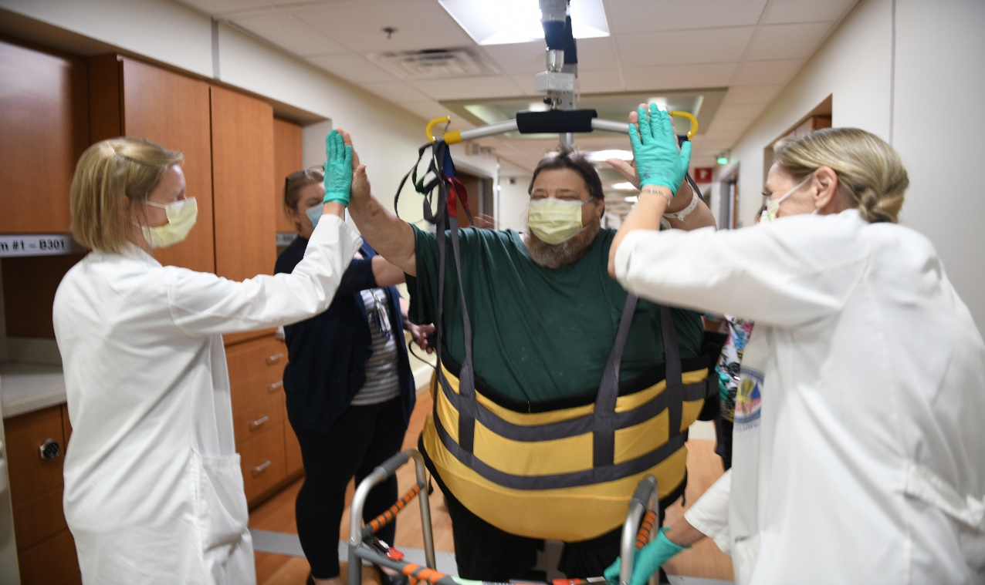
(From left to right Victoria Karr Physical Therapy, Lori Swope RN SPHM FC, Michael Wagenknecht Patient, Jenifer Millikin RN and Kimberly Smith Physical Therapy)
This Veteran was admitted due to fall. He weighed over 600lbs at admission. As a nurse with over 25 years’ experience, I’ve heard many times “people that big usually are not walking”. I might have even said as much at some point. But I ask you to challenge your assumptions, beliefs and stereotypes. This gentleman was walking at home with a walker until the fall. He now felt despondent and hopeless as he heard from many physicians, staff and supporting services that he many need to go to a Long-Term Care Facility… a nursing home. He also was told he would likely be hospitalized for several days to weeks. This was because of his size and also because very few receiving community facilities have equipment needed to care for a patient of his size. Further complicating his stay were the staffing issues related to the COVID-19 Pandemic. His wife, family and friends were unable to visit because of the visiting restrictions. We were his support team!
The Nursing staff, Therapy Staff, Administrators and Safe Patient Handling & Mobility Facility Coordinator had been preparing and training for someone Just…Like…Him. The team collaborated to obtain the necessary size/weight appropriate equipment that could be used for his care while keeping both the patient and the staff safe.
Our patient was skeptical and fearful of falling again…so was staff. But we were ready to serve him, as he has done for us!
The Veteran was able to roll very well but had difficulty sitting up and standing due to his body shape. We applied a specialized walking sling to the veteran while in bed. This allowed staff to assist him into the sitting position using the ceiling lift. Due to the nature of the bed surface that the veteran was on, there was a concern of the patient slipping off the side of the bed to the floor. Once we were sitting, we moved on to standing and eventually walking. The day after his admission, the veteran became convinced he was safe using the walking sling; he believed we had him. He did happen to lose his balance the first time and the sling supported him, prevented his fall, just as was intended. During his stay not only did the veteran not have any falls/injuries but bedside staff was not injured in the process of caring for this veteran.
With the guidance of PT and cues from the patient, the lift was able to offload some weight from the knee but still allow the patient to exercise with a walker. The first time he got to the recliner on his own without being lifted by full body sling, he called his wife immediately and told her his excitement. By the 4th day from admission the veteran had lost enough weight for another piece of equipment that would allow him to walk in the hallways while still providing the support and safety as before. With the veteran's motivation and the VA’s readiness to serve our veterans, this gentleman was discharge to short stay Rehab facility and finally to home!

