Beating COVID-19 is About Partnership
Connie Fagan, RN

Connie Fagan, a Registered Nurse in Primary Care at Coatesville VAMC with 44 years of experience in nursing stands ready in the Urgent Care Center on Aug 7. Fagan deployed for 11 weeks as the Southeastern Veterans’ Center’s Liaison to CVAMC
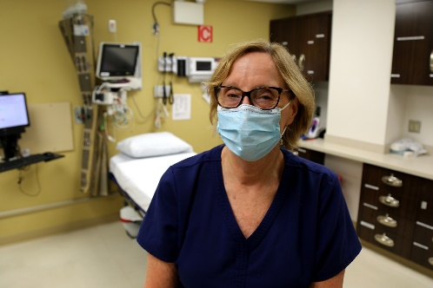
Nurses, like Connie Fagan, a Registered Nurse in Primary Care at the Coatesville VA Medical Center do their part to help Veteran patients fight the novel coronavirus by serving on the frontlines of care at the state-run Southeastern Veterans' Center in Spring City.

VA's Fourth Mission
Coatesville VA Medical Center supported mission assignments with direct clinical care, testing, education and training at the Southeastern Veterans' Center (SEVC) in Spring City. The initial team arrived on April 27 and included 40 nurses from different medical centers across the country. Four of those were from Coatesville VAMC.
Connie Fagan, a Registered Nurse in Primary Care at Coatesville VAMC with 44 years of experience in nursing served as the SEVC's Liaison to the Coatesville VA Medical Center Interim Director, Jennifer Harkins, who oversaw the overall mission. Fagan has been with the VA and at Coatesville for 37 years, but this would be her first deployment.
"A mission like this requires expertise and collaboration. With Connie taking the lead as the onsite liaison between our VA nurses and the SEVC, I was very confident we would be able to provide the highest level of support," said Harkins. "Connie is an excellent, experienced nurse so I was very grateful when she, like so many others, stepped up when we asked for volunteers."
Fagan managed the daily logistics and resources required to assess the situation at the SEVC and combat the spread of COVID-19 at the state-run facility. They coordinated the first testing of 100% of the staff and patients, oversaw staffing assignments, followed up on patient issues, and tracked the personal protective equipment "burn rate" or how fast the PPE was used.

Everything is About Partnership
Fagan also worked closely with other agencies and attributed the eventual success to their support.
The Centers for Disease Control, Pennsylvania Department of Health, U.S. Public Health Service, all evaluated procedures during their visits and provided education on testing, isolation, infectious disease control and cleaning requirements.
Fagan said, "They recommended changes to procedures in place at the time of their visits. We implemented them and by the time we left on July 11th, COVID-19 was very much controlled."
The Pennsylvania National Guard was there to assist the floor staff with nursing care and assisted with housekeeping by wiping things down and keeping spaces clean. "The soldiers were there every day and were genuine in their concern for our Veterans. They comforted our Veterans by spending time with them and just talking with them," said Fagan.

A Look Back
Fagan was the longest serving federal VA representative at the SEVC and looks back on the team's accomplishments. “The COVID that had been extensive was very much controlled. We went from Red and Yellow status to all Green and only two positive asymptomatic patients," explains Fagan. "That was a huge improvement."

