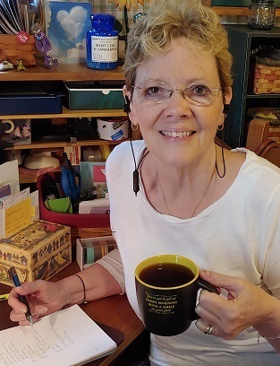
DC VAMC Nurse Connects Heart to Heart with Veterans
“Humanity is our race. Love is our religion.” Veterans suggested adopting this quote as the “hashtag” for the Live Whole Health Coffee Hour that is held every weekday under the moderation of Whole Health Nurse Educator, Kathleen Bixby, MSN, RN, Caritas Coach, of the Washington DC VA Medical Center.
Kathy is a U.S. Army Veteran having spent nine years on active duty working in oncology and critical care at Walter Reed Army Medical Center, Tripler Army Medical Center in Hawaii, and Fort Belvoir, Virginia. She has been a VA nurse for fifteen years, serving in hospice and palliative care before transitioning to DC’s Whole Health and Integrative Health and Wellness Program.
The Live Whole Health Coffee hour is offered over the phone and attracts between nine and twelve Veterans every day. “It gives Veterans a safe place to talk about what is happening in the world and how it is affecting them personally – their physical well-being, mental and emotional well-being, and their day to day life,” says Kathy. “I have taught them some techniques such as an anchoring heart technique where they place their hand on their heart and breathe with and through the feelings and emotions, allowing them to rise up, be with them, and then let them go.”
Focusing on mindful awareness, which is a key element of the Whole Health Circle of Health and Well-Being, participants are encouraged to share what is happening in their lives and explore their thoughts and emotions in a safe place. “We just started passing a virtual rock from person to person which gives everyone the opportunity to talk,” she said. “On Juneteenth, I was the only white person on the call, and I asked them all to share something they wanted me to understand; to explain the meaning of this day to them, to me.”
Kathy may start the call with a check-in, quote, or topic the Veteran’s want to explore, but she is clear that there is no agenda for the call, except to relate their dialogue to the Circle of Health. “We take the time to breathe into our heart-space and share what is going on.”
One member of the group has social anxiety and indicated that he would not feel as comfortable sharing in person. The virtual aspect of the call helps him to connect with others at his comfort level and has drastically reduced his isolation. During the pandemic, so many Veterans have lost the important social connections they had from coming to the VA Medical Center and the call has been referred to as a lifeline for some of the Veterans.
Kathy, who spent most of her career working with people in crisis or at the end of their lives, says it is a blessing to her that she is able to help people explore what really matters to them before they get to the end of life. “After 40 years as a nurse, I feel so blessed to be doing this kind of work, which truly helps people talk about what matters to them, their emotions, dreams, and accomplishments – and to be heard.”
Kathy’s role at the DC VAMC as Whole Health Educator, allows her to provide group and individual coaching, teaching, and experiential practices such as iRest Yoga Nidra, HeartMath, and Reiki. The DC VAMC has a staff of four people who are transforming the health care system to a Whole Health model of care which helps Veterans to understand their mission, aspiration, and purpose and to create a personalized health plan with their medical team. Complementary and integrative health practices such as yoga, tai chi, massage, and acupuncture are also available to Veterans at the DC VAMC.

