VISN 23 Western Tier Clinical Contact Center (CCC)
Connecting Veterans to the Healthcare Needed Now
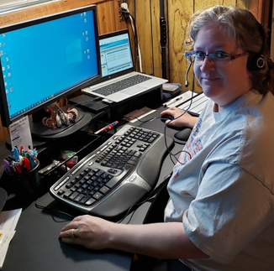
Heather Helfer a VISN 23 CCC Daytime RN Triage, RN
The VISN 23 Western Tier Black Hills Clinical Contact Center (CCC) features over 40 employees consisting of four different services. The four services consist of Triage Registered Nurses, Medical Support Assistants, Pharmacy Technicians, and a Licensed Independent Practitioner (LIP), all at the ready to assist veterans with the care they need.
The VISN 23 CCC is there to support Veterans whether they are calling for an appointment, need a medical referral, or have a symptom that needs to be triaged. Sometimes however, Veterans call in with a problem they just don’t know how to handle, hoping that the VA can find an answer for them. The VISN 23 CCC is ready for all and any of those circumstances. As an example, recently a Veteran called in after having received treatment in a local private sector Emergency Department (ED). The Veteran received a prescription for an antibiotic that would cost $100 to be filled. The Veteran wanted to receive the treatment, but the cost was prohibitive, and this was causing fear and frustration. The question was “Can the VA” help me get this care that I need? The nurse who responded to the CCC call was able to provide several options available to the Veteran easily while collaborating with her coworkers to make sure she had all the options covered to get the antibiotics quickly. A coworker suggested the LIP in the CCC had an appointment available that day and to reach out to her for help. The nurse did just that; scheduled an appointment for same day with the LIP and the Veteran was almost drawn to tears. The LIP was able to diagnose the Veterans symptoms and prescribe affordable treatment. Before the veteran ended the call with the LIP, the veteran stated, “the nurse was so nice and helpful and I am so grateful for the care, if she didn’t keep looking for solutions for the me, it would not have gotten taken care of quickly.” This is one small example of the care Veterans experience in our CCC. At the VISN 23 CCC, we are here to help connect Veterans to health care.

