# **Thinking Outside the Box- Innovative Strategies for Combating COVID19 Pandemic**

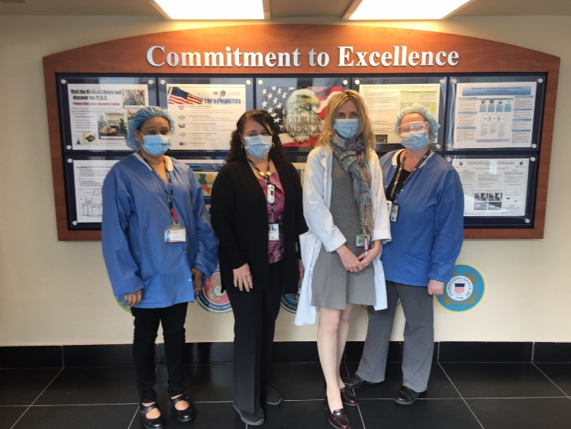

L to R Delilah Mendonca, Annette Lopez, Maureen J. Merges & Bridget C. Maybury

The emergence of the COVID 19 pandemic in January 2020 is the backdrop to the creation of the James J. Peters VAMC (JJP VAMC) COVID19 Infection Control Task Force. As a result of pandemic- the Infection Control Preventionist developed an Infection Control Task Force that would be a multidisciplinary team approach with a wide-ranging expertise, to assist with prevention, mitigation and management of COVID 19 exposures. The committee oversees the development of plans based on findings from risk assessments and practice exercises. Findings used to address the potential vulnerabilities of the facility response. The COVID 19 Task Force also reinforced the hospitals “True North” Strategic Plan of Safety, Quality, and Innovation

**Some of the highlights from the task force activities from March 2020 to present**:

* Daily Walking Rounds and meetings with the Task Force and Frontline Staff.
* EMS Training and communication process with nursing to meet the requirements of the VHA Directives on the cleaning processes. PPE training including N95 masks and assist with distribution of supplies.
* Daily Data Tracking and reporting to Senior Leadership that included Persons Under Investigation (PUI) for patients and staff.
* Main entrance screening – includes “Screening questions and Temperature Checks” for entry into the hospital.
* Recommended Plexi Glass to form a barrier to protect staff at screening process. This concept was eventually adopted and put in place throughout the Medical Center.
* Creation of COVID 19 Infection Control Alert in CPRS that included Infection Control education for clinical staff when caring for COVID 19 patients.
* COVID 19 Discharge Education Instructions that was templated and rolled out to other VAs.
* Contributed Infection Control content to the “COVID Chatter” including “Shining Star Recognition of Staff.”
* Positive Messaging, to reinforce leadership support to frontline staff. Water was distributed to all staff to say, “Thank You.”
* Intravenous Lines extended outside positive COVID patient rooms covered with plastic tubing to mitigate Infection Control risks.
* To prepare for the potential COVID surge JJP VAMC purchased temporary tents for testing and vaccination use. An Infection control evaluation of the tent set-up found a sink is needed for handwashing. Portable stainless-steel sinks were purchased and set-up in the tents. Cleaning and maintenance schedules for pluming shop were implemented to meet regulatory standards.
* Inpatient rooms converted to negative pressure using a HEPA-Filter unit. Negative pressure indicators were installed to help staff verify negative pressure.

**Lessons Learned**:

* On the spot staff education was effective
* Daily “COVID Chatter” updates facilitated staff communication of changing information
* Shining Star and staff recognition increased morale during COVID19 Pandemic.
* Having differing professional backgrounds added to the expertise of Infection Control Task Force.
* Implemented COVID19 documentation alerts to keep clinical staff informed of the patient clinical status.

**Our Task Force would like to Acknowledge and give Special Thanks to the following Services:**

* Quad Leadership
* Chief of Infectious Diseases and Infection Control Medical Director
* Quality Management and Patient Safety
* Environmental Management Service (EMS)
* Emergency Management
* Logistics/Supply Chain
* Clinical Nursing Staff
* Facility Management
* Canteen Service
* VA Police Department
* Pharmacy
* Clinical Applications Coordinators (CACs)
* Medicine Service
* COVID Task Force and Workgroup

**Core Members of the Infection Control Task Force**:

Maureen J. Merges, RN MSN CIC, Delilah Mendonca RN and Bridget Maybury RN from Quality Management and Annette Lopez, Chief of Environmental Services.