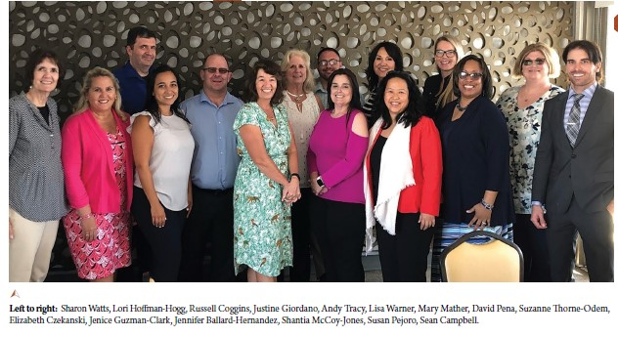

Clinical Practice Program
- The Office of Nursing Services (ONS) Clinical Practice Program (CPP) supports VA nursing practice at the point of care, providing guidance and supporting field-based operations in high risk patient populations
- CPP is comprised of 13 Field Advisory Committees (FACs) which include: cardiology, mental health, perioperative, diabetes/metabolic syndrome, pain management, pressure injury prevention, geriatrics/extended care, community livings center, polytrauma/rehab./spinal cord injury, emergency dept, primary care, intensive care unit/inpatient medicine, and oncology.
- Each FAC is chaired by field-based Clinical Nurse Advisors who are subject matter experts in their field and represent the Office of Nursing Services (ONS) on multiple National committees and taskforces
- Clinical Nurse Advisors have provided invaluable recommendations at the National level regarding equipment, PPE and clinical management of patients during the COVID-19 crisis
- Clinical Nurse Advisors continue to actively participate in the Electronic Health Record Modernization (EHRM) Cerner Implementation
- The ONS FACs provide National VA recommendations regarding:
    - evidence-based nursing practice
    - policy guidance
    - development of National products and/or tools for use by front line nursing staff
- The ONS FACS consist of over 200 members from the field, representing all nursing roles and educational backgrounds
The National Nursing Practice Council (NNPC)
  - Part of the shared governance structure of ONS; Chaired by a front-line RN staff nurse
  - Comprised of 250 staff nurses, representing each Medical Center
  - Provides perspective for issues and activities that impact professional nursing practice and VHA national nursing strategic planning.
Office of Nursing Services (ONS) - Clinical Practice Program
Clinical Nurse Advisors March 2020

Suzanne Thorne-Odem, DNP, FNP-C Contact Phone: 202-680-0052
Clinical Practice Program Manager Suzanne.Thorne-Odem@va.gov

Jennifer Ballard-Hernandez, DNP, NP, CCRN, CHFN, AACC, FAHA, FAANP Contact Phone: 562-826-8000 x2005
ONS Clinical Nurse Advisor, Cardiology Jennifer.Ballard-Hernandez@va.gov

David Pena RN, MSN, MBA, CEN Contact Phone: 414-795-6930
ONS Clinical Nurse Advisor, Emergency Department david.pena2@va.gov
Jenice Guzman-Clark, PhD, GNP-BC Contact Phone: 520-792-1450 x6518
ONS Clinical Nurse Advisor, Geriatrics & Extended Care JeniceRia.Guzman@va.gov

Mary Mather, MSN, RN, CNL, NEA-BC, VHA-CM Contact Phone: 210-612-7710
ONS Clinical Nurse Advisor, Community Living Center (CLC) Mary.Mather@va.gov

Russell S. Coggins, MSN, RN Contact Phone: 828-298-7911 x4210
ONS Clinical Nurse Advisor, ICU/Medical Surgical Russell.Coggins@va.gov

Elizabeth Czekanski, DNP, MS, RN-BC, NE-BC, VHA-CM Contact Phone: 412-801-1125
ONS Clinical Nurse Advisor, Mental Health Elizabeth.Czekanski@va.gov

Sharon A. Watts, DNP, FNP-BC, CDE Contact Phone: 440-554-6450
ONS Clinical Nurse Advisor, Metabolic Syndrome & Diabetes Sharon.Watts@va.gov

Lori Hoffman-Hogg, MS, RN, CNS, AOCN Contact Phone: 518-626-7304
ONS Clinical Nurse Advisor, Oncology Lori.Hoffman-Hogg2@va.gov

Debra S. Hall, PhD, MSN, RN, CCRN-K Contact Phone: 859.233.4511 x 4404
ONS Clinical Nurse Advisor, Pain DebraS.Hall@va.gov

Lisa J. Warner, MHA, RN, CNOR Contact Phone: 480-433-7515
ONS Clinical Nurse Advisor, Perioperative Lisa.Warner@va.gov

Susan Pejoro, MSN, RN, GNP-BC Contact Phone: 650-678-9268
ONS Clinical Nurse Advisor, Polytrauma/SCI/Rehabilitation Susan.Pejoro@va.gov

Shantia McCoy-Jones, PhD(candidate), MSN, RN, CRNP, CWCN Contact Phone: 267-838-1077
ONS Clinical Nurse Advisor, Pressure Injury Prevention & Management Shantia.McCoy-Jones@va.gov

Cynthia Murray BN RN-BC Contact Phone: 302-388-5540
ONS Clinical Nurse Advisor, Primary Care Cynthia.Murray3@va.gov

Justine Giordano RN, BSN, BA, MHA Contact Phone: 631-948-1511
Chair, National Nursing Practice Council (NNPC) Justine.Giordano@va.gov

