John J. Pershing VA Medical Center Congratulates their Facility’s First DAISY Award Recipient!

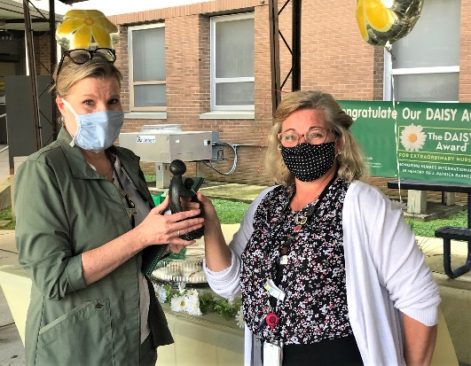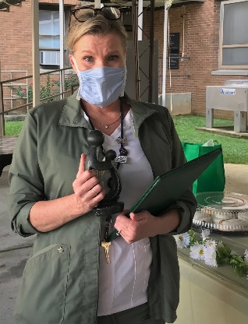
Lisa Bernstein, LPN being handed the award by her ADPCS Candy Miller, MSN, RN, CNL

Lisa Bernstein, a nurse with the John J. Pershing VA Medical Center, has been honored with The DAISY Award for Extraordinary Nurses ®. The award is part of the DAISY Foundation's mission to recognize the extraordinary, compassionate nursing care they provide patients and families every day.
Bernstein “has the highest respect for our veterans,” said to the nomination. She “spent endless amounts of time with (hospice) veterans to ensure they do not die alone – especially in this time of COVID-19 (isolation).” The nomination continued by describing how Bernstein “has been observed sitting with veterans, playing music for them, singing with them, providing them a gentle and compassionate hand, or giving a tender ‘we love you’ to those needing it most. Lisa goes above and beyond to make sure veterans are cared for with the utmost professional standards and compassion,” it concluded.
Bernstein is a licensed practical nurse who was born and raised in Poplar Bluff who has long wanted to work at VA. “To work with our veterans has been my goal from the start,” Bernstein said. “Throughout my career, all my encounters with patients have been special. But there’s something even more special about caring for a veteran. I have found the John J. Pershing VA mission to ring true: we are truly veteran focused. To have the opportunity to care for those who served us is an immeasurable privilege.”
Asked if she likes her job, Bernstein said, “To like this job would be an understatement. To love the calling would more accurate. To help someone at their most vulnerable state, keeping their dignity intact, and to win their trust is important. But to maintain that trust day after day, and even after they’ve left us is what’s most important. Our greatest compliment is having some of our veteran’s call or come visit us after (recovery.)”
Now that she’s an honoree, Bernstein was asked what she would like others to know about this award. “I would want them to know that it’s not about me, it’s about every nurse who answers the call. Accolades is not the reason we do what we do. It’s that smile, or hug, or glint in the eye which tells us we’ve done our job well. To give of yourself day in and day out, to wake up in the middle of the night wondering if you’ve done your best for a patient. It’s also about the staff member who taught me my duties. Each of our CNAs, LPNs, RNs and NPs have a way of teaching new staff the best way of doing things, but it lies within each us individually to carry that out to the best of our ability. So, basically, I’m a reflection of people who have taught, guided and corrected my steps. And for that I’m grateful.”
Bernstein was completely caught off guard when her name was announced during the ceremony. “I heard my name but looked around for Lisa Bernstein. I truly didn’t comprehend what had been said. It was when I turned back to see Mrs. Chandra Miller; ADPCS looking directly at me and for me to come forward, that I realized I was the person named. How did I feel? Numb and unworthy. I was literally surrounded by the most brilliant class of nurses that outshine me on their worst day. And yet, here they were smiling and offering congratulations and tears of joy. How lucky am I to have them?”
The award, presented on August 13, 2020, included a sculpture called The Healer’s Touch. Hand-carved by artists in Zimbabwe, each piece is signed by one of the many Shona artists that The DAISY Foundation supports. “The economy and politics of Zimbabwe have been in turmoil for decades, and the artists are able to support hundreds of people in their families with this work,” according to the DAISY Foundation.
Chandra Miller, Associate Director for Patient Care Services and Chief Nursing Officer at the John J. Pershing VA Medical Center, said, “Lisa exhibits the highest standards of professionalism and compassion and is very deserving of this award. She demonstrates our ICARE Values of Integrity, Commitment, Advocacy, Respect, and Excellence in everything she does. We are proud to be among the healthcare organizations participating in The DAISY Award program. Nurses are heroes every day. It’s important that our nurses know their work is highly valued, and The DAISY Foundation provides a way for us to do that.”
The DAISY Foundation is a not-for-profit organization, established in memory of J. Patrick Barnes, by members of his family. Patrick died at the age of 33 in late 1999 from complications of Idiopathic Thrombocytopenic Purpura (ITP), a little known but not uncommon auto-immune disease. (DAISY is an acronym for Diseases Attacking the Immune System.) The care Patrick and his family received from nurses while he was ill inspired this unique means of thanking nurses for making a profound difference in the lives of their patients and patient families.

