ONS Metabolic Syndrome & Diabetes Field Advisory Committee

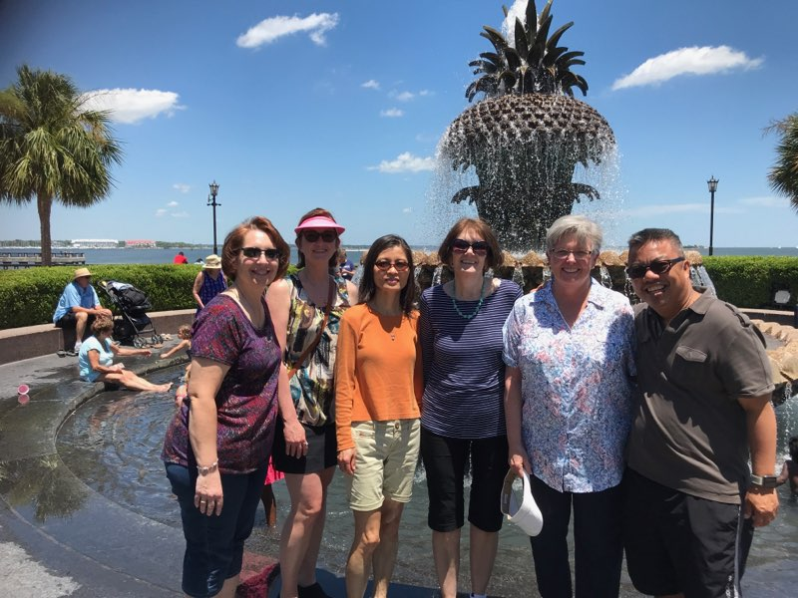
The Office of Nursing Services field advisory committee for diabetes has been active for the past 10 years. This Clinical Practice Program was developed to support clinical practice in diabetes through the development of evidence-based products and resources, develop policies in coordination with other VHA program offices, and to disseminate communication to the field. Our committee has ten nurses spread across the United States who have a passion and commitment to improving the care of Veterans with diabetes. We represent a range of clinical expertise and backgrounds, including PhD, DNP, Clinical Nurse Leaders, Clinical Nurse Specialists, RN’s and Nurse Practitioners, as well as a member who is both dietitian and a nurse. Our nurses work in both outpatient clinics and on inpatient units. Some of our members are Veterans. Throughout the years our committee has developed and reviewed materials for VA nurses who care for Veterans with diabetes. One recent project was to create a competency on the use of insulin as a high-risk medication, with the goal of improving safety in administering these medications to keep Veterans safe and to “do no harm.” We have reviewed contributions for the new electronic health medical record to improve methods of charting and collecting data to better manage care and measure outcomes. This includes collecting information for diabetes self-management education programs for Veterans so that sites can obtain national recognition for certification.
Left to Right: Margaret Adams, Leigh Ann Russell, Jino Howard, Sharon Watts, Dana Yelverton, Roman Samiley

Additional projects that the Metabolic Syndrome & Diabetes Field Advisory Committee has worked on include:
- TMS modules on inpatient diabetes, Hypoglycemia, Nutrition & Diabetes, Medications & Diabetes
- Live education modules on diabetes
- Contributions to the creation of an Inpatient Glycemic Cornerstone Project
- Interprofessional collaboration with Nutrition, Specialty Care & Pharmacy committees
- Creation of content for both employee/Veteran diabetes education on the Virtual Medical Center
- Review of national diabetes education
- Collaboration in writing national guidance for diabetes technology
- Review of VA/DoD DM Guidelines Patient Education Tools
- Peer-reviewed publications
- Development of and timely updates on multiple competencies for outpatient and inpatient nurses

