FIRST DAISY AWARD WINNER AT THE JAMES J. PETERS (JJP) VAMC

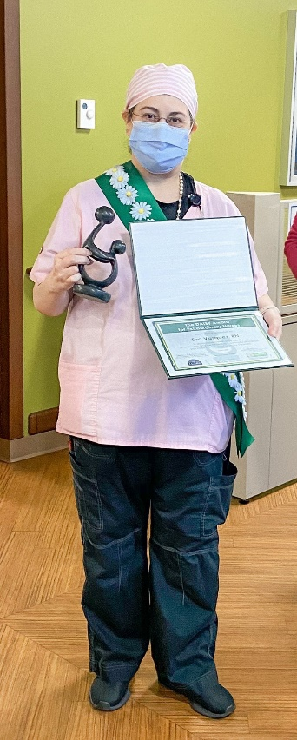
The DAISY award is a national award that recognizes extraordinary nurses. JJP VAMC announced its first ever DAISY award honoree to Ms. Eva Vazquez, PACT RN, on Wednesday, August 26, 2020. She was nominated by Dr. Maryann Paul. The award was presented by our Chief Nurse Executive, Dr. Kathleen Capitulo, and members of the Nurse Recognition Committee.
An excerpt from her nomination form read:
“She is unparalleled in her dedication to those patients. Every single patient knows her, respects her, and loves her. I hear countless times over and over when I have patients visit ‘Give my regards to Eva she saved my life’…. She is always and consistently going above and beyond her call of duty. She exemplifies the DAISY award. The Queens patient cohort data consistently reveals the best managed hypertension and diabetic data and that is solely on the added efforts of Eva and her panel management skills.”
Please join us in congratulating DAISY honoree, Ms. Eva Vazquez.

