# RN Crystal Davis-Whited Deployed to the Navaho Nation

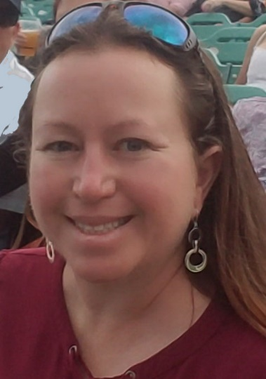When asked to talk about my experience working on the Navajo Nation in Gallup New Mexico, it is hard. It is hard to describe why I feel I was called, and it is hard to discuss which things to talk about. Much of it is still very raw.

I have always been drawn to help those in need, especially in a crisis. I think that is how I found my way into Nursing, as well as me volunteering at a local Fire Department. Like many nurses I want to help those who may need us. This time when I felt “called” I knew our fellow nurses were struggling and I felt I might be able to help. I also knew patients were dying alone, and being an old ICU nurse, I always hated that. If at all possible, I feel people should not have to die alone. If I could be there for a small window, maybe I could help even just one person. So I asked to go. Blanca Aragon, Nurse Executive was amazing and told me yes.

When I arrived in Gallup, in the middle of the country’s hot spot for COVID-19, I was greeted so kindly. I was a little nervous even walking into the hotel, but the hotel had posters up thanking us nurses. The front desk clerk was so kind and helpful she said, “thank God you are here, we need you, thank you so much for volunteering to come help us”. That small act of kindness started my trip off on the perfect note. The next morning I showed up where I thought I was supposed to be (the instructions were not very clear) and was met by chaos (what I expected). They had no idea I was coming or who I was. The CNO who arranged everything was out unexpectedly and didn’t tell anyone we were coming. The Nursing Supervisor on duty said that they were short Med/Surg nurses, “so let’s throw you there for today”. And that is how my day started. They put me to work immediately.

*Crystal Davis-Whited, MBA/HCA, BSN, RN Las Cruces, NM CBOC Nurse Manager*

## Photo of people in scrubs spaced apart outdoors with text Outbreak on edge of Navajo Nations overwhelms hospital Gallup, New Mexico

There were two regularly employed nurses on shift that day and the rest were us “volunteers”. That hospitals Med/Surg floor consisted of everything except Mother/Baby and ER and ICU. We even had Peds. After taking a patient and an hour into my shift, someone from Education found me and another nurse who came from a different part of New Mexico to assist. He had our names. I was so happy to know that I was in at least the right place! Whew.

After completing “new employee paperwork and orientation” that was about 30 minutes long, they sent me to work! I had one patient the first day so I could “learn the computer” (on my own), then away we went. I hadn’t done clinical nursing in about 12 years so it was great knowing it came back pretty quickly. After about 3 days I felt like I got my sea legs and was good to go. They mixed their patients there so you had COVID and non-COVID patients each day. When I asked them why they did it that way, they said they assumed everyone had COVID. They just don’t always know which ones did and didn’t. So it was easier to place everyone in droplet and airborne isolation. Almost all the staff I had talked to had been sick or hadn’t been tested. This made me curious as to why. I was also very curious wondering why this area in particular was hit so hard. I understood why New York was hit so hard, because everyone is on top of each other, but why in such a rural area? It didn’t take long for me to figure that out. It seemed that almost all of my COVID patients fit into two categories. In one group, it seemed to be the same patients on paper but a different face. They had a history of hypertension, diabetes, hyperlipidemia, obesity, and many had heart disease and/or kidney disease. The other group was the full care group. They had end stage Dementia, Parkinson’s disease, etc. This group was the full care group before COVID hit, and then they got hit with COVID. Everyone I saw was chronically very sick, then plagued with a new disease. Luckily almost all of them lived and were going to be ok.

Talking to the staff and patients, they all stated their challenges in the area with COVID were living conditions. Many families didn’t have running water, lived with 10 people or more in a house with one or two bedrooms. They are dependent on going to places where they share germs just to get water and food. Then they take it back, without any hygiene practices, and the whole house would quickly get infected. They said that many people have no idea what COVID is other than through word of mouth, and in several areas, the word of mouth was that it just causes a cough. They were trying to get better education out, but many mistrusted the medical field.

What made things hard for the patients in the hospital was that no family could visit. Everyone in the hospital was alone, scared and lonely. We were all busy just trying to keep up, but every day that I worked I tried hard to do something for each patient to help them feel a little less lonely, and something for each staff to let them know that they are making a difference. I worked hard to connect patients with family if that was possible, and if it wasn’t, I worked to find them someone, like the Chaplin they had not yet met. I felt I was able to make a difference in that way. I was able to help them feel a little less scared, a little less lonely.

For the staff, we were all completely emotionally, physically, and spiritually exhausted and just done at the end of each day. But I made sure that I asked each of them if they needed anything, even though I felt I had nothing more to give (this was something nice I learned working in ICU). But you know what? Just by asking them, I found more. I found more to give, I found more ways to help, I found more friends, I found more within myself, just more. Very rarely did anyone even take me up on it, but I was told that little act of kindness made a big difference at the end of a long day. I noticed before I left that everyone started doing it. I left my little dent on their world!

Everyone there was so appreciative, even on the days there was only one employed nurse on shift, and the rest of us were “miscellaneous” nurses with “miscellaneous” experience. They just thanked us. None of us were Med/Surg nurses. One nurse was a Neonatal NP, one worked in the prisons, one worked outpatient Oncology, one in an ER, one in a Rehab, one in Case Management, but we all figured it out and came to help. It was amazing to see the support coming to help and the people appreciating the help. They never got mad or frustrated at me for asking how to do something. They just said, “if you weren’t here we would have the whole floor to take care of by ourselves; ask away.” They were so patient, so kind, even though they had been put through so much. Their kindness was contagious. They made you want to be there to help. They didn’t complain, they just appreciated what positives they had. My kind of people.

As we left, the hospital was able to hire some travel nurses that were able to stay longer, and because we were there, they were even able to get a couple of days training before we left. It felt good knowing that they were going to be ok now. What a great experience! I am happy I went and am forever grateful to have helped where I felt I was meant to be at that time.

A big thank you to my Las Cruces CBOC staff! My team would send me uplifting pics while I was gone and I loved them! Thank you to Kraig White for covering me while I was out, to Blanca for letting me go and to everyone who was supportive of me!

Crystal

