The Evidence-Based Practice Field Advisory Committee
The Evidence-Based Practice (EBP) Field Advisory Committee (FAC) is comprised of Veterans Healthcare Administration nurses and other healthcare professionals from all over the country. These members help facilitate the implementation of EBP throughout VHA facilities across the network. Some of the great work they have done is to provide resources on the Office of Nursing Services (ONS) website for healthcare professionals to access to improve their processes at their own facilities. We have been able to provide access to the leading EBP experts from around the world such as Johns Hopkins, The Helene Fuld Institute, the Iowa Model, Joanna Briggs Institute and the National Nursing Practice Network. The EBP FAC is constantly updating resources to help the field with their EBP journey. We also provide virtual and face to face consultation to support sites as needed.
The ONS contracted with the Helene Fuld Institute for EBP last fall to assist in training the field on best practices for implementing EBP. Over 100 nurses attended this training face to face or virtually and are currently working on implementing EBP initiatives at their facilities. We continue to mentor these participants and follow their progress.
One of our EBP FAC members, Dr. Lisa Wayman leads a virtual 6-month intensive class for groups from VHA facilities to participate in real time training to assist with identifying EBP problems, development of their Problem, Intervention, Comparison, Outcome (PICO) question, literature searches, implementation and evaluation of outcomes. Dr. Wayman is assisted by two other members, Dr. Colleen Walsh-Irwin and Ms. Kimberly Barnes. We have 12 facilities actively engaged in this training and look forward to the completion of the EBP initiatives.
The EBP FAC was recently called upon to do a comprehensive evidence-based literature review to assist the Executive in Charge with one of his missions to decrease medication errors. The comprehensive review consisted over 100 articles and was completed in relatively short time. Having an expert group of healthcare providers improve our practice across VHA is an invaluable resource. We salute our Evidence-Based Practice Field Advisory Committee nurses for their great work during the Year of the Nurse!
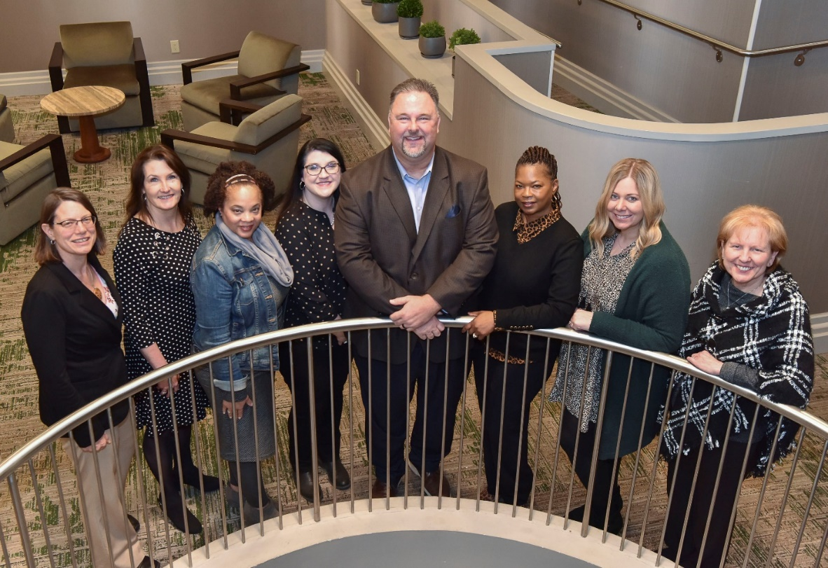
The Office of Nursing Services Evidence-Based Practice Field Advisory Committee members. From L-R: Lisa Wayman, Colleen Walsh-Irwin, Kathleen Parker, Clinta Che Reed, Randy Moore, Kimberly Barnes, Danielle Burzlaff, Debi Sampsel.

