EBP Mentor Course

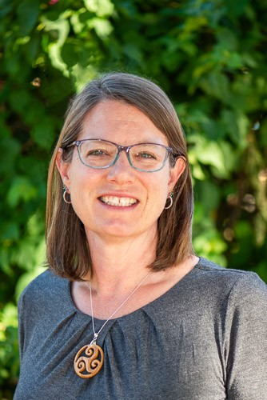
In 2015, Dr. Lisa Wayman of the Phoenix VA Health Care System (PVAHCS) developed an EBP Mentor course designed to train staff to conduct EBP and develop the skills to mentor other staff to conduct EBP. The course is offered over six months so participants can learn EBP skills and then put the learned skills into practice. Staff who have completed the EBP Mentor training are members of the EBP council and are assigned to assist others.
Since 2015 PVAHCS has undertaken more than thirty EBP initiatives. We have addressed restraint reduction in the ICU, implemented a quick look triage RN in outpatient Mental Health, reduced aspiration in non-Ventilated patients, promoted RN certifications and implemented early mobility programs. The EBP initiatives have measurably improved patient outcomes while controlling cost. The PVAHCS mentors provide support for bedside nurses to practice at the top of their scope and enable more initiatives than the EBP council could undertake on their own.
In 2018 the PVAHCS EBP Mentor course was opened to facilities in VISN 22. In 2019 the PVAHCS EBP mentor course was opened to VA facilities across the nation. The course is taught virtually so no travel is required. To date twenty VA facilities have participated in the EBP Mentor course. The EBP Field Advisory Committed in collaboration with the Office of Nursing Service, is currently conducting research on the effectiveness of the EBP course and will modify the EBP Mentor course based on the research. In 2021 the modified EBP Mentor Course will be offered to VA facilities across the nation. Please contact the VHA ONS EBP FAC at VHAONSNNECEBP@va.gov for more information.

