Nurses promote quality geriatric care in acute care setting!
Elder Veteran Program (EVP): Creating a Geriatric Sensitive Culture
Maureen Haske-Palomino DNP, MSN, GNP-BC is the clinical leader and co-developer of the Elder Veteran Program (EVP) at the William S. Middleton VA Hospital located in Madison Wisconsin. Dr. Haske-Palomino has been a gerontological nurse practitioner for over 20 years. She has worked for the VA since 2014.
The Elder Veteran Program (EVP) is a nurse practitioner (NP) led inpatient geriatric consult service designed to guide nurses and other team members to identify risk early and employ veteran centered interventions that focus on prevention and/or prompt treatment of active geriatric syndromes. EVP prioritizes those inpatients with cognitive impairment, working to identify key strategies such as engagement activities (music, books, use of animatronic pets, walking schedule) to improve their stay and reduce risk of functional decline and delirium.

The EVP model is founded on the use of experiential learning to disseminate evidence based practice and quality gerontological nursing care. The EVP NPs and RNs perform focused comprehensive geriatric assessments including a thorough family and social history that highlights the veteran as a unique individual. EVP team members work in sync with the veteran’s nurse, educating and modeling at the bedside, and providing feedback on the care plan. EVP promotes excellence consistent with the I CARE Values through this consistent interaction with the veteran, family, and care team.

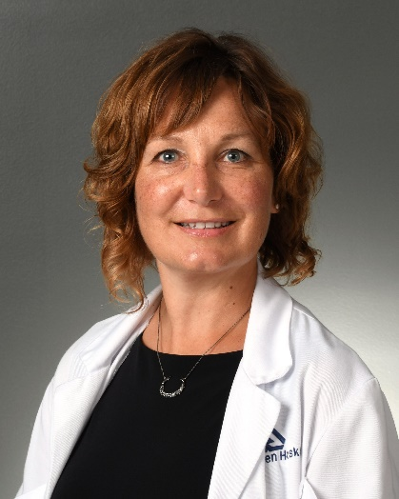 Maureen Haske-Palomino DNP, MSN, GNP-BC
Prior to the start of EVP, older veterans were less likely to receive inpatient geriatric care and have repeat behavioral codes.

Press Ganey scores improved in areas of Veterans feeling ready for discharge (DC), educated on care and condition, and being kept informed post EVP implementation.

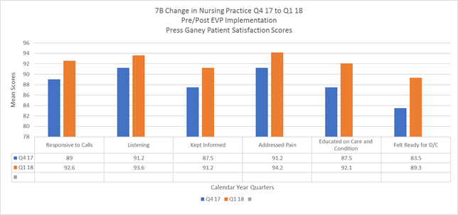

A qualitative evaluation reveals positive impact on nursing growth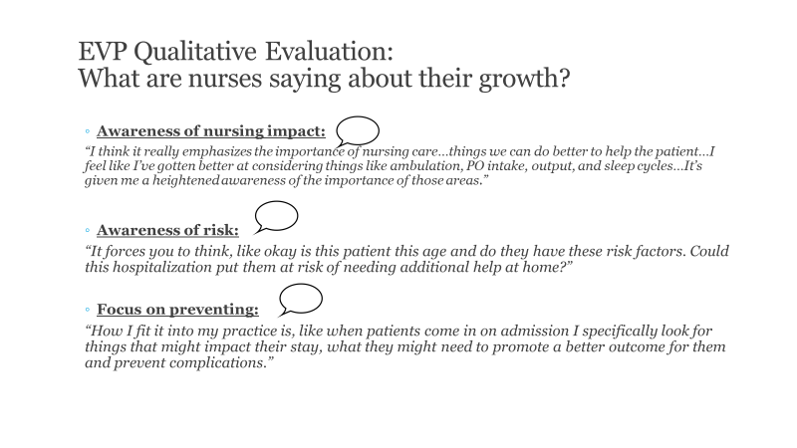

Acknowledgements:
EVP Team
Liza Gatley, DNP, AGACNP-BC
Tess Anderson, BSN, RN-BC
Karen Hewitt, BSN, RN
Rachel Pfeiffer, BSN, RN-BC

- David E. Murray MSN, RN, APN, NE-BC, Associate Director Patient Care Service
- Carole Borland, MSN, RN, Chief of Inpatient Nursing
- Steven Barczi, MD, FAASM, Director of Education & Clinical, Madison VA Geriatric Research, Education and Clinical Center
- Daniel Liebzeit PhD, RN, Advanced Fellow in Geriatrics, William S. Middleton Memorial Veterans Hospital, GRECC
- Geriatric Steering Committee members:
  - Rochelle Carlson, MS, RN, GNP-BC, CRRN (Chair)
  - Pamela Crary, PhD, RN, AHN-BC, VHA-CM
  - Kris Drager, MS, RN, CNL, CEN
  - Maureen Haske-Palomino, DNP, MSN, GNP-BC
  - Sara Feist, MS, RN

