The Float Pool Nurse, Resilience and Bridge to the Future of Quality Care
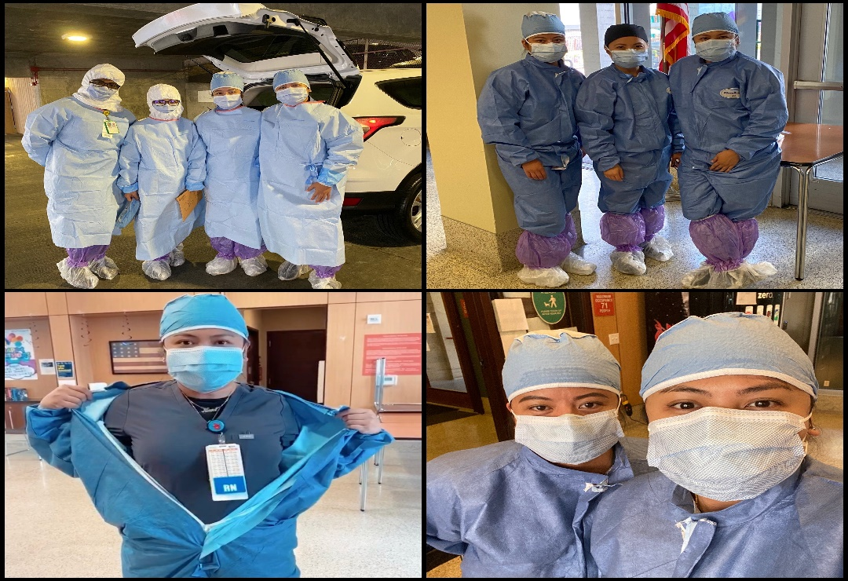
Rochelle
Angelie
Angelie
Rochelle
Angelie
Katherine
Fedeline
Rochelle
Katherine
Angelie
Angelie Pangilinan RN, Rochelle Flores RN, Fedelie Pierre-Louise RN, Katherine Borromeo
“In times like these, where there may be fear and lack of knowledge, I think there’s relief in knowing you’re able to get tested and hoping you’re negative,” stated Rochelle Flores.)
Gowned up, boots and masks on, our San Francisco VA Float Pool Nurses are ready to battle the invisible enemy- COVID 19! Without hesitation, they stand in the gap to take on a mission that impacts indispensable care outside our VA hospital, reaching out to our most vulnerable community- our very own Homeless Veterans! The COVID-19 outbreak has brought attention to disparities in our cities, and most importantly, the access to healthcare, healthcare information, resources and treatments. Homeless veterans have limited personal protection making them the high-risk patient population for COVID 19. Especially with compact living environments common to homeless populations, COVID-19 is very easily spread. This group of Veterans are focused on meeting their Maslow’s Hierarchy basic needs, such as food and shelter FIRST. While important, their medical needs are not their greatest concern.
The San Francisco Veteran Health Care System understands this prioritization, and, thus, we provided resources for our homeless veterans through cohesive collaboration with our interdisciplinary healthcare teams, from administration to expert clinicians such as nurses, doctors, and social workers. Through multidisciplinary teamwork, we were not only able to screen for the COVID-19 virus and provide critical education, we were also able to connect our homeless veterans to essential resources.
Our Float Pool Nurses bravely brought preventative care for our Veterans to fight the COVID-19 Pandemic from outside our hospital walls. Demonstrating strong leadership, commitment, service and courage, our nurses screened, educated and showed compassion in this time of great need. Float Pool Nurses provided quality nursing care and reflects the VHA I CARE model. The I CARE model values the integrity, commitment, advocacy, respect, and excellence for ALL our veterans. Inspired by street medicine, our Float Pool Nurses took an active role, led by example to bridge quality nursing care and showed empathy to our homeless veterans scattered in the Streets of San Francisco, prioritizing their safety. These nurses volunteered their time in testing vulnerable communities. They demonstrated the importance of primary prevention by educating and protecting those who do not have access to healthcare resources. By taking a proactive stance in preventing COIVD-19 spread through screening and educating, these nurses prioritized the safety of our community, not just our patients.
To close the gap in access and increase public knowledge of COVID-19, Float Pool Registered Nurses at the SFVA have been at the forefront of combating the pandemic and preventing the spread of this virus. Having strong and reliable Float Pool Nurse Resources is the key to augment care and provide an exemplary patient experience. The SFVA Float Pool Nurses hope to have been instrumental in this outreach and inspired many to GO OUT THERE and serve the HOMELESS VETERANS!

