Vietnam Veteran Finds Meaning and Peace through Meditation
By: Andrea Young, Office of Patient Centered Care & Cultural Transformation

Meditation, relaxation and movement classes have changed one Veteran’s relationship with VA – from stranger to friend; and he is grateful that, despite COVID -19 stay-at-home orders, he is still able to be connected in a meaningful way to this friend and others.

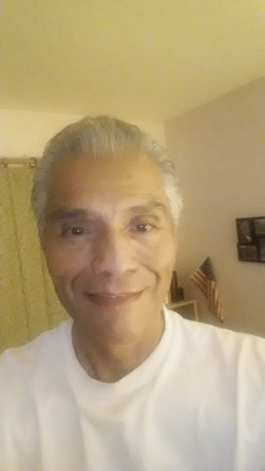
Victor Hernandez attends iRest meditation sessions over the phone, and Meditative Movement through VA Video Connect. He says, “I feel the energy of the other Veterans, even over the phone, and I feel the connection and that helps me feel not so isolated. Knowing that the other Veterans are calling in and getting help through this time makes me feel better knowing that they are okay, and that helps my own healing.”

Hernandez, a now 69-year-old Vietnam Veteran, came to the Greater Los Angeles VA Medical Center in 2011 with anxiety, depression, insomnia, flashbacks, and a history of alcohol abuse and work-related stress. He was diagnosed with PTSD, and a VA psychiatrist recommended medication and group therapy sessions; but Victor didn’t follow-up with the group sessions, preferring to listen to music and walk as his form of therapy.
Recognizing the healing power of that music and movement offered, Victor’s psychiatrist referred him to the Mental Health Integrated Care program, which offered him an Introduction to Relaxation and Meditation group class series. Being buoyed by these groups, he joined the ongoing weekly classes in Meditative Movement and iRest offered at the Sepulveda VA outpatient clinic.
By 2013, when Victor saw his VA psychiatrist, he reported that he was unsure if the medications were helping, and he was not taking them consistently; but the yoga and meditation classes were helping his symptoms to improve. Since then he continues taking a variety of complementary and integrative health classes.
Victor now feels optimistic about his future, his finances are in control, and his satisfaction with his life has greatly improved. He has relationships and no longer seeks isolation. He has found a sense of inner peace which had alluded him before.

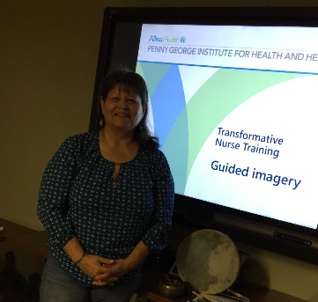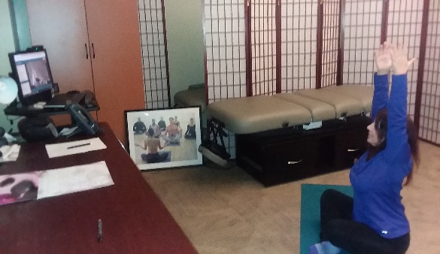
Elizabeth Marin, RN Terri Telligman, RN

The Integrative Holistic Nurses, Terri Telligman, RN and Elizabeth Marin, RN, at Greater Los Angeles VAMC currently provide care through video conferencing by teaching the Veterans tools and techniques they can use for pain, stress and anxiety. These include guided imagery, meditation, breathing techniques, progressive muscle relaxation, meditative movement, mindfulness techniques like finger labyrinth, acupressure relaxation tapping, and Healing Touch techniques such as Mind Clearing and Self Chakra Connection.

A healing touch clinic was created to activate and support patients’ self-healing through patient activation, empathic social support (an environment in which the Veteran feels understood, safe, and cared about), and the specific, evidence-based, healing mechanisms activated by and through meditation, yoga, and healing touch, when done by or with the assistance of well-trained providers.

