Did you know the largest cause of pneumonia comes from bacteria in the patient’s own mouth?
VA nurse researcher Shannon Munro, PhD, NP discovered one of the ways to reduce the risk of hospital-acquired pneumonia in her hospital: encouraging and assisting patients to brush their teeth and clean their dentures. According to the CDC, pneumonia is the number one hospital-acquired infection in the U.S., with the largest cause of pneumonia stemming from bacteria originating from the patient’s own mouth. Bacteria multiply rapidly in an unclean mouth and they are frequently aspirated into the lungs during sleep. Non-ventilator associated hospital-acquired pneumonia (NV-HAP) is a significant risk for patients, especially those who are elderly with multiple chronic medical problems. NV-HAP risk can be lowered through consistent oral care, early ambulation, head of bed elevation, aspiration precautions, and other common nursing activities.
Dr. Munro is the National Implementation Lead for HAPPEN (Hospital Acquired Pneumonia Prevention by Engaging Nurses). Munro and her team have significantly reduced the risk of developing NV-HAP by assisting Veterans with their oral hygiene during hospital admissions. This initiative is supported by the VA Diffusion of Excellence (DOE) Initiative, the Quality Enhancement Research Initiative (QUERI), the Office of Strategic Integration, the Veterans Engineering Resource Center, the Office of Nursing Services, the Office of Dentistry, and the Office of Rural Health. HAPPEN supports the mission of modernizing systems/ processes with a focus on preventive care and improving the quality of health care provided; and by improving access and timeliness of service through reductions in length of stay. A QUERI/ DOE funded partnered evaluation of HAPPEN is in progress.
Munro received her PhD in Nursing from the University of Hawaii in 2009 and her MSN from Old Dominion University in 2001. She began her nursing career over 30 years ago with close to half of those years with VA. She started working as a nursing assistant at age 19 while completing her RN degree. This early start gave her valuable work experience, insight into the responsibilities and challenges of each staff member, and a true appreciation for how hard each member of our profession works. Her experiences at the bedside, as a researcher, and a nurse practitioner give her a unique understanding of the challenges of translating research findings to best practices.
HAPPEN was first tested at the Salem VAMC in the Community Living Center (CLC), which offers long-term care to Veterans, many of whom are elderly and have multiple chronic health conditions. The CLC team has maintained a 90% decrease in NV-HAP rates from the baseline for over 3 years now. Likewise, the medical surgical units 4H and 4J at Salem have sustained significant improvement from their baseline for over 2 years. While leading expansion throughout VISN 6, Munro also partnered with nurse manager Daryl Edgemon at the Houston VAMC’s Coronary Care Unit and 3D Step Down Unit. Due to the success at the 8 VA pilot sites, national deployment of HAPPEN is underway with 68 VA hospitals in various stages of implementation in 184 medical surgical, pre-surgical, intensive care, long term care, hospice and palliative care, spinal cord injury, blind rehabilitation, and inpatient mental health units.
Many health care providers do not realize that 70% of hospitalized patients do not receive assistance with their oral hygiene placing them at risk for pneumonia. Consistent oral care helps save lives at an average cost of $3 for oral care supplies and a few extra minutes per patient per shift. Each case of NV-HAP prevented can save an average of $40,000 per patient and return the patient home to their family sooner.

For the program to be successful, the team had to get VA nurses and nursing assistants on board. And as the largest nursing workforce in the nation with over 80,000 nurses, that is no small feat. The team is proud to see so many nurses leading efforts to adopt this practice and recognize success wouldn’t be possible without the many nurse champions across the VA network serving in a leadership capacity for the program. With HAPPEN, VA nurses are collaborating with other disciplines across the network to improve our health care system, sharing the wealth of their experiences and innovative ideas, and saving lives.

For more information about launching HAPPEN at your facility:

- Email VAHAPPEN@va.gov (outside VA email)

- Munro, S., Baker, D. (2018). Reducing missed oral care opportunities to prevent non-ventilator associated hospital acquired pneumonia at the Department of Veterans Affairs. Applied Nursing Research 44, 48-53. Doi: 10.1016/j.apnr.2018.09.004
- Munro S, Haile-Mariam A, Greenwell C, Demirci S, Farooqi O, Vasudeva S. (2018). Implementation and dissemination of a Department of Veterans Affairs oral care initiative to prevent hospital acquired pneumonia among non-ventilated patients. Nursing Administration Quarterly 42(4), 363-372. Doi: 10.1097/NAQ.0000000000000308
- Munro S, Baker D. (2019). Integrating oral healthcare into patient management to prevent hospital-acquired pneumonia- A team approach. Michigan Dental Association Journal, 48-57.
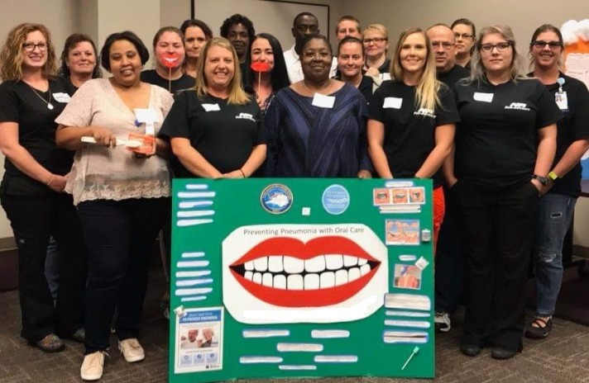
A team of nurses showcasing HAPPEN at the VA hospital in Asheville, North Carolina

