Kristie Harmon, MSN RN CHSE
Clinical Educator
Poplar Bluff, MO
Nurse Educator

The John J. Pershing VA Medical Center in Poplar Bluff, MO is situated in the rolling hills of the Missouri boot heel. This Level 3 facility provides foundational services to a rural cohort of Veterans and cares for a limited number of emergencies. Ms. Kristie Harmon MSN, RN, CHSE helps the nurses prepare and maintain competencies by engaging them in simulated emergency drills, keeping the local procedures up to date with the most current evidence. These skills are being put to the test as increasing urgent care admissions related to COVID-19 spread to the most rural of communities during this national crisis.

With meticulous attention to donning and doffing Personal Protective Equipment (PPE) and the use of state-of-the-art infection prevention practices Kristie educates nursing staff to protect themselves while saving the lives of their patients. As you can see from the photo Kristie enjoys the “light-bulb” moment when the learner sees the connection of the concepts and feels empowered.

Kristie has been at John J. Pershing for ten years, and she was recruited by her father, a veteran of the Vietnam era, who encouraged her to move to VA because he thought it was a nice place to work. Kristie loves the VA and wouldn’t work anywhere else. She says she is “honored” to provide care for Veterans, because of what they sacrificed for our country.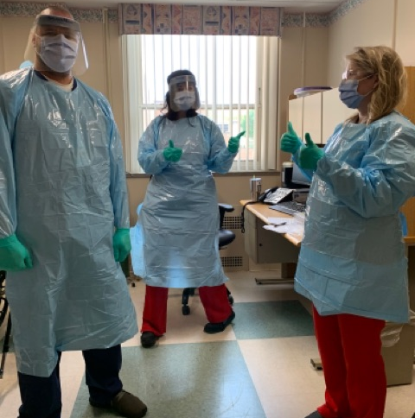
Photo caption Chad Keeney RN (left) and Kimberly Henson RN receive PPE training updates by clinical educator Kristi Harmon MSN, RN, CHSE

