Story by H. Ho, RN, Nursing Education, VA Pacific Islands Health Care System (28 years of VA/DOD service, non-veteran)

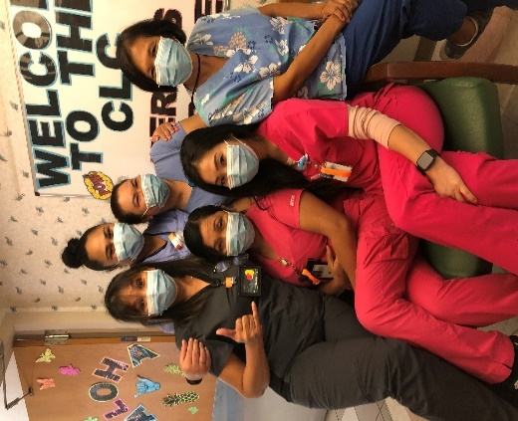The annual observance of Nurse Assistants Week (June 18-25) and Career Nurse Assistants Day (June 18) is a special time to celebrate and recognize the efforts of our (certified) nurse assistants (NAs) in long-term care services. Their dedication and contribution to our organization go beyond providing daily routine care to our Veteran residents.

In the Center for Aging (CFA) of VA Pacific Islands Health Care System (PIHCS), each of our NAs brings forth his/her work experiences to provide personalized care that are guided by residents’ preferences and values. They can use perspective and tailor care based on the needs of each individual resident. These seasoned nurse assistants have displayed their confidence, skill sets and values by demonstrating their ability to interact with patient, family and members of our multidisciplinary team.

Left to right top: Remedios Bautista, Jewel Vaka-Faileaso, Anna Liza Dumot, Ever Cruz; bottom left to right: Marites Marquez and Laura Koike.

With their enriched bedside experiences, they also perform as peer teachers for our pre licensed nurse graduates.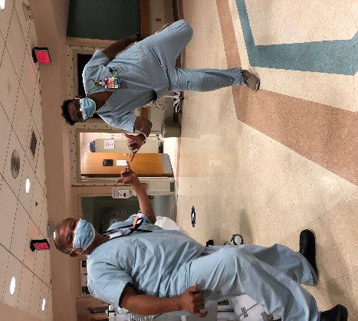 Through peer teaching, there are potential learning opportunities for reciprocal mentoring for both seasoned and novice in interdisciplinary communication, teamwork and patient advocacy. This invaluable teacher-peer duet relationship creates a safe and supportive clinical environment that allows novice professionals to build confidence towards the transition to the Registered Nurse ‘s role. A statement shared by P. Batorne, RN, “I really appreciate our NAs. They are on the frontline; our eyes and ears in the resident’s status. They can pick up subtle changes and provide baseline data and information to us right away.”

Jay Tabayan and Everett Glenn

It is imperative to acknowledge and recognize the real values on how our NA’s carry out his or her role. Their dedication and commitment to deliver quality care and to meet residents’ individualized needs align with the ICARE values. New grad nurse, R. Rapoza, commented, ‘They treat me with respect as a new grad; they check on me throughout the day and let me know that I am doing well.’

The value of advocacy and excellence in our NAs’ role also plays an integral part of providing emotional support and maintaining a home-like environment for CFA residents. The Center is surrounded by well-maintained lawns and two gardening areas that are CLC resident in wheelchair with nursing assistant outdoors
planted with vegetables and plants, such as Thai basil, long beans, sweet potato, papaya, gardenia, spider lily, pikake, rose bushes, etc. These areas are frequented by the residents throughout the day, where they can get a fresh breath of basil plants and fully bloomed roses, or just be outside in the gardens. Resident Shim, one of two master planters who has been getting gardening help more than two years from our devoted NAs, stated, “It is hard to find good help. Remy (a CNA) has always been there after she finishes her work to help me in the garden.” RN, M. Forte, also added that, “Our NAs work hard. They are always on their feet and quick to answer calls. We are blessed to have them.” These positive personality traits come from their hearts as they are not just dedicated to their job, they take care our Residents like their own family.

Resident Shim and C. Iwamoto

Let us make this National Nurse Assistants Week and Career Nurse Assistant Day a time to celebrate all the things our nurse assistants, unlicensed assistive personnel, and health and patient care assistants have done to make the profession everything it can be!