Healing Garden Yoga for the Heart and Soul
Nancy Ruud, MSN, RN, AHN-BC, NBC-HWC, RYT-200, is a holistic nurse in action teaching weekly outdoor yoga classes for our Veterans in Fargo, ND. She also is a Whole Health coach and VHEC within our healthcare system. Veterans praise Nancy’s ability to create healing relationships and environments in a currently chaotic world. This photo shows the first Gentle Yoga class held since the COVID-19 pandemic began. Some Veterans were moved to tears for the opportunities to see their comrades after long absences due to self-quarantine. Nancy is a leader in Whole Health practices for the facility and has been a change agent in the facility’s acceptance and integration of Whole Health methodology. Today we would like to honor Nancy for her contributions! Thank you.
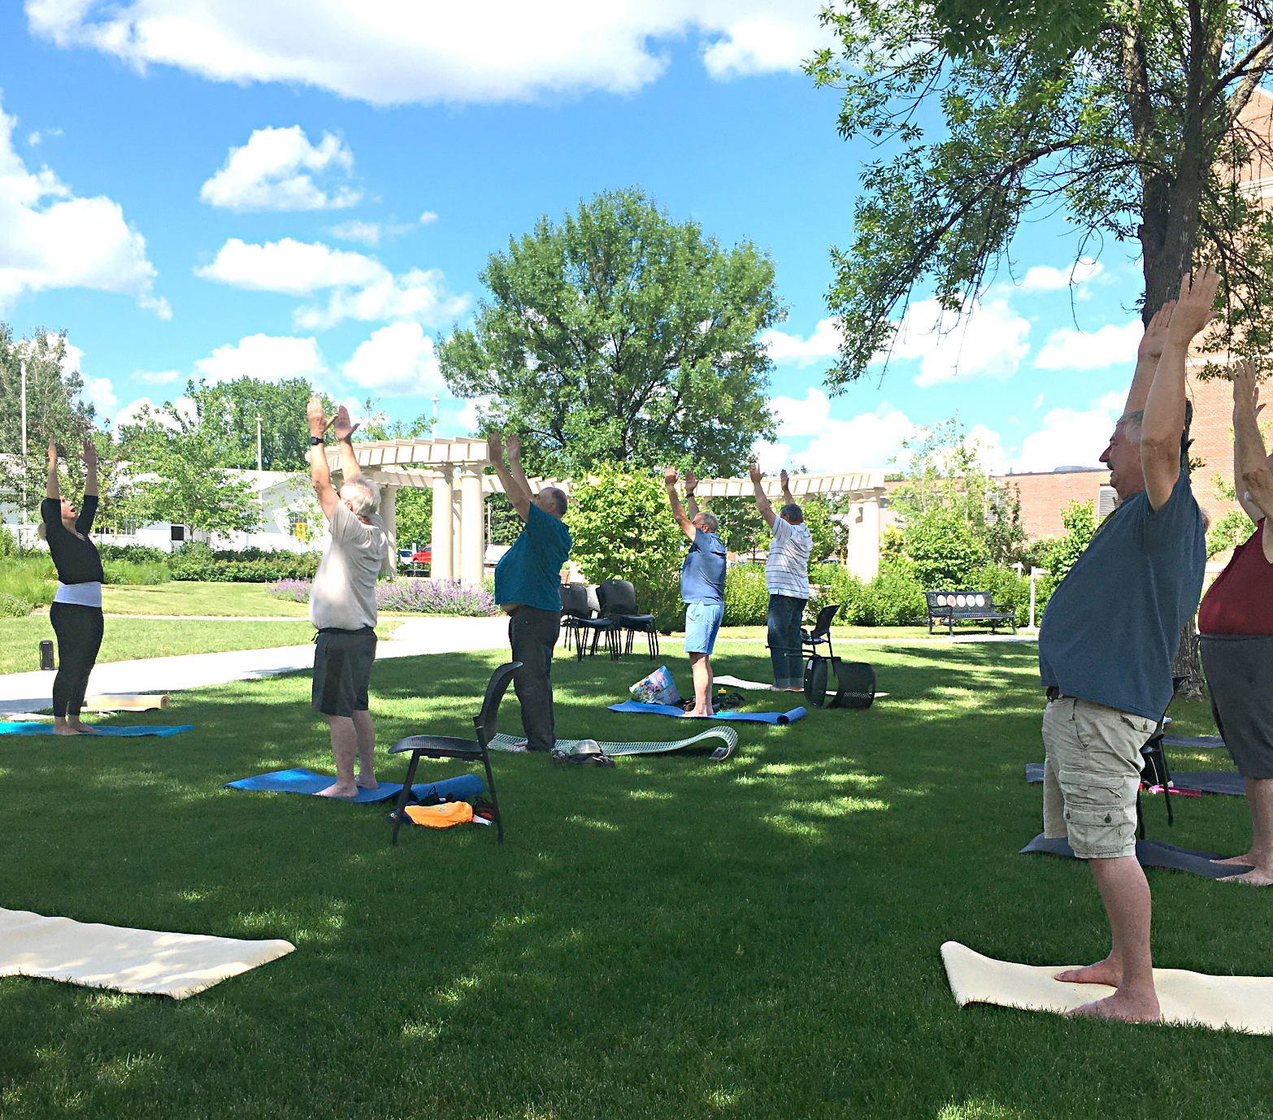
Nancy Ruud, RN leads yoga with Veterans in the Fargo VAMC Healing Garden

